Appendix: the stimuli used in the Fast mapping task. The stimuli were in color.
types of stimuli | Stimuli IPA | Novel Object
Similar to Hebrew phonotactics | Trial 1 /marban/  /galid/ | 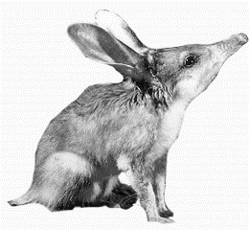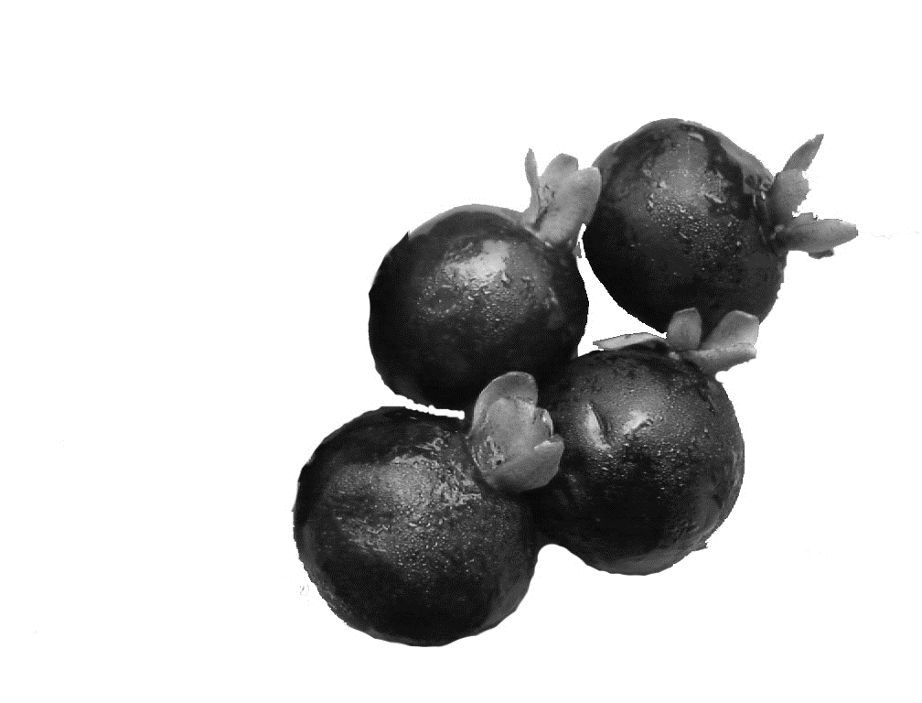
 | Trial 2 /xatsik/  /batur/ | 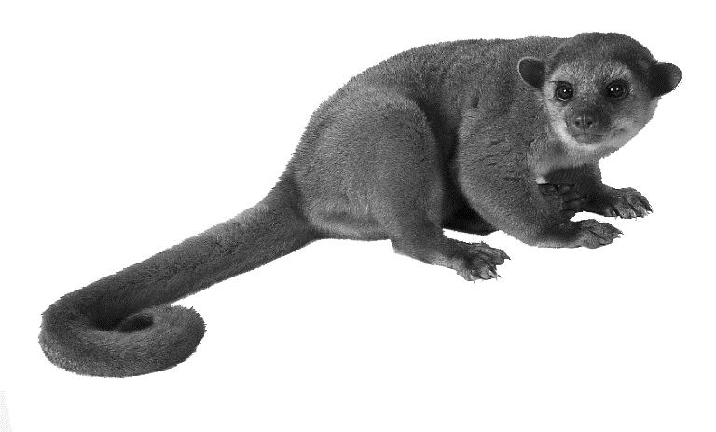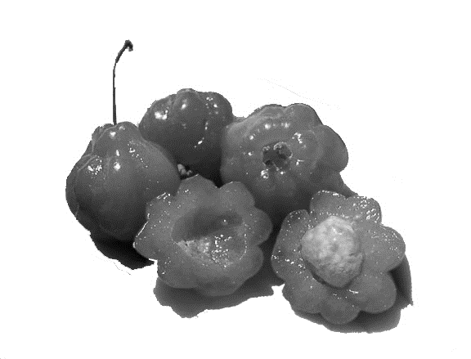
 | Trial 3 /gavas/  /midlar/ | 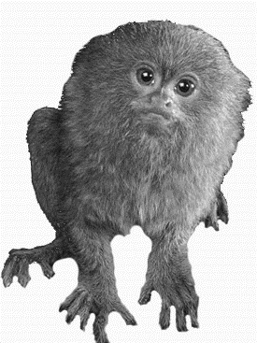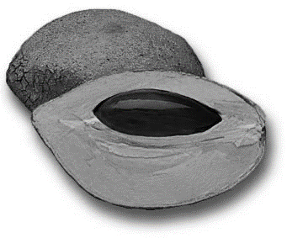
Similar to Arabic phonotactics | Trial 1 /d3wmʔn/  /barʢwf/ | 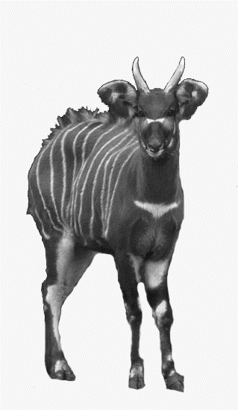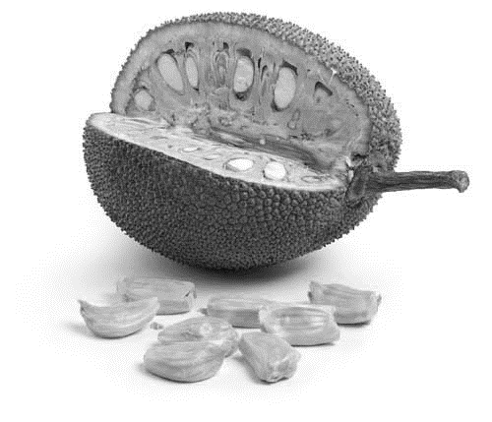
 | Trial 2 /mandwr/  /dʒarbwd/ | 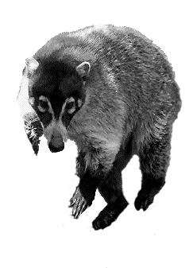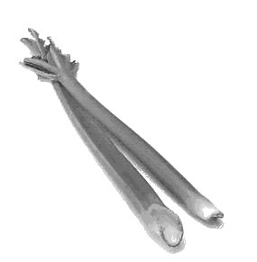
 | Trial 3 /kʔme̞n/  /ħanfwr/ | 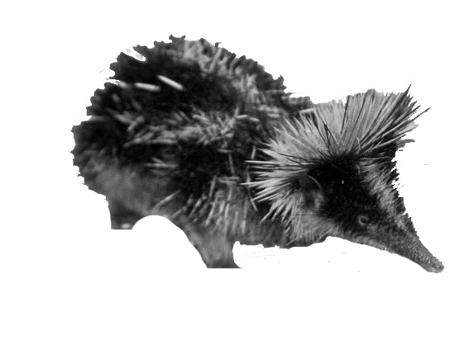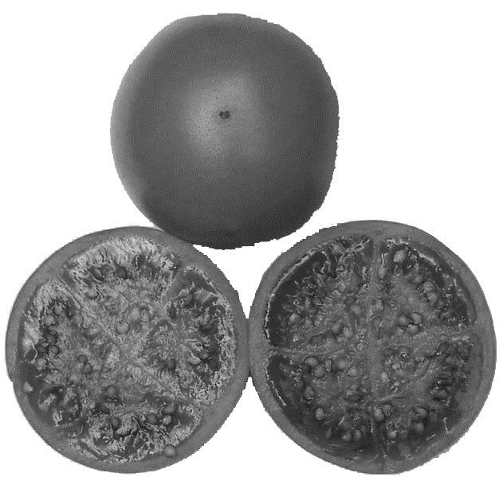
Neutral phonotactics | Trial 1 /bongo/  /salek/ | 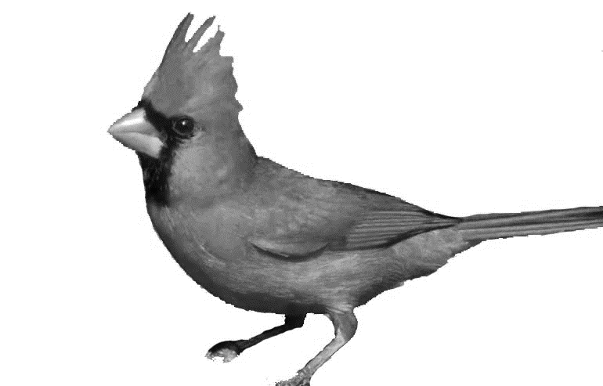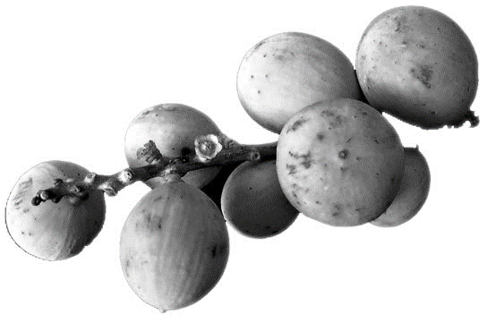
 | Trial 2 /dʒakka/  /tsif/ | 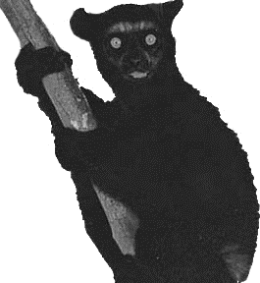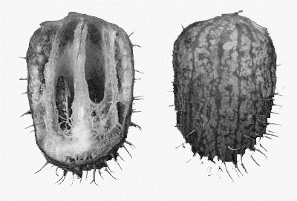
 | Trial 3 /santol/  /yottah/ | 