**10. Supplementary material**

**1. MGB literature**

**Proportion of review articles**

There is a very high proportion of review articles in the MGB field, whichever search term is used.

* "Gut brain bacteria” finds 326 reviews out of 768 articles (43%)
* “Gut-brain microbiota” finds 167 reviews out of 325 articles (51%)
* “Microbiota brain” finds 386 reviews out of 865 articles (45%).

Those numbers only include whatever PubMed automatically lists as a review. The true numbers are probably higher. We discarded the reviews that turned up in our highly cited list in order to get at the core experimental corpus of the field.

**Most prolific authors**

The five most prolific authors in the field as of 22.05.2017 (represented by the 867 source articles):

1. John F Cryan (81 articles, including >43 reviews)
2. Timothy/Ted G Dinan (79 articles, including >44 reviews)
3. Gerard Clarke (29 articles, including >17 reviews)
4. John Bienenstock (21 articles, including >6 reviews)
5. Premysl Bercik (19 articles, including >9 reviews)

Cryan (a neuropharmacologist) and Dinan (a pharmacologist/psychiatrist) are both leaders of gut-brain microbiota axis at the APC Microbiome Institute (University College Cork, Ireland) and have authored 222 papers together. They have also published with Clarke, a neuropharmacologist/psychiatrist at UCC. Bienenstock, an immunologist (McMaster, Canada) and Bercik (McMaster), a neural gastroenterologist, are not directly connected to this group.

**Supplementary Table 1**: The broad range of MGB-associated methods, with exemplar publications selected from 25 most-cited MGB experimental papers (see Section 4).

|  |  |
| --- | --- |
| **General method** | **Specific features of methods** |
| Animal models | * Germ-free (GF), specific pathogen free (SPF), and conventionalized rodents (e.g., Sudo et al. 2004) * Autism model rats (e.g., de Theije et al. 2014) * Colitis model rodents (e.g., Ohland et al. 2013) * Depression model rodents (e.g., Park et al. 2013) * Maternal immune activation rodents (e.g., Hsiao et al. 2013) * Pups undergoing maternal separation (e.g., O’Mahony et al. 2009) |
| Animal behavioural tests | * Forced swim (e.g., Bravo et al. 2011) * Step down (e.g., Bercik et al. 2011) * Elevated plus maze (e.g., Neufeld et al. 2011b) * Light-dark choice (e.g., Gareau et al. 2011) * Open field (e.g., Diaz Heijtz et al. 2011) * Object recognition (e.g., Desbonnet et al. 2015) * Social interaction (e.g., Hsiao et al. 2013) |
| Rodent gut, brain and blood biochemical assays | * Neurochemical brain analysis and blood metabolites by high-performance liquid chromatography (e.g., Clarke et al. 2013) * Microbial metabolites in faeces by gas chromatography (e.g., Leclercq et al. 2014) * Measurements of neurotrophin, nerve growth factor protein (e.g., Sudo et al. 2004), C-reactive protein (e.g., Leclercq et al. 2014), hormones (e.g., Bruce-Keller et al. 2015), cytokines and chemokines by immunoassays (e.g., Ohland et al. 2013) * Intestinal permeability assays (e.g., Hsiao et al. 2013) * Blood endotoxin tests (e.g., Ait-Belgnaoui et al. 2014) |
| Human behavioural assessments | * Human patient self-reports, depression and anxiety scales (e.g., Messaoudi et al. 2011; Steenbergen et al. 2015) |
| Experimental interventions in rodents | * Probiotics (e.g., Tillisch et al. 2013) * Microbiota transplants (e.g., Diaz Heijtz et al. 2011) * Antibiotic treatments (e.g., Bercik et al. 2011) * Dietary alterations (e.g., Ohland et al. 2013) * Pathogen introduction (e.g., Gareau et al. 2011) * Vagotomy (e.g., (Bravo et al. 2011) |
| Experimental interventions in humans | * Probiotics and dietary interventions (e.g., Tillisch et al. 2013) * Antibiotic treatments (e.g., Bajaj et al. 2013) |
| Microbiome analyses | * Comparisons of gut microbiomes of mice/humans with brain or behavioural disorders to the microbiome of healthy organisms (e.g., Bailey et al. 2011; Jiang et al. 2015) * Comparison of host microbiomes before and after interventions (e.g., Messaoudi et al. 2011; Tillisch et al. 2013) |

**Supplementary Table 2**: Probiotic methods in 25 most cited MGB publications

|  |  |  |
| --- | --- | --- |
| **Publication** | **Probiotic** | **Model** |
| Bravo et al. (2011) | *Lactobacillus rhamnosus* | BALB/c mice |
| Messaoudi et al. (2011) | *Lactobacillus helveticus* R0052 *Bifidobacterium longum* R0175 | Wistar rats Human (clinical trial) |
| Gareau et al. (2011) | *Lactobacillus rhamnosus* R0011 *Lactobacillus helveticus* R0052 | C57BL/6 mice |
| Ait-Belgnaoui et al. (2012) | *Lactobacillus farciminis* | Wistar rats |
| Hsiao et al. (2013) | *Bacteroides fragilis* | C57BL/6N mice |
| Ohland et al. (2013) | *Lactobacillus helveticus* | 129/SvEv mice |
| Ait-Belgnaoui et al. (2014) | *Lactobacillus helveticus* R0052 *Bifidobacterium longum* R0175 | C57Bl6 mice |
| Steenbergen et al. (2015) | *Bifidobacterium bifidum* W23 *Bifidobacterium lactis* W52 *Lactobacillus acidophilus* W37 *Lactobacillus brevis* W63 *Lactobacillus casei* W56 *Lactobacillus salivarius* W24 *Lactococcus lactis* | Human (clinical trial) |

**Supplementary Table 3**: Microbiome methods in the 25 most cited MGB publications

|  |  |  |
| --- | --- | --- |
| **Publication** | **Method** | **Comment** |
| O’Mahony et al. (2009) | DGGE | Detects different profiles between two groups; an older qualitative method. |
| Bercik et al. (2011) | Culture DGGE + Sanger sequencing | Detects different profiles between two groups; some specific taxa listed; an older qualitative method. Sanger sequencing superseded. |
| Bailey et al. (2011) | V4-V6 16S rRNA 454-pyrosequencing | Superseded sequencing and analysis methods, with a small number of reads obtained per sample. Some evidence for differences at time 0 from clustering, but not narrowed down to specific taxa. |
| Gareau et al. (2011) | 16S rRNA qPCR | Some taxa are estimated by qPCR. No mention of the exact normalization performed (e.g., Is rRNA copy number taken into account?). |
| Bajaj et al. (2013) | V1-V2 16S rRNA GS-Junior pyrosequencing | No significant changes in profile are reported. A correlation network was built for microbiome and metabolome data, and connectivity of the network was compared. |
| Park et al. (2013) | DGGE | Detection of different profiles between two groups via an older qualitative method. |
| Hsiao et al. (2013) | V3-V5 16S rRNA 454-pyrosequencing | Appropriate bioinformatic and statistical tools used. |
| Tillisch et al. (2013) | V5-V6 16S rRNA 454-pyrosequencing | “Post-hoc analysis of fecal microbiota composition indicated a good randomization of the subjects at baseline. No significant change in microbiota composition vs baseline was found after intervention between groups” (p. 1397). In other words, the study did not observe any change in the microbiota. |
| Ohland et al. (2013) | T-RFLP | An old-fashioned method that flattens the diversity in the sample to small number of distinguishable peaks. That flattening might be the reason for a very clear separation of the samples on the PCA plot. |
| Leclercq et al. (2014) | V1-V2 16S rRNA 454-pyrosequencing 16S rRNA qPCR | Appropriate bioinformatic and statistical tools used. |
| de Theije et al. (2014) | V3-V5 16S rRNA 454-pyrosequencing | Appropriate bioinformatic and statistical tools used. |
| Jiang et al. (2015) | V1-V3 16S rRNA 454-pyrosequencing | Appropriate bioinformatic and statistical tools used but no beta-diversity/PCA presentation in the main figures, due to high variation. Instead, the authors perform multiple tests with the aim of finding significant taxa. |
| Bruce-Keller et al. (2015) | V3-V4 16S rRNA Illumina MiSeq sequencing | Appropriate bioinformatic and statistical tools used. |

**Abbreviations**

DGGE: denaturing gel electrophoresis; T-RFLP: terminal restriction fragment length polymorphism; V1-V6 16S rRNA: 16S ribosomal RNA variable regions 1-6.

**Supplementary Tables 4a-d:** Five categories of central nervous system-related foci and methods in 25 most cited MGB papers

**Supplementary Table 4a:** Neuroendocrine “stress” axis

|  |  |  |
| --- | --- | --- |
| **Publication** | **HPA-axis assessment** | **Species** |
| Bravo et al. (2011) | Forced swim, Cort | BALB/c mice |
| Sudo et al. (2004) | Restraint, CRH, ACTH, Cort | BALB/c mice |
| O’Mahony et al. (2009) | Maternal separation, Cort | Sprague Dawley rats |
| Neufeld et al. (2011b) | Cort 48 h after arrival in lab | Swiss Webster mice |
| Messaoudi et al. (2011) | Urinary 24 h Cort | Human |
| Clarke et al. (2013) | Novel cage, Cort | Swiss Webster mice |
| Gareau et al. (2011) | Water avoidance stress, Cort | C57BL/6 mice |
| Ait-Belgnaoui et al. (2012) | Restraint, CRH, ACTH, Cort | Wistar rats |
| Crumeyrolle-Arias et al. (2014) | Open field, CRH, Cort | F344 rats |
| Ohland et al. (2013) | Brain and fecal Cort | 129/sVEv mice |
| Park et al. (2013) | Water avoidance stress, CRH | C57BL/6 mice |
| Ait-Belgnaoui et al. (2014) | Water avoidance stress, Cort, c-Fos PVH | C57Bl6 mice |
| Desbonnet et al. (2015) | Restraint, Cort | NIH Swiss mice |

**Abbreviations**

ACTH: adrenocorticotropic hormone; c-Fos: immediate early gene product often used as cellular activation marker; Cort: corticosterone; CRH: corticotropin-releasing hormone; PVH: paraventricular nucleus of the hypothalamus

**Supplementary Table 4b:** Emotion-mood: Anxiety

|  |  |  |
| --- | --- | --- |
| **Publication** | **Anxiety assessment** | **Species** |
| Diaz Heijtz et al. (2011) | Light-dark box, elevated plus maze, open field | NMRI mice |
| Hsiao et al. (2013) | Open field | C57BL/6N mice |
| Bravo et al. (2011) | Elevated plus maze, fear conditioning, open field | BALB/c mice |
| Bercik et al. (2011) | Light-dark box, step down test | BALB/c mice |
| O’Mahony et al. (2009) | Open field fecal boli | Sprague Dawley rats |
| Neufeld et al. (2011b, 2011a) | Elevated plus maze | Swiss Webster mice |
| Messaoudi et al. (2011) | Conditioned defensive probe burying  HADS anxiety subscale | Wistar rats  Human |
| Clarke et al. (2013) | Light-dark box | Swiss Webster mice |
| Gareau et al. (2011) | Water avoidance stress, light-dark box | C57BL/6 mice |
| Leclercq et al. (2014) | State-trait anxiety inventory | Alcohol-dependent humans |
| Steenbergen et al. (2015) | Beck anxiety inventory | Human |
| Bruce-Keller et al. (2015) | Elevated plus maze, fear conditioning, open field | C57BL/6 mice |
| Crumeyrolle-Arias et al. (2014) | Open field | F344 rats |
| Ohland et al. (2013) | Barnes maze | 129/sVEv mice |
| Park et al. (2013) | Open field, step down test | C57BL/6 mice |
| Desbonnet et al. (2015) | Light-dark box | NIH Swiss mice |

**Abbreviations**

HADS: Hospital Anxiety and Depression Scale

**Supplementary Table 4c:** Mood disorder: Depression

|  |  |  |
| --- | --- | --- |
| **Publication** | **Depression assessment** | **Species** |
| Bravo et al. (2011) | Forced swim test | BALB/c mice |
| Messaoudi et al. (2011) | HADS depression subscale | Human |
| Jiang et al. (2015) | DSM, Hamilton’s depression scale, Montgomery–Asberg Depression Rating Scale | Human |
| Leclercq et al. (2014) | Beck depression inventory | Alcohol-dependent humans |
| Steenbergen et al. (2015) | LEIDS-r, Beck depression inventory | Human |
| Park et al. (2013) | Tail suspension test | C57BL/6 mice |

**Abbreviations**

DSM: Diagnostic and Statistical Manual of Mental Disorders

**Supplementary Table 4d:** Autism spectrum/developmental disorders

|  |  |  |
| --- | --- | --- |
| **Publication** | **Autism spectrum assessment** | **Species** |
| Hsiao et al. (2013) | Pre-pulse inhibition, marble burying, social interaction | C57BL/6N mice |
| de Theije et al. (2014) | Social interaction | BALB/c mice |

**Supplementary Table 4e:** Cognition

|  |  |  |
| --- | --- | --- |
| **Publication** | **Cognition assessment** | **Species** |
| Bravo et al. (2011) | Fear conditioning | BALB/c mice |
| Gareau et al. (2011) | Novel object recognition, T‑maze | C57BL/6 mice |
| Bajaj et al. (2013) | BDT and the psychometric hepatic encephalopathy score (PHES; consists of NCT-A, NCT-B, DST, line tracing test and serial dotting) | Cirrhotic humans |
| Bruce-Keller et al. (2015) | Fear conditioning | C57BL/6 mice |
| Ohland et al. (2013) | Elevated Barnes maze | 129/sVEv mice |
| Desbonnet et al. (2015) | Novel object recognition, social transmission food preference (social memory) | NIH Swiss mice |

1. **Terminology evaluation**

When addressing anxiety and depression in animals, it is important to keep in mind that these categories depend on verbal reports of feelings in humans and can therefore not be assessed in the same way in animals. It can even be questioned if animals experience anxiety and depression, even though we can readily observe behavioural and physiological changes in test situations that we consider would induce fear or giving up an active coping strategy. To emphasize the distinction between human anxiety and depression and what scientists can assess in animals, it is considered good scientific practice to describe the results of such behavioural tests with terms such as “anxiety-like” or “depression-like” rather than directly inferring anxiety and depression. As shown in tables 5a and 5b, all MGB animal studies relevant to anxiety and depression employ appropriate “anxiety-like” and “depression-like” descriptive terms, even though they all also discuss anxiety and depression as such.

**Supplementary Table 5a**: Behavioural tests and descriptive terms relative to anxiety

|  |  |  |
| --- | --- | --- |
| **Publication** | **Behavioural test** | **Descriptions** |
| Diaz Heijtz et al. (2011) | Light-dark box, elevated plus maze, open field | Anxiety, anxiety behaviour, anxiety-like behaviour |
| Hsiao et al. (2013) | Open field | Anxiety, anxiety-associated, anxiety-like behaviour |
| Bravo et al. (2011) | Elevated plus maze, fear conditioning, open field | Anxiety, anxiety behaviour, anxiety-like behaviour, anxiety-related, anxiety responses |
| Bercik et al. (2011) | Light-dark box, step down test | Anxiety, anxiety-like behaviour |
| O’Mahony et al. (2009) | Open field fecal boli | Anxiety, anxiety-like behaviour |
| Neufeld et al. (2011a, 2011b) | Elevated plus maze | Anxiety, anxiety-like behaviour |
| Messaoudi et al. (2011) | Conditioned defensive probe burying | Anxiety, anxiety-like behaviour, anxiety related |
| Clarke et al. (2013) | Light-dark box | Anxiety, anxiety behaviour, anxiety-like behaviour |
| Gareau et al. (2011) | Water avoidance stress, light-dark box | Anxiety, anxiety-like behaviour |
| Bruce-Keller et al. (2015) | Elevated plus maze, fear conditioning, open field | Anxiety, anxiety behaviour, anxiety-based behaviour, anxiety-like behaviour |
| Crumeyrolle-Arias et al. (2014) | Open field | Anxiety, anxiety-like behaviour, anxiety-like response, signs of anxiety |
| Ohland et al. (2013) | Elevated Barnes maze | Anxiety, anxiety behaviour, anxiety-like behaviour |
| Park et al. (2013) | Open field, step down test | Anxiety, anxiety-like behaviour |
| Desbonnet et al. (2015) | Light-dark box | Anxiety, anxiety behaviour |

**Supplementary Table 5b:** Behavioural tests and descriptive terms relative to depression

|  |  |  |
| --- | --- | --- |
| **Publication** | **Behavioural test** | **Descriptions** |
| Bravo et al. (2011) | Forced swim test | Depression, depression-related behaviour |
| Park et al. (2013) | Tail suspension test | Depression, depression-like behaviour; behavioural depression |

In addition to scoring the occurrences of descriptive terms, we also assessed the context in which they were used. We found several instances of inappropriate descriptive terms. With respect to the open field test, for example, Hsiao et al. (2013) write that: “Open field exploration involves mapping an animal’s movement in an open arena to measure locomotion and anxiety (Bourin et al., 2007)”, and Bravo et al. (2011) report that “*L. rhamnosus* (JB-1)-fed mice were less anxious”. Similarly for depression, Park et al. (2013) state that “The induction of chronic depression alters motor activity and the microbial proﬁle in the colon”, and Jiang et al. (2015) note that “Studies using animal models have shown that depression affects the stability of the microbiota”. Thus, even though all studies in our sample do use “anxiety-like” and “depression-like” descriptive terms when describing findings obtained in animal behavioural tests, several of them also employ anxiety and depression in an inappropriate way, namely to describe anthropomorphically phenomena derived from rodent models.

**Supplementary Table 6**: Independent variables tested, plus statistical methods used in the 25 most cited MGB papers. **Bold font** in the statistical-test cells indicates seemingly inappropriate use of statistical tests in view of the experimental design.

|  |  |  |
| --- | --- | --- |
| **Publication** | **Independent variables** | **Statistical test** |
| Diaz Heijtz et al. (2011) | Microbiota status (GF vs SPF) | Repeated measures ANOVA (phenotype between, time within)  One-way ANOVA |
| Hsiao et al. (2013) | Maternal immune activation;  *B. fragilis* treatment | **Student’s t-test, one way ANOVA, two-way repeated measure ANOVA (PPI, CD4+ stim)** |
| Bravo et al. (2011) | Ingestion of *Lactobacillus;*  Vagotomy | Student’s t-test, two-way ANOVA |
| Sudo et al. (2004) | Microbiota status (GF, SPF and gnotobiotic);  Stress (restraint, ether);  Reconstitution with bacteria | **Factorial analysis of variance** |
| Bercik et al. (2011) | Microbiota status (antibiotic);  Recolonization;  Nerve transection | **Analysis of variance** |
| O’Mahony et al. (2009) | Early life stress  (Open field, but all animals)  (Colorectal distension, but all animals) | Student’s t-test, two-way ANOVA (CRD, open field) |
| Neufeld et al. (2011a, 2011b) | Microbiota status (GF vs SPF; colonized GF vs SPF) | Student’s t-test, **two-way ANOVA (OF, EPM)** |
| Tillisch et al. (2013) | Consumption of probiotics | T test |
| Messaoudi et al. (2011) | Consumption of probiotics;  Diazepam  (Conditioned defensive burying, but all animals) | Kruskal-Wallis rank sum test, Mann-Whitney U test, Wilcoxon test |
| Bailey et al. (2011) | Social disruption stress;  Antibiotic | Two-way ANOVA |
| Clarke et al. (2013) | Microbiota status (GF, conventional and colonized GF);  Novelty stress  Sex | One-, two- and three-way ANOVA |
| Gareau et al. (2011) | Infection (*Citrobacter rodentium*);  Water avoidance stress;  Probiotic treatment;  Microbiota status (GF vs conventional) | Student t-test, *one-*, two-way ANOVA, Mann-Whitney test |
| Ait-Belgnaoui et al. (2012) | Partial restraint stress;  *L. farciminis* treatment;  Myosin light chain kinase inhibitor;  Antibiotic treatment | **Student’s t-test** |
| Bajaj et al. (2013) | Rifaximin treatment;  Time (before and after treatment) | Student t-test, principal coordinate analysis (PCA), Wilcoxon matched-pair signed rank tests |
| Jiang et al. (2015) | Depression (active MDD, respond MDD, healthy control | Kruskal-Wallis rank sum test |
| Leclercq et al. (2014) | Alcohol dependent detoxification before and after;  Intestinal permeability (high, low) | **Parametric ANOVA**, Kruskal-Wallis, Wilcoxon or paired Student t-tests |
| de Theije et al. (2014) | Valproic acid injection during gestation;  Sex | Kruskal-Wallis rank sum test, Mann-Whitney U test |
| Steenbergen et al. (2015) | Probiotic consumption (multispecies preparation vs placebo);  Time (before) | Repeated measures ANOVA (treatment between, time within), Bayesian probabilities |
| Bruce-Keller et al. (2015) | Microbiota transfer (high fat or control diet-fed donors) | Student t-test, repeated measures two-way ANOVA (body weight, fear conditioning) |
| Crumeyrolle-Arias et al. (2014) | Microbiota status (GF vs SPF);  Novelty stress (open field or not) | Student’s t-test, two-way repeated measures ANOVA (microbial status between, time on sniffing within), Mann-Whitney and Kruskal |
| Ohland et al. (2013) | Genotype (WT vs IL-10 KO);  Diet (standard chow vs Western);  *Lactobacillus helveticus* gavage | **Student’s one-way ANOVA** |
| Park et al. (2013) | Olfactory bulbectomy;  Intracerebroventricular injection (CRH vs vehicle)  (Water avoidance stress, but all animals) | Student’s t-test |
| Ait-Belgnaoui et al. (2014) | Probiotic administration (*Lactobacillus helveticus* R0052 & *Biﬁdobacterium longum* R0175, *L. salivrius*, placebo);  Chronic water avoidance stress | **One-way ANOVA** |
| Desbonnet et al. (2015) | Microbiota status (antibiotic)  Restraint stress | Student t-test, factorial and repeated measures ANOVA (antibiotic and stress between, time within) |

**7. Microbiota patents and probiotics**

We used the European Patent Office’s search tool to find all patents written in English containing the words “microbiome OR microbiota” in the title, abstract or the full text. This search found 2096 patents, which we downloaded and analysed. There is inflationary growth in the number of patents awarded since mid-2016 (Fig. S1).

Macintosh HD:Users:Kasia:data:microbiota:gut-brain:patents_dates.eps

**Figure S1.** Histogram of the number of microbiota-related patents published in the last ten years.

The majority of microbiota patents in the EPO database are filed from the US,[[1]](#footnote-2) and the contribution of the next most prolific country, France, is one-tenth that of US (Fig. S2A). Patent applicants vary from food companies and for-profit biotech companies to academic research institutions (Fig. S2). Elwha LCC, the second most prolific patent applicant, is a holding company with a large but latent patent portfolio. Its business model involves acquiring patents and never attempting to commercialize them, but instead using them to file lawsuits against institutions using those inventions.

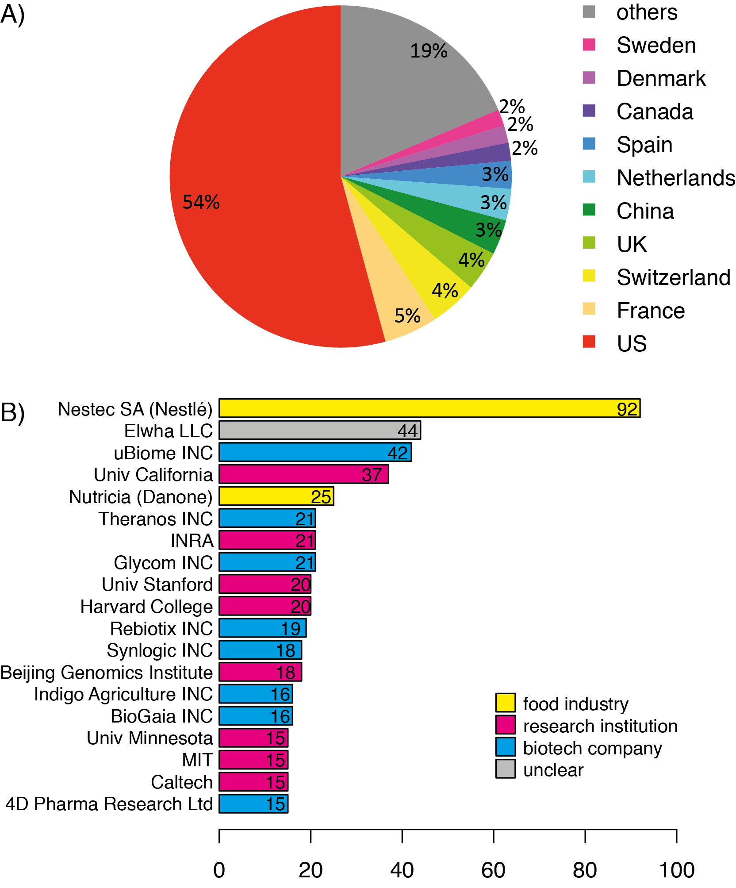

**Figure S2**. Microbiota patents applicants A) Country of origin of the microbiota related patents’ applicants. B) The most prolific patent applicants.

As might be expected, the most popular class of microbiota patents is the category labelled C12Q1/68: “Measuring or testing processes involving enzymes, nucleic acids or microorganisms”. The next largest proportion of patents involves administration or preparation of probiotics (class A61K3 and its subclasses).

**8. Microbiota gut brain in general press and online sources**

We used Factiva (<http://www.factiva.com>) to search for mass media articles about MGB research. The search was performed on July 4th, 2018 with the term: “(microbiome OR microbiota) AND ((brain AND (cogn\* OR (behavio\* AND (mood OR stress)))) OR gut brain axis)”. The search scoured English-language major news and business sources, and resulted in 310 articles. Among those articles, the most mentioned companies include University College Cork and Synthetic Biologics. The most prolific source was the Daily Mail with 46 articles, followed by The Times (UK) with 25 articles. US sources include Dow Jones Newswires and The New York Times (Fig. S3).

**Figure S3.** Most mentioned Subjects, Industries, Sources, Companies and Regions in the 310 general press articles pertaining to “microbiota gut brain” found through a Factiva search.

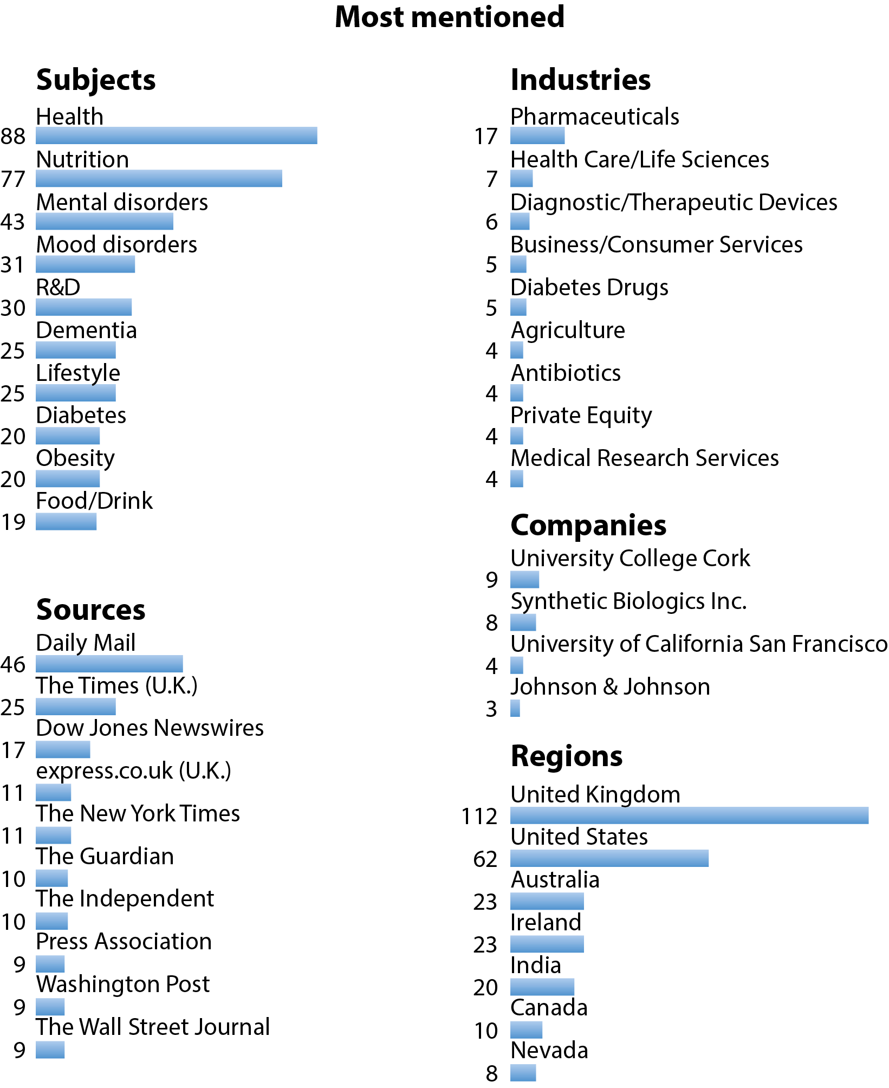

**Supplementary Material Table 8:** Selected quotes from online sites(in order of appearance in a list generated from a Google search for ‘gut brain microbiome’). 50 hits were examined, scholarly articles discarded, and quotes extracted from the first 10 remaining sites.

|  |  |
| --- | --- |
| ‘The microbiome-gut-brain axis also has the potential to fortify mental toughness in both sport and life’ | [Psychology Today Blog](https://www.psychologytoday.com/blog/the-athletes-way/201708/the-microbiome-gut-brain-axis-relies-your-vagus-nerve) |
| ‘Recent findings between the gut microbiota and the brain suggest that our microbiota can deeply influence our health, brain and potentially even our behaviour. The microbiota has been associated with several neurological conditions and it could be playing a role in your migraine condition’ | [MigrainePal](http://www.blog.migrainepal.com/blog/leaky-gut-migraine-and-other-gi-conditions) |
| ‘It is of course not surprising that gut microbiota profiling is not included as part of the routine clinical practice … Most psychiatric patients have digestive disorders, where 99% of all cognitive disorders start, so why are they being treated with Psychotropic drugs [and not diet?]’ | [Dr John Bergman](http://www.drjohnbergman.com/the-microbiome-and-the-gut-brain-connection-part-1/) |
| ‘Down in your large intestine live trillions and trillions of helpful bacteria and other microscopic creatures, collectively known as your gut microbiome. These critters help digest your food, keep you in good health, and — according to new research — influence your thoughts’ | [Nine Digital Coach](https://coach.nine.com.au/2017/06/30/10/25/gut-microbiome-link-to-brain-emotions-mood) |
| ‘It seems that our minds are, in some part, controlled by the bacteria in our bowels’ | [Medical News Today](https://www.medicalnewstoday.com/articles/312734.php) |
| ‘Gut flora influence various brain functions, affecting your thoughts, emotions, and memory’ | [Dr Lam Coaching](https://www.drlam.com/blog/microbiome-gut-flora/23823/) |
| ‘What we eat or take can also weaken our microbiome. Pharmaceuticals such as anti-biotics, the oral contraceptive pill, antidepressants all wipe out our beneficial bacteria. Foods such as coffee, alcohol, refined sugar, Artificial and GMO Foods also disrupt the balance’ | [Griffith Consulting](http://griffithconsulting.com/media-hub/blog/news-events/the-microbiome-and-gut-brain-axis/) |
| ‘Research suggests that up to 90% of health conditions be [sic] linked to the microbiome and the gut. Find out which top foods to avoid in your diet and which to increase in order to create a healthy gut-brain connection. Learn all of the other ways, including supplementation, which can protect the microbiome. Your gut-brain axis also affects your memory, concentration and focus’ | [Institute of Holistic Nutrition](http://instituteofholisticnutrition.com/lectures_and_worksho/microbiome-gut-brain-axis/) |
| ‘This study suggests that reduced microbiome diversity may be related to weight gain in women taking atypical antipsychotics. Atypicals are in widespread use in the US. Given the other benefits of probiotic supplementation, it would be a winning proposition to add probiotics for those taking atypical antipsychotics’ | [Janet Settle Integrative Psychiatry](http://janetsettle.com/microbiome-gut-brain-axis-mounting-evidence-in-psychiatry/) |
| ‘The lack of diversity in the microbial population, and the integrity of the intestinal wall – which is maintained with a healthy, flourishing microbiome – may influence negative symptoms and disease such as depression, anxiety, autism and Parkinson’s disease. Gut bacteria may also impact teen behavior,and appears to influence levels of mood modulating neurotransmitters, such as dopamine, GABA, histamine, acetylcholine and serotonin.What is interesting, is diet seems to have powerful sway over the state of balance (symbiosis), or imbalance (dysbiosis) of the microbiota, and therefore our mental and brain health’ | [That Sugar Film](http://thatsugarfilm.com/blog/2016/07/05/the-microbiome-and-the-gut-brain-axis/) |
| ‘When your gut microbiome is balanced, you stay healthy, you are in a good mood and you have a lot of energy. When your gut microbiome is out of balance, you are setting yourself up for a host of health issues, including weight gain, diabetes, brain fog, and cancer … The good new[s] is that you can change your gut microbiome. You see, the average lifespan of a bacterium in your microbiome is 20 minutes! So you have the opportunity every time you eat to begin to change the population of your gut microbiome. This is good news because it means that rather than having to subscribe to theories, such as the Paleo diet, which assumes our genes evolve so slowly that we all need to eat like cavemen, we can begin to change our gut microbiome (and thus it’s [sic] genes) one meal at a time, and even achieve a healthy gut very quickly’ | [Dr Northrup](https://www.drnorthrup.com/how-to-improve-your-gut-microbiome-in-a-day/) |

**Supplementary Material Table 9:** Most popular news articles about MGB shared on Twitter in November and early December 2017.

We made an advanced Twitter search with the phrase: “gut brain microbiota OR bacteria OR micro OR bact OR bug since:2017-11-01” on December 17, 2017. A representative quote for each article is presented in the table. Articles are ordered by decreasing popularity.

|  |  |
| --- | --- |
| ‘If the research holds up … it may one day be possible to prevent the development of the malformations in susceptible newborns by manipulating their microbiome – perhaps with a simple fecal transplant.’ | The New York Times  [A Baffling Brain Defect Is Linked to Gut Bacteria, Scientists Say](https://www.nytimes.com/2017/05/10/health/brain-defect-gut-bacteria-microbiome.html?smid=fb-share)  10.06.2017 |
| ‘these microbes have eons of experience modifying our brains, they are likely to be more precise and subtle than current pharmacological approaches, which could mean fewer side effects.’ | The Atlantic  [When Gut Bacteria Change Brain Function](https://www.theatlantic.com/health/archive/2015/06/gut-bacteria-on-the-brain/395918/?utm_source=atlfb)  24.06.2015 |
| ‘Right now, we don't know enough to justify the claims made for probiotic supplements. The marketing is leagues ahead of the evidence, and we’d do well to view these claims with skepticism.’ | Forbes  [Science Is Showing How Gut Bacteria Affect The Brain, But Don't Bother Taking Probiotics Yet](https://www.forbes.com/sites/daviddisalvo/2017/08/27/science-is-showing-how-gut-bacteria-affect-the-brain-but-dont-bother-taking-probiotics-yet/)  27.08.2017 |
| ‘A three-way relationship between the brain, gut and stress hormone cortisol appears to influence how 'messages' are communicated in the body, which may result in autistic symptoms’ | Daily Mail  [Is gut bacteria linked to autism? Pathogens in the stomach alter the brain's development and may increase the risk of condition](http://www.dailymail.co.uk/health/article-4819730/Does-gut-bacteria-cause-autism-Pathogens-alter-brain.html)  25.08.2017 |
| ‘researchers listed 10 different ways that the microbiome may contribute to the development of Alzheimer’s disease, including fungal and bacterial infections in the intestinal tract and increased permeability of the blood-brain barrier.’ | Huffington Post  [Targeting Gut Bacteria May Be The Key To Preventing Alzheimer’s](https://www.huffingtonpost.com/entry/gut-bacteria-alzheimers_us_589e0e09e4b03df370d628be)  21.02.2017 |
| ‘Could it be a similar case to that of the human genome – another great hope in predicting disease and personalised preventative medicine, but which becomes more impenetrably complex the more we learn about it?’ | The Guardian  [Is your gut microbiome the key to health and happiness?](https://www.theguardian.com/lifeandstyle/2017/nov/06/microbiome-gut-health-digestive-system-genes-happiness?CMP=share_btn_tw)  6.11.2017 |
| ‘It's far too soon to know whether the probiotic has any effect, but [a study participant] suspects it might.’ | National Public Radio  [Gut Bacteria Might Guide The Workings Of Our Minds](https://www.npr.org/sections/health-shots/2013/11/18/244526773/gut-bacteria-might-guide-the-workings-of-our-minds?sc=tw&cc=share)  18.11.2017 |
| ‘According to influential neurologist from the US, Dr David Perlmutter, there is some good news about the treatment of brain disorders in the future.’ | Australian Broadcasting Corporation, All in the Mind  [The second brain](http://www.abc.net.au/radionational/programs/allinthemind/the-second-brain/6926796#transcript)  17.01.2016 |
| ‘1. Reduce sugar and processed foods …  2. Increase your intake of Omega-3 fats …  3. Eat more tryptophan-containing foods like pork, chicken, seeds and walnuts …  4. Feed your gut bugs’ | BBC  [How food can improve your mental health](http://www.bbc.com/news/health-39976706)  22.05.2017 |
| ‘the findings are enough to determine that “strategies that alter the gut microbiota composition in the elderly,” such as developing a good diet and taking probiotics and prebiotics, “reduce inflammaging and promote healthy aging,” says Dr Fransen.’ | Daily Mail  [Healthy gut bacteria could help protect you from almost EVERY age-related disease, study finds](http://www.dailymail.co.uk/health/article-5040845/Study-links-gut-bacteria-age-related-disease.html)  2.11.2017 |

**10. Supplementary Material References**

Ait-Belgnaoui, A., Durand, H., Cartier, C., Chaumaz, G., Eutamene, H., Ferrier, L., Houdeau, E., Fioramonti, J., Bueno, L., and Theodorou, V. (2012). Prevention of gut leakiness by a probiotic treatment leads to attenuated HPA response to an acute psychological stress in rats. Psychoneuroendocrinology 37, 1885–1895.

Ait-Belgnaoui, A., Colom, A., Braniste, V., Ramalho, L., Marrot, A., Cartier, C., Houdeau, E., Theodorou, V., and Tompkins, T. (2014). Probiotic gut effect prevents the chronic psychological stress-induced brain activity abnormality in mice. Neurogastroenterol. Motil. 26, 510–520.

Bailey, M.T., Dowd, S.E., Galley, J.D., Hufnagle, A.R., Allen, R.G., and Lyte, M. (2011). Exposure to a social stressor alters the structure of the intestinal microbiota: implications for stressor-induced immunomodulation. Brain. Behav. Immun. 25, 397–407.

Bajaj, J.S., Heuman, D.M., Sanyal, A.J., Hylemon, P.B., Sterling, R.K., Stravitz, R.T., Fuchs, M., Ridlon, J.M., Daita, K., Monteith, P., et al. (2013). Modulation of the metabiome by rifaximin in patients with cirrhosis and minimal hepatic encephalopathy. PLoS One 8, e60042.

Bercik, P., Denou, E., Collins, J., Jackson, W., Lu, J., Jury, J., Deng, Y., Blennerhassett, P., Macri, J., McCoy, K.D., et al. (2011). The intestinal microbiota affect central levels of brain-derived neurotropic factor and behavior in mice. Gastroenterology 141, 599–609, 609.e1-3.

Bravo, J.A., Forsythe, P., Chew, M. V., Escaravage, E., Savignac, H.M., Dinan, T.G., Bienenstock, J., and Cryan, J.F. (2011). Ingestion of *Lactobacillus* strain regulates emotional behavior and central GABA receptor expression in a mouse via the vagus nerve. Proc. Natl. Acad. Sci. USA 108, 16050–16055.

Bruce-Keller, A.J., Salbaum, J.M., Luo, M., Blanchard, E., Taylor, C.M., Welsh, D.A., and Berthoud, H.-R. (2015). Obese-type gut microbiota induce neurobehavioral changes in the absence of obesity. Biol. Psychiatry 77, 607–615.

Clarke, G., Grenham, S., Scully, P., Fitzgerald, P., Moloney, R.D., Shanahan, F., Dinan, T.G., and Cryan, J.F. (2013). The microbiome-gut-brain axis during early life regulates the hippocampal serotonergic system in a sex-dependent manner. Mol. Psychiatry 18, 666–673.

Crumeyrolle-Arias, M., Jaglin, M., Bruneau, A., Vancassel, S., Cardona, A., Daugé, V., Naudon, L., and Rabot, S. (2014). Absence of the gut microbiota enhances anxiety-like behavior and neuroendocrine response to acute stress in rats. Psychoneuroendocrinology 42, 207–217.

Desbonnet, L., Clarke, G., Traplin, A., O’Sullivan, O., Crispie, F., Moloney, R.D., Cotter, P.D., Dinan, T.G., and Cryan, J.F. (2015). Gut microbiota depletion from early adolescence in mice: Implications for brain and behaviour. Brain. Behav. Immun. 48, 165–173.

Diaz Heijtz, R., Wang, S., Anuar, F., Qian, Y., Björkholm, B., Samuelsson, A., Hibberd, M.L., Forssberg, H., and Pettersson, S. (2011). Normal gut microbiota modulates brain development and behavior. Proc. Natl. Acad. Sci. USA 108, 3047–3052.

Gareau, M.G., Wine, E., Rodrigues, D.M., Cho, J.H., Whary, M.T., Philpott, D.J., Macqueen, G., and Sherman, P.M. (2011). Bacterial infection causes stress-induced memory dysfunction in mice. Gut 60, 307–317.

Hsiao, E.Y., McBride, S.W., Hsien, S., Sharon, G., Hyde, E.R., McCue, T., Codelli, J.A., Chow, J., Reisman, S.E., Petrosino, J.F., et al. (2013). Microbiota modulate behavioral and physiological abnormalities associated with neurodevelopmental disorders. Cell 155, 1451–1463.

Jiang, H., Ling, Z., Zhang, Y., Mao, H., Ma, Z., Yin, Y., Wang, W., Tang, W., Tan, Z., Shi, J., et al. (2015). Altered fecal microbiota composition in patients with major depressive disorder. Brain. Behav. Immun. 48, 186–194.

Leclercq, S., Matamoros, S., Cani, P.D., Neyrinck, A.M., Jamar, F., Stärkel, P., Windey, K., Tremaroli, V., Bäckhed, F., Verbeke, K., et al. (2014). Intestinal permeability, gut-bacterial dysbiosis, and behavioral markers of alcohol-dependence severity. Proc. Natl. Acad. Sci. USA 111, E4485-93.

Messaoudi, M., Lalonde, R., Violle, N., Javelot, H., Desor, D., Nejdi, A., Bisson, J.-F., Rougeot, C., Pichelin, M., Cazaubiel, M., et al. (2011). Assessment of psychotropic-like properties of a probiotic formulation (*Lactobacillus helveticus* R0052 and *Bifidobacterium longum* R0175) in rats and human subjects. Br. J. Nutr. 105, 755–764.

Neufeld, K., Kang, N., Bienenstock, J., and Foster, J.A. (2011a). Reduced anxiety-like behavior and central neurochemical change in germ-free mice. Neurogastroenterol. Motil. 23, 255–264, e119.

Neufeld, K., Kang, N., Bienenstock, J., and Foster, J.A. (2011b). Effects of intestinal microbiota on anxiety-like behavior. Commun. Integr. Biol. 4, 492–494.

O’Mahony, S., Marchesi, J.R., Scully, P., Codling, C., Ceolho, A.-M., Quigley, E.M.M., Cryan, J.F., and Dinan, T.G. (2009). Early life stress alters behavior, immunity, and microbiota in rats: implications for irritable bowel syndrome and psychiatric illnesses. Biol. Psychiatry 65, 263–267.

Ohland, C.L., Kish, L., Bell, H., Thiesen, A., Hotte, N., Pankiv, E., and Madsen, K.L. (2013). Effects of *Lactobacillus helveticus* on murine behavior are dependent on diet and genotype and correlate with alterations in the gut microbiome. Psychoneuroendocrinology 38, 1738–1747.

Park, A.J., Collins, J., Blennerhassett, P.A., Ghia, J.E., Verdu, E.F., Bercik, P., and Collins, S.M. (2013). Altered colonic function and microbiota profile in a mouse model of chronic depression. Neurogastroenterol. Motil. 25, 733-e575.

Steenbergen, L., Sellaro, R., van Hemert, S., Bosch, J.A., and Colzato, L.S. (2015). A randomized controlled trial to test the effect of multispecies probiotics on cognitive reactivity to sad mood. Brain. Behav. Immun. 48, 258–264.

Sudo, N., Chida, Y., Aiba, Y., Sonoda, J., Oyama, N., Yu, X.-N., Kubo, C., and Koga, Y. (2004). Postnatal microbial colonization programs the hypothalamic-pituitary-adrenal system for stress response in mice. J. Physiol. 558, 263–275.

de Theije, C.G., Wopereis, H., Ramadan, M., van Eijndthoven, T., Lambert, J., Knol, J., Garssen, J., Kraneveld, A.D., and Oozeer, R. (2014). Altered gut microbiota and activity in a murine model of autism spectrum disorders. Brain. Behav. Immun. 37, 197–206.

Tillisch, K., Labus, J., Kilpatrick, L., Jiang, Z., Stains, J., Ebrat, B., Guyonnet, D., Legrain-Raspaud, S., Trotin, B., Naliboff, B., et al. (2013). Consumption of fermented milk product with probiotic modulates brain activity. Gastroenterology 144, 1394–1401, 1401.e1-4.

1. These patents would also be filed at the US Patent Office, which is larger than the EPO. [↑](#footnote-ref-2)