<A>Online supplement
[INSERT ONLINE SUPPLEMENT from separate file]

<A>MATLAB code
This section contains the different MATLAB files used to simulate the forager and the environment described in the article. In particular, the first one (startAgent.m) provides the different variables whose numerical values could be modified, and the second one (updateInnerStates.m) notably includes the equations governing the forager’s food-seeking behavior. Note that the code has been modified since its initial creation, with some symbols referring to notions no longer used thereafter. Also, mass-dependent predation risk (R_{mass} in the description above) was described in terms of mass-dependent safeness (S_{m}) relative to predators. This unconventional formulation was therefore avoided in the article. In the code, S_{m} = R_{mass}.
File 1: startAgent.m
%% Init experiment
rng('shuffle');
% Experimental variables
trial.plot = 0; % Set to 1 to plot the movement of the bot
trial.text = 1; % Set to 1 to write some output to the command window
trial.save = 1; % Set to 1 to save results to hard drive
trial.storeSteps = 50; % Store inner states of the bot every given number of steps
% (in addition to the CS/UCS save)
trial.endProgram = 25000; % Number of steps required to stop the program

% Field variables
trial.rows = 500; % Rows of field
trial.cols = 500; % columnds of field
trial.numCS = 0; % Number of CS on the field: CS --> 1
trial.numUCS = 0; % Number of UCS on the field: UCS --> 2
trial.optDen = 800; % Optimal density!

% Definitions for the agent (increments and decrements)
trial.EDecrease = 0.001; % Decrease of energy for each step
trial.EIncrease = 0.25; % Increase of energy after finding an UCS
trial.EShort2Long = 0.004; % Energy that moves from short to long-term battery during % each step
trial.E_Sm = 50; % Threshold for computation of mass-dependent saveness
trial.ERestSteps = 400; % Number of steps to be done after the probability of % resting is checked
trial.ERestDecrease = 0.09; % Decreasse of long term energy during resting
trial.moveProbMax = 0.95; % Maximum value that can be reached to walk into a % direction of a CS/UCS or away from the border
trial.moveProbDecr = 0.0005; % Decrement of probability for each step
trial.memLen = 30; % "Entries" in memory that are used to compute the subjective probability
trial.memUCSLen = 30; % Entries for the number of steps walked between two UCS
trial.memCSLen = 20; % Entries for the number of steps walked between two CS
trial.memCSPosLen = 5; % Entries for the coordinates of the last CS the bot found
trial.ignoreUCS = 5; % Number of steps where the bot ignores any CS or UCS % after finding a UCS (set 0 to disable)
trial.ignoreCS = 1; % Number of steps where the bot ignores any CS or UCS % after finding a CS (set 0 to disable)

% Initial values for the agent
trial.initELong = 5; % Initial energy of the long-term battery 0 to 10)
trial.initWh = 0; % Initial hope related wanting (0 to 0.25)
trial.initWn = 0.5; % Initial need ralated wanting (0 to 1)
trial.initSe = 1; % Environmental saveness (0 to 1) is a fixed value that % doesn't change
trial.initSm = 0.3; % Mass-dependent saveness (0 to 1) is a varying value % (depends on long term energy)
trial.initCSDetect = 3; % Initial value for CS detect
trial.initV = [1 1]; % Stress vulnerability (a values between the given two will % be choosen)

% Conditions to end the game
trial.satiety = 10; % Threshold that defines the satiety to leave the % patch (energy of long-term battery high enough)
trial.exhaustion = 0; % Threshold that defines when the energy level of the % long-term battery is too low

% Input check
if(trial.numUCS > trial.optDen)
error('trial.numUCS > trial.optDen is not allowed !!!');
end

%% Init bot
moveDir = randperm(4);
moveDir = moveDir(1);

bot.x = round(trial.cols/2); % x position in field
bot.y = round(trial.rows/2); % y position in field
bot.E = 0; % Energy of the short-term battery (0 to 1)
bot.ELong = trial.initELong; % Energy of long-erm battery (0 to 10)
bot.moveP = [0.25 0.25 0.25 0.25]; % Search probability for all directions
bot.moveDir = moveDir; % Actual moving direction of bot
bot.moveDirOld = 0; % the moving direction before
bot.CSDetect = trial.initCSDetect; % Distance between bot and CS to % rise probability to move towards the CS (computed % in updateInnerStates)
bot.Wn = trial.initWn; % Need related wanting -> Motivation to seek food (0 to 1)
bot.memory = 0; % Sequence of trials (CS=0 and UCS=1) as average
bot.memCSx = zeros(1,trial.memCSPosLen); % Memory of last CS (x pos)
bot.memCSy = zeros(1,trial.memCSPosLen); % Memory of last CS (y pos)
bot.memUCS = zeros(1,trial.memCSLen); % Memory of number of steps between the UCS
bot.memUCSTot = zeros(1,trial.memUCSLen); % Memory of total number of steps for every USC
bot.memCS = zeros(1,trial.memCSLen); % Memory of number of steps between the CS
bot.memCSTot = zeros(1,trial.memCSLen); % Memory of total number of steps for every CS
bot.countUCS = 0; % Counter of the UCS
bot.countCS = 0; % Counter of the CS
bot.countCSPos = 0; % Counter of the last visited CS potitions
bot.p = 0; % Subjective probability
bot.u = 0; % Reward uncertainty
bot.Wh = trial.initWh; % Hope related wanting (0 to 0.25)
bot.Wt = 0; % Total wanting (0 to some computed value)
bot.c = 0; % Coefficient of variation
bot.a = 0; % Decrease in attractiveness
bot.Se = trial.initSe; % Environmental saveness
bot.Sm = trial.initSm; % Mass-dependent saveness
bot.S = 1/(trial.numUCS/trial.optDen)-1; % Multiplicative factor which % corresponds to "expected scarcity"
bot.v = (trial.initV(2) - trial.initV(1)) * rand + trial.initV(1); % Stress % vulnerability
bot.pRest = 0; % Probability to res after number of steps
bot.trial = 0; % Counter for the number of trials the bot did
bot.alive = 1;
bot.trial = 0; % Number of trials, trial counter
bot.stepCount = 0; % counts the number of loops/steps
bot.endGame = 0; % Indicator to end the game
bot.directCounter = [0 0 0 0]; % Counter that for the direction over the whole experiment
bot.directProb = bot.Wt/1.5; % Probability for a special direction if bot is % closer than X to a CS/UCS (a function of % Wt --> computed in updateInnerStates.m)
bot.close2CSUCS = 0; % An indicator if the bot is close to a CS/UCS
bot.close2Border = 0; % An indicator if the bot is close to a border or not
bot.counterSave = 0; % Counter for saving the data
bot.result = 0; % Field that is used to show if bot found a CS or UCS
bot.resting = 0; % Variable is set to one if the bot rests
bot.ignoreUCSCount = 0; % Counter that counts for how long we ignore any % CS/UCS after finding a UCS
bot.ignoreCSCount = 0; % Counter that counts for how long we ignore any % CS/UCS after finding a CS

%% Init environment
if(trial.plot == 1)
trial.text = 1;
end

trial.env = zeros(trial.rows, trial.cols);

% First CS: on this field the value changes to 1
% Get random numbers ranging from 1 to rows*cols
tmp = randperm(trial.rows*trial.cols, trial.numCS);
trial.env(tmp) = 1;

% Now UCS: on this field the value changes to 2
trial.env = addUCS2Field(trial.env, trial.numUCS);

%% Set up area to plot
if(trial.plot == 1)
figure;
set(gca, 'Xlim', [0 trial.cols], 'Ylim', [0 trial.rows])
% Plot CS and UCS
[rCS,cCS] = ind2sub([trial.rows, trial.cols], find(trial.env==1));
[rUCS,cUCS] = ind2sub([trial.rows, trial.cols], find(trial.env==2));
hold on
plot(cUCS,rUCS, '.g');
plot(cCS, rCS, '.b');
pind = plot(bot.x, bot.y,'r*');
hold off
drawnow
end

%% Start main loop
i = 0;
k = 0;
l = 0;
m = 0;
try
while(i <= trial.endProgram)
i=i+1;

%% Plot bot
if(trial.plot == 1)
set(pind, 'XData', bot.x, 'YData', bot.y)
drawnow
grid on
end
%% Move to next position
[trial, bot, newDirection] = moveNextStep(trial, bot);

%% Update inner states
[bot, newTrial] = updateInnerStates(trial, bot);

%% Save data for analysis
if(mod(bot.stepCount, trial.storeSteps) == 0)
% Save data for this step as well
k = k+1;
saveBot(k) = bot;
% Compute mean of saveBot
l = l+1;
meanBot(l) = computeMean(saveBot);
% Clear counter
k = 0;
else
% Save data
k = k+1;
saveBot(k) = bot;
end

% Save data for every new direction the bot chose
if(newDirection == 1)
m = m+1;
newDirBot(m) = bot;
end

% Save data for each step (only some information)
rawBot(i).x = bot.x;
rawBot(i).y = bot.y;
rawBot(i).moveDir = bot.moveDir;
rawBot(i).trial = bot.trial;
rawBot(i).resting = bot.resting;
rawBot(i).countCS = bot.countCS;
rawBot(i).countUCS = bot.countUCS;
rawBot(i).result = bot.result;

%% Check if we have to update the environment
% After consuming an UCS it's associated CS disappears and a new UCS occurs
% elsewhere in the environment
if(newTrial > 0 || mod(bot.stepCount, trial.storeSteps) == 0)
% Save state of bot for every trial after first CS/UCS
bot.counterSave = bot.counterSave+1;
agent(bot.counterSave) = bot;

% Prepare data for next trial and plot some user info
if(newTrial == 1 && trial.text == 1)
disp([num2str(i) '/' num2str(bot.trial) ' - Found CS (' num2str(agent(bot.counterSave).countCS) ' in total) - New trial'])
elseif(newTrial == 2)
trial.env(bot.y, bot.x) = 0;
trial.env = addUCS2Field(trial.env, 1);
if(trial.text == 1)
disp([num2str(i) '/' num2str(bot.trial) ' - Found UCS (' num2str(agent(bot.counterSave).countUCS) ' in total) - New trial'])
end
elseif(newTrial == 3 && trial.text == 1)
% User info
disp([num2str(bot.stepCount) ' - Energy decrease of ' num2str(trial.ERestDecrease) ' - RESTING']);
elseif(newTrial == 99 && trial.text == 1)
disp([num2str(i) '/' num2str(bot.trial) ' - Last entry!'])
end
end

%% Check when the game ends
if(bot.endGame > 0)
i = inf;
end
end
hold off
disp('DONE !!!');
disp(['Number of UCS: ' num2str(bot.countUCS)]);
disp(['Number of CS: ' num2str(bot.countCS)]);
% More user info
computeRestPhase;

%% Plot results
figure
plotResult(agent)

%% Save data
if(trial.save == 1)
save(['.\Result\' datestr(now,'YYYYmmDDHHMM') '_solitaryForaging2.mat'], 'trial', 'bot', 'agent', 'meanBot', 'saveBot', 'rawBot', 'newDirBot');
end
catch
% Save what we have
tmp = datestr(now, 'YYYYmmDDHHMMSS');
err = lasterror;
save(['ErrorSave' tmp]);
disp('ERROR !!!')
end

File 2: updateInnerState.m
%% Init variables
newTrial = 0;
actField = trial.env(bot.y, bot.x);

%% Handle inner states depending on position
% actField = 0 --> no CS and no UCS
% actField = 1 --> CS but no UCS (hole, odor, noise)
% actField = 2 --> UCS (food)
if(actField ~= 0)
%% Update trial counter
bot.trial = bot.trial+1;
index = mod(bot.trial-1,trial.memLen)+1;

%% Set variables specific for CS and UCS
if(actField == 1)
% Set new trial to 1 to signal that we found a CS
% -----------------------------------------------
newTrial = 1;
% Memory
bot.memory(index) = 0;
bot.result = 1;
% Save position of last CS (UCS fanishes anyway)
bot.countCSPos = bot.countCSPos+1;
indexCSPos = mod(bot.countCSPos, trial.memCSPosLen)+1;
bot.memCSx(indexCSPos) = bot.x;
bot.memCSy(indexCSPos) = bot.y;
% Save distance between this and last CS
indexCS = mod(bot.countCS, trial.memCSLen)+1;
indexCSLast = mod(indexCS-2, trial.memCSLen)+1; % Entry of CS before
bot.memCS(indexCS) = bot.stepCount - bot.memCSTot(indexCSLast);
bot.memCSTot(indexCS) = bot.stepCount;
bot.countCS = bot.countCS + 1;
% Update field to ignore the new CS/UCS for the next nunmber of steps
bot.ignoreCSCount = trial.ignoreCS;
elseif(actField == 2)
% Set new trial to 2 to signal that we found a UCS
% ------------------------------------------------
newTrial = 2;
% Memory
bot.memory(index) = 1;
bot.result = 2;
% Save distance between this and last CS
indexUCS = mod(bot.countUCS, trial.memUCSLen)+1;
indexUCSLast = mod(indexUCS-2, trial.memUCSLen)+1; % Entry of CS before
bot.memUCS(indexUCS) = bot.stepCount - bot.memUCSTot(indexUCSLast);
bot.memUCSTot(indexUCS) = bot.stepCount;
bot.countUCS = bot.countUCS + 1;
% Compute coefficient of variation
bot.c = std(bot.memUCS)/mean(bot.memUCS);
% Compute decrease in attractiveness
bot.a = 1/(1+exp(-0.05*mean(bot.memUCS)+5));
% Update field to ignore the new CS/UCS for the next nunmber of steps
bot.ignoreUCSCount = trial.ignoreUCS;
end

%% Now update general CS and UCS entries
% Subjective probability of reward
bot.p = sum(bot.memory)/length(bot.memory);
% Reward uncertainty
bot.u = bot.p*(1-bot.p);
% Hope induced wanting
bot.Wh = bot.Wn*(bot.p*(1-bot.p) + bot.S*bot.c);
end

%% Compute general inner states for each step
bot = energyUsage(bot, trial, actField);

% Need related wanting
% Compute Wn as a nonlinear function of the long term energy.
% Wn ranges from 0 to 1. Long term energy ranges from 0 to 10
bot.Wn = 1-(10^-4*bot.ELong^4);
if(bot.Wn < 0)
bot.Wn = 0;
end

% Compute Mass-dependent saveness
% Sm depends on the long-term energy: Sm gradually decreases when energy
% overcomes a fixed threshold according to an exponential curve)
%bot.Sm = 1-(10^-trial.E_Sm * bot.ELong^trial.E_Sm);
bot.Sm = 0.15*bot.ELong - 0.5;

% Condition unter which predation risk is cencelled
if(bot.ELong <= 3.5)
bot.Sm = 0;
end

% Finally compute total Wanting
% bot.Wt = bot.Se*bot.Sm*(bot.Wn+bot.Wh);
bot.Wt = bot.Wn+bot.Wh;

% Adjust CSDetect depending on Wt
bot.CSDetect = round(12/(1+exp(-4*bot.Wt+4)));

% Compute the probability to walk into the direction of a CS/USC. The
% probability depends on Wt and is linear in the range of Wt=0 to Wt=1.5.
% Because Wt could theoretically be infinitive the probability is
% set to a fixed maximum value.
if(bot.Wt >= 0 && bot.Wt <= 1.5)
bot.directProb = (bot.Wt/1.5) * trial.moveProbMax;
elseif(bot.Wt > 1.5)
bot.directProb = trial.moveProbMax;
elseif(bot.Wt < 0)
bot.directProb = 0;
end

% Compute probability to rest after a given number of steps
%bot.pRest = (1-bot.Se*bot.Sm + trial.numUCS/trial.optDen)/2;
bot.pRest = (bot.Se*bot.Sm + trial.numUCS/trial.optDen)/2;
if(bot.pRest > 1)
bot.pRest = 1;
end

%% Check for resting
% Check resting only after given amount of steps!
bot.resting = 0;

if(mod(bot.stepCount, trial.ERestSteps) == 0)
num1 = round(100*bot.pRest);
num0 = 100-num1;
num = [ones(1,num1), zeros(1,num0)];
num(randperm(100)) = num;

if(num(1) == 1)
% Set new trial to 3 to signal that rest
% --------------------------------------
newTrial = 3;
bot.resting = 1;

if((bot.ELong - trial.ERestDecrease) >= 0)
bot.ELong = bot.ELong - trial.ERestDecrease;
else
bot.ELong = 0;
end
end
end

%% Check, if the game continues
if(bot.ELong >= trial.satiety)
disp('Threshold to leave the patch is reached! - Satiety is high enough!');
bot.endGame = 2;
end

if(bot.ELong <= trial.exhaustion)
disp('Energylevel too low. Bot is dead :(');
bot.alive = 0;
bot.endGame = 3;
newTrial = 99;
end

if(bot.endGame > 0)
bot.trial = bot.trial + 1;
newTrial = 99;
end

File 3: moveNextStep.m
%% Init variables
x = bot.x;
y = bot.y;
moveP = bot.moveP;
newDirection = 0;

%% Check if bot is close the border of the field
[moveDir, bot] = check4Borders(bot,trial);

%% Choose new direction
% Check if direction is close to a CS or UCS and move to that direction.
% Choose a random direction if there is nothing around
if(bot.close2Border == 0)
[moveDir, bot] = findDirection2Target(bot, trial);
end

% Set probability high for given direction to walk to a CS/UCS
if(bot.close2CSUCS > 0)
if(moveDir == 1)
% Set probability high to direction of CS/USC
moveP = [bot.directProb (1-bot.directProb)/3 (1-bot.directProb)/3 (1-bot.directProb)/3];
elseif(moveDir == 2)
% Set probability high to direction of CS/USC
moveP = [(1-bot.directProb)/3 bot.directProb (1-bot.directProb)/3 (1-bot.directProb)/3];
elseif(moveDir == 3)
% Set probability high to direction of CS/USC
moveP = [(1-bot.directProb)/3 (1-bot.directProb)/3 bot.directProb (1-bot.directProb)/3];
elseif(moveDir == 4)
% Set probability high to direction of CS/USC
moveP = [(1-bot.directProb)/3 (1-bot.directProb)/3 (1-bot.directProb)/3 bot.directProb];
end
end

% Set probability even higher if we are close to a border! We want to go
% away from that border !!!
if(bot.close2Border > 0)
if(moveDir == 1)
% Set probability high to direction of CS/USC
moveP = [trial.moveProbMax (1-trial.moveProbMax)/3 (1-trial.moveProbMax)/3 (1-trial.moveProbMax)/3];
elseif(moveDir == 2)
% Set probability high to direction of CS/USC
moveP = [(1-trial.moveProbMax)/3 trial.moveProbMax (1-trial.moveProbMax)/3 (1-trial.moveProbMax)/3];
elseif(moveDir == 3)
% Set probability high to direction of CS/USC
moveP = [(1-trial.moveProbMax)/3 (1-trial.moveProbMax)/3 trial.moveProbMax (1-trial.moveProbMax)/3];
elseif(moveDir == 4)
% Set probability high to direction of CS/USC
moveP = [(1-trial.moveProbMax)/3 (1-trial.moveProbMax)/3 (1-trial.moveProbMax)/3 trial.moveProbMax];
end
end

%% MOVE BOT
% Set next step
[x, y] = moveBot(x, y, moveDir, trial);

%% Decrease direction probability
% Positions in direction vector [forward right backward left]
% 1 --> forward | 2 --> right | 3 --> backward | 4 --> left
if(moveDir == bot.moveDir)
% Bot moves into the same direction --> decrement probability and increment the other prob values
if(moveDir == 1)
moveP = [bot.directProb-trial.moveProbDecr (trial.moveProbDecr+1-bot.directProb)/3 (trial.moveProbDecr+1-bot.directProb)/3 (trial.moveProbDecr+1-bot.directProb)/3];
elseif((bot.moveDir == 2))
moveP = [(trial.moveProbDecr+1-bot.directProb)/3 bot.directProb-trial.moveProbDecr (trial.moveProbDecr+1-bot.directProb)/3 (trial.moveProbDecr+1-bot.directProb)/3];
elseif((bot.moveDir == 3))
moveP = [(trial.moveProbDecr+1-bot.directProb)/3 (trial.moveProbDecr+1-bot.directProb)/3 bot.directProb-trial.moveProbDecr (trial.moveProbDecr+1-bot.directProb)/3];
elseif((bot.moveDir == 4))
moveP = [(trial.moveProbDecr+1-bot.directProb)/3 (trial.moveProbDecr+1-bot.directProb)/3 (trial.moveProbDecr+1-bot.directProb)/3 bot.directProb-trial.moveProbDecr];
end
else
% Directtion has changed! Set indicator to 1
newDirection = 1;
end

%% Copy coordinates to bot struct
bot.x = x;
bot.y = y;
% Save new direction
bot.moveDirOld = bot.moveDir;
bot.moveDir = moveDir;
% save new moving probability
bot.moveP = moveP;

%% Count steps
bot.stepCount = bot.stepCount+1;
bot.directCounter(bot.moveDir) = bot.directCounter(bot.moveDir)+1;

File 4: moveBot.m
%% Check for every direction
if(moveDir == 1)
if(y+1 <= trial.rows)
y = y+1;
end
elseif(moveDir == 2)
if(x+1 <= trial.cols)
x = x+1;
end
elseif(moveDir == 3)
if(y-1 > 0)
y = y-1;
end
elseif(moveDir == 4)
if(x-1 > 0)
x = x-1;
end
end

File 5: getMovingDataFromBot.m
%% Load data
[f,p] = uigetfile;
load([p, f]);
len = length(rawBot);

%% Init variables
if(nargin == 0)
startStep = 1;
stopStep = len;
elseif(nargin == 1)
stopStep = len;
end

x = [rawBot(startStep:stopStep).x];
y = [rawBot(startStep:stopStep).y];
moveDir = [rawBot(startStep:stopStep).moveDir];

%% Plot trajectories
figure;
plot(x, y);
% Set axes to the environment
set(gca, 'Xlim', [0 trial.cols], 'Ylim', [0 trial.rows])
grid on

% Plot CS and UCS
[rCS,cCS] = ind2sub([trial.rows, trial.cols], find(trial.env==1));
[rUCS,cUCS] = ind2sub([trial.rows, trial.cols], find(trial.env==2));
hold on
plot(cUCS,rUCS, '.g');
plot(cCS, rCS, '.b');
pind = plot(bot.x, bot.y,'r*');
hold off

%% Compute steps on a straight line
i = 1;
j = 1;
cStep = moveDir(1);
bSteps = 0; % Number of steps the bot walks into one direction
bAngle = 0; % Change of angle for each new direction
bDirect = 0; % Direction where the bot moves
bStepPos = 0; % Number of steps when a change occurs

while(i<length(moveDir))
% Does bot move into the same direction?
if(moveDir(i) == cStep)
% Count steps
bSteps(j) = bSteps(j)+1;
bDirect(j) = moveDir(i);
else
% Bot moves into new direction -> compute new angle
% 1 --> forward
% 2 --> right
% 3 --> backward
% 4 --> left
if(ismember(moveDir(i)-moveDir(i-1), [-3 1]))
bAngle(j+1) = 90;
elseif(ismember(moveDir(i)-moveDir(i-1), [-1 3]))
bAngle(j+1) = -90;
elseif(ismember(moveDir(i)-moveDir(i-1), [-2 2]))
bAngle(j+1) = 180;
else
disp('Error');
end

% Save step count when change occurs
bStepPos(j+1) = i+startStep-1;

% Increment event counter and init variables for new direction
j = j+1;
bSteps(j) = 0;
cStep = moveDir(i);

% Count steps
bSteps(j) = bSteps(j)+1;
bDirect(j) = moveDir(i);
end

% Increment i
i = i+1;
end

%% Save all in one matrix
res = [bSteps;bDirect;bAngle;bStepPos];

%% Save to matlab file
filename = [p f(1:end-4) '_analysis.mat'];
save(filename, 'res', 'agent', 'trial', 'rawBot');
disp(['File saved: ' filename]);

File 6: findDirection2Target.m
%% Init variables
order = randperm(4);
i = 1;
out = 0;
ignoreFood = 0;

%% After consuming a CS/UCS the bot ignores all new CS/UCS for a certain number of steps
if(bot.ignoreUCSCount > 0)
ignoreFood = 1;
bot.ignoreUCSCount = bot.ignoreUCSCount-1;
end

if(bot.ignoreCSCount > 0)
ignoreFood = 1;
bot.ignoreCSCount = bot.ignoreCSCount-1;
end

%% Check environment
while(ignoreFood==0 && out == 0 && i<=length(order))
[out, bot] = checkEnvironment4Targets(bot, trial, order(i));
i = i+1;
end

%% Choose random direction
if(out == 0)
out = chooseRandomDirection(bot);
end

File 7: findCSAndUCS.m
%% Check upper right corner for CS/UCS
tmp=trial.env(bot.y+(0:CSDetect-1), bot.x+(0:CSDetect-1));

if(any(any(tmp)))
% Find x and y pos of UCS
[yyp,xxp]=ind2sub(size(tmp),find(tmp>0));
% Find closest CS/UCS
ind = findClosestTarget(xxp, yyp);
xp = bot.x+xxp(ind)-1;
yp = bot.y+yyp(ind)-1;

% Compute angle
angl = abs(180*atan((yp-bot.y)/(xp-bot.x))/pi); % Angle between bot ans CS/UCS
if(bot.x == xp && bot.y == yp)
disp('DONE')
trial.env(bot.y, bot.x) = 0;
else
if(angl < 45)
% Move to the right
disp('Right')
%bot.x = bot.x-1;
else
% Move upwards
disp('Up');
%bot.y = bot.y+1;
end
end
end
%%
tmp=trial.env(bot.y+(0:CSDetect-1), bot.x+(0:CSDetect-1));

if(any(any(tmp)))
% Find x and y pos of UCS
xp = bot.x+find(any(tmp),1)-1;
yp = bot.y+find(any(tmp'),1)-1;
angl = 180*atan((yp-bot.y)/(xp-bot.x))/pi; % Angle between bot ans CS/UCS
if(bot.x == xp && bot.y == yp)
disp('DONE')
trial.env(bot.y, bot.x) = 0;
else
if(angl < 45)
% Move to the right
disp('Right')
else
% Move upwards
disp('Up');
end
end
end

%% Check upper left corner for CS/UCS
tmp=trial.env(bot.y+(0:CSDetect-1), bot.x-(0:CSDetect-1));

if(any(any(tmp)))
% Find x and y pos of UCS
[yyp,xxp]=ind2sub(size(tmp),find(tmp>0));
% Find closest CS/UCS
ind = findClosestTarget(xxp, yyp);
xp = bot.x-xxp(ind)+1;
yp = bot.y+yyp(ind)-1;

% Compute angle
angl = abs(180*atan((yp-bot.y)/(xp-bot.x))/pi); % Angle between bot ans CS/UCS
if(bot.x == xp && bot.y == yp)
disp('DONE')
trial.env(bot.y, bot.x) = 0;
else
if(angl < 45)
% Move to the right
disp('Left')
%bot.x = bot.x-1;
else
% Move upwards
disp('Up');
%bot.y = bot.y+1;
end
end
end

%% Check lower right corner
tmp=trial.env(bot.y-(0:CSDetect-1), bot.x+(0:CSDetect-1));

if(any(any(tmp)))
% Find x and y pos of UCS
[yyp,xxp]=ind2sub(size(tmp),find(tmp>0));
% Find closest CS/UCS
ind = findClosestTarget(xxp, yyp);
xp = bot.x+xxp(ind)-1;
yp = bot.y-yyp(ind)+1;

% Compute angle
angl = abs(180*atan((yp-bot.y)/(xp-bot.x))/pi); % Angle between bot ans CS/UCS
if(bot.x == xp && bot.y == yp)
disp('DONE')
trial.env(bot.y, bot.x) = 0;
else
if(angl < 45)
% Move to the right
disp('Right')
%bot.x = bot.x-1;
else
% Move upwards
disp('Down');
%bot.y = bot.y+1;
end
end
end

%% Check lower left corner - WORKS WITH MORE THAN ONE MARKER !!!
tmp=trial.env(bot.y-(0:CSDetect-1), bot.x-(0:CSDetect-1));

if(any(any(tmp)))
% Find x and y pos of UCS
[yyp,xxp]=ind2sub(size(tmp),find(tmp>0));
% Find closest CS/UCS
ind = findClosestTarget(xxp, yyp);
xp = bot.x-xxp(ind)+1;
yp = bot.y-yyp(ind)+1;

% Compute angle
angl = abs(180*atan((yp-bot.y)/(xp-bot.x))/pi); % Angle between bot ans CS/UCS
if(bot.x == xp && bot.y == yp)
disp('DONE')
trial.env(bot.y, bot.x) = 0;
else
if(angl < 45)
% Move to the right
disp('Left')
%bot.x = bot.x-1;
else
% Move upwards
disp('Down');
%bot.y = bot.y+1;
end
end
end

File 8: findClosestTarget.m
%% Check input
if(length(xxp) == 1)
out = 1;
else
% Compute distance
d = sqrt(xxp.^2+yyp.^2);
% Find index of smalles distance
[~, out] = min(d);
end

File 9: energyUsage.m
%% Increase energy of short-term battery in case we found food
if(actField == 2)
bot.E = bot.E+trial.EIncrease;
end

%% Moving enery from short-term to long-term battery
if((bot.E-trial.EShort2Long) >= 0)
bot.ELong = bot.ELong+trial.EShort2Long;
bot.E = bot.E-trial.EShort2Long;
else
bot.ELong = bot.ELong+bot.E;
bot.E = 0;
end

%% Decrease energy of long-term battery for each step
bot.ELong = bot.ELong-trial.EDecrease;
if(bot.ELong < 0)
bot.ELong = 0;
end

File 10: computeRestPhase.m
%% Init variables
% Get index of rest trials
ind = logical([agent.resting]);

% Compute number of rest phases
numSteps = sum(ind);

% Compute distance between rest phases
diffSteps = diff([agent(ind).stepCount]);

%% User info
disp('-----------------------------------------------------------------');
disp([' Number of rest phases in total: ' num2str(numSteps)]);
disp([' Trialnumber of rest pase: ' num2str(find(ind))]);
disp([' Number of steps bewteen rest phases: ' num2str(diffSteps)]);

File 11: choseRandomDirection.m
%% Check direction depending on the inputs
if(nargin == 1)
% Coose random direction
p = round(bot.moveP*100);
direction = [ones(1,p(1)) 2*ones(1,p(2)) 3*ones(1,p(3)) 4*ones(1,p(4))];
direction = direction(randperm(length(direction)));
out = direction(1);
else
% Move away from the border!
if(ignoreDir == 1)
out = 3;
elseif(ignoreDir == 2)
out = 4;
elseif(ignoreDir == 3)
out = 1;
elseif(ignoreDir == 4)
out = 2;
end
end

File 12: checkEnvironment4Targets.m
%% Init variables
out = 0;
CSDetect = bot.CSDetect;
memX = bot.memCSx;
memY = bot.memCSy;
dbOut = 0;

%% Check upper right corner for CS/UCS
if(lrud == 1)
tmp=trial.env(bot.y+(0:CSDetect-1), bot.x+(0:CSDetect-1));

if(any(any(tmp)))
% Find x and y pos of UCS
[yyp,xxp]=ind2sub(size(tmp),find(tmp>0));
% Find closest CS/UCS
ind = findClosestTarget(xxp, yyp);
xp = bot.x+xxp(ind)-1;
yp = bot.y+yyp(ind)-1;

if(any(xp == memX) && any(yp == memY))
% We are close to an old CS/UCS --> move away!
out = round(rand+3); % 3 or 4
bot.close2CSUCS = 1;
else
% Compute angle
angl = abs(180*atan((yp-bot.y)/(xp-bot.x))/pi); % Angle between bot ans CS/UCS
if(bot.x ~= xp || bot.y ~= yp)
if(angl < 45)
% Move to the right
if(dbOut == 1), disp('Right'); end
out = 2;
bot.close2CSUCS = 1;
else
% Move upwards
if(dbOut == 1), disp('Up'); end
out = 1;
bot.close2CSUCS = 1;
end
end
end
end
elseif(lrud == 2)
tmp=trial.env(bot.y+(0:CSDetect-1), bot.x-(0:CSDetect-1));

if(any(any(tmp)))
% Find x and y pos of UCS
[yyp,xxp]=ind2sub(size(tmp),find(tmp>0));
% Find closest CS/UCS
ind = findClosestTarget(xxp, yyp);
xp = bot.x-xxp(ind)+1;
yp = bot.y+yyp(ind)-1;

if(any(xp == memX) && any(yp == memY))
% We are close to an old CS/UCS --> move away!
out = round(rand+2); % 2 or 3
bot.close2CSUCS = 1;
else
% Compute angle
angl = abs(180*atan((yp-bot.y)/(xp-bot.x))/pi); % Angle between bot ans CS/UCS
if(bot.x ~= xp || bot.y ~= yp)
if(angl < 45)
% Move to the right
if(dbOut == 1), disp('Left'); end
out = 4;
bot.close2CSUCS = 1;
else
% Move upwards
if(dbOut == 1), disp('Up'); end
out = 1;
bot.close2CSUCS = 1;
end
end
end
end
elseif(lrud == 3)
tmp=trial.env(bot.y-(0:CSDetect-1), bot.x+(0:CSDetect-1));

if(any(any(tmp)))
% Find x and y pos of UCS
[yyp,xxp]=ind2sub(size(tmp),find(tmp>0));
% Find closest CS/UCS
ind = findClosestTarget(xxp, yyp);
xp = bot.x+xxp(ind)-1;
yp = bot.y-yyp(ind)+1;

if(any(xp == memX) && any(yp == memY))
% We are close to an old CS/UCS --> move away!
if(rand > 0.5)% 1 or 4
out = 1;
else
out = 4;
end
bot.close2CSUCS = 1;
else
% Compute angle
angl = abs(180*atan((yp-bot.y)/(xp-bot.x))/pi); % Angle between bot ans CS/UCS
if(bot.x ~= xp || bot.y ~= yp)
if(angl < 45)
% Move to the right
if(dbOut == 1), disp('Right'); end
out = 2;
bot.close2CSUCS = 1;
else
% Move upwards
if(dbOut == 1), disp('Down'); end
out = 3;
bot.close2CSUCS = 1;
end
end
end
end
elseif(lrud == 4)
tmp=trial.env(bot.y-(0:CSDetect-1), bot.x-(0:CSDetect-1));

if(any(any(tmp)))
% Find x and y pos of UCS
[yyp,xxp]=ind2sub(size(tmp),find(tmp>0));
% Find closest CS/UCS
ind = findClosestTarget(xxp, yyp);
xp = bot.x-xxp(ind)+1;
yp = bot.y-yyp(ind)+1;

if(any(xp == memX) && any(yp == memY))
% We are close to an old CS/UCS --> move away!
out = round(rand+1); % 1 or 2
bot.close2CSUCS = 1;
else
% Compute angle
angl = abs(180*atan((yp-bot.y)/(xp-bot.x))/pi); % Angle between bot ans CS/UCS
if(bot.x ~= xp || bot.y ~= yp)
if(angl < 45)
% Move to the right
if(dbOut == 1), disp('Left'); end
out = 4;
bot.close2CSUCS = 1;
else
% Move upwards
if(dbOut == 1), disp('Down'); end
out = 3;
bot.close2CSUCS = 1;
end
end
end
end
end

File 13: check4Borders.m
%% Init variables
x = bot.x;
y = bot.y;
CSDetect = bot.CSDetect;
moveDir = bot.moveDir;

%% Check for borders
if(bot.close2Border == 0)
if(~(x+CSDetect-1 <= trial.cols && x-CSDetect-1 >= 1 && y+CSDetect-1 <= trial.cols && y-CSDetect-1 >= 1))
moveDir = chooseRandomDirection(bot, bot.moveDir);
bot.close2Border = 4*bot.CSDetect;
end
else
bot.close2Border = bot.close2Border-1;
end

File 14: addUCS2Field.m
%% Get random positions for UCS
% Let's create ten times more positions than we need, in case a position is
% blocked
tmp = randperm(size(field,1) * size(field,2), numberOfUCS*10);
%field(tmp(1:numberOfUCS))

%% Find position where a UCS or CS exists and delete from index vector
while(~all(field(tmp(1:numberOfUCS)) == 0))
% Find positions where an UCS or CS exists
index = field(tmp(1:numberOfUCS)) > 0;
% Delete from tmp index vector
tmp(index) = [];
disp('One position for UCS was occupied');
end

%% Copy UCS into field
field(tmp(1:numberOfUCS)) = 2;

Figures
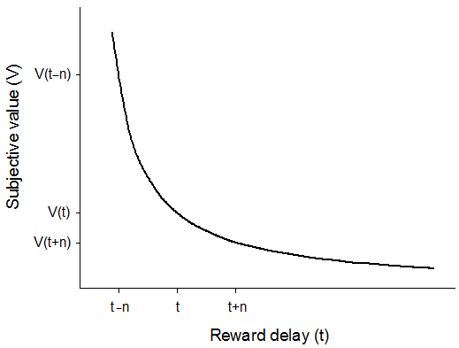
<CAPT>Fig. 1. The subjective value V of a delayed reward decreases in a hyperbolic fashion as the delay (or time t) before receiving that reward increases. As a result, a variable-delay schedule (reward after t – n or t + n) is preferred over a constant-delay schedule (reward after t) equal to its mean. Here, V(t) is smaller than the mean subjective value between V(t + n) and V(t – n) – a property called Jensen’s inequality – because of the high attractiveness of immediate or rapid rewards (received at t – n) in comparison with more delayed rewards (received at t + n).

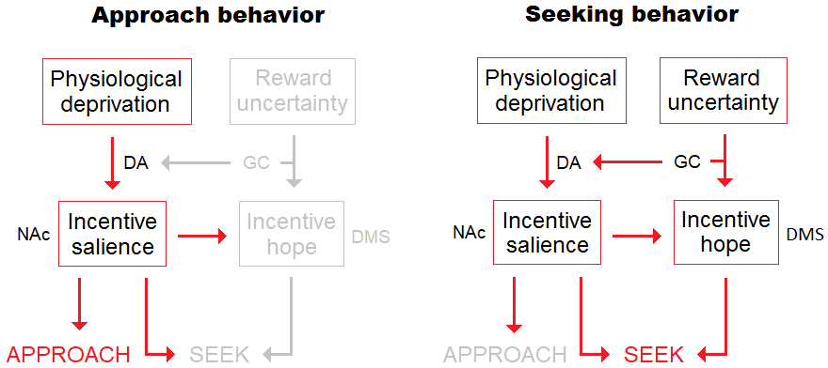

<CAPT>Fig. 2. Interaction between incentive salience (“wanting”) and incentive hope. The left side depicts a situation where no uncertainty is present (the food items are predictable or accessible). Approach behavior results from incentive salience processes (involving the release of dopamine in the nucleus accumbens), while seeking behavior remains subactivated and, hence, prevented. The right side represents what happens when the animal is subject to food uncertainty (unpredictable access). The animal comes to produce not only incentive salience but also incentive hope. Although approach could potentially be produced, its expression is canceled to the detriment of seeking, because the former behavior receives less activation than the latter. Of course, if uncertainty is temporarily abolished, then seeking is prevented and the stimulus is approached. This simple schema suggests that approach and seeking are differently processed while depending on the same motivational basis. It shows how a change in reward uncertainty can mechanically convert approach into seeking, and vice versa. DA = dopamine, GC = glucocorticoids, NAc = nucleus accumbens, DMS = dorsomedial striatum.

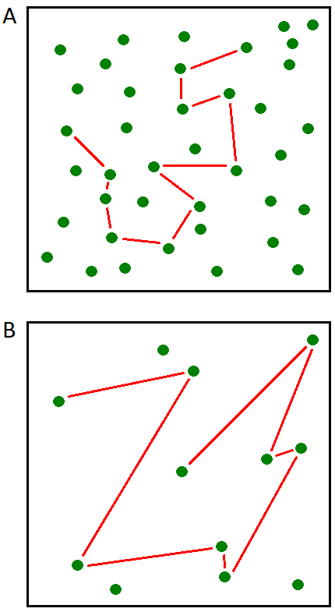
<CAPT>Fig. 3. (A) When food is abundant, there is no risk of starvation because the mean delay (the straight lines) to find edible items is short. (B) When food is scarce, there is a risk of starvation because the mean delay (the straight lines) to find edible items is longer. In such an environment, animals should hope for delays shorter than the mean and act accordingly.

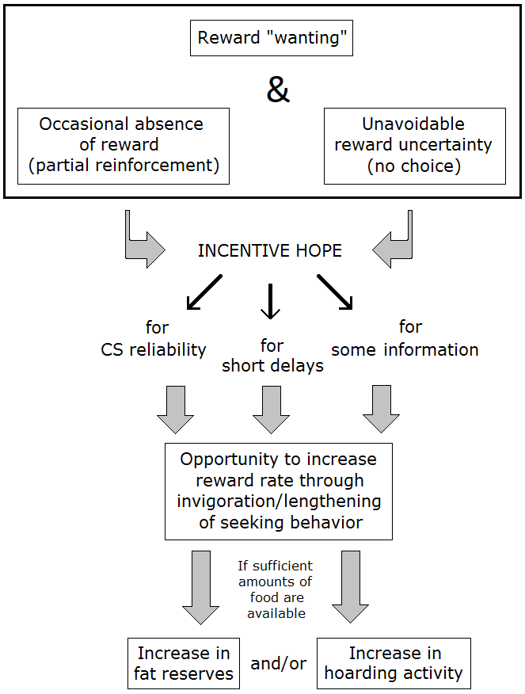
<CAPT>Fig. 4. The incentive hope hypothesis. On top, the three conditions required for the development of incentive hope, which can be shown for different survival-related parameters (especially CS reliability, short delays, and additional information). Incentive hope is believed to increase food-seeking behavior and, when food is in sufficient amounts in the environment, food consumption as well. As a result, the animals seeking food items whose uncertainty is unavoidable have the opportunity to increase their fat reserves and/or to hoard more items. Autoshaping consists of a special case, in which incentive hope is only produced for CS reliability, and the experimental procedure does not allow the animal to increase reward rate. CS = conditioned stimulus.
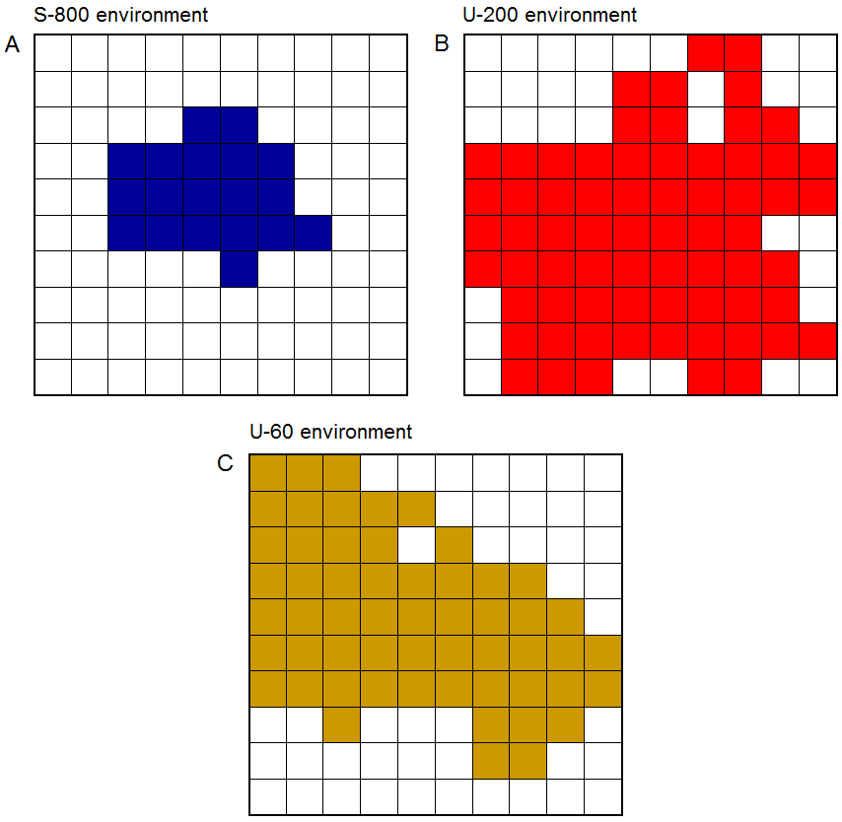
<CAPT>Fig. 5. Portion of an environment traveled depending on its density of food. (A) Safe environment. (B) Moderately unpredictable environment. (C) Highly unpredictable environment. The safe environment was less explored than the two unpredictable environments. In each environment, the colored squares represent the total number of squares crossed by the eight foragers (a square was colored when at least one of the eight foragers entered, and consisted of a surface of 50 steps × 50 steps).

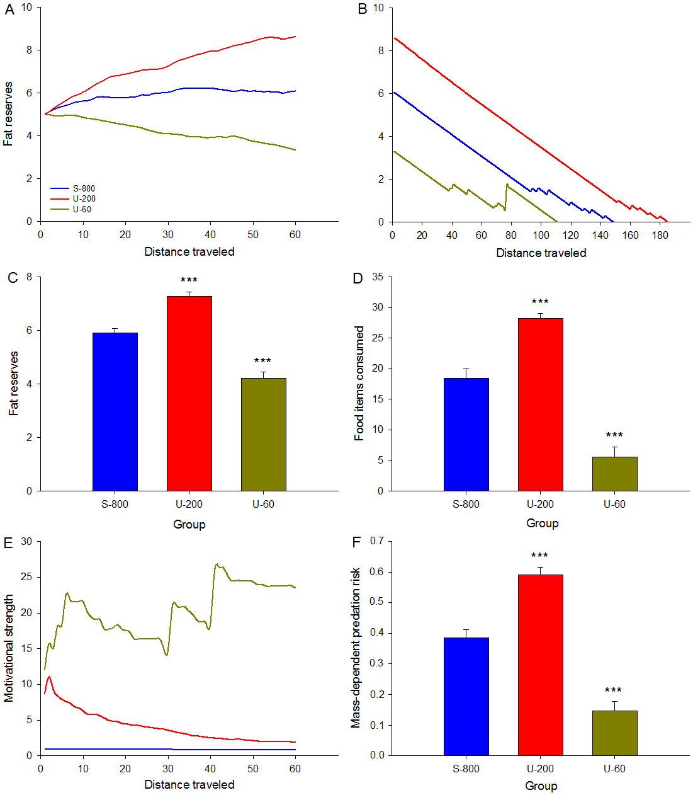
<CAPT>Fig. 6. The beneficial effects of increased food seeking imply that food amounts remain within a biologically acceptable range. (A) Compared with foragers exposed to a safe environment (group S-800), more fat is stored over time in group U-200, but there is a gradual loss of initial fat reserves in group U-60. (B) When food is not available, the ability to survive for longer periods = is proportional to the amount of fat stored. (C) Overall group comparisons indicate that fat reserves were higher in U-200 and lower in U-60 compared with S-800 foragers. (D) The number of food items consumed was higher in U-200 and lower in U-60 compared with S-800 foragers. (E) Motivational strength in seeking food was higher in U-200 than in S-800 foragers, but it even reached a greater intensity in U-60 foragers. (F) Mass-dependent predation risk was higher in U-200 foragers (because they gained weight) and lower in U-60 (because they lost weight) compared with S-800 foragers. Each data point on the abscissa must be multiplied by 50 to obtain the number of steps actually traveled (total: 60 × 50 = 3,000 steps).

