Appendix A.
Source: Author
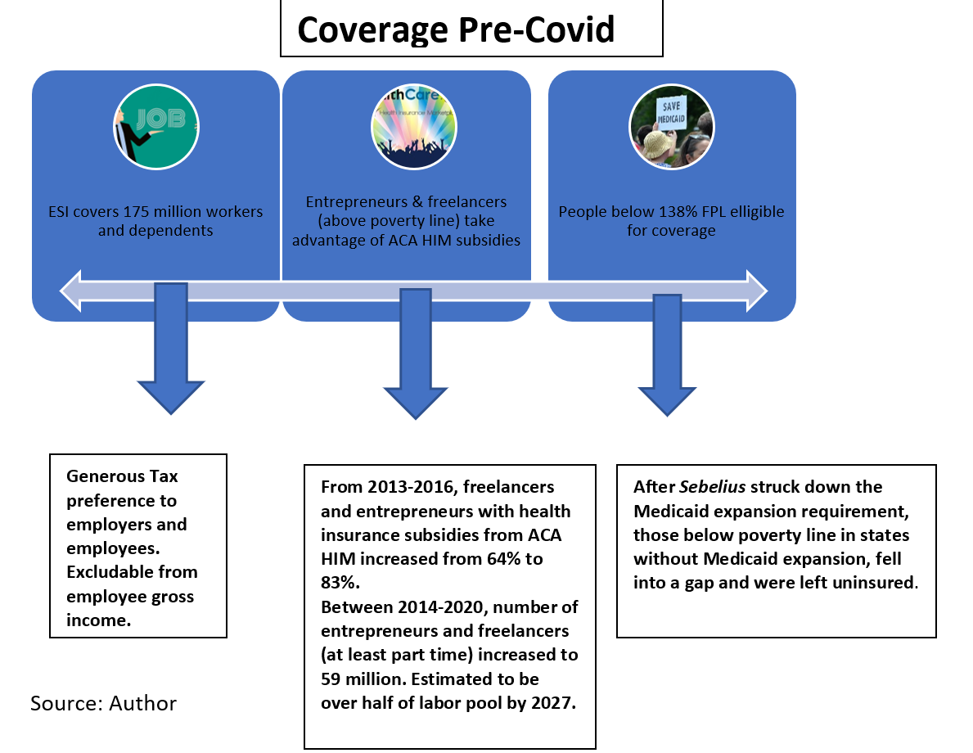

Appendix B.
Source: Cong. Budget Off., A Public Option for Health Insurance in the Nongroup Marketplaces: Key Design Considerations and Implications 2 fig.S-1 (2021).
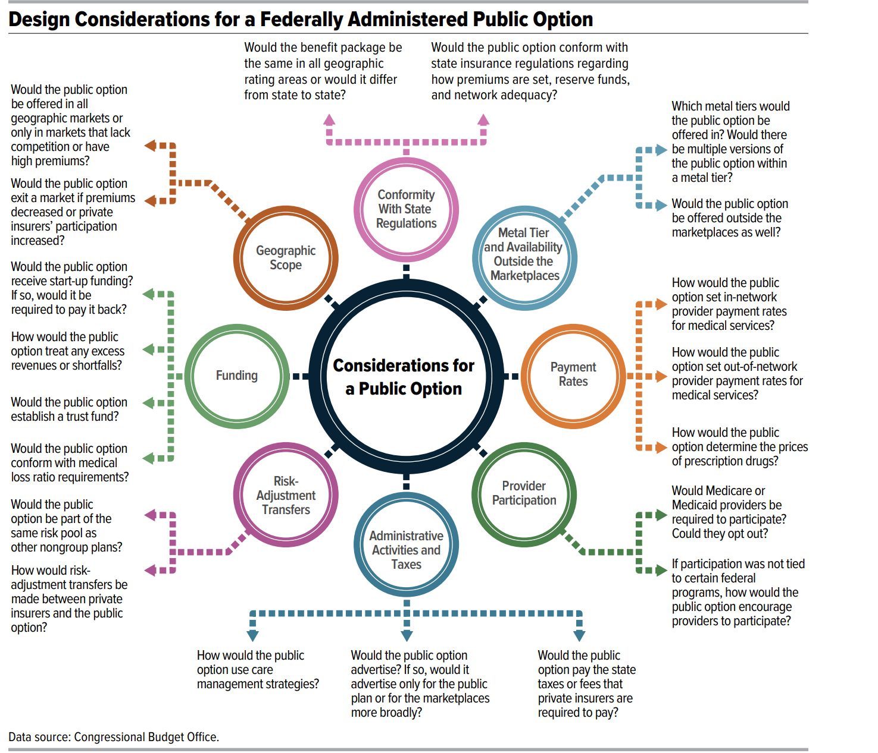

Appendix C.
Source: Christine Monahan, Kevin Lucia & Justin Giovannelli, State Public Option-Style Laws: What Policymakers Need to Know, Commonwealth Fund (July 23, 2021), https://www.commonwealthfund.org/blog/2021/state-public-option-style-laws-what-policymakers-need-know.

