Supplement

Data sets
All unpublished data were provided by original authors and are used with their permission. All study areas are subtidal, dominated by soft sediments, characterized by good exchange with oceanic water, and relatively unaffected by anthropogenic eutrophication and other activities. Of the 31 habitat-level data sets, 26 habitats have siliciclastic sediments (plus carbonate shell material), and 5 habitats are exclusively carbonate sediments. Eight habitats are from tropical zones (Amazon shelf, La Mancha Lagoon, Virgin Islands, Yucatan peninsula), five habitats are from subtropical zones (Corpus Christi and Galveston shelves, Texas; heavily trawled), and 18 habitats are from temperate zones (southern California, Chihama, Patagonia, and Eddystone-English Channel shelves (latter sampled in 1932, before trawling and anthropogenic eutrophication); San Juan Channel, Mannin and Tomales Bays, Mugu Lagoon). Sixteen habitats are situated in coastal embayments, where fair-weather open-ocean waves and currents do not impinge unimpeded upon the shore (Mugu Lagoon, Mannin Bay, La Mancha Lagoon, Tomales Bay, four habitats from Yucatan and two from Virgin Islands), two habitats from a high-energy strait (San Juan Channel), and 13 habitats are from open continental shelves.

California 1975 shelf (Los Angeles area) (33-34°N). Living assemblages: unpublished data from the 1975 BLM-funded survey conducted by Alan Hancock Foundation, which we have digitized from rescued printouts. Death assemblages: our unpublished data generated from unprocessed sieve residues of these same samples, archived by the Los Angeles County Museum of Natural History. Two habitats on a narrow open continental shelf: sandy muds and muddy sands, ranging from 30 to 90 meters of water depth, sampled with Van Veen grabs. All stations are outside the impact areas of publicly operated wastewater outfalls. Mesh size 2 mm.
California 2003 shelf (Los Angeles to San Diego) (33°N). Living assemblages: SCCWRP Bight 2003 survey [www.sccwrp.org/data/2003_bight_survey 3.html]. Death assemblages: our unpublished data generated from sieve residues of these same samples, rescued from disposal. Two habitats on a narrow open continental shelf: sandy muds and muddy sands ranging from 30 to 110 meters of water depth, sampled with Van Veen grabs. All stations are outside the impact areas of publicly operated wastewater outfalls. Mesh size 1 mm.
Chihama shelf, Pacific Japan (35°N). Data published by Tsuchi (1959). One habitat with fine sand on a narrow open continental shelf, sampled from 4–43 m water depth, subsamples of dredge hauls. Mesh size 1 mm.
Corpus Christi shelf, Texas (27.5°N). Unpublished data from White et al. (1983). Two habitats sampled from 6–22 m water depth on a wide open continental shelf: sand and, muddy sand. Sampled using a Smith-McIntyre grab (0.013 m^3). [Area subject to bottom trawling.] Mesh size 1 mm.
Patagonia shelf, Argentina (55°S). Published data from Linse (1997, 1999) and Linse and Brandt (1998). Muds and shelly muds on a wide continental shelf subject to strong seasonal upwelling were assigned to one habitat, sampled from 100–217 m water depth, subsamples of epibenthic sledge hauls. Mesh size 0.3 mm.
San Juan Channel, Washington State (48°N). Unpublished data from Kowalewski et al. (2003). Two facies, sampled from 20–115 m water depth using mud dredge: sandy mud with gravel, and clean gravel in a high-energy fully marine strait. Mesh size 2.3 mm.
Mannin Bay, Ireland (53°N). Unpublished data from Bosence (1979). Four habitats, sampled from 2–8 m water depth using diver-operated suction: subtidal mosaic of coralline algal bank, clean algal gravel, muddy algal gravel, fine sand, and mud in a shallow v-shaped coastal embayment. Mesh size 0.5 mm.
Mugu Lagoon, California (34°N). Published data from Warme (1971). Three habitats sampled from 0–2 m water depth, hand excavated: intertidal sand, subtidal eelgrass and subtidal channel sand. Mesh size 3 mm.
Virgin Islands (Smuggler’s Cove) (18°N). Unpublished data from Miller (1981, 1988). Two facies, sampled from 3–5 m water depth, using diver-operated suction: subtidal dense grass and mixed grass-sand in a tropical carbonate back-reef lagoon. Mesh size 5 mm.
Galveston shelf, Texas (29°N). Unpublished data from White et al. (1985). Three shelf habitats with sufficient counts of individuals: shoreface sands (stations shallower than 7.6 m), muddy sands (11-16 m water depth), and sandy muds (stations deeper than 9 m), sampled using Smith-McIntyre grab (0.013 m^3). [This area is subjected to bottom trawling and to nutrient-enriched outflow from the Mississippi drainage —it was assigned to AE1 in Kidwell (2007).] Mesh size 1 mm.
La Mancha Lagoon, Veracruz, Mexico (19°N). Unpublished data from Reguero Reza (1994). Two habitats: muddy and sandy silt substrate, sampled using Van Veen grab (2 liters). Mesh size 1.5 mm.
Eddystone, English Channel (50°N). Published data from Smith (1932), subsampled from conical dredge hauls. We analyze living and death assemblages from one habitat: four subtidal sites characterized by lithic (gneiss) gravel that have sufficient numbers of living and dead individuals. Mesh size 1.5 mm.
Amazon shelf, Brazil (0-4°N). Unpublished data from Aller and Stupakoff (1996) and Aller (1995). Sufficient numbers of individuals available for one offshore habitat: of firm mud (20–70 m water depth), sampled using a 0.25 m² box core. Mesh size 0.3 mm.
Tomales Bay, California (38°N). Unpublished data from Johnson (1965), sampled by Van Veen grabs (0.1 m²). Two habitats had sufficient individuals: nine subtidal sites characterized by soft black mud and four subtidal sites with well-sorted fine sand. Mesh size 1.5 mm.
Yucatan peninsula, Mexico (21°N). Unpublished data from Ekdale (1972, 1977). Three habitats with sufficient counts of individuals: Two are sandy muds from mangrove-edged lagoons (one from Isla Contoy, one from Isla Cancun) and one is muddy shell gravel from a back-reef lagoon (Isla Cancun), sampled by diver-operated suction. Mesh size 3 mm.

Sources
Aller, J. Y. 1995. Molluscan death assemblages on the Amazon shelf – implications for physical and biological controls on benthic populations. Palaeogeography, Palaeoclimatology, Palaeoecology 118, 181-212.
Aller, J. Y., and I. Stupakoff. 1996. The distribution and seasonal characteristics of benthic communities on the Amazon shelf as indicators of physical processes. Continental Shelf Research 16:717-751.
Bosence, D. W. J. 1979. Live and dead faunas from coralline algal gravels, Co. Galway. Palaeontology 22:449-478.
Ekdale, A. A. 1972. Ecology and paleoecology of marine invertebrate communities in calcareous substrates, northeast Quintana Roo, Mexico. M.S. thesis. Rice University, Houston.
———. 1977 Quantitative paleoecological aspects of modern marine mollusk distribution, northeast Yucatan coast, Mexico. In S. H. Frost, M. P. Weiss, and J. B Saunders, eds. Reefs and related carbonates: ecology and sedimentology. AAPG Studies in Geology 4:195-207.
Johnson, R. G. 1965. Pelecypod death assemblages in Tomales Bay, California. Journal of Paleontology 39:80-85.
Kowalewski, M., M. Carroll, L. Casazza, N. Gupta, B. Hannisdal, A. Hendy, R. A. Krause Jr., M. LaBarbera, D. G. Lazo, C. Messina, S. Puchalski, T. A. Rothfus, J. Sälgeback, J. Stempien, R. C. Terry, and A. Tomašových. 2003. Quantitative fidelity of brachiopod-mollusk assemblages from modern subtidal environments of San Juan Islands, USA. Journal of Taphonomy 1:43–65.
Linse, K. 1997. Die Verbreitung epibenthischer Mollusken im chilenischen Beagle-Kanal. [Distribution of epibenthic Mollusca from the Chilean Beagle Channel.] Berichte zur Polarforschung 228:1-131.
———. 1999. Abundance and diversity of Mollusca in the Beagle Channel. Scientia Marina 63(Suppl. 1):391-397.
Miller, A. I. 1981. Gradients in nearshore marine molluscan assemblages: Smuggler’s Cove, St. Croix, U.S. Virgin Islands. M.S. thesis. Virginia Polytechnic Institute and State University, Blacksburg.
———. 1988. Spatial resolution in subfossil molluscan remains: implications for paleobiological analyses. Paleobiology 14:91-103.
Reguero Reza, M. M. 1994. Estructura de la comunidad de moluscos en lagunas costeras de Veracruz y Tabasco, Mexico. Ph.D. thesis. Ciudad Universitaria, Universidad Nacional Autónoma de México, Mexico City.
Smith, J. E., 1932. The shell gravel deposits, and the infauna of the Eddystone Grounds. Journal of the Marine Biological Association of the U.K. 13:164-224.
Tsuchi, R. 1959. Molluscs and shell remains from the coast of Chihama in the Sea of Enshu, the Pacific side of central Japan. Reports of Liberal Arts and Science Faculty, Shizuoka University (Natural Science) 2:143-152.
Warme, J. E. 1971. Paleoecological aspects of a modern coastal lagoon. University of California Publications in Geological Sciences 87:1-110.
White, W. A., T. R. Calnan, R. A. Morton, R. S. Kimble, T. G. Littleton, J. H. McGowen, and H. S. Nance. 1983. Submerged lands of Texas, Corpus Christi area: sediments, geochemistry, benthic macroinvertebrates, and associated wetlands. Bureau of Economic Geology, University of Texas, Austin.
White, W. A., T. R. Calnan, R. A. Morton, R. S. Kimble, T. G. Littleton, J. H. McGowen, H. S. Nance, and K. E. Schmedes. 1985. Submerged lands of Texas, Galveston-Houston area : sediments, geochemistry, benthic macroinvertebrates, and associated wetlands. Bureau of Economic Geology, University of Texas, Austin.

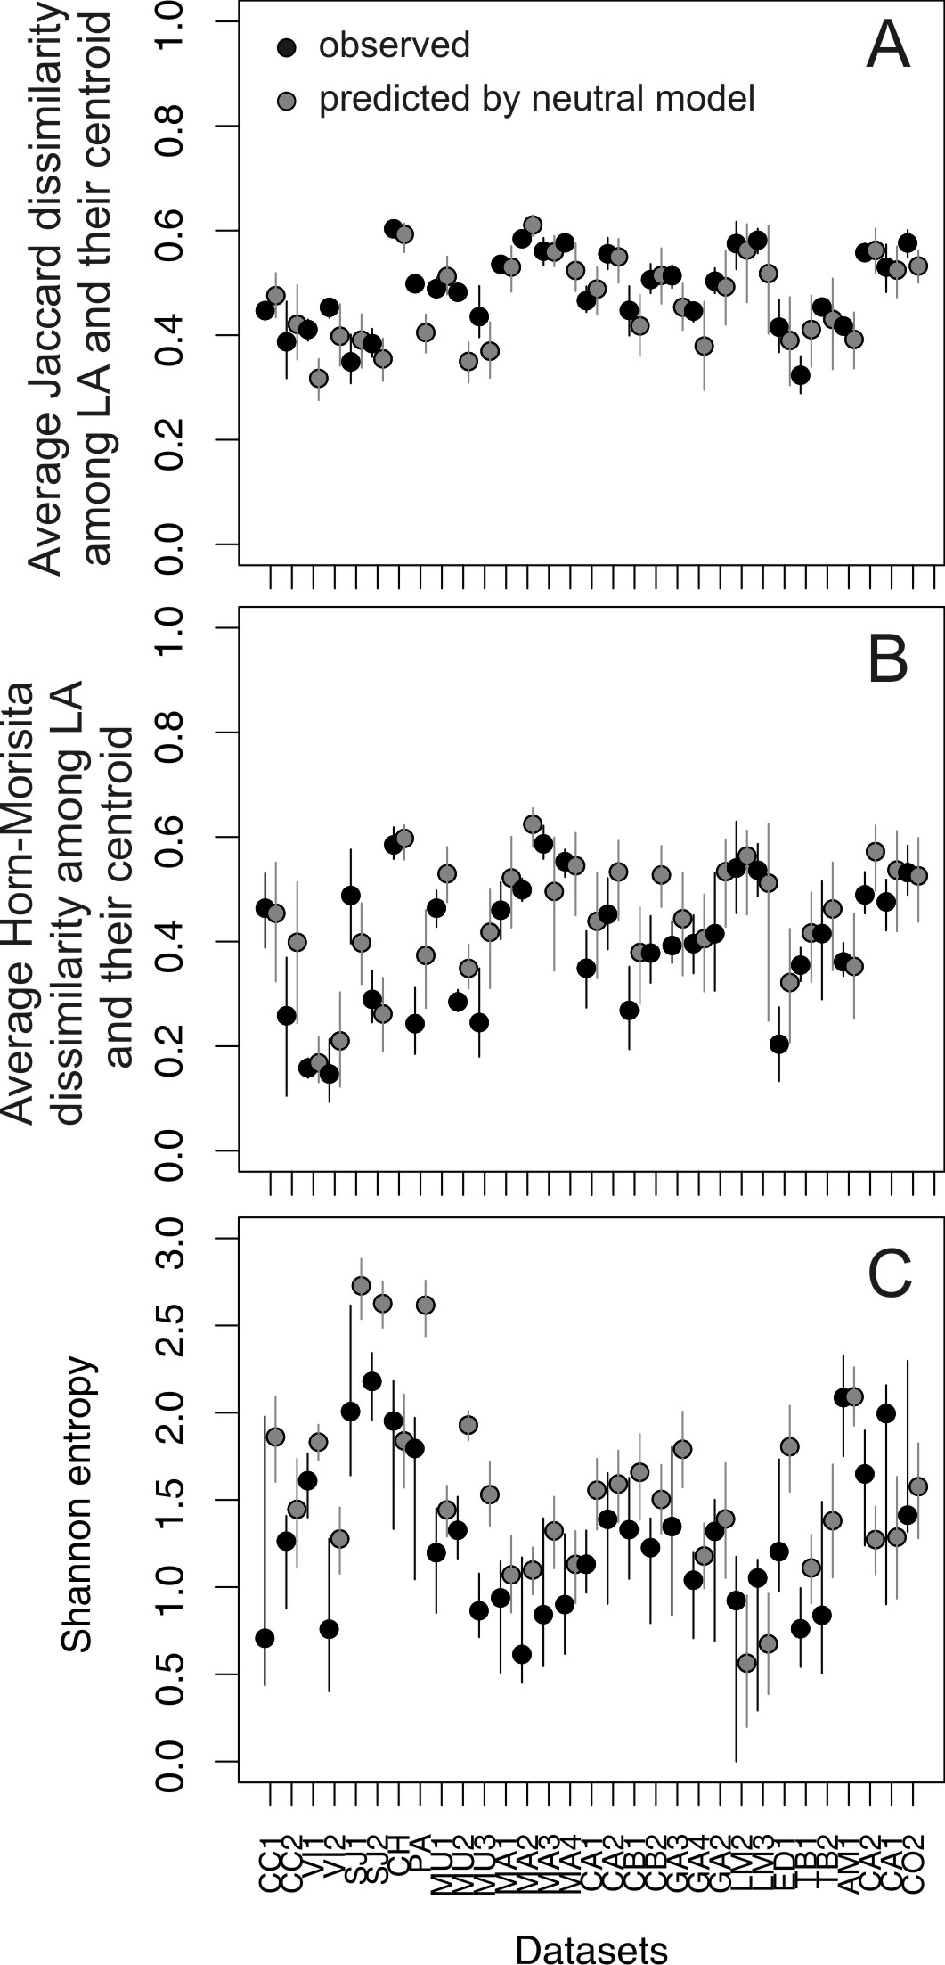

Figure S1. Observed (black) and expected (gray) average variation among living assemblages on the basis of Jaccard (A) and Horn-Morisita dissimilarity (B) and observed (black) and expected (gray) species diversity on the basis of the Shannon entropy at point scale (C) in 31 molluscan data sets. All data sets were used in general modeling of time averaging effects on live-dead fidelity.
Predictions of Total Live-Dead Variation for Individual Data Sets Using the Neutral Model
Overall, the total LD variation observed in all data sets that conform to the neutral model is equal to or slightly higher than the total LD variation expected under the neutral model. A series of several data sets from three regions illustrate data set-by-data set differences between observed and expected LD variation (Fig. 5). The lack of data about time averaging in the 31 data sets precludes evaluating the observed variation with the variation expected under neutral model. However, it can be instructive to inspect the changes in total LD variation expected under a wide range of possible durations of time averaging. For example, on the basis of Jaccard dissimilarity, LD variation is slightly but consistently higher than expected under a null model of no postmortem bias or environmental condensation, regardless of time averaging, in three data sets from Mannin Bay (Fig. 5D), three data sets from Mugu Lagoon (Fig. 5E), and two data sets from the California shelf (Fig. 5F). On the basis of Horn-Morisita dissimilarity, one data set from the California shelf exhibits a LD variation that is much higher than expected (Fig. 5C). In other data sets, total LD variation lies entirely within the range predicted by the neutral model.

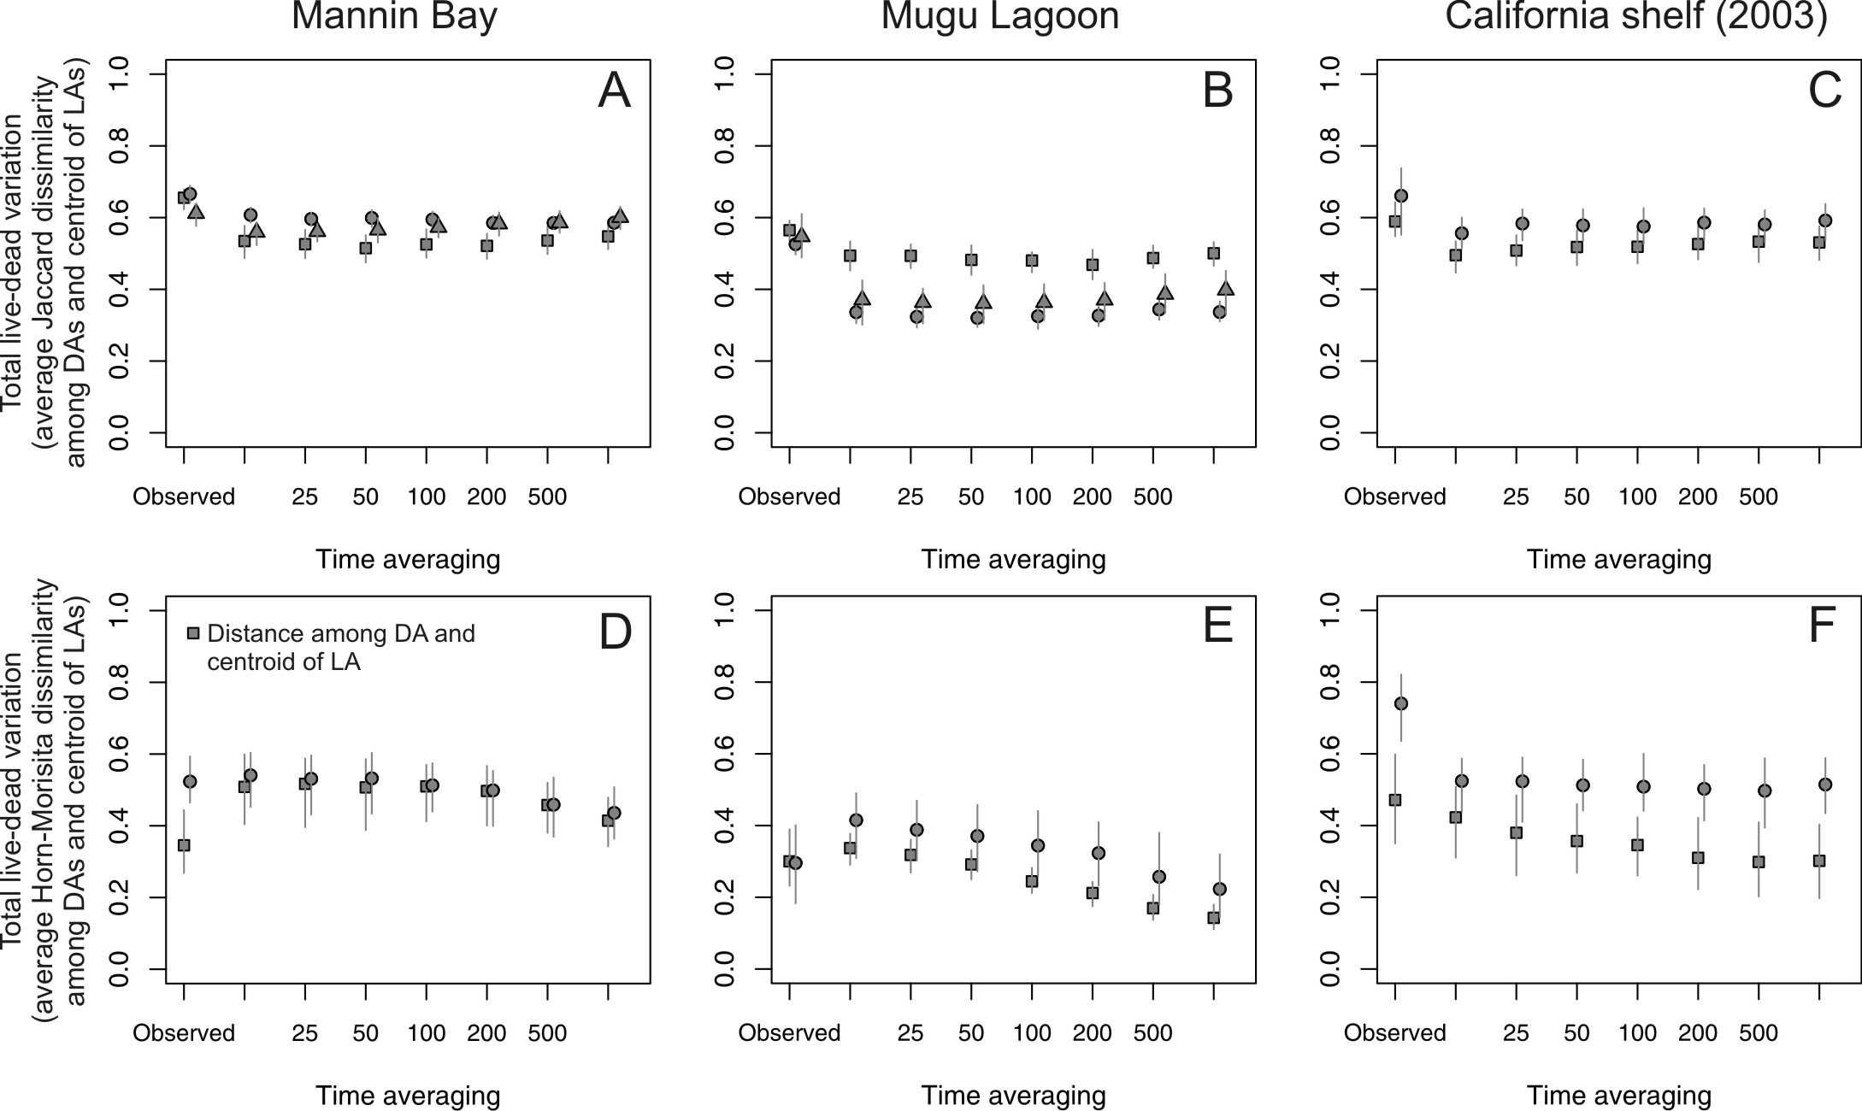

Figure S2. Selected examples of data sets from three regions showing that the total live-dead variation predicted under increasing time averaging using the neutral metacommunity model (series of points generated over intervals up to 1000 years) is generally comparable to the observed total live-dead variation (data points at far left in each plot). Where a region yields several data sets, drawn from different habitats, data sets are denoted by different symbols; LA = living assemblage, DA = death assemblage. Top row: On the basis of Jaccard presence/absence-based dissimilarity, live-dead variation in three data sets from Mannin Bay (A), three data sets from Mugu Lagoon (B), and two data sets from the California shelf (C) are all slightly but consistently higher than expected under null model of no postmortem bias or condensation, regardless of time averaging. Bottom row: On the basis of Horn-Morisita proportional abundance-based dissimilarity, total live-dead variation in two data sets from Mannin Bay (E), two data sets from Mugu Lagoon (F), and one data set from the California shelf (G) is comparable to the values expected from the null model. Exceptionally, total live-dead variation observed in one data set from the California shelf is consistently higher than expected, regardless of time averaging, indicating postmortem bias or environmental condensation (G). In all other data sets analyzed (not shown), total live-dead variation lies entirely within the range predicted by the null model.

