Supplement

Diversity partitioning with equal weights using the Shannon entropy, Gini-Simpson index and species richness.—We use formulas that decompose total diversity into independent alpha and beta components: their decomposition does not always follow multiplicative or additive rules (Jost 2007). In order to equalize sample weights, we resample (without replacement) samples to the lowest sample size observed either in living or in death assemblages within each data set (mean sample size [alpha] = 17, mean sample size [gamma] = 256), and decompose total diversity into alpha and beta components with the Shannon entropy (H), the Gini-Simpson index (D), and species richness (S). The Shannon entropy (H) is
,
where p_{i} represents the proportional abundance of species i in a sample. The alpha diversity index (H_{within}) for a data set is calculated by summing sample-level Shannon values that have been weighted for sample size (Crist et al. 2003). The gamma diversity index (H_{total}) for a data set is based on species abundances that have been summed across samples. The beta diversity index (H_{among}) is expressed as expressed by additive decomposition (Lande 1996):
H_{among} = H_{total} – H_{within},
The exponential of Shannon entropy defines the numbers equivalent—the effective number of equally common species (alpha and gamma diversity) and the effective number of distinct communities (beta diversity). In contrast to the Shannon entropy, the Gini-Simpson index (D) disproportionately favors dominant species:
,
and the beta component of the Gini-Simpson index is (Jost 2007):
D_{among} = (D_{total} – D_{within})/(1 – D_{within}).
The numbers equivalent of the Gini-Simpson index is 1/(1-D). The beta component of species richness is based on multiplicative decomposition, S_{among} = S_{total}/S_{within}, and the numbers equivalent equals to its own species richness (S). At the level of numbers equivalents, multiplicative decomposition of total diversity into alpha and beta components is universal (Jost 2007).

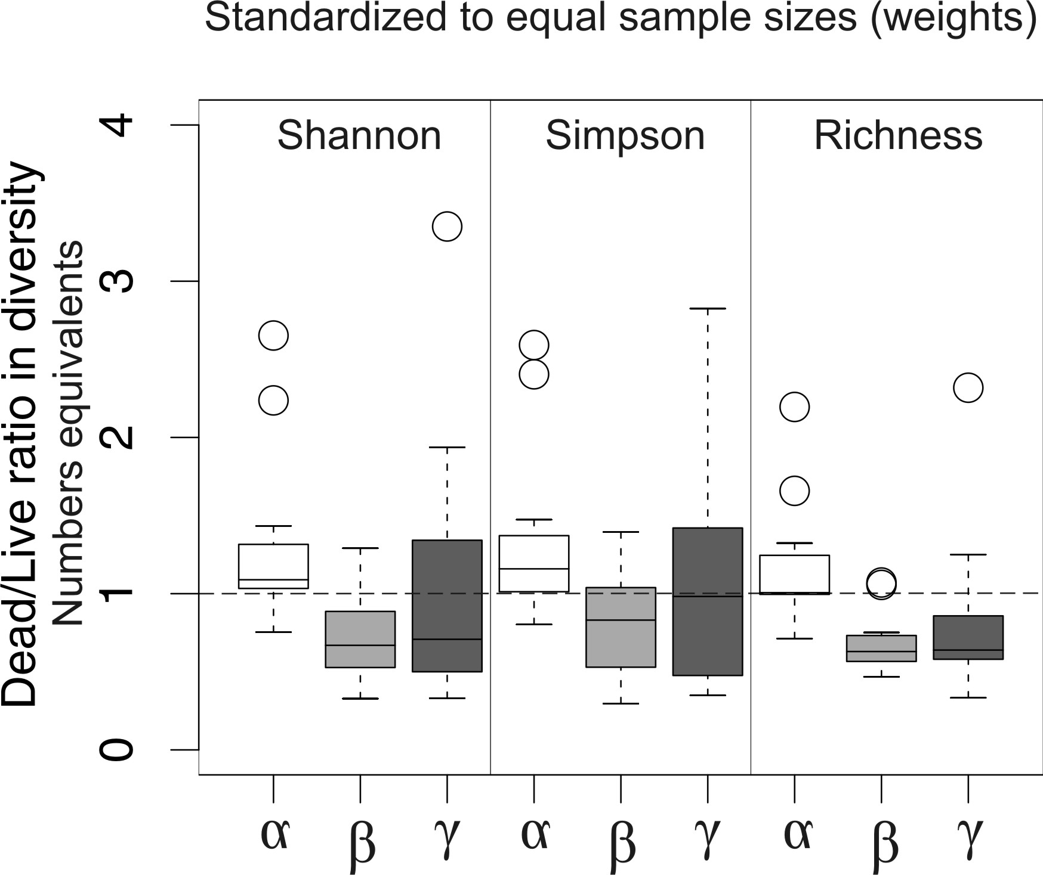

Supplement Figure - Dead/live ratio alpha, beta, and gamma diversity expressed by exp (Shannon), 1/(1-Gini-Simpson) and species richness in analyses with equal sample sizes. With all three diversity measures, death assemblages are more diverse at alpha levels, whereas diversity is lower at the beta level. However, the median diversity at gamma level is not significantly different from 1 (Wilcoxon signed-rank test).
Supplement Table – Results of the Wilcoxon signed-rank test evaluating whether (1) median rank correlation of dissimilarities between LAs and DAs averaged across 11 datasets is significantly larger than zero, (2) median dead-live difference in average dissimilarity is significantly different from zero, and (3) median dead-live difference in variation in dissimilarities is significantly different from zero.

 | Rank correlation between LAs and DAs | Rank correlation between LAs and DAs | Dead-Live difference | Dead-Live difference | Dead-Live difference | Dead-Live difference
 | Between-sample dissimilarity | Dissimilarity between samples and centroid | Median between-sample dissimilarity | Mean dissimilarity between samples and centroid | Variation in between-sample dissimilarities | Variation in dissimilarities between samples and centroid
Unstandardized analyses | p | p | p | p | p | p
D-L agreement (Manhattan) | 0.0049 | 0.034 | 0.00195 | 0.00098 | 0.001 | 0.0049
D-L agreement (BC untrans) | 0.001 | 0.1 | 0.0098 | 0.0068 | 0.76 | 0.86
D-L agreement (BC sqrt) | 0.00049 | 0.0019 | 0.0049 | 0.0067 | 0.37 | 0.21
D-L agreement (BC pres-abs) | 0.00049 | 0.0025 | 0.00098 | 0.0038 | 0.067 | 0.002
Size-standardized analyses | p | p | p | p | p | p
D-L agreement (Manhattan) | not applied | not applied | 0.0059 | 0.024 | 0.0067 | 0.04
D-L agreement (BC untrans) | not applied | not applied | 0.042 | 0.1 | 0.58 | 1
D-L agreement (BC sqrt) | not applied | not applied | 0.042 | 0.05 | 0.92 | 0.93
D-L agreement (BC pres-abs) | not applied | not applied | 0.012 | 0.0087 | 0.24 | 0.29

