MEGALO NISI GALANIS (6300 – 1800 BC): CONSTRUCTING A CULTURAL SEQUENCE FOR THE NEOLITHIC OF WEST MACEDONIA, GREECE

by Michael Fotiadisª, Areti Hondroyanni-Metoki^{b}, Alexandra Kalogirou^{c}, Yannis Maniatis^{d}, Anna Stroulia^{e} and Christina Ziota^{f}

ªUniversity of Ioannina
^{b}Hellenic Ministry of Culture and Sports, Ephorate of Antiquities of Kozani
^{b}Hellenic Ministry of Culture and Sports, Executive Unit, Athens
^{d}National Centre for Scientific Research Demokritos, Athens
^{e}University of Southern Indiana, Evansville
^{f}Hellenic Ministry of Culture and Sports, Ephorate of Antiquities of Florina

SUPPLEMENTARY MATERIAL

1. Geology, previous archaeological work in Kitrini Limni, lignite mining and archaeology (Text SM 1 and Figure SM1.1)

2. Trench Μ26δ, lower part (below the Final Neolithic) (Text SM 2 and Figures SM 2.1 and SM2.2)

3. Pottery from trenches Μ26, Μ27 and Μ36 (Figures SM3.1–SM3.9)

SM Text 1
Geology, previous archaeological work in Kitrini Limni, lignite mining and archaeology; Fig. SM1.1.

Geology
The Kitrini Limni basin is part of the Florina–Ptolemais–Servia graben, formed through tectonism in the Middle to Late Miocene and filled with lacustrine sediments, including lignite, of Miocene, Pliocene and Quaternary age. It is separated from the main part of the Ptolemais basin (to the northwest) by the Komanos horst, and from the Servia part of the graben (to the south) by Mt Skopos (see Diamantopoulos, Krohe and Dimitrakopoulos 2013, especially figs 2 and 11:a; Fig. SM1.1). In the past several centuries the lowest part of the basin, around the 660 m contour line, was occupied by a marsh, known as ‘Sarigiol’ (Turkish for ‘Yellow Lake’). The marsh was artificially drained in the 1950s. Before that time, Sarigiol drained to the northwest via the Soulou Creek, flowing through a defile in the Komanos horst. Military maps from the first half of the 20th century show the extent of the marsh (e.g., OKH/Gen St d H 1944) and its seasonal fluctuations (Ministry of Public Works 1952). Some of those maps must have descended from cartographic work of the late 19th and early 20th centuries, collectively known as ‘the Austrian maps’ (Livieratos 2011).
The Kitrini Limni basin is bounded on all sides by faults. It is classified as an area of low seismicity, still, dozens of tremors of low magnitude (mostly 1.0–2.6) have been recorded in the basin itself and its immediate vicinity between 1910 and 2010 (Delogkos 2011, fig. 2.2.3.1). Though small-scale, such events seem relevant to the history of the Sarigiol marsh: the water level (stand), hence also the extent of the marsh, have been controlled by the condition of its outlet through the Komanos horst. Given the low gradients characteristic of the basin floor, even a subsidence of the order of centimetres could have a far-reaching effect on the extent of the marsh (see also Main Text, section ‘The abandonment of the Kitrini Limni basin floor in the later Holocene’).

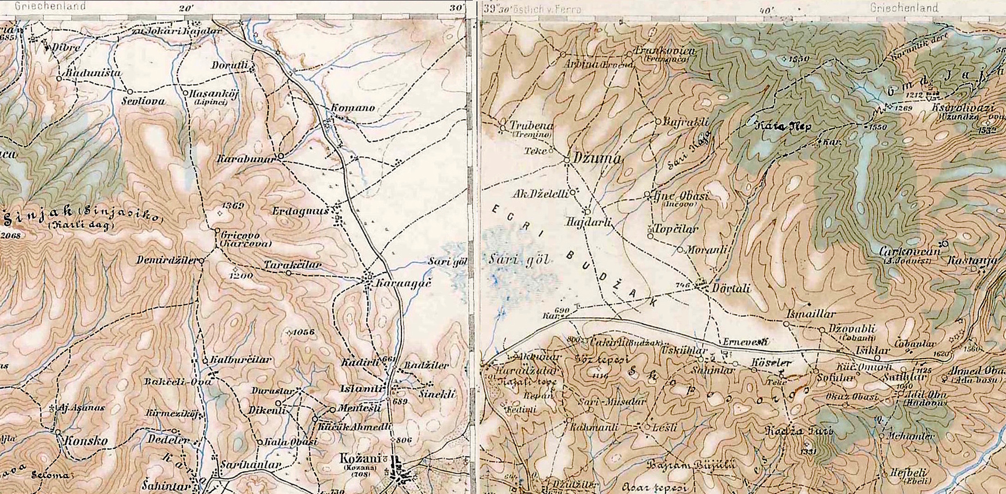

Fig. SM1.1. Map of Sarigiol and vicinity, composed of parts of Sheets 39/40 (Janina) and 40/40 (Larisa) of the 3rd Military Mapping Survey of Austria-Hungary, General Map of Central Europe, 1: 200 000. Date of publication of Sheets 39/40 and 40/40 is not recorded. Notes on the Sheets themselves indicate that they were in part corrected, valid until (‘teilweise berichtigt bis’) 9 August, 1915 (Sheet 39/40) and 11 December, 1913 (Sheet 40/40).
Beside the marsh (marked ‘Sari göl’), the map shows the Soulou Creek (un-named) as it flows by the village ‘Komano’ and continues further to the northwest through a defile in higher terrain (=the Komanos horst). See SM Text 1.
Sheets 39/40 and 40/40 downloaded from https://commons.wikimedia.org/wiki/Category:3rd_Military_Mapping_Survey_of_Austria-Hungary. Accessed 14 August 2019.

Previous archaeological work in Kitrini Limni
To our knowledge, the earliest mention of the toponym ‘Sarigiol’ occurs in the travelogues of Evlija Çelebi, who explored the area in the 1660s (Dimitriadis 1973, 197–9); but we have not researched earlier (Medieval) sources relevant to the issue. Apostolos Arvanitopoul[l]os (1874–1942) was the first archaeologist to note the presence of Neolithic mound sites ‘in marshy ground’ in the Sarigiol basin while he served as artillery officer in west Macedonia during the Balkan Wars (Arvanitopoullos 1912, 240; Kalogirou 1994, 28; Petrakos 1987, 120). But Arvanitopoulos’ discovery fell in a vacuum. For the next half a century, no one undertook prehistoric research in the area.
In the mid-1960s, David H. French (1933–2017), soon after Director of the British Institute at Ankara (1968–94), undertook a pedestrian survey of the Sarigiol basin floor while he held a postgraduate scholarship at the University of Thessaloniki. He discovered nine Neolithic sites (including MNG), dated the potsherds he collected in his survey by recourse to the Thessalian Neolithic sequence, and outlined his conclusions about cultural regions and their connections with reference to geographical features (French 1970). That geographical-cultural frame in interpreting the prehistory of Macedonia was hardly new, but its 1960s version was a radical departure from the Interwar approaches of Stanley Casson (1889–1944), Walter A. Heurtley (1882–1955), Antonios Keramopoullos (1870–1960) and others (for the Interwar takes on the matter see Fotiadis 2001). In retrospect, no less important than the new geographical-cultural frame seems French’s emphasis on the usefulness of surface surveys, at a time when that species of archaeology was not yet widespread in Greece. Some archaeology students in Thessaloniki a few years later, including the first author of this report, quickly noticed the novelty, were given access to French’s typed notes and hand-drawn map of his surveyed sites in Macedonia, and spent many Sunday mornings visiting those sites. We attended to their morphology and to the surrounding landscape, we collected potsherds from the surface, and examined our collections in the light of French’s descriptions and chronological/cultural conclusions. To put the matter simply, David French’s survey work has been an inspiration to us.
Systematic exploration of the prehistory of Kitrini Limni began only in the 1980s. It was at first carried out by Georgia Karamitrou-Mentesidi, then head of the Ephorate of Antiquities Kozani. Proceeding in a manner comparable to French’s, she identified four more prehistoric sites and, in her report, she presented precise topographical information about them and about French’s sites, in addition to details about their chronology and other useful observations (Karamitrou-Mentesidi 1986). As a result, the basin floor of Kitrini Limni now appeared to be an area of exceptionally high site density during the Neolithic (at least during its later phases), rivalling in that respect lowland Thessaly. The project about which we report in the present volume followed on the heels of those discoveries.

Lignite mining and archaeology
Lignite strip-mining in the basin began in 1959. It was undertaken by the Public Power Corporation (PPC [Δημόσια Επιχείρηση Ηλεκτρισμού: ΔΕΗ], instituted in 1950). Since that time the mines have been expanding rapidly (see also Main Text, ‘Introduction’), swallowing in the process living villages (which have been relocated) and threatening with obliteration archaeological sites. The 13 prehistoric (principally Neolithic) sites that were known in Kitrini Limni by 1985 were soon after listed as monuments under the Greek antiquities law (Karamitrou-Mentesidi 1986). Newly-discovered sites in the projected path of the mine are required by law to be extensively excavated before they are turned to the control of the PPC (e.g., Kleitos: Ziota 2014). Still, state laws, like all human contrivances, are subject to upheavals and reversals. Are, then, MNG and the other sites today under protection from the ever expanding mine? If so, for how long? Electricity production in Greece today depends heavily on combustion of lignite, which is therefore a strategic fuel. The Ptolemais basin, including Kitrini Limni, holds the largest reserves of acceptable quality lignite in the country, expected to provide fuel for the power plants in the area for several more decades, unless renewable, environment-friendly energy sources prevail. In view of such parameters, it is uncertain whether MNG will survive in the long run, but in the short run we expect that it will be adequately excavated before it passes to the control of the PPC.

SM Text 2
Trench Μ26, quarter δ, lower part (below the Final Neolithic); Figs SM2.1 and SM2.2

We have divided the sequence exposed in the M trenches into five chronostratigraphic units, Final Neolithic (FN), Late Neolithic (LN), Middle to Late Neolithic transition (MN–LN), Middle Neolithic (MN) and natural sediments. The FN unit is readily distinguishable from the rest on stratigraphic, pedological, chronological and cultural grounds (see Main Text of the article) and need not be further considered here. We present instead the evidence for the divisions pertaining to the four lower units (LN to natural sediments). We concentrate on the lower part of trench Μ26, quarter δ, which affords the clearest, most complete view of the sequence in question (Figs SM2.1 and SM2.2). Nevertheless, we submitted trench Μ26, quarter β, to an equally detailed examination and analysis. We found that our observations about Μ26δ are applicable to Μ26β as well, with one significant exception pertaining to the LN chronostratigraphic unit (see below). We leave out of discussion the remaining trenches (Μ26αγ, Μ27 and Μ36), for excavation in them did not reach below the LN chronostratigraphic unit.
The assignment of the units to specific phases of the Neolithic is based on what we regard as period-diagnostic ceramic types (‘phase markers’) the frequencies of which change from one chronostratigraphic unit to the next. The types are described in the Main Text of the article, ‘The ceramic sequence’ section. Here we use only the labels of those types: black topped, plates, black burnished, red-slipped, and barbotine. The text below is to be read in tandem with Figs SM2.1 and SM2.2.
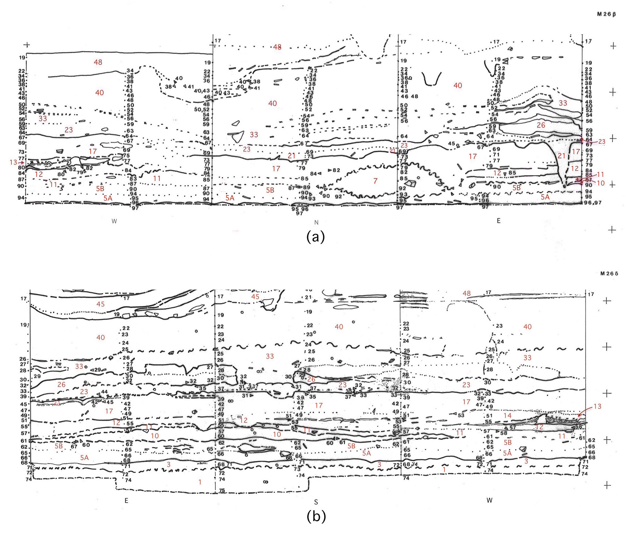

Fig. SM2.1. Stratigraphy in the lower part of trench quarters M26β (a) and M26δ (b), showing chronostratigraphic units LN, MN–LN transition, MN and natural deposits. Scale: crosses are at 0.5 m apart. Boundaries between deposits are graded from distinct and sharp (continuous lines) to distinct but diffuse (squiggles) to moderately distinct (dashed lines) to barely detectable (dotted lines). Numbers in black refer to excavation units (passes), numbers in red pertain to depositional units referred to in SM Text 2.
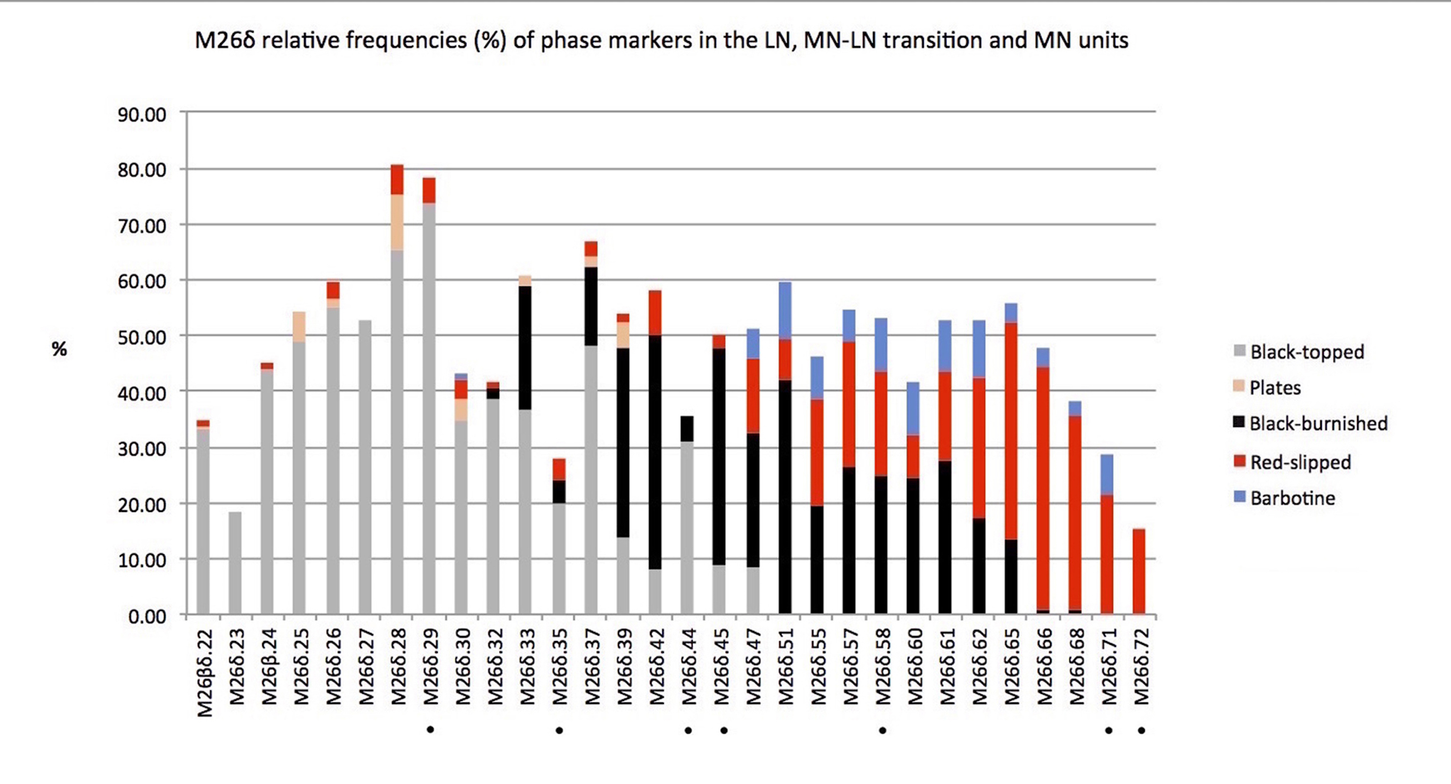
Fig. SM2.2. Stratigraphy in the lower part of trench quarters M26β (a) and M26δ (b), showing chronostratigraphic units LN, MN–LN transition, MN and natural deposits. Scale: crosses are at 0.5 m apart. Boundaries between deposits are graded from distinct and sharp (continuous lines) to distinct but diffuse (squiggles) to moderately distinct (dashed lines) to barely detectable (dotted lines). Numbers in black refer to excavation units (passes), numbers in red pertain to depositional units referred to in SM Text 2.

Potsherd counts in most passes are sufficiently high to render quantification of phase markers in terms of percentages meaningful. As Fig. SM2.2 shows, few passes contained fewer than 50 sherds, and in fact only passes δ.71 and δ.72 contained too few (14 and 13 respectively) to be reliable. At the other end of the spectrum, 26 passes in Μ26β and Μ26δ combined contained between 100 and 300 sherds.

The LN chronostratigraphic unit
Main phase marker: black topped pottery.
A distinct boundary separates the topmost LN deposit, no. 40, from the FN deposits above. The unconformity of the interface between the LN and FN deposits (Fig. SM2.1) suggests that deposit no. 40 is truncated. Support for this suggestion comes also from the temporal distance, several hundred years, between the LN and FN ¹⁴C dates (see section ‘Radiocarbon dating’ in the Main Text of the article).
The lower boundary between the LN and the underlying MN–LN transitional unit is the interface between deposit nos 23–21 and 17. This too is a distinct boundary, clearly traceable over both Μ26β and Μ26δ (Fig. SM2.1).
In brief, the LN chronostratigraphic unit comprises, from top to bottom, deposit nos 40, 33, 26, 23 and 21. In M26δ those deposits were removed in passes βδ.22 (at the top of the sequence) to δ.45 (bottom). Deposit nos 40 and 33 (passes βδ.22 to δ.32) contain much black topped pottery (18–74 %) plus small amounts of plate fragments (≤9.8 %) and sporadic red-slipped pieces. They lack, however, examples of black burnished pottery, which are a salient characteristic of the underlying chronostratigraphic unit, the MN–LN transition (see below). Deposit nos 26, 23 and 21, on the other hand, would appear to contain, variable amounts of black burnished pottery, in addition to the black topped. However, the passes that contain black burnished pottery in the case (δ.33, δ.37, δ.39, δ.44 and δ.45) have transgressed the boundary between deposit nos 23–21 (LN unit) and no. 17 (MN–LN transitional unit). A different picture emerges, however, from trench Μ26β. Here, black burnished pottery is present (along with black topped) in deposits nos 26, 23 and 21 and in passes (especially β.64 and β.67) that did not transgress the boundary with deposit no. 17. In view of the above and other considerations (e.g., the distinct character of the interface between deposit nos 23–21 and 17, also the increasing frequency of black burnished from pass δ.33 to pass δ.45; Fig. SM2.2) we favour the following conclusion. The LN deposits are distinguished from those of the MN–LN transition by the continuous presence of black topped and, except in their lowest members (nos 26, 23 and 21), by the absence of black burnished pottery. They also contain examples of plates (which are absent from all deposits below) and small amounts of red-slipped potsherds, the percentages of which increase sharply in the MN–LN transitional unit.
Four ¹⁴C dates have been obtained from the LN chronostratigraphic unit. DEM-1344 comes from the lower part of the unit, pass δ.33, which straddled deposit nos 26 and 23. DEM-1345, from pass β.56 and stratigraphically equivalent to passes δ.26 and δ.27, comes from deposit no. 33, higher up the stratigraphic sequence. The two remaining dates, Beta-48507 and Beta-48508, also come from deposit no. 33 (pass δ.26). Modelled, the four dates form a coherent cluster among themselves and are in harmony with the ¹⁴C sequence from the M trenches (Fig. 5 in Main Text). According to the model, the duration of the LN phase was rather short (about 60 years) but with a large error that would allow for a duration up to twice as long (see section ‘Radiocarbon dating’ in the Main Text of the article). In any case, 60–120 years is a perfectly reasonable estimate, given that, as noted above, the upper part of the LN deposits is missing.

The MN–LN transitional chronostratigraphic unit
Main phase markers: black burnished, red-slipped and barbotine.
The existence of a transitional MN–LN phase, closely comparable with that we encountered at MNG, had been recognized at Servia, in the Aliakmon valley, half a century ago (Ridley and Wardle 1979, 212–13; Ridley, Wardle and Mould 2000, 44; see also Heurtley 1939, 66). In the Servia stratigraphic system, that was Phase 6, the first of two phases the excavators assigned to the Late Neolithic. At MNG the gradual and continuous nature of the transition in trench Μ26 has discouraged us from assigning the MN–LN transitional unit either to the Middle or the Late Neolithic. That is so despite the existence of fairly distinct pedological boundaries between several pairs of deposits, shown in Fig. SM2.1. Since the publication of Servia, a gradual transition between the MN and LN phases has been documented in other sites both in northern and southern Greece (Urem-Kotsou and Dimitriadis 2004, 305–6; Urem-Kotsou and Gioura 2004, 219 and 238–9; Mee, Cavanagh and Renard 2014).
The MN–LN transitional unit comprises, from top to bottom, deposit nos 17, 15, 14, 13, 12, 11, 10 and 5B. In general those deposits consist of dark-coloured sediments, rich in clay (they are often described in the excavation notebook as ‘muds’) and containing scores of shells of the shallow, still water gastropod Planorbis (Fotiadis and Hondroyanni–Metoki 1993, 26–7). This suggests that the dark, fine-grain sediments of those deposits are lacustrine clays that were mined from marshy (or once marshy) areas in the basin floor and were brought onto the site as construction material.
Deposit no. 17 is most typical in terms of the pedological features mentioned: dark, ‘muddy’ sediments (clay loam) abounding with Planorbis shells. In M26δ its uppermost part was ‘brushed’ by passes δ.33, δ.37, δ.39, δ.44 and δ.45 while excavating the overlying LN deposits (see above). Its main part and the pedologically comparable deposits below (nos 14, 12, 11 and 5B) as well as the lenticular deposit no. 10 were removed in passes δ.42 and δ.47 to δ.65. Black topped pottery is present through most of deposit no. 17, its frequency dropping significantly with increasing depth, down to 8–9 % in the passes (δ.42 and δ.47) that did not transgress the boundary with the overlying LN chronostratigraphic unit. Finally, black topped is entirely absent from the bottom of deposit no. 17 (pass δ.51) and from all deposits below. Black burnished, on the other hand, is abundant (13.5–42 %) throughout deposit no. 17 and (in lower frequencies) in all deposits below down to deposit no. 5B. Red-slipped also is well represented throughout the MN–LN unit, its frequency increasing downward (maximum 39 % in deposit no. 5B, pass δ.65). Barbotine, though less frequent (3.5–10.5 %), has a comparable distribution to red-slipped.
Deposit no. 13, sandwiched between deposit nos 14 and 12, is in fact an ensemble of thin, pedologically distinct layers, including layers of charcoal. Constituted by earthen materials distinctly different from the ‘muds’ of the MN–LN transitional unit (e.g., light-grey clay, a spread of small chunks of red clay), the ensemble most probably represents a hearth.
Four ¹⁴C dates are available from the MN–LN transitional unit (see Fig. 5 in the Main Text of the article). DEM-1342 comes from deposit no. 5B (pass Μ26β.90, corresponding stratigraphically to pass Μ26δ.62). DEM-1341 is from deposit no. 12 (pass δ.57). DEM-1359 comes from pass δ.55, which cut across deposit nos 17 (bottom), 14 and 12. No matter which of those deposits the charcoal sample was retrieved from, DEM-1359 is laden with an issue: it is in better agreement with the ¹⁴C dates from the following chronostratigraphic unit (LN) than with those of its cohort, the MN–LN transition (see Fig. 5 in the Main Text of the article), and that suggests the possibility that the sample was contaminated with charcoal from higher up the sequence. In short, DEM-1359 should be treated with caution.
The fourth ¹⁴C date from the MN–LN transition, Beta-098971 (an AMS date), comes from deposit no. 5 (pass δ.65), but it is obviously too old, by about 500–600 years, to pertain to the formation of that deposit. Such a large discrepancy between the expected and the measured date cannot be an effect of ‘old wood’ (see Main Text, section ‘Radiocarbon dating’). It is more likely that Beta-098971 dates the EN material incorporated in deposit no. 5 (see Main Text, section ‘The Early Neolithic at MNG’). The EN sherds in trench Μ26δ come from passes δ.60, δ.61, δ.62, δ.65, δ.66 and δ.68. Pass δ.65 yielded three such sherds. In Μ26β, EN sherds also come from deposit no. 5, passes β.90, β.94, β.95 and β.96. The measured value of Beta-098971 (mean about 6250 BC) places it unquestionably in the Greek Early Neolithic and roughly coincides with the age of the EN ceramics in trench Μ26. The possibility of a certain degree of contamination by old carbon from the sediment matrix of the sample cannot be entirely excluded, yet it is rather unlikely that such carbon would produce a considerable shift (500–600 years) in age (see Main Text, section ‘Radiocarbon dating’).
According to the Bayesian modelling of the MNG ¹⁴C measurements, the MN–LN transitional phase lasted about 366 ± 45 years, bracketed between the start boundary of the phase (5750 BC) and the transition boundary between the MN–LN and the LN phase (5200 BC; see section ‘Radiocarbon dating’ in the Main Text of the article). Greater precision in the matter is beyond reach at this time. It would require a dense latticework of dates from MNG and other sites in west Macedonia and/or Thessaly, and that is unavailable. More important however, the length of 300–400 years (12–18 human generations) calculated by the model for the MN–LN transition seems excessively long. This problem arises, on the one hand, from the paucity of ¹⁴C dates from the MN–LN phase, and on the other hand, from the doubts concerning date DEM-1359, discussed above. All said, we intuitively estimate that the length of the MN–LN transition has been of the order of 100–200 years, dateable about the middle of the sixth millennium BC or soon after.

The MN chronostratigraphic unit and the natural deposits
Main phase markers: red-slipped and barbotine (MN unit), scarcity or complete absence of cultural residue (natural deposits).
The MN chronostratigraphic unit is essentially deposit no. 5A. In M26δ it was removed in passes δ.66 to δ.71. A handful of potsherds, however, were also found in the upper part of the underlying dark clay, a natural deposit (no. 3), in pass δ.72.
Black burnished pottery, present in deposit no. 5B in appreciable quantities (13.5 to 17 %), is very rare (c.1 %) in the top part of deposit no. 5A (passes δ.66 and δ.68) and completely absent further down. The only period-diagnostic types found in quantity throughout deposit no. 5A are red-slipped (21 to 43 %) and barbotine (3.5 to 7 %). In deposit no. 3 (pass δ.72) no barbotine pieces were found, but this is probably the effect of the very low sherd count (13, the lowest figure in the entire pass sequence) contained in the pass.
In sum, the MN chronostratigraphic unit is delimited on its bottom by deposit no. 3, the dark-brown clay of lacustrine origin (see Main Text); and, on its top, by the appearance, in frequencies greater than 10 %, of black burnished pottery (pass δ.65).
Natural deposit no. 1 is a light-grey marl free of even the smallest pebbles. It is probably of terminal Pleistocene age (see Main Text). Its top 10–20 cm were excavated in passes δ.74 and δ.75 and were found to be devoid of any kind of cultural residue.
No ¹⁴C dates pertinent to the MN chronostratigraphic unit and the natural deposits were obtained.

3. Pottery from trenches Μ26, Μ27 and Μ36 (Figs SM3.1–SM3.9)
For Fig. SM3.1 see above and Main Text, ‘The Early Neolithic at MNG’. For Figs SM3.2–SM3.9 see Main Text, ‘The ceramic sequence’.
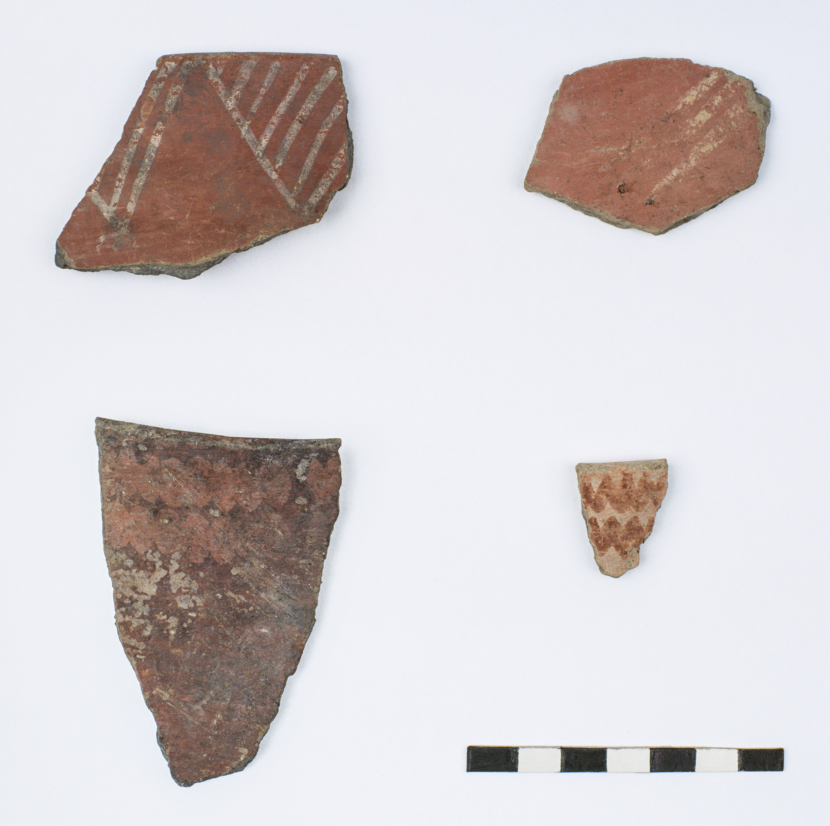

Fig. SM3.1. Early Neolithic potsherds from deposit no. 5, trench M26, quarters β and δ. Photo: G. Marinos.

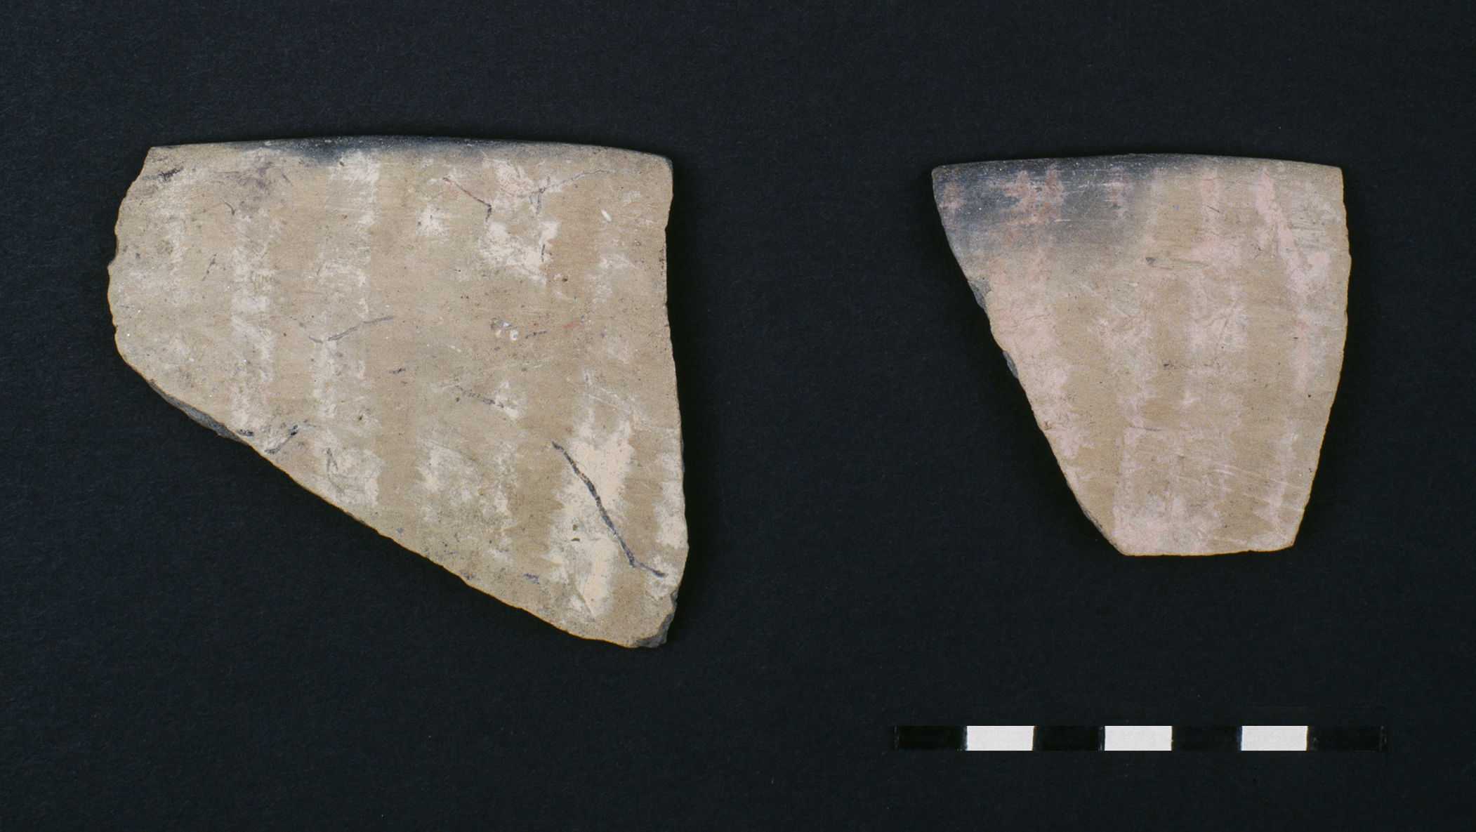

Fig. SM3.2. Middle Neolithic rim sherds from shallow bowls with cream and pink-coloured stripes. Photo: G. Marinos.

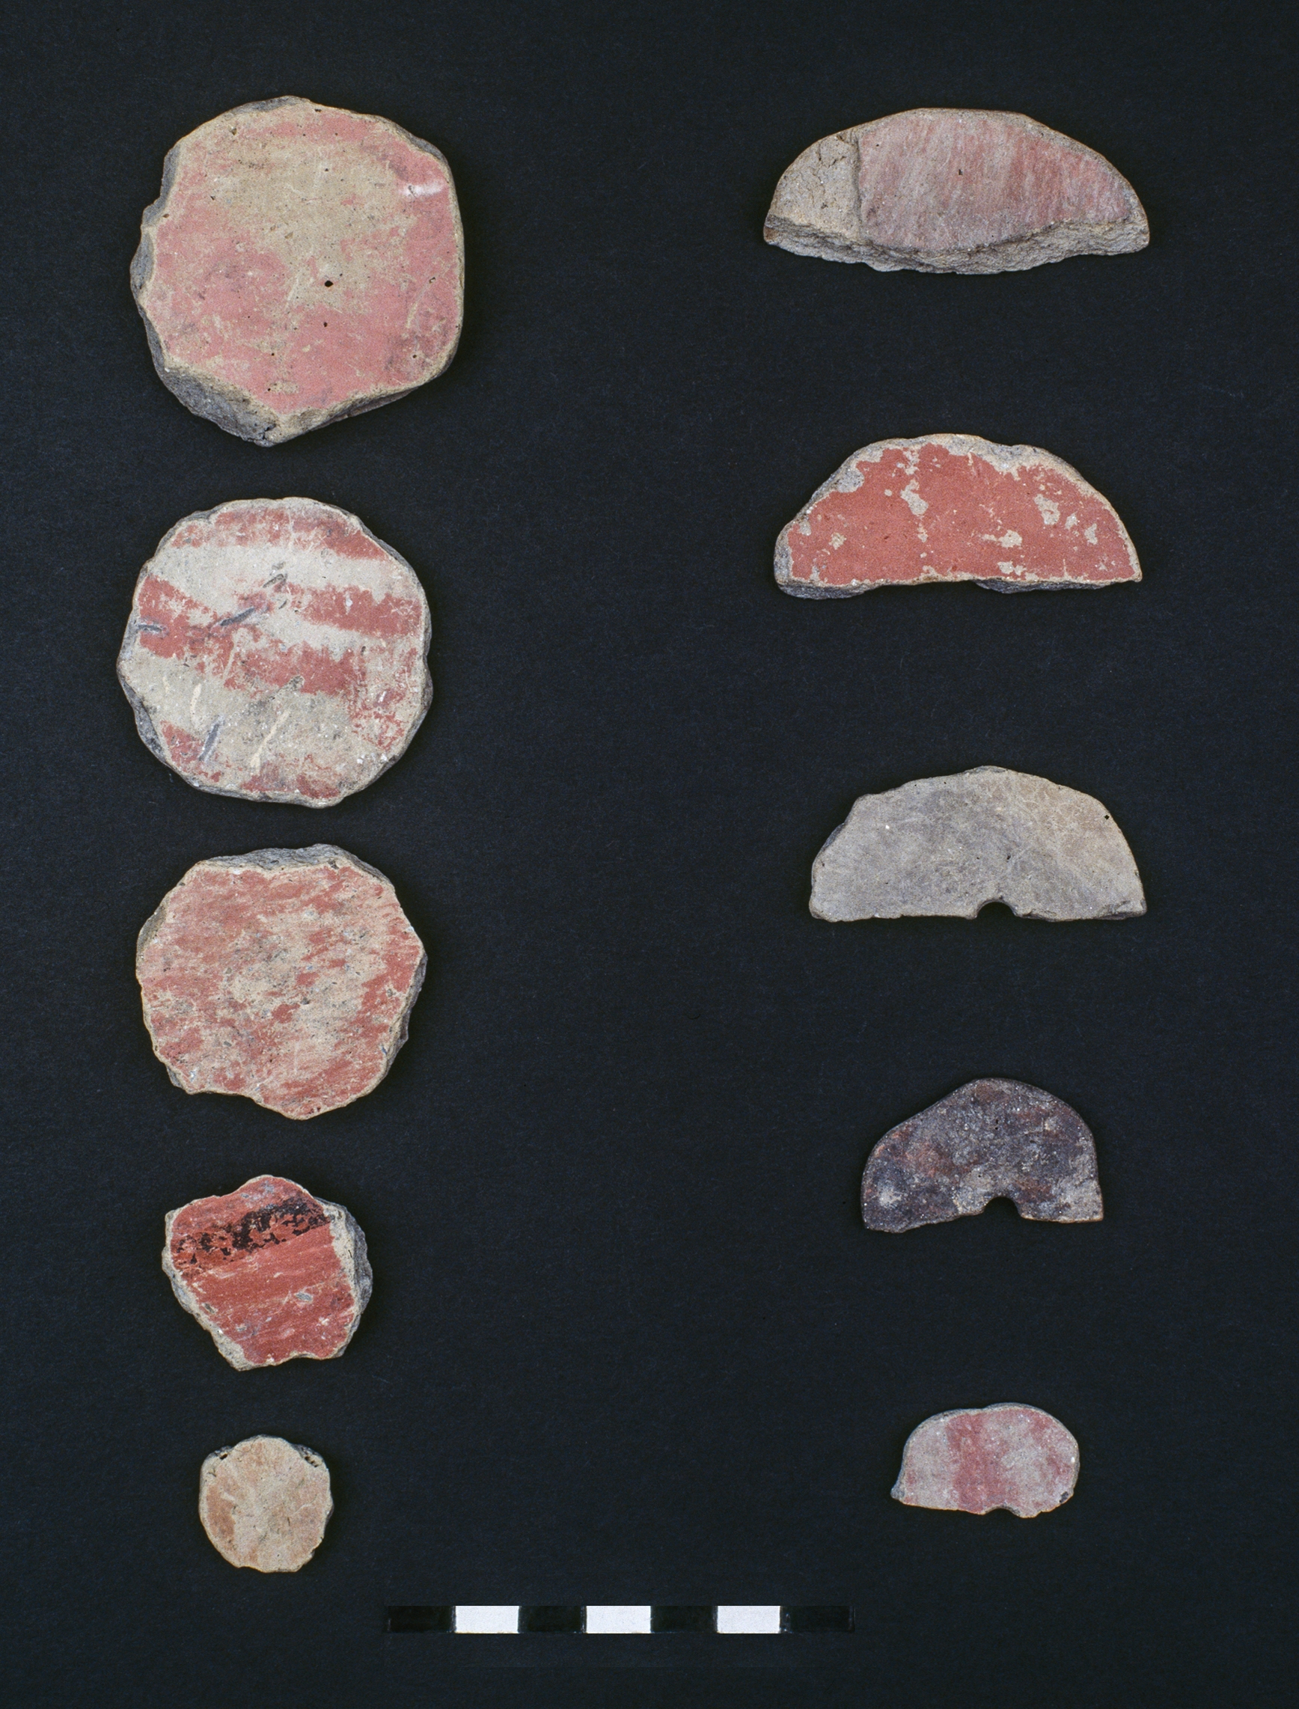

Fig. SM3.3. Middle Neolithic and MN–LN transition, recycled potsherds (discs). Photo: G. Marinos.

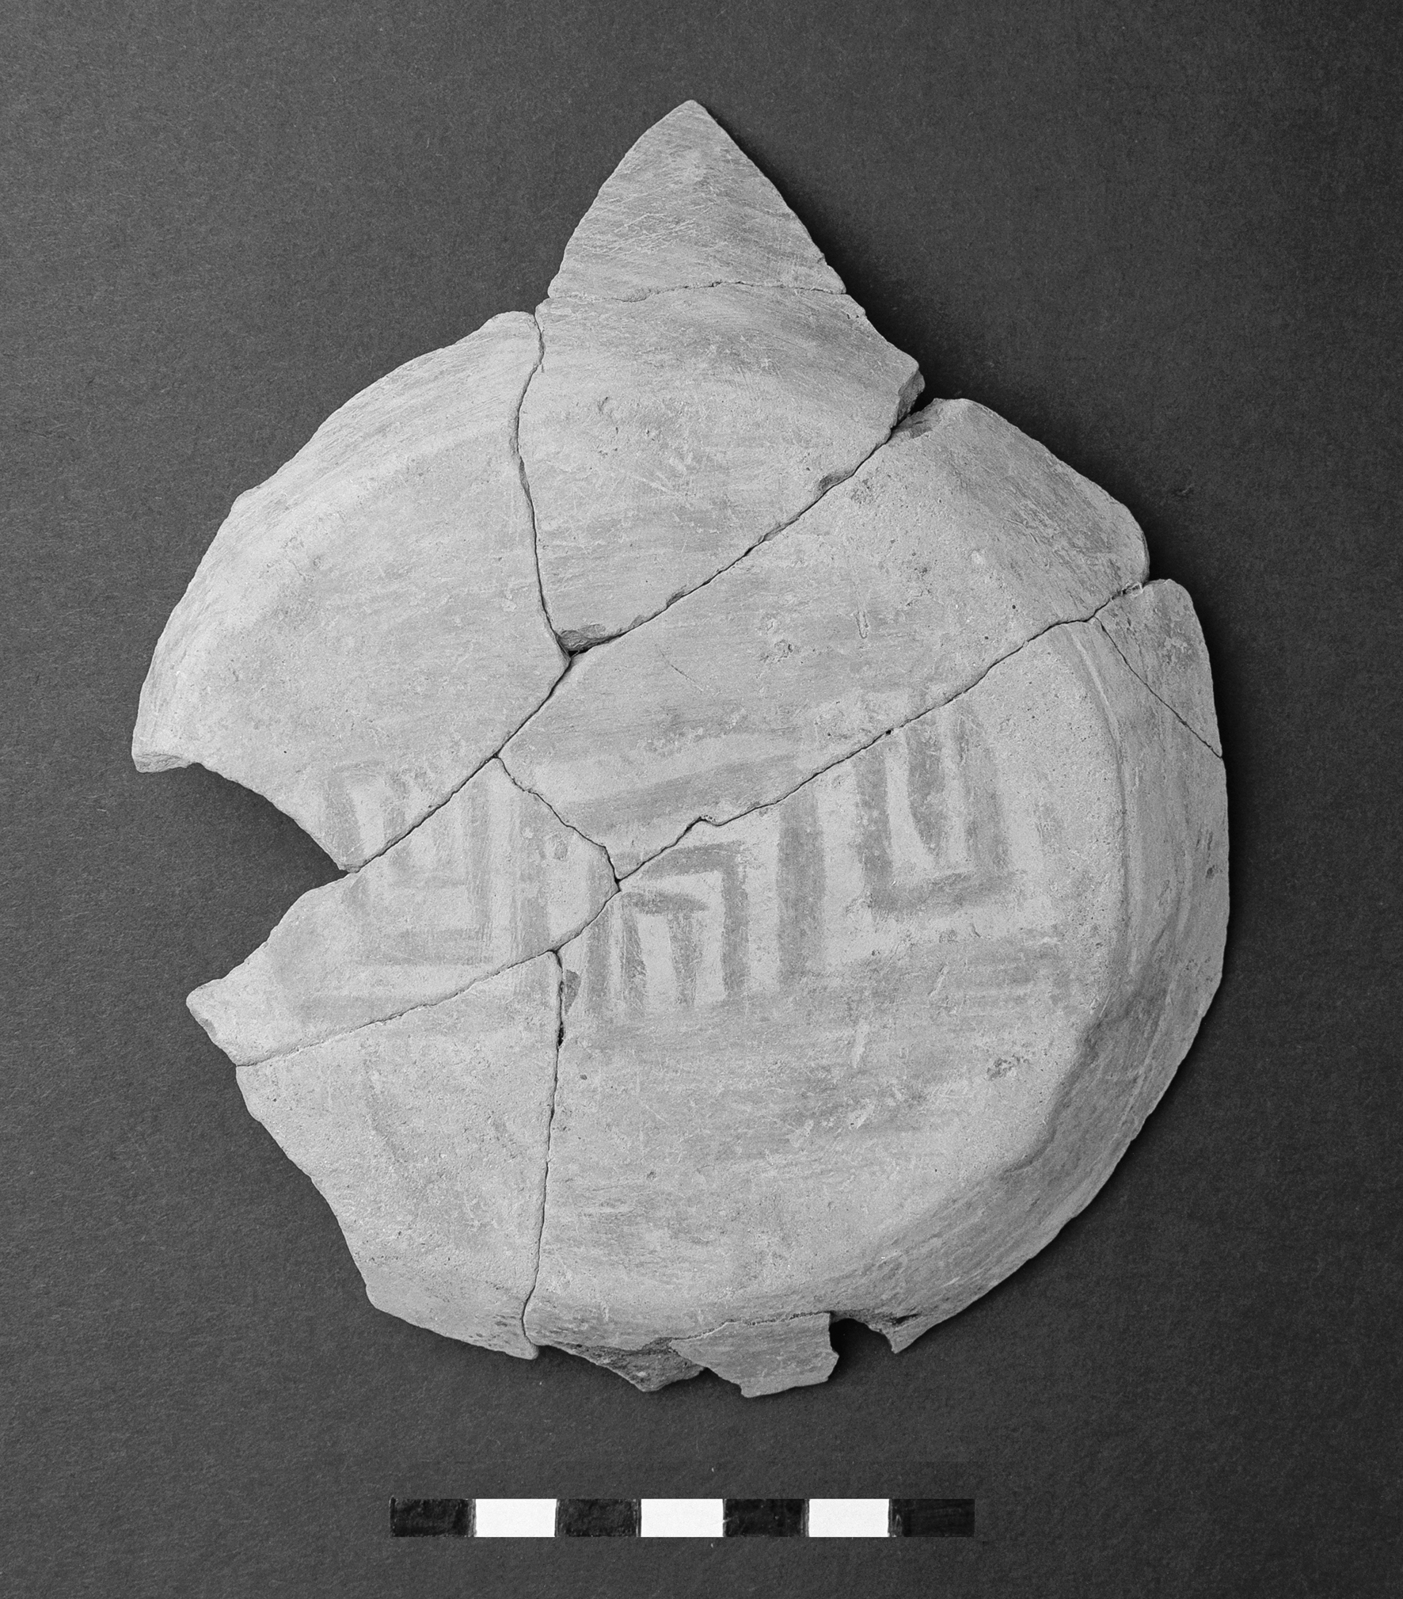

Fig. SM3.4. Late Neolithic pattern-burnished bottom (underside) of black topped bowl. Photo: G. Marinos.

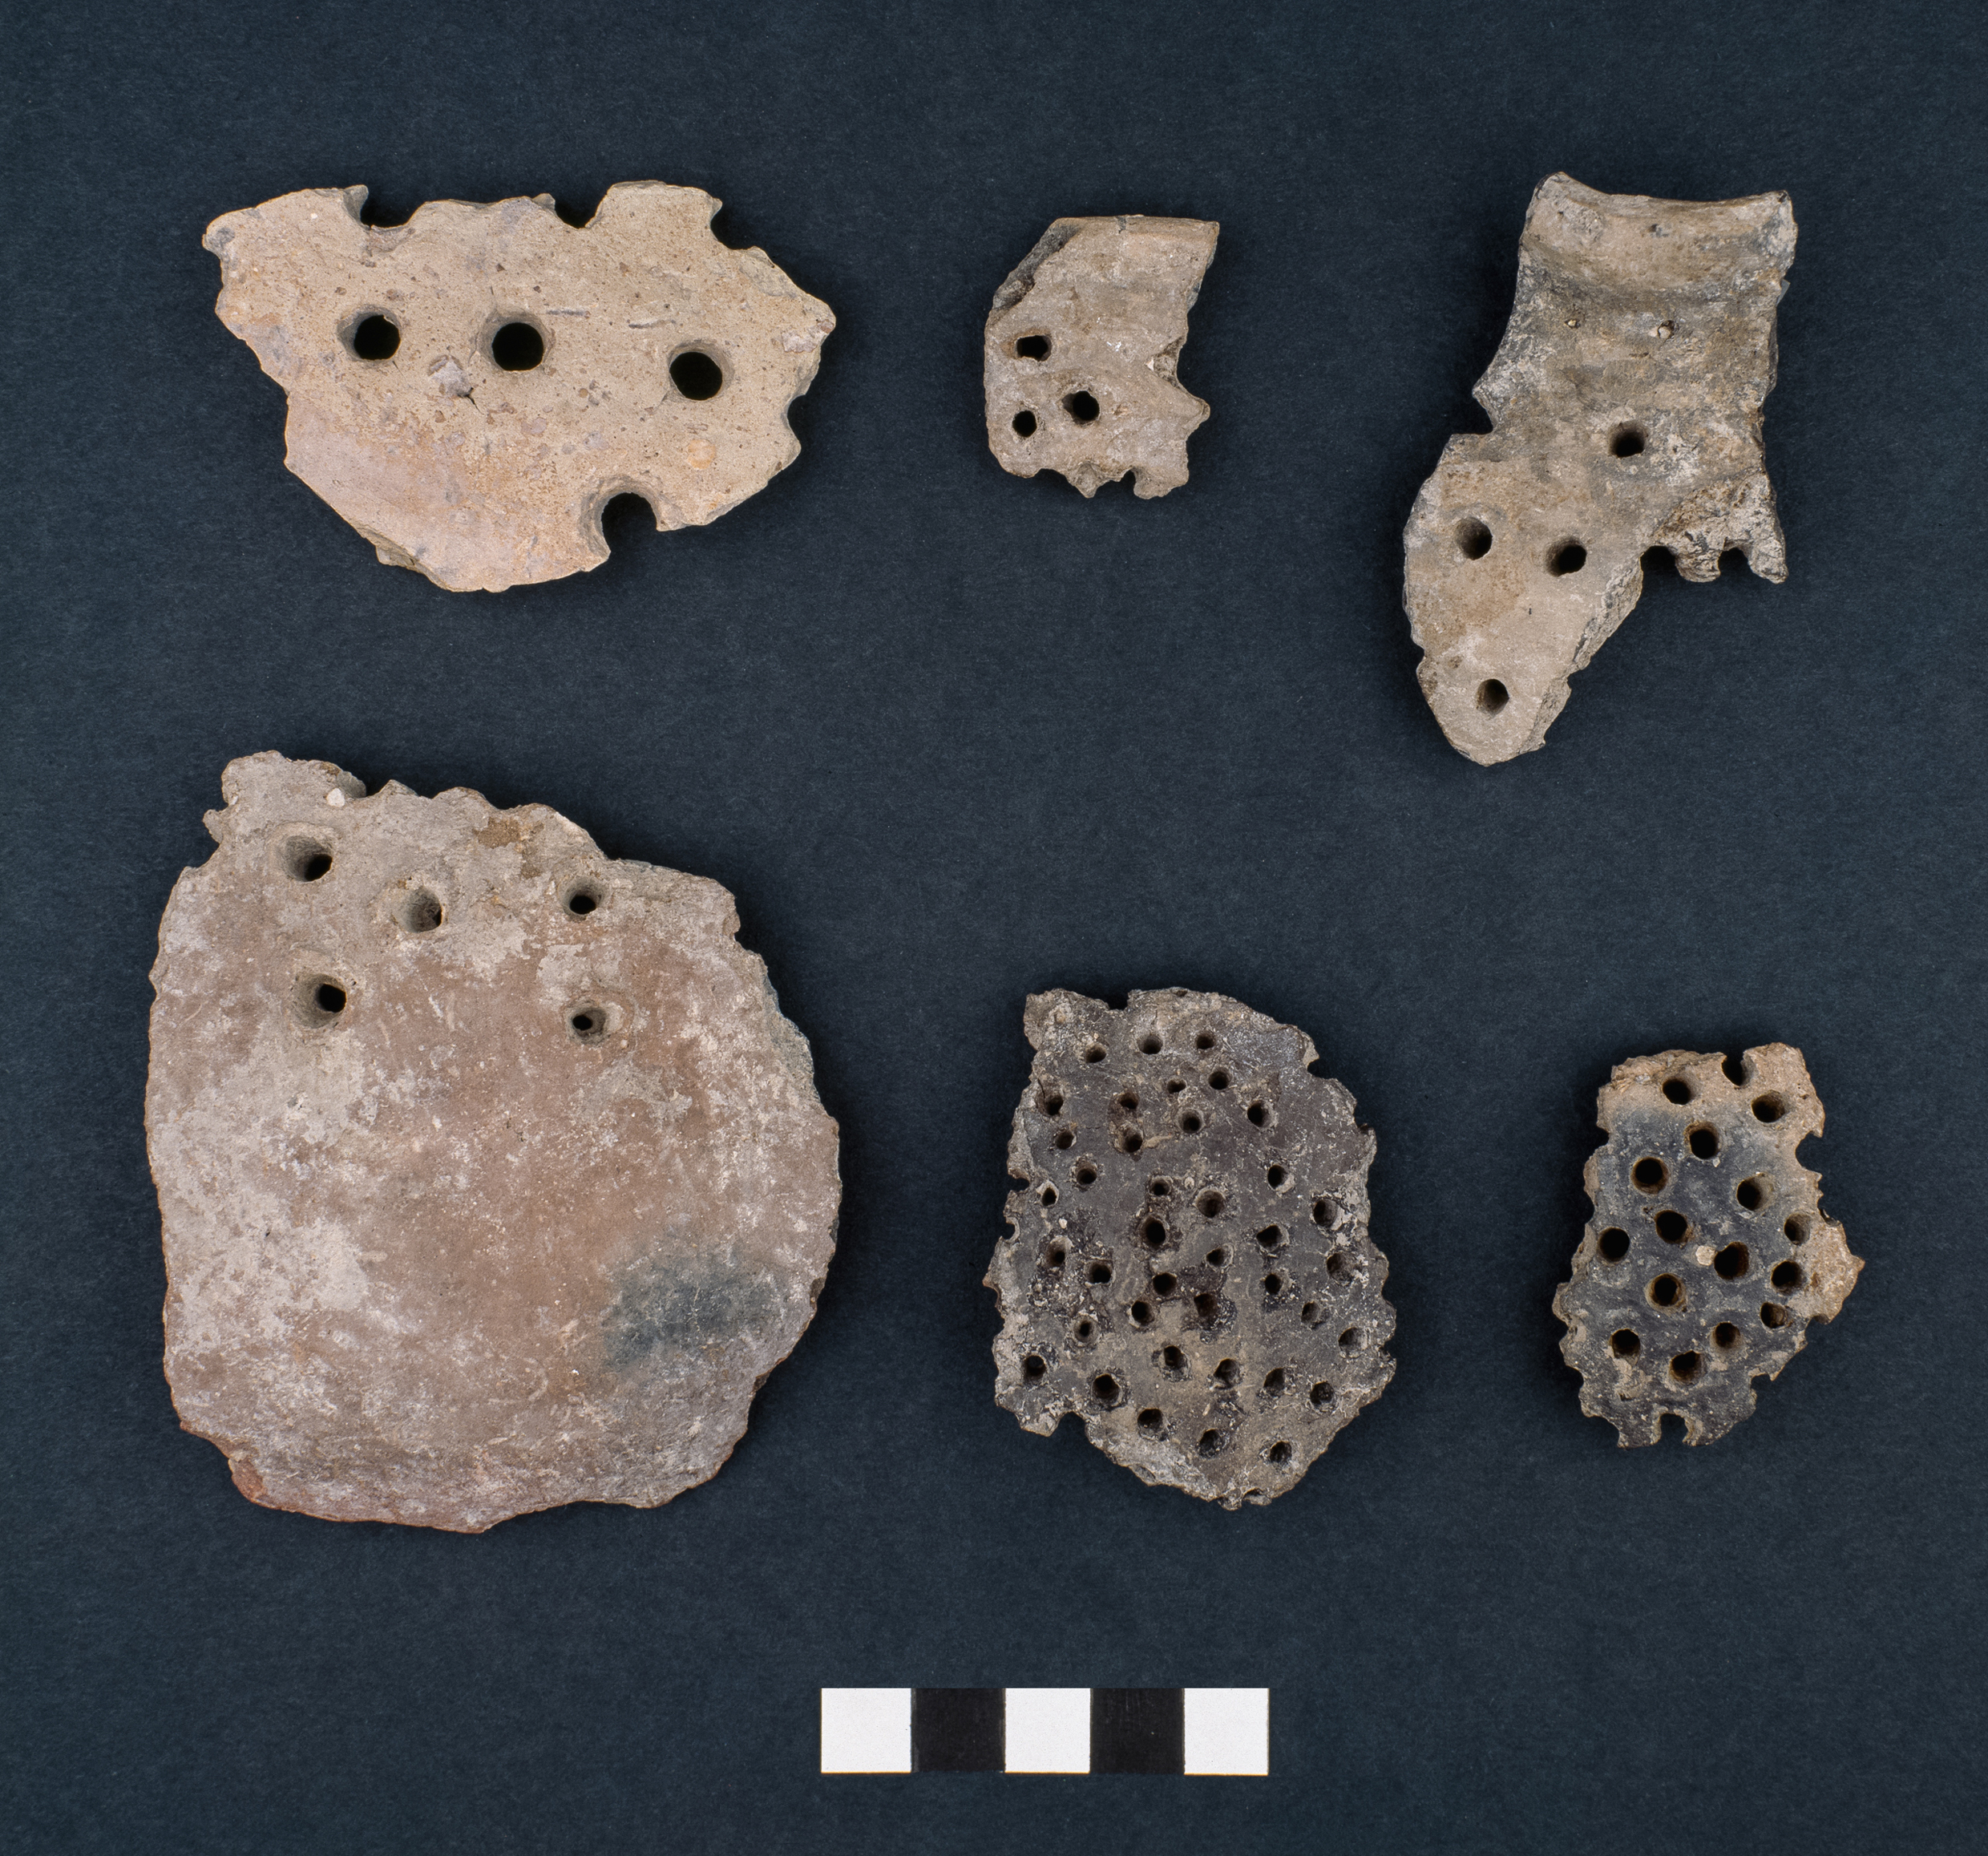

Fig. SM3.5. Final Neolithic (early), perforated utensils. Photo: G. Marinos.

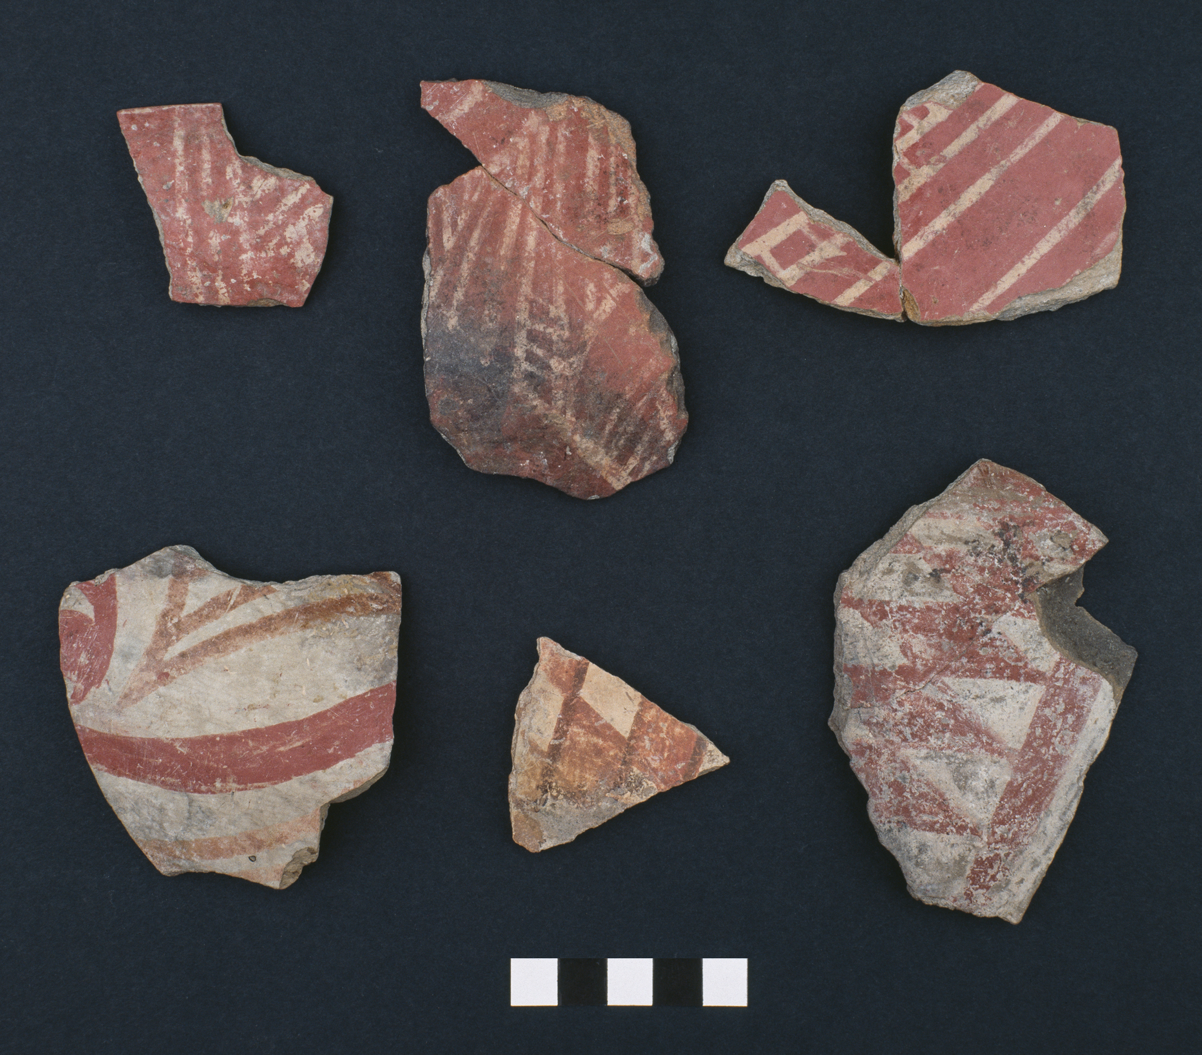

Fig. SM3.6. Final Neolithic (early), pattern-painted pottery. Photo: G. Marinos.

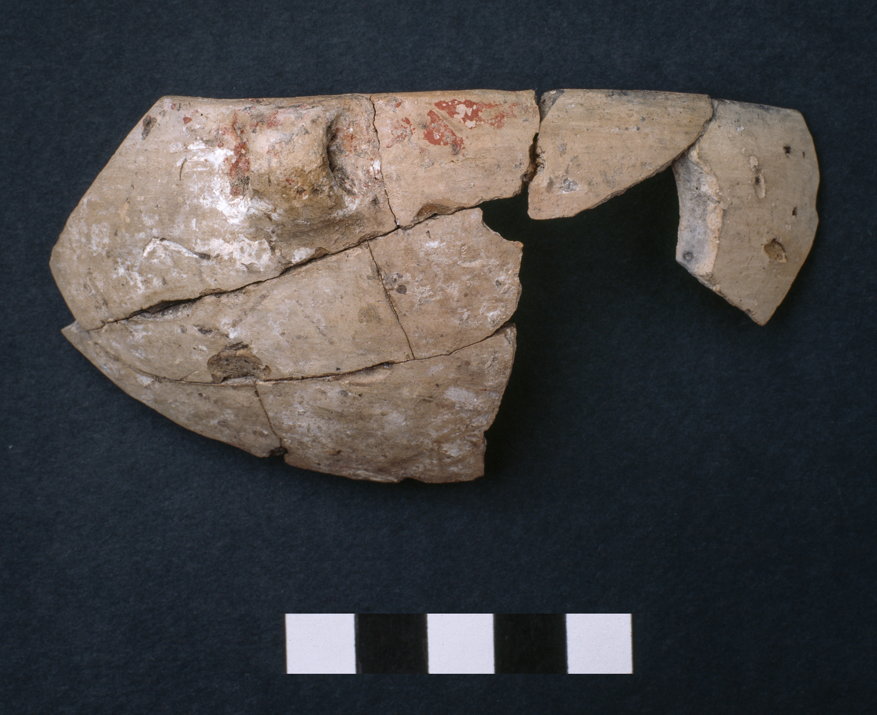

Fig. SM3.7. Final Neolithic (early) bowl with red and white ‘crusts’. Photo: G. Marinos.
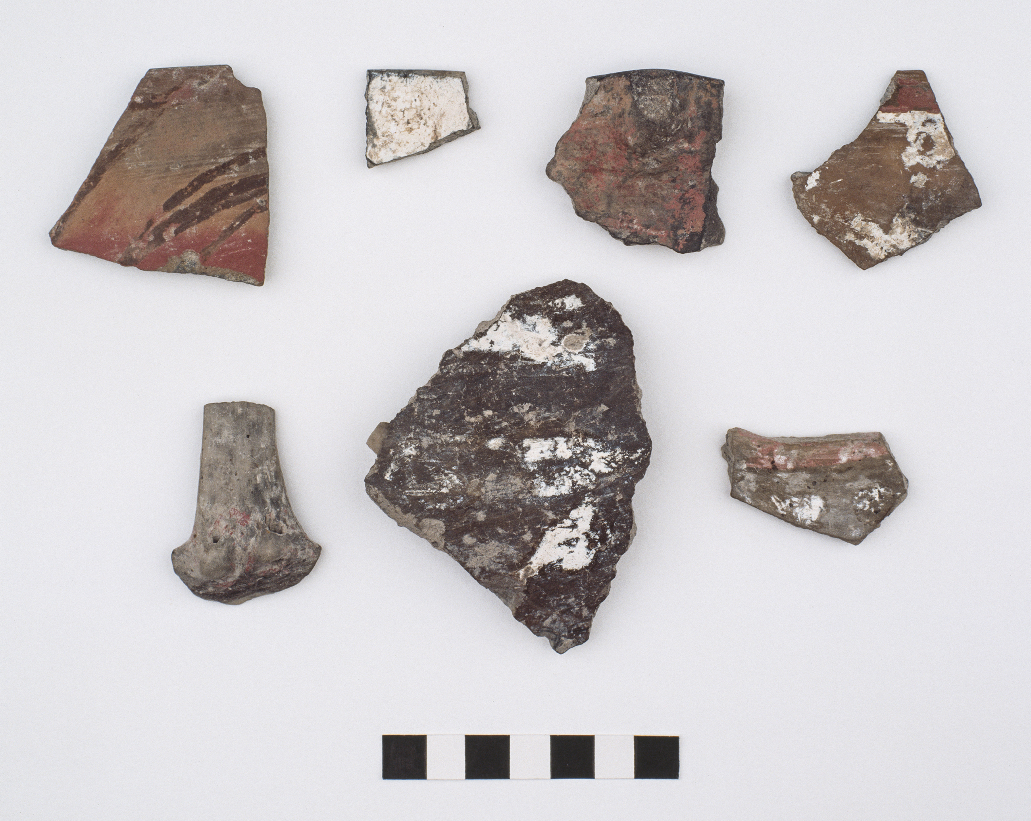

Fig. SM3.8. Final Neolithic (early) ‘crusted’ potsherds. Photo: G. Marinos.
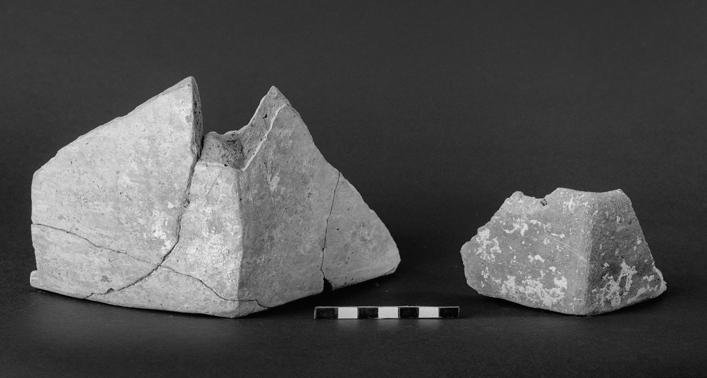

Fig. SM3.9. Final Neolithic (early) angular/quadrangular containers. Photo: G. Marinos.

REFERENCES

Arvanitopoullos, A. 1913. “ Έρευνα εν Δυτική Μακεδονία”, Prakt 1912, 237–42.

Delogkos, E. 2011. ‘Quantitative analysis of geometric evolution of fault zones of Mavropigis’ lignite field in Ptolemais basin (W. Macedonia, Greece)’ (unpublished Master’s thesis, University of Thessaloniki).

Diamantopoulos, A., Krohe, A. and Dimitrakopoulos, D. 2013. ‘Deformation partitioning in a transtension-dominated tectonic environment: the illustrative kinematic patterns of the Neogene – Quaternary Ptolemais Basin (northern Greece)’, Journal of the Geological Society [London] 171, 65–81.

Dimitriadis, V. 1973. Η κεντρική και δυτική Μακεδονία κατά τον Εβλιγιά Τσελεμπή. Εισαγωγή, μετάφραση, σχόλια (Macedonian Library 39, Thessaloniki).

Fotiadis, M. 2001. ‘Imagining Macedonia in prehistory’, JMA 14, 115–35.

Fotiadis, M. and Hondroyanni-Metoki, A. 1993. “Κίτρινη Λίμνη. Διαχρονική σύνοψη, ραδιοχρονολογήσεις, και η ανασκαφή του 1993”, Το αρχαιολογικό Έργο στη Μακεδονία και Θράκη 7, 19–30.

French, D. 1970. ‘Pottery distributions and the geographical regions of Macedonia’, Zbornik Narodnog muzeja u Beogradu 6, 5–19.

Heurtley, W.A. 1939. Prehistoric Macedonia (Cambridge).

Kalogirou, A. 1994. ‘Production and consumption of pottery in Kitrini Limni, west Macedonia, Greece, 4500 B.C. – 3500 B.C’ (unpublished PhD thesis, Indiana University).

Karamitrou-Mentesidi, G. 1986. “Προϊστορικοί οικισμοί Κίτρινης Λίμνης (Σαριγκιόλ) Κοζάνης”, in Αμητός: τιμητικός τόμος για τον καθηγητή Μανόλη Ανδρόνικο (Thessaloniki), 391–416.

Livieratos, E. 2011. ‘Panorama of the Austrian cartographic impact in the late 18th, 19th and early 20th century Greece. A strong example of the international character of cartographic heritage’, Perimetron 6, no. 1, 1–13.

Mee, C., Cavanagh, B. and Renard, J. 2014. ‘The Middle–Late Neolithic transition at Kouphovouno’, BSA 109, 1–31.

Ministry of Public Works. 1952. Έλος Σαριγκιόλ, στραγγιστικόν δίκτυον, οριζοντιογραφία 1: 10,000 (Thessaloniki; unpublished map [Cartographic work dates to the 1930s]).

OKH/Gen St d H. 1944. Deutsche Heereskarte. Griechenland 1: 100,000. Sheet Kosani.

Petrakos,V.C. 1987. Η εν Αθήναις Αρχαιολογική Εταιρεία. Η ιστορία των 150 χρόνων της, 1837–1987 (Library of the Athens Archaeological Society 104, Athens).

Ridley, C. and Wardle, K.A. 1979. ‘Rescue excavations at Servia 1971–1973: A preliminary report’, BSA 74, 185–230.

Ridley, C., Wardle, K.A. and Mould, C.A. 2000. Servia I. Anglo–Hellenic Rescue Excavations 1971–73, Directed by Katerina Rhomiopoulou and Cressida Ridley (BSA Supp. Vol. 32; London).

Urem-Kotsou, D. and Dimitriadis, S. 2004. “Η τεχνολογία της κεραμικής του νεολιθικού οικισμού της Σταυρούπολης: νεώτερες παρατηρήσεις και συμπεράσματα”, in Grammenos, D. and Kotsos, S. (eds), Σωστικές ανασκαφές στο Νεολιθικό οικισμό Σταυρούπολης Θεσσαλονίκης, μέρος ΙΙ (1998–2003) (Thessaloniki), 305–37.

Urem-Kotsou, D. and Gioura, E. 2004. “Η κεραμική των νέων ανασκαφών”, in Grammenos, D. and Kotsos, S. (eds), Σωστικές ανασκαφές στο Νεολιθικό οικισμό Σταυρούπολης Θεσσαλονίκης, μέρος ΙΙ (1998–2003) (Thessaloniki), 231–303.

Ziota, C. 2014. “Ο οικισμός του Κλείτου Κοζάνης στο ευρύτερο φυσικό και ανθρωπογενές περιβάλλον της Νεότερης και Τελικής Νεολιθικής περιόδου,” in Stefani, E., Merousis, N. and Dimoula, A. (eds), 1912–2012. Εκατό χρόνια έρευνας στην προϊστορική Μακεδονία, Πρακτικά διεθνούς συνεδρίου, 22-24 Νοεμβρίου 2012 (Thessaloniki), 323–36.

