The use of Celtic coinage in early Roman London: A re-interpretation of Bloomberg Tablet 31

ONLINE SUPPLEMENTARY MATERIAL

Supplementary material

This supplementary information material includes further data which support assertions made in the main text. These data relate to quinarius wear rates, coin weights, assemblages and images of halved and quartered denarii recorded by the Portable Antiquities Scheme.

Contents
1. Comparative Wear and Weight of quinarii Recorded by the Portable Antiquities Scheme D2
2. Halved and Quartered Denarii Recorded by the Portable Antiquities Scheme D10
3. Weight Data and Distributions of ASIA RECEPTA and IMP CAESAR )( CAESAR DIVI F D12
4. Weight Data and Distribution of Cunobelin “Victory Units” D21
5. Weight Data of Epaticcus Silver Unit (VA 581) D24
6. Assemblages D26

1. Comparative Wear and Weight of quinarii Recorded by the Portable Antiquities Scheme

RRC 333/1 (C EGNATVLEI C F Q)

Hoard | Hoard Closing Date | Number in hoard | Average Weight (g)
Pontecorvo | 74 BC | 26 | 1.89
Policoro | 72 BC | 36 | 1.87
Sustinenza | 56 BC | 251 | 1.86
Cisterna di Latina | 40 BC | 1 | 1.76
Gallarate | 15 BC | 4 | 1.63
Vico Pisano | AD 4 | 5 | 1.59
Villeneuve-au-Chatelot | AD 4 | 17 | 1.48
Tenuta di Lungezzina | AD 37 | 2 | 1.41

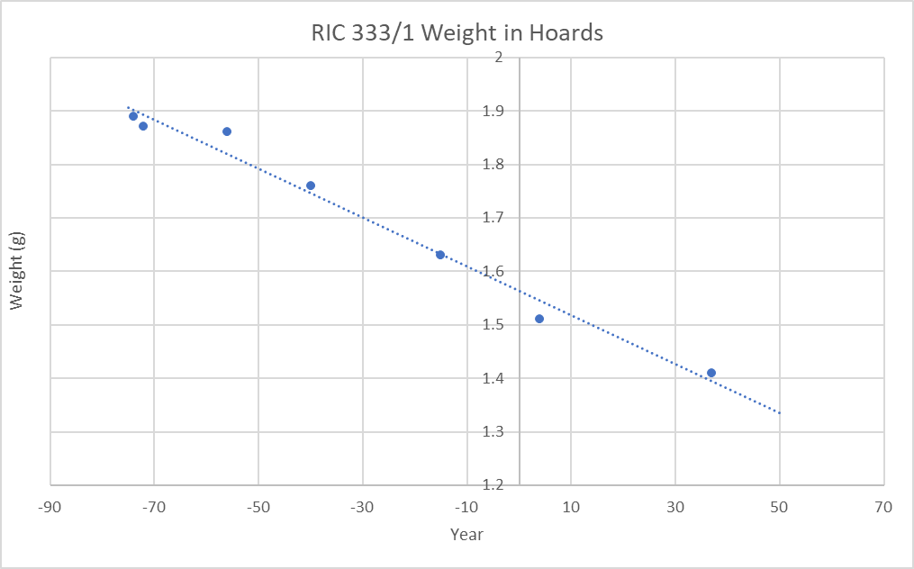

RRC 333/1 Recorded by PAS

1) LVPL-D19795
Weight: Not Supplied

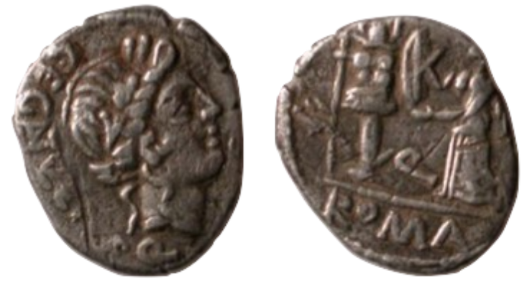
Courtesy of the Portable Antiquities Scheme

No weight data is provided by PAS but its condition clearly demonstrates that it did not remain in circulation for over 150 years. The similar wear of this coin to examples from the Sustinenza and Cisterna di Latina assemblages, with closing dates of 51 and 40 BC respectively suggests a similar date for this example to have left circulation.

2) YORYM-5C6AA4
Weight: 1.80g
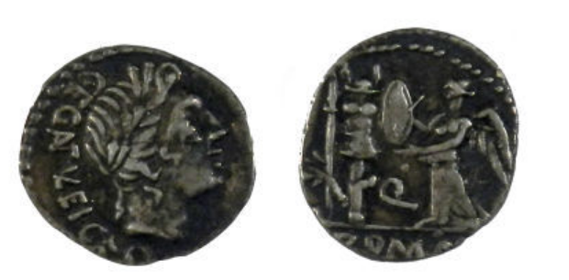
Courtesy of the Portable Antiquities Scheme

3) WMID-OAD9B8
Weight: 1.1g

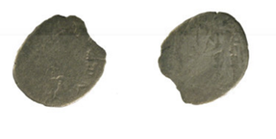
Courtesy of the Portable Antiquities Scheme

RRC 341/3 (Q TITI)

Hoard | Hoard Closing Date | Number in hoard | Average Weight (g)
Pontecorvo | 74 BC | 38 | 2.11
Policoro | 72 BC | 24 | 2.21
Sustinenza | 56 BC | 61 | 1.93
Gallarate | 15 BC | 1 | 1.78
Port-Haliguen (I) | 3 BC | 1 | 1.97
Casteggio | AD 4 | 1 | 1.71
Villeneuve-au-Chatelot | AD 4 | 1 | 1.81

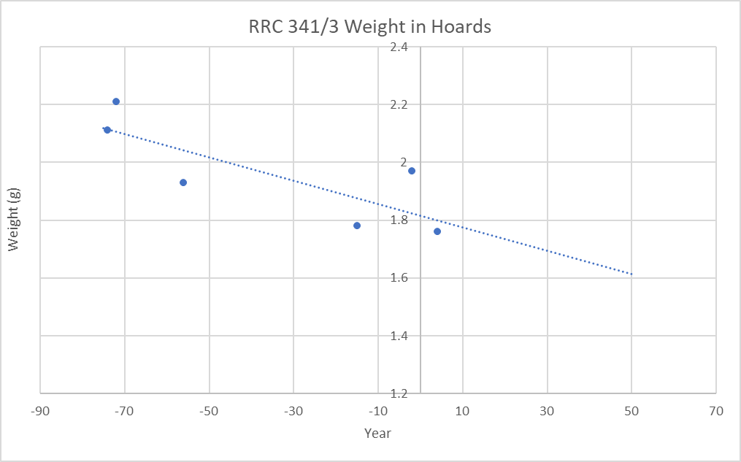

RRC 341/3 Recorded by PAS

1) FASAM-2FBEF7
Weight: 1.06g
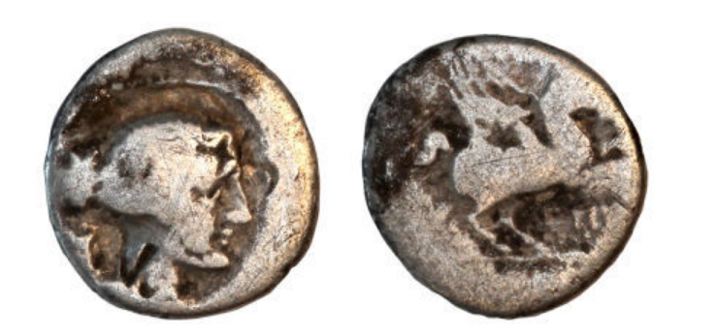
Courtesy of the Portable Antiquities Scheme

RRC 343/2 (M CATO)
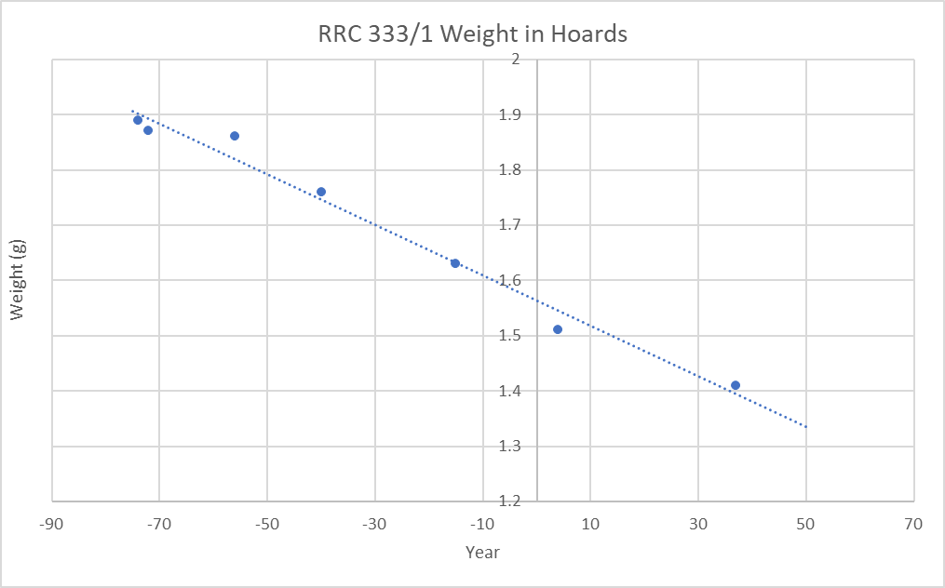
Hoard | Hoard Closing Date | Number in hoard | Average Weight (g)
Pontecorvo | 74 BC | 70 | 2.15
Policoro | 72 BC | 47 | 2.12
Sustinenza | 56 BC | 380 | 2.10
Morgantina | 46 BC | 1 | 2.05
Gallarate | 15 BC | 5 | 1.76
Port-Haliguen (I) | 3 BC | 2 | 1.97
Vico Pisano | AD 4 | 7 | 1.77
Port-Haliguen (II) | AD 4 | 3 | 1.80
Casteggio | AD 4 | 2 | 1.70
Villeneuve-au-Chatelot | AD 4 | 22 | 1.85

RRC 343/2 Recorded by PAS

1) IARCW-63DAE1F18D
Weight: 1.02g
No Image

2) YORYM-5C3625
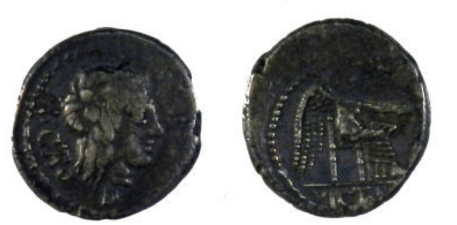
Weight: 1.9g
Courtesy of the Portable Antiquities Scheme

RRC 462/2 (M CATO PROPR)

Hoard | Hoard Closing Date | Number in hoard | Average Weight (g)
Gallarate | 15 BC | 1 | 1.82
Port-Haliguen (I) | 3 BC | 2 | 1.97
Vico Pisano | AD 4 | 1 | 1.94
Casteggio | AD 4 | 1 | 1.83
Villeneuve-au-Chatelot | AD 4 | 7 | 1.81
Tenuta di Lungezzina | AD 37 | 5 | 1.62
Le Mans | AD 37 | 1 | 1.42
Augst | AD 37 | 1 | 1.52
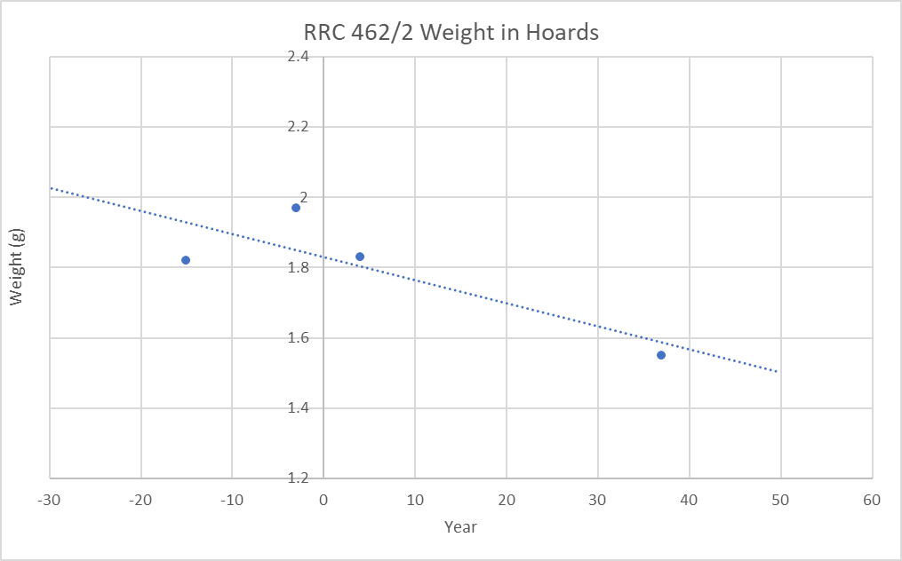

RRC 462/2 Recorded by PAS

1) WMID-1DDD04
Weight: 1.13g
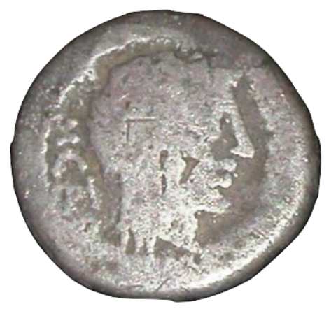
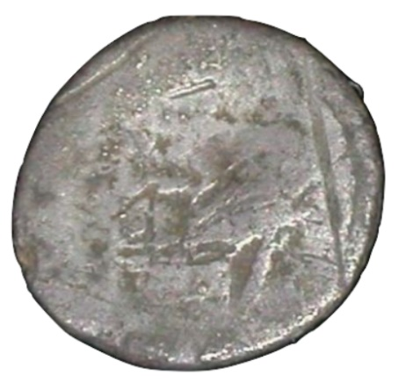
Courtesy of the Portable Antiquities Scheme

2) Example from Selby (N. Yorks.) (IARCH-6487B0)

Weight: 1.19g (“broken”)
No Image

RRC 489/6 (ANTONI IMP III VIR R P C XLI)

Hoard | Hoard Closing Date | Number in hoard | Average Weight (g)
Vico Pisano | AD 4 | 1 | 1.63
Villeneuve-au-Chatelot | AD 4 | 1 | 1.57

RRC 489/6 Recorded by PAS

1) PUBLIC-2EA3F1
Weight: 1.4g
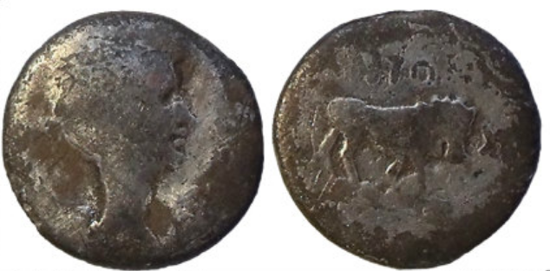
Courtesy of the Portable Antiquities Scheme

2) HAMP-EE4687
Weight: 1.51g
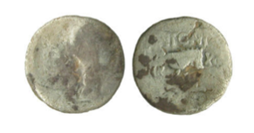
Courtesy of the Portable Antiquities Scheme

RIC I² 276 (CAESAR IMP VII)

Hoard | Hoard Closing Date | Number in hoard | Average Weight (g)
Gallarate | 15 BC | 5 | 1.66
Vico Pisano | AD 4 | 2 | 1.68
Villeneuve-au-Chatelot | AD 4 | 2 | 1.70
Tenuta di Lunghezzina | AD 37 | 2 | 1.51
Pompeii (Regio VIII) | AD 79 | 1 | 1.37

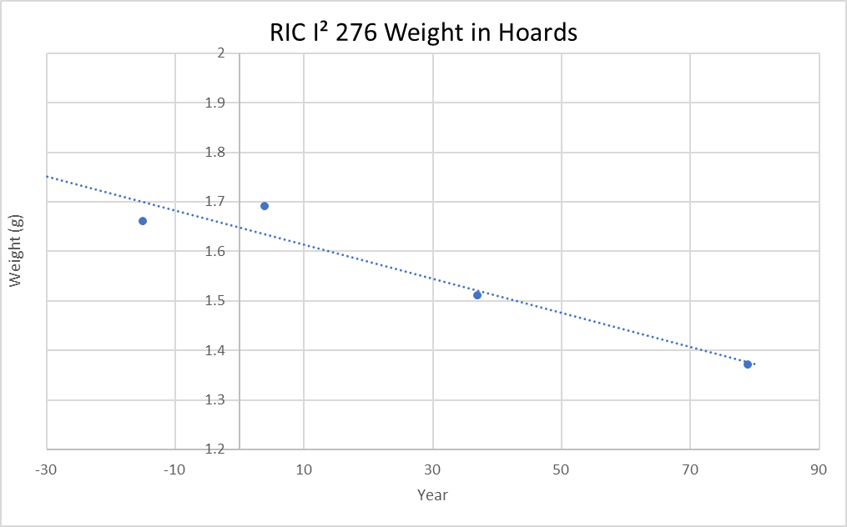

RIC I² 276 Recorded by PAS
1) SF6934
Weight: 1.24g
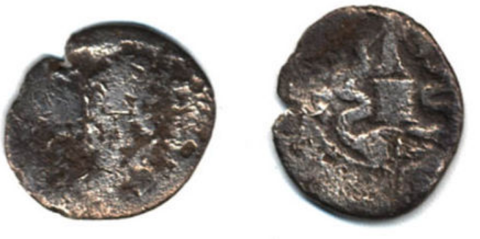
Courtesy of the Portable Antiquities Scheme

RIC I² 001 (AVGVST. P CARISI LEG)

Hoard | Hoard Closing Date | Number in hoard | Average Weight (g)
Port Haliguen (I) | 3 BC | 1 | 1.63
Villeneuve-au-Chatelot | AD 10 | 3 | 1.60
Tenuta di Lunghezzina | AD 37 | 1 | 1.57

RIC I² 001 Recorded by PAS

1) HESH-9BE877
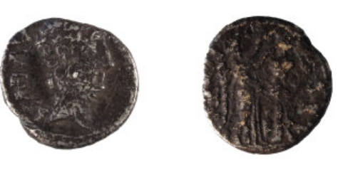
Weight: 1.63g
Courtesy of the Portable Antiquities Scheme

2) Example from Charlwood (Surrey) (IARCH-49F573)
?RIC I² 001
Weight: 0.98g (chipped/incomplete)
No image
High Level of Wear

2. Halved and Quartered Denarii Recorded by the Portable Antiquities Scheme
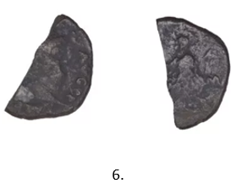
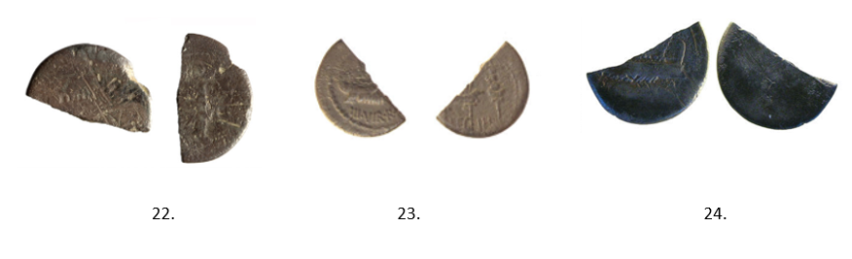
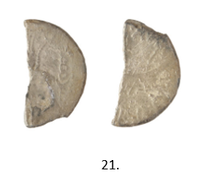
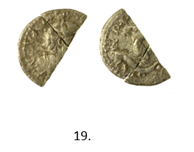
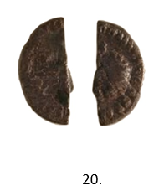
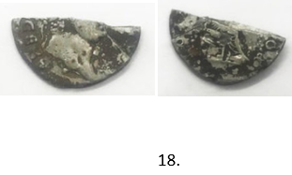
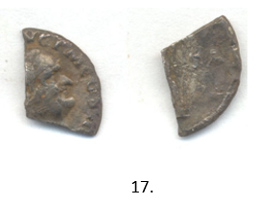
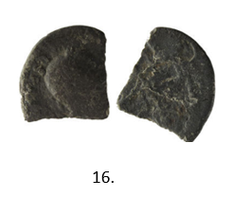
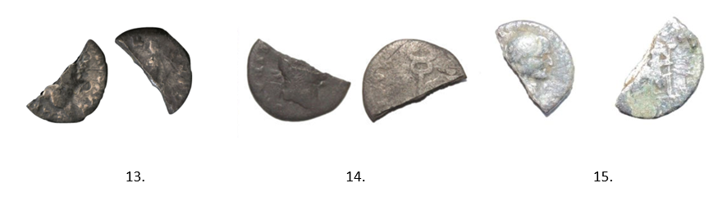
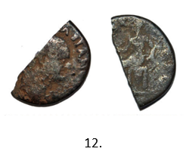
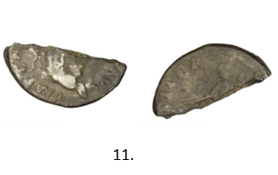
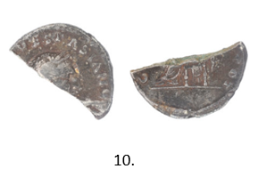
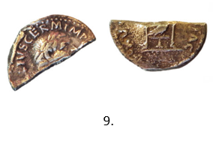
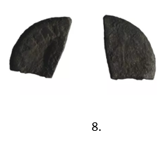
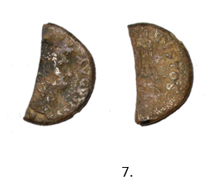
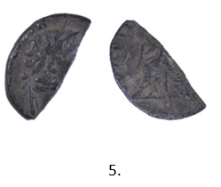
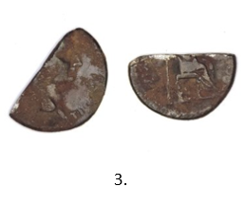
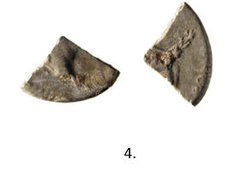
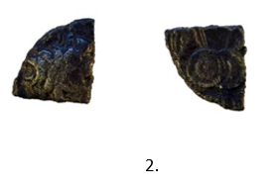
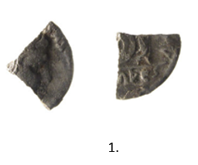
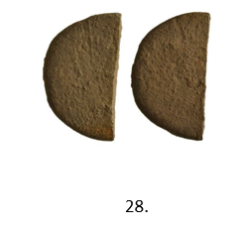
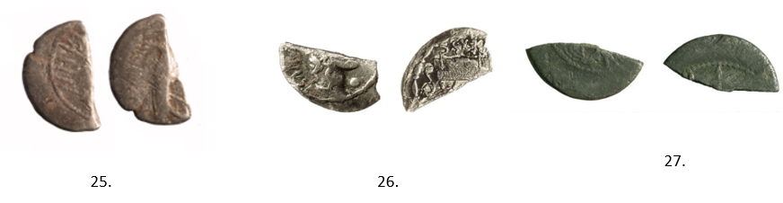

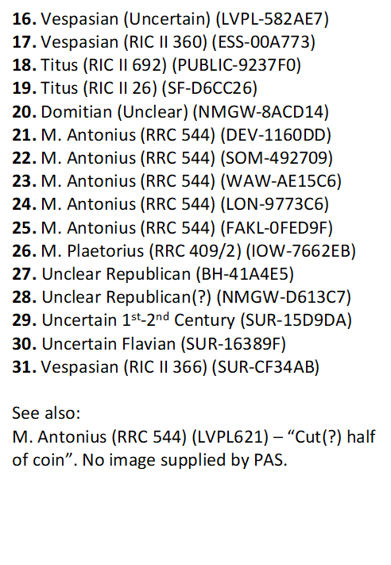
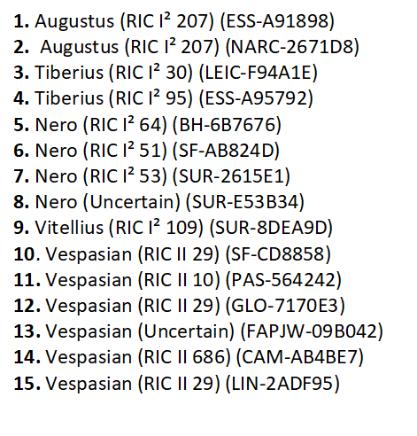
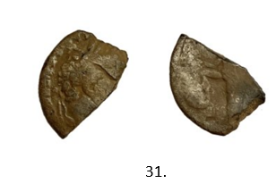
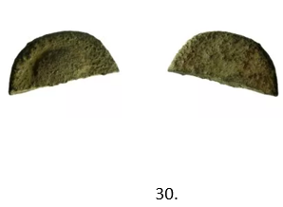
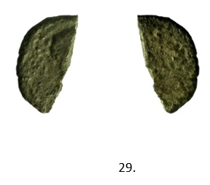

All images Courtesy of the Portable Antiquities Scheme

3. Weight Data and Distributions of ASIA RECEPTA and IMP CAESAR )( CAESAR DIVI F

RIC I² 276 (ASIA RECEPTA)

Museum ID | Weight (g)
BM 2002,0102.5020 | 1.81 | *
BM R.6174 | 1.75 | *
BM R.6173 | 1.92 | *
BM R.348 | 1.42
BM 2002,0102.5425 | 1.65
BM 1866,1201.4182 | 1.81 | *
SMB 18204721 | 1.71 | *
SMB 18202447 | 1.69 | *
SMB 18207825 | 1.76 | *
SMB 18207827 | 1.52 | *
SMB 18207828 | 1.57 | *
SMB 18207829 | 1.54
SMB 18207830 | 1.82 | *
SMB 18207831 | 1.52
ANS 1944.100.39162 | 1.57 | *
ANS 1978.64.390 | 1.58 | *
ANS 1944.100.39161 | 1.76 | *
ANS 1995.11.1644 | 1.61 | *
ANS 1963.237.58 | 1.66 | *
ANS 1937.158.450 | 1.86 | *
ANS 1984.88.14 | 1.45
ANS 1931.119.2 | 1.73 | *
ANS 1944.100.39160 | 1.74 | *
ANS 1896.8.2 | 1.59
ANS 1909.78.23 | 1.78 | *
ANS 1984.88.13 | 1.66 | *
ANS 1978.64.389 | 1.13
ANS 1974.26.6180 | 1.833
Mainz ID266 | 1.79
Gottingen UK-00198 | 1.776 | *
Gottingen AS-00640 | 1.628 | *
Gottingen AS-00642 | 1.618
Gottingen AN-0132 | 1.638
Gottingen AS-00641 | 1.481
Gottingen UK-00199 | 1.706
Boston 01.5086 | 1.55 | *
Boston 32.560 | 1.8 | *
ASH 237 | 1.45
ASH 238 | 1.91
ASH 239 | 1.55
ASH 240 | 1.65
ASH 241 | 1.62 | *
ASH 242 | 1.75
ASH 244 | 1.71
ASH 245 | 1.51
ASH 246 | 1.54
ASH 247 | 1.51
ASH 248 | 1.45 | *
ASH 251 | 1.48
ASH 252 | 1.53 | *
ASH 254 | 1.43
Hunterian C 3637 | 1.66 | *
Hunterian 270 | 1.64 | *
Paris 899 | 1.81 | *
Paris 900 | 1.72
Paris 901 | 1.51 | *
Paris 902 | 1.8 | *
Paris 903 | 1.64 | *
Paris 904 | 1.6
HRV 1942.176.60 | 1.56
HRV 1976.79.1050 | 1.66
HRV 1977.216.3445.18 | 1.74
HRV 1986.528.241 | 1.67
Bochum M 2439 | 1.55
Bochum M 2440 | 1.55 | *
Ingolstadt 353 | 1.69
Erlangen H 296 | 1.57
Frankfurt 65a | 2
Freiburg 00438 | 1.48
Freiburg 00439 | 1.44
Freiburg 00440 | 1.45
Mean | 1.64
Median | 1.64
Mean (Finest) | 1.69
Median (Finest) | 1.7

* Least worn examples
IMP CAESAR )( CAESAR DIVI F Museum Weights

RIC I² | Museum ID | Weight (g)
250a | SMB 18207003 | 3.7
 | BM R.6153 | 3.56
 | BM R.6154 | 3.25
 | BM 2002,0102.5001 | 3.65
 | Bochum M 3006 | 3.65
 | ASH 197 | 3.67
 | ASH 198 | 3.79
250b
 | MUN 16-00003 | 3.54
 | SMB 18207004 | 3.53
 | BM R.6155 | 3.65
 | ASH 199 | 3.74
251
 | ANS 1944.100.39143 | 3.99
 | ANS 1948.19.1036 | 3.85
 | Mainz ID218 | 3.54
 | SMB 18202444 | 4.02
 | SMB 18207007 | 3.82
 | SMB 18202445 | 3.88
 | BM 2002,0102.5004 | 3.73
 | BM R.6161 | 3.71
 | BM 2002,0102.5003 | 3.87
 | BM 1866,1201.4185 | 3.74
 | Freiburg ID1366 | 3.68
 | ASH 196 | 3.58
252
 | ANS 1944.100.39140 | 3.8
 | ANS 1944.100.39141 | 3.85
 | ANS 1996.4.1 | 3.52
 | ANS 1937.158.437 | 3.89
 | ANS 1947.2.411 | 3.79
 | ANS 1944.100.39142 | 3.57
 | Graz 212 | 3.79
 | SMB 18206999 | 3.66
 | SMB 18206998 | 3.9
 | BM 1868,0514.62 | 3.92
 | BM R.6160 | 3.34
 | BM 1901,0407.456 | 4.02
 | BM R.6159 | 3.72
 | BM 2002,0102.5002 | 3.91
 | Freiburg ID1367 | 3.76
 | Wien ID 567 | 3.68
 | ASH 194 | 3.79
253
 | ANS 1937.158.438 | 3.76
 | ANS 1985.140.24 | 3.6
 | ANS 1967.153.108 | 3.85
 | Fitz CM.576-1960 | 3.53
 | Graz 977 | 3.98
 | SMB 18207006 | 3.76
 | SMB 18207005 | 3.45
 | BM 1866,1201.4184 | 3.88
 | BM 1866,1201.4188 | 4.06
 | BM 1841,0916.15 | 3.61
 | BM 1860,0328.112 | 3.98
 | BM 2002,1012.5005 | 3.93
 | Bochum ID347 | 3.77
254a
 | MUN 16-00004 | 3.61
 | SMB 18206997 | 3.44
 | BM R.6156 | 3.72
 | Wien ID568 | 3.76
 | ASH 191 | 3.54
254b
 | Mainz ID426 | 3.78
 | Wien ID56587 | 3.93
 | SMB 18202353 | 3.95
 | SMB 18206995 | 3.71
 | SMB 18206993 | 3.76
 | SMB 18206994 | 3.92
 | WWU ID497 | 3.8
 | ASH 192 | 3.66
255
 | ANS 1948.19.1035 | 3.86
 | SMB 18202355 | 3.91
 | BM R.6158 | 3.93
256
 | ANS 1944.100.39145 | 3.91
 | ANS 1937.158.439 | 3.73
 | ANS 1944.100.39144 | 3.28
 | SMB 18207002 | 3.77
 | SMB 18202371 | 3.65
 | BM R.6162 | 3.67
 | BM 2002,0102.5006 | 3.6
 | WWU ID149 | 3.71
 | ASH 190 | 3.92
257
 | ANS 1944.100.39137 | 3.85
 | ANS 1911.105.423 | 3.73
 | ANS 1957.172.1498 | 3.91
 | ANS 1905.57.283 | 3.44
 | ANS 1941.131.679 | 3.88
 | Graz 311 | 3.61
 | SMB 18206991 | 3.8
 | SMB 18206989 | 3.22
 | BM 1984,0222.1 | 3.54
 | BM 1866,1201.4178 | 3.06
 | BM R.6152 | 3.65
 | BM 2002,0102.5000 | 3.6
 | BM R.6151 | 3.71
 | BM 1994,0915.242 | 3.7
 | Bochum ID348 | 3.44
 | Freiburg ID1368 | 3.6
 | ASH 201 | 4.01
 | ASH 202 | 3.82
 | ASH 203 | 3.69
 | ASH 204 | 3.44
 | ASH 205 | 3.51
263
 | HAR 1942.176.59 | 3.62
 | BM R.6163 | 3.78
264
 | ANS 1937.158.441 | 3.74
 | ANS 1941.131.680 | 3.08
 | ANS 1937.158.440 | 3.99
 | ANS 1944.100.39146 | 3.88
 | Mainz ID223 | 3.88
 | Gottingen AS-00635 | 3.76
 | SMB 18207258 | 3.98
 | SMB 18207256 | 4
 | SMB 18207257 | 4.17
 | SMB 18207259 | 3.72
 | BM 1901,0407.459 | 3.98
 | BM 1848,0126.8 | 4
 | BM 1901,0407.458 | 3.84
 | BM R.6164 | 3.69
 | BM 1844,0425.426 | 3.83
 | BM 2002,0102.5007 | 3.79
 | Bochum ID349 | 3.99
 | Freiburg ID8209 | 3.76
 | Kiel ID202 | 2.81
 | Wien ID569 | 3.83
265a
 | ANS 1937.158.443 | 3.98
 | ANS 1948.19.1037 | 3.36
 | ANS 1995.11.1643 | 3.58
 | ANS 1937.158.444 | 3.84
 | ANS 1944.100.39149 | 3.9
 | ANS 1941.131.681 | 3.57
 | AMS 1957.172.1502 | 3.94
 | Mainz ID220 | 3.79
 | Gottingen AS-00636 | 3.48
 | SMB 18202360 | 3.87
 | SMB 18207260 | 3.91
 | SMB 18202361 | 3.72
 | NYM 08.170.89 | 3.8
 | BM R.6165 | 3.97
 | BM 2002,0102.5009 | 3.99
 | Freiburg ID1356 | 3.55
 | Kiel ID5 | 3.45
265b
 | ANS 1957.172.1503 | 3.75
 | SMB 18207264 | 3.57
 | SMB 18207265 | 3.36
 | BM 1901,0407.460 | 3.69
 | BM 2002,0102.5010 | 3.83
 | BM 1844,0425.423 | 3.6
266
 | ANS 1960.170.201 | 3.71
 | ANS 1937.158.446 | 4.02
 | ANS 1953.171.396 | 3.37
 | ANS 1944.100.39151 | 3.92
 | ANS 1944.100.39152 | 3.87
 | ANS 1957.172.1505 | 3.68
 | ANS 1935.117.355 | 3.73
 | Mainz ID224 | 3.73
 | SMB 18207251 | 3.75
 | SMB 18207252 | 3.61
 | SMB 18207250 | 3.72
 | SMB 18202364 | 3.81
 | BM 1904,0203.1 | 3.65
 | BM R.6167 | 3.95
 | BM 2002,0102.5013 | 3.91
 | Wien ID570 | 3.69
 | Wien ID571 | 3.61
267
 | ANS 1957.172.1500 | 3.68
 | ANS 1957.172.1501 | 3.61
 | ANS 1923.150.72 | 3.52
 | ANS 1944.100.39148 | 3.85
 | ANS 1937.158.442 | 3.45
 | Mainz ID427 | 3.54
 | Gottingen AS-00637 | 3.85
 | Gottingen UK-00197 | 3.98
 | SMB 18202359 | 3.9
 | SMB 18207268 | 3.98
 | SMB 18207281 | 3.62
 | SMB 18207280 | 3.73
 | SMB 18202358 | 3.72
 | SMB 18207267 | 3.83
 | NYM 08.170.88 | 3.9
 | BM 1988,0627.1033 | 2.75
 | BM 1843,1024.244 | 3.78
 | BM 2002,0102.5008 | 3.65
 | BM 1843,1024.244 | 2.87
 | BM 1843,1024.244 | 3.78
 | Bochum ID350 | 3.65
 | Freiburg ID1371 | 3.7
269a
 | ANS 1944.100.39150 | 3.67
 | ANS 1985.140.26 | 3.58
 | ANS 1957.172.1504 | 3.84
 | ANS 1937.158.445 | 3.66
 | SMB 18207289 | 3.31
 | SMB 18207288 | 3.63
 | SMB 18207285 | 3.71
 | SMB 18207287 | 3.5
 | SMB 18207286 | 3.46
 | BM R.6166 | 3.8
 | BM 1915,0407.17 | 3.79
 | BM 2002,0102.5011 | 3.9
269b
 | BM 1901,0407.457 | 3.54
 | BM 2002,0102.5012 | 3.79
270
 | ANS 1944.100.39155 | 3.85
 | ANS 1954.203.150 | 3.69
 | ANS 1957.172.1507 | 3.73
 | SMB 18207283 | 3.54
 | SMB 18202368 | 3.72
 | BM 2002,0102.5016 | 3.92
 | Freiburg ID1372 | 3.39
271
 | ANS 1944.100.39153 | 3.62
 | ANS 1957.172.1506 | 3.83
 | ANS 1937.158.448 | 3.83
 | ANS 1948.19.1039 | 3.91
 | ANS 1947.2.412 | 3.57
 | ANS 1937.158.447 | 3.97
 | Mainz ID221 | 3.31
 | SMB 18207254 | 3.04
 | SMB 18202362 | 3.8
 | SMB 18207253 | 3.4
 | BM 1867,0101.1274 | 3.56
 | BM R.6168 | 4.1
 | BM 2002,0102.5014 | 3.93
 | BM 1866,1201.4181 | 4.1
 | BM R.6169 | 3.56
 | BM 2002,0102.5015 | 3.85
 | BM 1994,0915.243 | 3.72
 | Freiburg ID1373 | 3.54
272
 | ANS 1973.999.49 | 3.76
 | ANS 1944.100.39156 | 3.92
 | ANS 1937.158.449 | 3.88
 | ANS 1944.100.39157 | 3.68
 | ANS 1948.19.1038 | 3.92
 | ANS 1947.2.413 | 3.64
 | Mainz ID222 | 3.87
 | Gottingen AS-00639 | 3.80
 | SMB 18202443 | 3.74
 | SMB 18207282 | 3.77
 | BM 1866,1201.4183 | 3.88
 | BM 2002,0102.5017 | 4.01
 | BM 1988,0627.1027 | 3.34
 | BM R.6171 | 3.8
 | BM 1904,0204.82 | 3.66
 | BM 1904,0204.83 | 3.75
 | BM 1860,0328.110 | 3.84
 | Freiburg ID8211 | 3.63
 | Wien ID572 | 3.63
274
 | ANS 1944.100.39158 | 3.81
 | ANS 1893.5.11 | 3.56
 | ANS 1947.2.414 | 3.51
 | SMB 18207291 | 3.89
 | SMB 18207292 | 3.8
 | SMB 18207293 | 3.17
 | SMB 18207294 | 3.62
 | BM 1841,0726.1086 | 3.41
 | BM 1946,1004.82 | 3.7
 | BM 2002,0102.5018 | 3.76
 | BM R.6172 | 3.73
 | BM 2002,1012.5019 | 3.92
 | BM 1841,0916.5 | 3.88
 | BM 1985,0421.26 | 3.7
 | Freiburg 8212 | 3.66
 | Wien ID573 | 3.57
 | Mean | 3.67
 | Median | 3.73

ANS: American Numismatic Society
ASH: Ashmolean Museum, Oxford
Bochum: Coin Collection of Ruhr-Universitat Bochum
BM: British Museum, London
Boston: Museum of Fine Arts, Boston
Erlangen: Coin collections of the Friedrich-Alexander-Universität Erlangen-Nürnberg (FAU)
Frankfurt: Coin Collections of the Goethe University, Frankfurt am Main
Freiburg: Münzsammlung des Seminars für Alte Geschichte der Albert-Ludwigs-Universität
Gottingen: Münzkabinett der Universität Göttingen
HRV: Harvard Art Museums
Hunterian: The Hunterian Museum, Glasgow
Ingolstadt: Coin Collection of the Professorship for Ancient History at the University of Eichstaett-Ingolstadt
Mainz: Johannes Gutenberg-Universitat
MUN: Staatliche Munzsammlung Munchen
NYM: Metropolitan Museum of Art, New York
Paris: Biblioteque Nationale de France, Paris
SMB: Staatlichen Museen zu Berlin
Wien: Institut für Numismatik und Geldgeschichte
WWU: Archäologisches Museum der Westfälischen Wilhelms-Universität, Munster

4. Weight Data and Distribution of Cunobelin “Victory Units”

VA 2045

PAS ID | Weight (g)
ESS-3A1970 | 1.3
ESS-42A011 | N/A
NMGW-F3F776 | 1.2
CCI-93001 | 1.19
CCI-00886 | 1.26
CCI-30137 | 1.15
CCI-30472 | N/A
CCI-40742 | 1.11
CCI-40987 | N/A
CCI-670172 | 1.18
CCI-680399 | 1.24
CCI-690389 | 1.29
CCI-720124 | 0.79
CCI-920996 | 1.22
CCI-930012 | 1.22
CCI-930925 | 1.32
CCI-940804 | 1.21
CCI-941235 | 1.26
CCI-962595 | N/A
CCI-963315 | 1.21
CCI-810074 | 1.35
CCI-982185 | 1.24
CCI-982326 | N/A
CCI-990317 | 1.2
CCI-981157 | 1.2
CCI-982004 | 1.24
De Jersey (2001) ID | Weight (g)
67.0172 | 1.18
68.0399 | 1.24
68.04 | 1.28
68.0401 | 1.18
69.0389 | 1.29
81.0074 | 1.35
92.0996 | 1.22
93.0010 | 1.19
93.0012 | 1.22
93.0925 | 1.32
94.0804 | 1.21
96.3315 | 1.21
98.1157 | 1.2
98.2004 | 1.24
98.2185 | 1.24

BMC 1883

PAS ID | Weight (g)
BM-E58BCF | 1.18
OXON-411B63 | 1.35
PAS-167156 | 1.2
BUC-12DA24 | 1.3
BERK-85E093 | 1.3
CCI-01418 | N/A
CCI-10732 | 1.28
CCI-2012 | 1.04
CCI21142 | 1.31
CCI-30709 | 1.16
CCI-31318 | 1.35
CCI-40005 | 1.31
CCI-920155 | 1.04
CCI-930929 | 1.27
CCI-941427 | 1.18
CCI-950949 | 1.23
CCI-952923 | N/A
CCI-963154 | 1.17
CCI-963283 | 0.96
CCI-963454 | 1.25
CCI-96362 | 1.09
CCI-970042 | 1.25
CCI-830272 | 1.21
CCI-860072 | 1.34
CCI-860404 | 1.24
CCI-890017 | 1.24
CCI-930652 | 1.28
CCI-991379 | 1.28
CCI-980713 | 1.16
CCI-981261 | 1.29
CCI-982061 | N/A
CAM-B48C02 | 1.2
LEIC-5E9416 | 1.19
BUC-B8075D | 1.31
NARC-3B2460 | N/A
BERK-223811 | 1.13
De Jersey (2001) ID | Weight (g)
83.0272 | 1.21
86.0072 | 1.34
86.0404 | 1.24
89.0017 | 1.24
92.0155 | 1.04
93.0652 | 1.28
93.0929 | 1.27
94.0718 | 1.26
94.1427 | 1.18
95.0949 | 1.23
95.3332 | 1.32
96.3154 | 1.17
96.3283 | 0.96
96.3454 | 1.25
96.362 | 1.09
97.0042 | 1.25
98.1261 | 1.29

5. Weight Data of Epaticcus Silver Unit (VA 581)

Identification Number | Weight (g)
BM 1988,0627.778 | 1.33
BM 1988,0627.88 | 1.15
BM 1988,0627.795 | 1.34
BM 1988,0627.794 | 1.23
BM 1988,0627.782 | 1.27
BM 1978,0108.168 | 1.02
BM 1978,0108.165 | 1.08
BM 1978,0108.161 | 1.17
BM 1978,0108.166 | 1.04
BM 1988,0627.791 | 1.15
BM 1978,0108.162 | 1.13
BM 1978,0108.167 | 1.25
BM 1978,0108.158 | 1.01
BM 1978,0108.163 | 1.17
BM 1954,0703.1 | 1.22
BM 1978,0108.160 | 0.84
BM 1988,0627.789 | 1.31
BM 1988,0627.786 | 1.1
BM 1988,0627.790 | 1.2
BM 1988,0627.777 | 0.86
BM 1988,0627.775 | 1.01
BM 1988,0627.783 | 1.27
BM 1978,0108.164 | 1.1
BM 1988,0627.779 | 1.14
BM 1988,0627.774 | 1.01
BM 1978,0108.159 | 1.23
BM 1988,0627.785 | 1.15
BM 1988,0627.787 | 1.43
BM 1988,0627.781 | 1.31
BM 1988,0627.793 | 1.14
BM 1988,0627.780 | 1.09
BM 1988,0627.784 | 1.12
BM 1973,0803.1 | 1.13
BM 1988,0627.792 | 1.25
NORTH C345 | 1.28
NORTH AGA53 | 1.3
NMW 80.4H/5 | 1.19
NMW 77.18H/1 | 1.28
PAS GLO-53715E | 1.21
PAS HAMP-BD27C2 | 1.08
PAS SUR-F30F51 | 1.15
PAS SUR-FE6330 | 1.25
PAS BERK-F60BE4 | 1.2
PAS BUC-63E7D3 | 1.4
CCI-00141 | 1.24
CCI-00518 | 1.15
CCI-11982 | 1.26
CCI-20445 | 1.25
CCI-30312 | 1.3
CCI-30395 | 1.23
CCI-31069 | 0.91
CCI-42401 | 1.2
CCI-640048 | 1.1
CCI-690333 | 1.22
CCI-780017 | 1.13
CCI-780018 | 1.13
CCI-810044 | 1.22
CCI-810045 | 1.08
CCI-810046 | 1.23
CCI-810047 | 1.08
CCI-820199 | 0.92
CCI-870004 | 0.98
CCI-870709 | 1.25
CCI-87071 | 1.17
CCI-900738 | 1.3
CCI-963037 | 1.27
CCI-970822 | 1.23
CCI-970823 | 1.24
CCI-930732 | 1.25
CCI-940071 | 1.26
CCI-940968 | 1.3
CCI-950635 | 0.95
CCI-951284 | 1.09
CCI-971625 | 1.27
CCI-980729 | 1.2
CCI-982095 | 1.3
CCI-990655 | 1.21
CCI-991202 | 1.09
PAS BERK-123197 | 1.3
Mean | 1.18

BM – British Museum
NMW – National Museum of Wales
NORTH – Northover 1992
CCI – Celtic Coin Index
PAS – Portable Antiquities Scheme

6. Assemblages

1) Pontecorvo (1923) (Frosinone, Italy)
Contents: 942 AR denarii, 1 AR victoriatus, 290 AR quinarii.
Closing Date: 74 BC
Reference: Pozzi 1962

2) Policoro (1968) (Matera, Italy)
Contents: 302 AR denarii, 232 AR quinarii
Closing Date: 72 BC
Reference: Siciliano 1974–1975.

3) Sustinenza, Casaleone (1888) (Mantova, Italy)
Contents: 65 AR denarii, 1052 AR quinarii,1 AE as (?stopper)
Closing Date: 56 BC
Reference: Modonesi 2001; with additional information from T.R. Volk.

4) Sustinenza, Casaleone (1901) (Mantova, Italy)
Contents: 714 AR denarii, 315 AR quinarii, 1 AE as (?stopper)
Closing Date: 51 BC
Reference: Modonesi 2001; with additional information from T.R. Volk.

5) Morgantina (1959) (Enna, Sicily)
Contents: 8 AR denarii (including one of Juba I), 1 AR quinarius, 1 AE of Massalia
Closing Date: 46 BC
Reference: Walthall 2013

6) Cisterna di Latina (1952) (Latina, Italy)
Contents: 506 AR denarii, 1 AR quinarius
Closing Date: 40 BC
Reference: Nicolai 2000

7) Warminster (1994-5) (Wiltshire, England)
Contents: 12 AR denarii
Closing Date: 31 BC
Reference: Meadows and Robinson 1997

8) Raydon (1995) (Suffolk, England)
Contents: 5 AR denarii
Closing Date: 6 BC
Reference: Newman 1997

9) Port Haliguen (I), Quiberon (1951) (Bretagne, France)
Contents: 4 AR denarii, 10 AR quinarii, 8 Republican AE asses, 359 Augustan asses, 38 Nemausus asses, 27 halved asses, 4 AR Gallic
Closing Date: 3 BC
Reference: Giard 1967

10) Port-Haliguen (II), Quiberon (1985) (Morbihan, France)
Contents: 2 AR denarii, 5 AR quinarii, 102 AE asses, 2 AV Gallic staters , 1 AR Gallic “quinarius"
Closing Date: AD 4
Reference: Goulpeau 1985

11) Vico Pisano (1913) (Pisa, Italy)
Contents: 170 AR denarii, 25 AR quinarii
Closing Date: AD 4
Reference: Sorge, Catalli, and Catalli 2008

12) Gallarate (1929) (Varese, Italy)
Contents: 27 AR denarii, 24 AR quinarii
Closing Date: AD 4
Reference: Dibernardi 2013

13) Casteggio (1930) (Pavia, Italy)
Contents: 36 AR denarii (of which three halved), 13 AR quinarii
Closing Date: AD 4
Reference: Vismara 2002

14) Villeneuve-au-Chatelot (1973) (Aube, France)
Contents: 141 AR denarii, 93 AR quinarii, 9 AE Rome, 558 AE Lugdunum asses, 11 Lugdunum quadrantes, 5 AE provincial dupondii/asses, 366 AE Nemausus asses (including halved issues), 41 AR Gallic, 14 AE Gallic.
Closing Date: AD 4
Reference: Zehnacker, Richard and Barrandon 1984

15) Lakenheath (1959) (Suffolk, England)
Contents: 76 AR denarii, 3 AV Celtic, 412 AR Celtic
Closing Date: AD 34
Reference: Bristow et al. 1959

16) Le Mans (1985) (Sarthe, France)
Contents: 5 AV aurei, 45 AR denarii, 3 AR quinarii, 1 AR drachm (Apollonia, Illyria)
Closing Date: AD 37
Reference: Amandry and Aubin 1993

17) Tenuta di Lunghezzina (1995) (Roma, Italy)
Contents: 1 AV aureus, 1 AV quinarius, 77 AR denarii, 12 AR quinarii, 1 AR victoriatus
Closing Date: AD 37
Reference: Bufalini 2005

18) Woolland (1993) (Dorset, England)
Contents: 16 AR denarii
Closing Date: AD 37
Reference: Bland 1997

19) Membury (1988) (Wiltshire, England)
Contents: 252 AR denarii
Closing Date: AD 37
Reference: Howgego and King 1992; Orna-Ornstein 1997b

20) Woodham Mortimer (1991) (Essex, England)
Contents: 189 AR denarii
Closing Date: AD 37
Reference: Hobbs 1992

21) Norton Subcourse (1982-1986) (Norfolk, England)
Contents: 97 AR denarii, 3 AR Celtic
Closing Date: AD 42
Reference: Burnett and Gregory 1988

22) Old Buckenham (1994) (Norfolk, England)
Contents: 14 AR denarii
Closing Date: AD 45
Reference: Davies 1997a

23) Wanborough Temple (1983) (Surrey, England)
Contents: 978 Celtic, 63 AR denarii
Closing Date: c. AD 50
Reference: Cheeseman 1994

24) Augst (1989) (Basel, Switzerland)
Contents: 3 AR denarii, 1 AR quinarius, 1 AE dupondius, 1 AE as (imitation)
Closing date: AD 54 (although imitation may be later)
Reference: Peter 1990

25) Scole (1982-3) (Norfolk, England)
Contents: 87 AR denarii, 202 AR Celtic
Closing Date: AD 61
Reference: Burnett 1986a

26) Needham (1992) (Norfolk, England)
Contents: 29 denarii
Closing Date: AD 64
Reference: Davies, Meadows and Williams 1997

27) Selby (1997) (North Yorkshire, England)
Contents: 8 AR denarii, 6 AE
Closing Date: AD 68
Reference: Barclay 2001

28) Skellow (1994) (South Yorkshire, England)
Contents: 267 AR denarii
Closing Date: AD 81
Reference: Crawley and Meadows 1997

29) Howe (1982) (Norfolk, England)
Contents: 14 AV aurei, 121 AR denarii
Closing Date: AD 87
Reference: Burnett 1986b;1988; Davies 1997b

Bibliography

Amandry, M. and Aubin, G. 1993: “Un trésor tibérien de deniers et d’aurei au Mans
(Sarthe)” Revue Archéologique de l’Ouest 10, 115-121
Barclay, C. 2001: “Selby, North Yorkshire” in Abdy, R., Leins, I. and Williams, J. (eds.),
Coin Hoards from Roman Britain vol. XI. London, 57-8
Bristow, B., Carson, R.A.G., and Dolley, R.H.M. 1959: “An Icenian coin hoard from
Lakenheath, Suffolk” BNJ 29, 215-219
Bland, R. 1997: “Woolland, Dorset” in R. Bland and J. Orna-Ornstein (eds.), Coin Hoards
from Roman Britain Vol. X. London, 32-3
Bufalini, G.A. 2005: “Il ripostiglio della Tenuta di Lunghezzina (Roma) 1995. Una
tesaurizzazione di eta tiberiana.” Bollettino di Numismatica 44-45, 3-62
Burnett, A.M. 1986a: “Scole, Norfolk, Treasure Trove” in A.M. Burnett and R. Bland (eds.),
Coin Hoards from Roman Britain VI. London, 7-12
Burnett, A.M. 1986b: “The Howe, Norfolk, Treasure Trove (Addenda)” in A.M. Burnett and
R. Bland (eds.), Coin Hoards from Roman Britain VI. London, 13
Burnett, A.M. 1988: “Howe, Norfolk (Addenda)” in R. Bland and A. Burnett (eds.), Coin
Hoards from Roman Britain VIII. London, 22
Cheeseman, C. 1994: “The Coins” in O’Connell, M.G. and Bird, J. “The Roman temple at
Wanborough, excavation 1985-1986”. Surrey Archaeological Collections 82, 31-92
Crawley, G. and Meadows, A. 1997: “Skellow, South Yorkshire” in R. Bland and J. Orna-
Ornstein (eds.), Coin Hoards from Roman Britain Vol. X. London, 54-57
Davies, J. 1997a: “Old Buckenham, Norfolk” in R. Bland and J. Orna-Ornstein (eds.), Coin
Hoards from Roman Britain Vol. X. London, 35-6
Davies, J. 1997b: “Howe, Norfolk (Addenda)” in R. Bland and J. Orna-Ornstein (eds.), Coin
Hoards from Roman Britain Vol. X. London, 62-3
Davies, J., Meadows, A. and Williams, J. 1997: “Needham, Norfolk. in R. Bland and J. Orna-
Ornstein (eds.), Coin Hoards from Roman Britain Vol. X. London, 47-8
Dibernardi, P. 2013: “The Gallarate Hoard, 1929”. The Numismatic Chronicle 173. 341-344
Giard, J-B. 1967: “Le trésor de Port-Haliguen. Contribution à l’étude du monnayage
d’Auguste”. Revue Numismatique 9, 119-139
Goulpeau, L. 1985: “Un second trésor d'époque augustéenne découvert à Port- Haliguen
(Quiberon, Morbihan)”. Revue archéologique de l'Ouest, 83-93.
Hobbs, R. 1992: “Woodham Mortimer, Essex” in R. Bland (ed.), Coin Hoards from Roman
Britain Vol. IX. London, 20-23
Howgego, C.J. and King, C.E. 1992: “Membury, Wiltshire” in R. Bland (ed.), Coin Hoards
from Roman Britain Vol. IX, 11-19
Meadows, A and Robinson, P. 1997: “Warminster, Wiltshire” in R. Bland and J. Orna-
Ornstein (eds.), Coin Hoards from Roman Britain Vol. X. London, 30
Modonesi, D. 2001: Ritrovamenti monetali di età romana nel Veneto - Provincia 3: Verona –
Volume 4. Casaleone e Sustinenza, Comune di Casaleone.
Newman, J. 1997: “Raydon, Suffolk” in R. Bland and J. Orna-Ornstein (eds.), Coin Hoards
from Roman Britain Vol. X. London, 31
Nicolai, R.M. 2000: “Il ripostiglio di Cisterna (Latina). Catalogo. Indici.” Bollettino di
Numismatica 34-35, 7-144
Orna-Ornstein, J. 1997: “Membury, Wiltshire (Addenda)” in R. Bland and J. Orna-Ornstein
(eds.), Coin Hoards from Roman Britain Vol. X. London, 34
Peter, M. 1990: “Ein romischer Geldbeutel aus Augst BL”. Archäologie der Schweiz.
Mitteilungsblatt der Schweizerischen Gesellschaft für Ur- und Frühgeschichte 13, 165-168
Pozzi, E. 1962: “Ripostigli repubblicani nel Museo Archeologico Nazionale di Napoli”.
Annali dell’ Instituto Italiano di Numismatica 7-8, 153-245.
Siciliano, A. 1974–1975: ‘Ripostiglio di monete repubblicane da Policoro.’ Annali
dell’Instituto Italiano di Numismatica 21–22, 103–154
Sorge, E., Catalli, F., and Catalli, G. 2008: Ripostiglio di Fornacette (Pisa), 1913: Monete
romane repubblicane ed imperiali (ed. Fiorenzo Catalli), Firenze: Soprintendenza per
i Beni Archeologici della Toscana 2008, Ripostigli Monetali in Italia Documentazione dei complessi
Vismara, N. (2002) “Il ripostiglio di Casteggio (Pavia) 1930: (denari romani repubblicani e di
Augustus)”. Ripostigli monetali in Italia
Walthall, D.A. 2013: “A hoard containing Late Republican denarii from Morgantina
(Sicily)”. American Journal of Numismatics 25, 171-177
Zehnacker, H., Richard, J.C. and Barrandon, J.N. 1984: “La trouvaille de la Villeneuve-au-
Chatelot (Aube)”. Tresors Monetaires 6, 9-92

Weights used only from 12 complete examples.
C.f. no. 740; Modonesi 2001.
C.f. no. 110; Nicolai 2000, 47.
The two issues from Port-Haliguen I have not been included in the graph. Their high weights suggest that they may well be issues of M. CATO PROPR (462/2) and there is a lack of images to corroborate their attribution.
Vico Pisano no. 25 has not been included due to the likelihood that it is not an issue of M. CATO (RRC 343/2) but of M. CATO PROPR (RRC 462/2).
Average of 21 complete examples given.
These are suspected examples of 462/2 due to their high weight but are recorded as 343/2. As there are no images to confirm this, they are not included on the graph.
Vico Pisano no.25 is included here since it appears to be an issue of RRC 462/2 and not, as recorded, 343/2.
Barclay 2001, 58.
Graphs not included where there are data for fewer than four closing dates.
Pardini 2017, 95.
Weight data from PAS, British Museum, and de Jersey 2001.
Dates given by RRC unless otherwise stated.
Believed by Modonesi 2001 to be part of a single deposit with the 1888 find from the same site.
For the closing dates of Port Haliguen (II), Vico Pisano, Gallarate, Casteggio, and La Villeneuve see footnote 17 in main text.

