Appendix

Table A. Our codebook: Emotions and populism

Emotions associated with different types of populisms (in previous research)
 |  | Emotions mobilized | Variables for the coding in our study | Examples from our coding
Right-wing populism |  | Anger,  ressentiment,  hate against out-groups (i.e. generic others),  repressed shame,  fear together with insecurity, powerlessness, déclassement  (e.g. Bauman 2001; Flecker et al. 2007; Furedi 2007; Kinnvall 2013; Wodak 2015; Ernst et al. 2019; Bracciale, Andretta and Martella 2021),  nostalgic longing for a better imagined past (e.g. Lilla 2016; Inglehart and Norris 2016; Kenny 2017; Capelos and Katsanidou 2018) | 1.‘fear and insecurity’  2.‘anger’ (at generic others)  3.‘hate’ (i.e. outgroup hostility) | ‘the sacrifice policies imposed by Europe which have enriched few and ruined many’ (Salvini, 2018, speech)  ‘against the corrupt elite, namely the political and cultural elites failing to protect peoples’ interest [and favoring outgroups at the expense of the ingroup] (League, many speeches)  ‘these are the people who go there [in parliament] to fuck us again’ (Grillo, 2013, speech)  ‘No miraculous promises (…), instead we want total control of borders, with mass expulsions for the hundreds of thousands of illegal immigrants who are in Italy illegally’ (Salvini, 2018, speech)
Left-wing populism |  | Acknowledged shame allowing for self-identifying as victims of neoliberalism, indignation,  but also joy and pride,  anger, resentment, (e.g. Flecker et al., 2007; Rackow, Schupp and Scheve 2012; Baumgarten, 2013; Benski and Langman 2013; Davou and Demertzis 2013; Perugorria and Tejerina 2013; della Porta 2015; Ernst et al. 2019; Bracciale, Andretta and Martella 2021). | 4. ‘indignation’ (victims_neoliberalism)  5. ‘joy and pride’ | ‘(…) this old man is ashamed, he feels as a failure the loosing of job. He finds the courage to tell his wife…maybe he even starts to change his family's diet in order to save money..” (Di Battista, 2018, speech)  ‘We have finally found this path and it leads us towards a future, …more concrete, supportive and happy’ (Grillo, 2013, speech)

Source: Authors elaboration

Table B. Italian Parties included in the analysis, Italy (2000-2020)
Country | Non-Populist Parties | Populist Parties
Italy | The Olive Tree (Ulivo), Italian Communist Party (PCI), The Rose in the Fist (La Rosa nel pugno), Democrats of the Left (DS), National Alliance (AN), Union of the Centre (UdC),  Democratic Party (PD), Movement for the Autonomies (MpA), The Right (La Destra), Socialist Party (PSI), Left Ecology and Freedom (SeL), Future and Freedom (FL), Democratic Centre (CD), The Megaphone – Crocetta List (Megafono), Moderate Party (PM), Civic Choice (SC), Amnesty Justice and Freedom (RI), Civil Revolution (RC), Enough Taxes (Basta Tasse), More Europe (Più Europa), Centrists for Europe (CpE),  Popular Civic List (CP), Freedom and Equal (LeU), Trentino Tyrolean Autonomist Party (PATT), Autonomy Progress Federalism Aosta Valley (VdA–APF), South Tyrolean People's Party (SVP),  Labour and Freedom List (3L)  Brothers of Italy (FdI), Italy of Values (IdV), Casapound (CPI) | The (North) League (LN), Five Star Movement (M5S),  Power to People (PaP), Go Italy! (FI) (*only when a political discourse of the specific party, and not of the overall coalition, was identifiable).

Note: The populist parties have been identified referring to the most common classifications (e.g. Roodujin et al. 2019; Zulianello 2020). We also included within this category the newly born political party ‘Power to People’, which has been found by previous studies to exhibit populist features (Di Cocco and Monechi , 2021)- considering it as left-wing populism. The inclusion of this party also allowed us to have a benchmark for considering left-wing populism in Italy, a country where populism has more traditionally been right-wing oriented.

Following Di Cocco and Monechi (2021), we excluded from the
category of ‘populism’ those parties that are ambiguously populist over time or are considered as populist only in some classifications, such as for instance Giorgia Meloni’s Brothers of Italy (FdI) or Casa Pound (CS). This enabled the classifier to focus more specifically on populism multidimensionality, by reducing the risk to mix populism and other components which do not define populism per se, such as nativism (De Cleen and Stavrakakis 2020).

Tab. B2 Leaders speeches (N), analysed in the study

Party | Leader | N of political speeches
ALA | Bassan | 2
 | Bruno | 5
 | Cavinato | 2
 | Giorgino | 1
 | Monti | 29
 | Ranieli | 1
 | Rossi | 1
 | Saponaro | 6
 | Verdini | 46
Alleanza Nazionale | Fini | 3
Amnistia Giustizia e Libertà | Bonino | 6
Basta Tasse | Paglietti | 16
Casa delle Libertà | Berlusconi | 86
Casapound | Antonini | 4
 | Di Stefano | 111
Centristi per l'Europa | Casini | 27
 | Casini | 20
Centro Democratico | Tabacci | 46
Civica Popolare | Lorenzin | 33
 | Olivero | 2
DS | D’Alema | 2
FL | Barbareschi | 6
 | Fini | 65
Fiamma Tricolore | Santanché | 16
Forza Italia | Berlusconi | 132
 | Prodi | 5
Fratelli d’Italia | Meloni | 154
 | Santanché | 3
Insieme | Prodi | 2
 | Santagata | 40
Italia agli Italiani | Fiore | 61
Italia dei Valori | Di Pietro | 57
La Destra | Storace | 67
La Rosa nel Pugno | Bonino | 30
 | Pannella | 14
LeU | D’Alema | 1
 | Fratorianni | 1
 | Grasso | 121
 | Speranza | 1
Lega Nord | Bossi | 37
 | Maroni | 39
 | Salvini | 778
M5S | Di Battista | 50
 | Di Maio | 1435
 | Grillo | 93
Megafono | Crocetta | 23
Moderati | Portas | 9
Movimento per le Autonomie | Cuccreddu | 4
 | Holzmann | 12
 | Lombardo | 4
 | Pudda | 4
PATT | Rossi | 14
PCI | Diliberto | 32
PD | Bersani | 54
 | Mor | 7
 | Renzi | 442
 | Veltroni | 36
PaP | Carofalo | 247
Partito Comunista | Rizzo | 48
Partito Socialista | Boselli | 40
Partito Valore Umano | Galloni | 39
 | Venturi | 2
PdF | Adinolfi | 25
 | Berlusconi | 64
 | Meloni | 6
 | Romani | 10
Più Europa | Bonino | 16
Rifondazione Comunista | Bertinotti | 46
Rivoluzione Civile | Ingroia | 36
SEL | Vendola | 40
Scelta Civica | Monti | 34
TeP | Lanice | 12
UDC | Casini | 35
 | Fitto | 30
Ulivo | Berlusconi | 1
 | Prodi | 102
Unione | Prodi | 174

Note: the speeches have been found though data mining, using key words (e.g. the ‘name of the leader’ AND ‘populism’, AND ‘party congress’, AND ‘political/electoral campaign*), across time. Only the first google/You tube search results have been considered.

Table C. More on Training the algorithm

Scheme summarising the different phases for classifying emotions using supervised machine learning.

Corpus (manifestos, speeches)

label

training

70%

validation

20%

testing

10%

Score of emotion

text pre-processing

corpus division

into snippets

70% - 20% - 10%
Random Forest (RF) consists of a large number of individual decision trees that operate as an ensemble. Each individual tree spits out a class prediction, and the class with more votes becomes the model’s prediction. For training the algorithm, we prepared the dataset following standard procedures in automated text analysis (for an overview on text pre-processing see Kannan and Gurusamy 2014). We split each manifesto and speech into snippets composed of one or more sentences depending on the structure of the original text. We turned all words to lowercase, removed punctuation, numbers, and stop words (e.g. and, but, or, that). We stemmed the remaining words, removed unnecessary space between words (where existent) and converted each snippet into a ‘bag-of-words’. A bag-of-words is a vector assigned to each snippet of which the dimension is the total number of words in the snippet, with each element of the vector representing a specific word. In bag-of-words, any information about the order of words is discarded since the model is only concerned with whether the specific words occur in the text. At this stage, we did not control for manifestos’ or speeches’ length.
The different lengths of speeches and party manifestos can potentially lead to less accurate estimates of the emotional scores because the longer they are, the higher the probability to cover more topics and, consequently, more emotions. Therefore, the presence or absence of these topics – and connected emotions – could affect the predictions. However, we argue that this limitation could be overcome by segmenting the data so that each party is represented by a set of snippets belonging to specific topics. Furthermore, the choice of 70% - 20% for training and validating, and 10% for testing is rather arbitrary.
To check whether the accuracy of the method varies with the fractions of the sample used for training, testing and validating, we changed the proportions to 80% - 10% for training and validating, and 10% for testing. There is little variation in AuROC values both for validation and testing (see table E and F below).
We could not implement the method presented in Hawkins et al. (2018) because we had a large dataset that did not allow the leave-one-out cross-validation approach

Table D. Cohen’s Kappa for the two-coder manual coding process
 | Hate | Anger (at generic  others) | fear_  insecurity | joy_pride | indignation_victims_  neoliberalism
Cohen’s Kappa | 0.99 | 0.96 | 0.97 | 0.96 | 0.97

Table E. AuROC and accuracy score for the test and validation sets
Type of emotion | AuROC (test) | AuROC (validation) | Accuracy score  (test) | Accuracy score  (validation)
hate | 0.90 | 0.86 | 0.95 | 0.93
anger (at generic others) | 0.73 | 0.74 | 0.71 | 0.72
fear_insecurity | 0.74 | 0.72 | 0.84 | 0.81
joy_pride | 0.67 | 0.80 | 0.85 | 0.88
indignation_victims_neoliberalism | 0.78 | 0.84 | 0.85 | 0.84

Note: 70% for training, 20% for testing, 10% for validation

Table F. AuROC and accuracy score for the test and validation sets
Type of emotion | AuROC (test) | AuROC (validation) | Accuracy score  (test) | Accuracy score  (validation)
hate | 0.87 | 0.91 | 0.95 | 0.91
anger (at generic others) | 0.72 | 0.75 | 0.70 | 0.71
fear_insecurity | 0.68 | 0.77 | 0.87 | 0.85
joy_pride | 0.72 | 0.81 | 0.82 | 0.88
indignation_victims_neoliberalism | 0.79 | 0.84 | 0.88 | 0.88

Note: 80% for training, 10% for testing, 10% for validation

Figure A. Different types of emotions in populist vs. non-populist’s party political discourse, across time, by type of source (manifestoes vs. speeches).
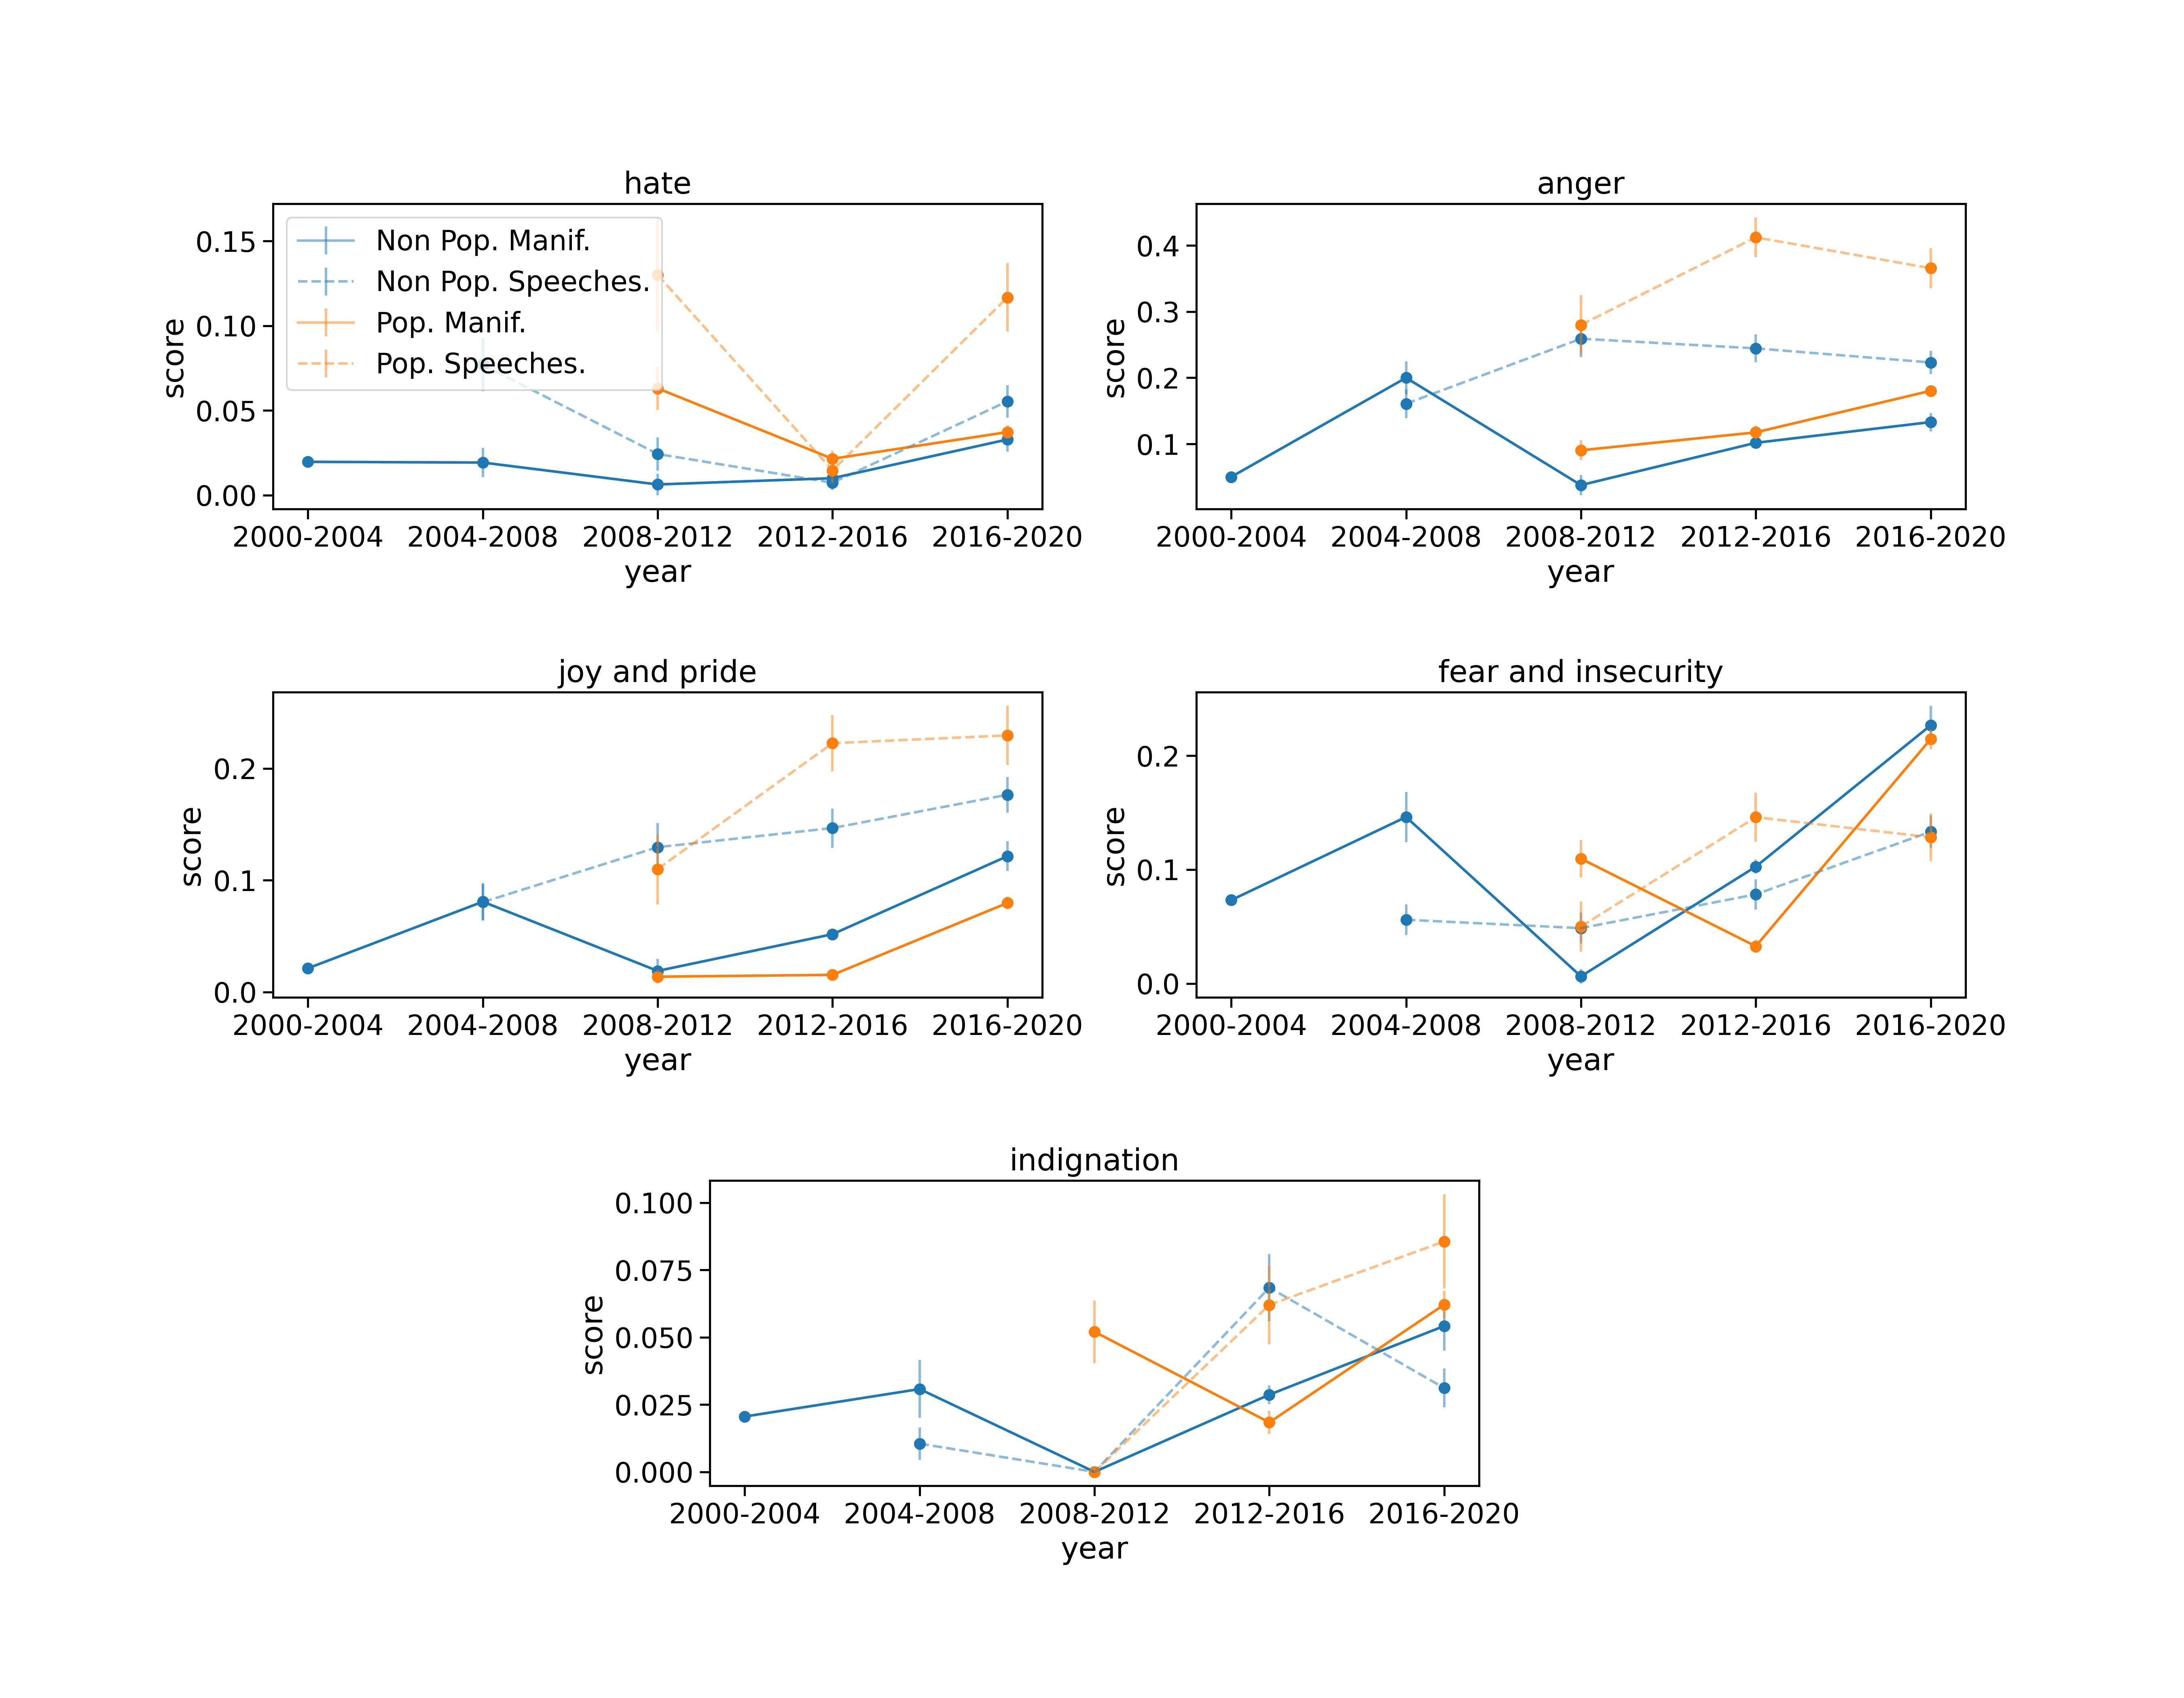

Note: In the figures, the label hate refers to ‘hate against outgroup’; indignation’ to ‘indignation against neoliberalism’.

Figure B. Different types of emotions, by specific Italian political parties (2000-2020).

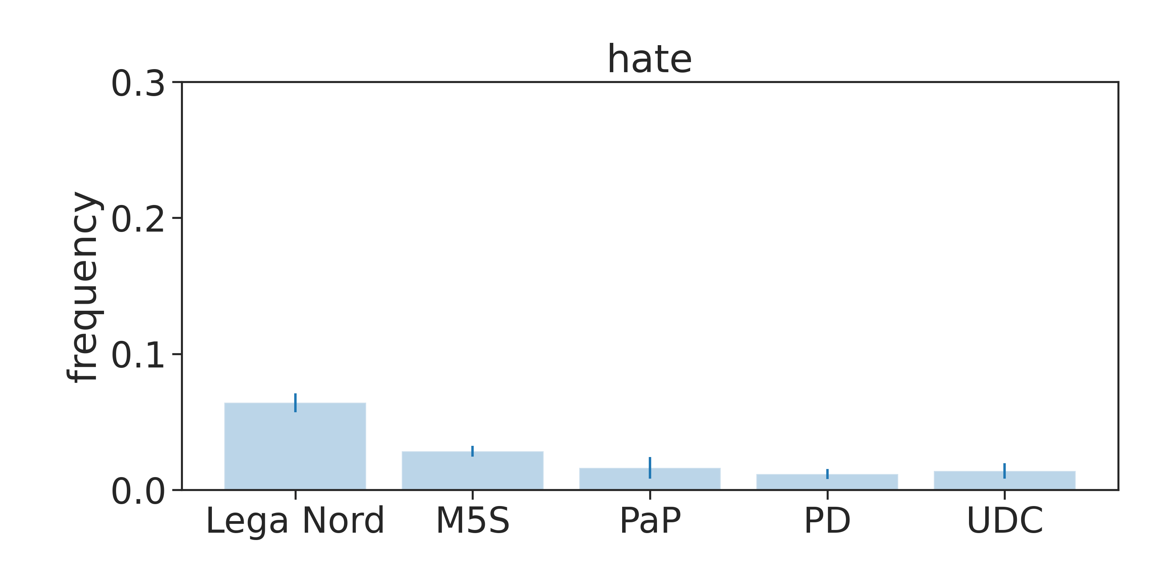 | 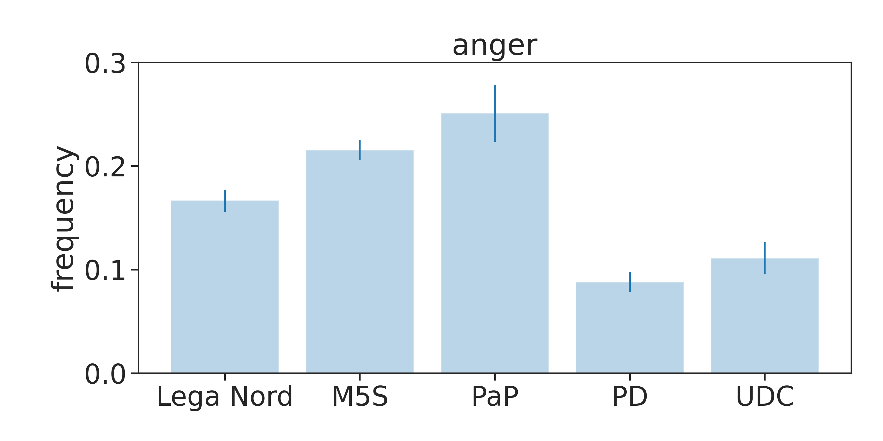

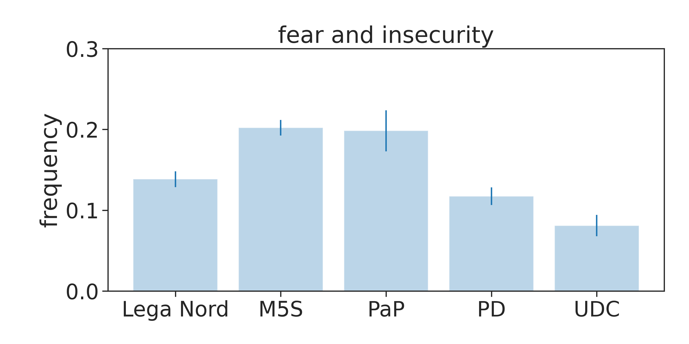 | 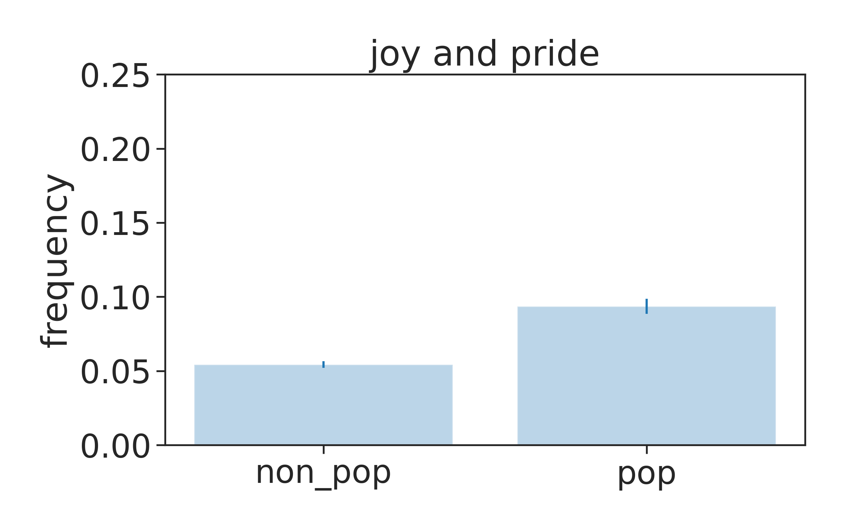
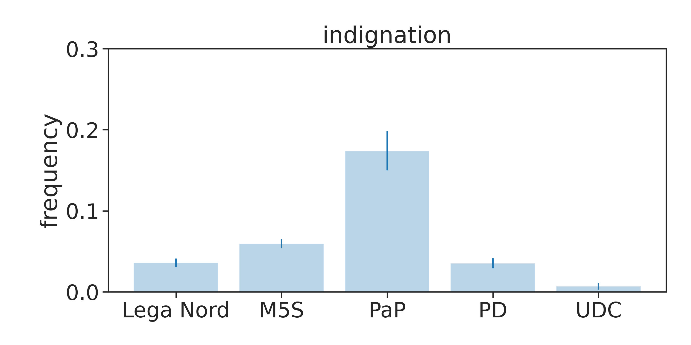

Note: In the figures, the label hate refers to ‘hate against outgroup’; indignation’ to ‘indignation against neoliberalism’. Abbreviations: 5SM=Five Star Movement; PaP=Potere al Popolo; PD= Democratic party; UDC= Unione di centro, center-right wing party. For a matter of comparison between populist and non populist parties we included here only the center left Democratic party (DP) and the centrist Union of Christians (UDC), as representatives of the most successful Italian mainstream parties allowing for continuity of the data across our timeframe of 20 years.

Table G. Afterwords for the Italian case
As for the Italian case and the context of grievances exploited (through) emotions by populists, we must note that being ‘populism in power’ (i.e. government) proved to be difficult for both the populist parties (i.e. The League and the 5SM) we investigated. The kind of ‘crises’ emphasized (and reproduced) by each party continued to be different also once in office, and different were the answers of the (respective) populist Italian constituencies to them. On the one hand, the League continued to strongly exploiting the migratory crisis, dominating the media agenda with this topic. This provoked several critiques from and within the governmental ally (for whose constituency the topic is not highly salient and partly unconfortable). On the other hand, the 5SM, as a party which is considered the ‘essence of the populist mentality’ (Tarchi 2016, 338), experienced increasing difficulties in maintaining its (electorally successful) image of political outsider, and discontent from part of its ‘people’ not in agreement with the compromises, in many populist promises with the League (e.g. on immigration for the inclusionary wing constituency of the 5SM, on the moderated socio-economic and inequality initiatives, etc.). Tensions exploded with the different results of the two populist parties at the European elections 2019, and brought about the governmental crisis. This end also suggests that emotional political communication is not enough alone to guarantee the long-term success for populist parties, they are strongly linked with their credibility as anti-elitists once in power (i.e. government, Zulianello 2019), as the further elections September 2022 testified.

References

Ansari MZ, Aziz MB, Siddiqui MO, Mehra H and Singh KP (2020) Analysis of political sentiment orientations on twitter. Procedia Computer Science 167, 1821–1828.
Bauman Z (2001) Identity in the globalising world. Social anthropology 9, 121-129.
Baumgarten B (2013) Geração à Rasca and beyond: Mobilizations in Portugal after 12 March 2011. Current Sociology 61, 457-473.
Benski T and Langman L (2013) The effects of affects: The place of emotions in the mobilizations of 2011. Current Sociology 61, 525-540.
Bindi J, Colombi D, Iannelli F, Politi N, Sugarelli M, Tavarone R and Ubaldi E (2018) Political Discussion and Leanings on Twitter: the 2016 Italian Constitutional Referendum. arXiv preprint arXiv:1805.07388.
Bracciale R, Andretta M and Martella A (2021) Does populism go viral? How Italian leaders engage citizens through social media. Information, Communication and Society 24, 1477-1494.
Bustikova L, Siroky DS, Alashri S and Alzahrani S (2020) Predicting Partisan Responsiveness: A Probabilistic Text Mining Time-Series Approach. Political Analysis 28, 47-64.
Capelos T and Katsanidou A (2018) Reactionary politics: Explaining the psychological roots of anti preferences in European integration and immigration debates. Political Psychology 39, 1271-1288.
Da Silva NF, Hruschka ER and Hruschka Jr ER (2014) Tweet sentiment analysis with classifier ensembles. Decision Support Systems 66, 170-179.
Davou B and Demertzis N (2013) Feeling the Greek financial crisis. Emotions in politics: The affect dimension in political tension, 93-123.
De Cleen B and Stavrakakis Y (2020) How should we analyze the connections between populism and nationalism: A response to Rogers Brubaker. Nations and nationalism 26, 314-322.
Della Porta D (2015) Social movements in times of austerity: Bringing capitalism back into protest analysis. John Wiley & Sons.
Di Cocco J and Monechi B (2021). How populist are parties? : measuring degrees of populism in party manifestos using supervised machine learning. Political Analysis, onlineFirst - https://hdl.handle.net/1814/72839
Ernst N, Blassnig S, Engesser S, Büchel F and Esser F (2019). Populists Prefer Social Media Over Talk Shows: An Analysis of Populist Messages and Stylistic Elements Across Six Countries’. Social Media + Society, DOI:10.1177/2056305118823358.
Flecker J, Hentges G and Balazs G (2016) Potentials of Political Subjectivity and the Various Approaches to the Extreme Right: Findings of the Qualitative Research1. In Changing working Life and the appeal of the extreme right . Routledge, pp. 35-61.
Hawkins KA, Carlin RE, Littvay L and Kaltwasser CR (eds) (2018) The ideational approach to populism: Concept, theory, and analysis. Routledge.
Inglehart RF and Norris P (2016) Trump, Brexit, and the rise of populism: Economic have-nots and cultural backlash.
Kenny PD (2017) Populism and Patronage: why populists win elections in India, Asia, and Beyond. Oxford University Press.
Kinnvall C (2013) Trauma and the Politics of Fear: Europe at the Crossroads. Emotions in politics: The affect dimension in political tension, 143-166.
Lilla M (2016) The end of identity liberalism. New York Times 18, 2016.
McAlexander RJ and Mentch L (2020) Predictive inference with random forests: A new perspective on classical analyses. Research and Politics 7.
Perugorría I and Tejerina B (2013) Politics of the encounter: Cognition, emotions, and networks in the Spanish 15M. Current Sociology 61, 424-442.
Rackow K, Schupp J and Scheve CV (2012) Angst und Ärger: Zur Relevanz emotionaler Dimensionen sozialer Ungleichheit/Anxiety and Anger. On the Emotional Dimensions of Social Inequality. Zeitschrift für Soziologie 41, 392-409.
Roodujin M, Van Kessel S, Froio C, Pirro A, De Lange S, Halikiopoulou D, Lewis P, Mudde C and Taggart P (2019) The PopuList. https://popu-list.org/
Van Kessel S (2015) Populist parties in Europe: Agents of discontent?. Springer.
Wodak R (2015) The politics of fear: What right-wing populist discourses mean. The Politics of Fear. London: Sage, 1-256.
Zulianello M (2019) Anti-system parties: From parliamentary breakthrough to government. Routledge.
Zulianello M (2020) Varieties of populist parties and party systems in Europe: From state-of-the-art to the application of a novel classification scheme to 66 parties in 33 countries. Government and Opposition 55, 327–347.

