Appendix 1: Variable Operationalisation

Variable | Question wording | Coding
Propensity to vote (PTV) | How probable is it that you will ever vote for the following parties? Please specify your views on a scale where 0 means “not at all probable” and 10 means “very probable | 0 to 10
EU Positional  Distance | Individual-level Positions (ICCP): How would you place your views on this scale, where 1 means you agree completely with the statement on the left (Leave the European Union), and 6 means you agree completely with the statement on the right (Stay in the European Union)? If your views fall somewhere in between, you can choose any number in between. What do you think should be done?  Party-level positions (CHES): What is the overall orientation of the party leadership towards European integration, where 1 means “strongly opposed” and 7 “strongly in favour”? | Distance = abs[Respondent position – (Party position – 1)] / 6  0 to 1
Immigration Positional Distance | Individual-level Positions (ICCP): How would you place your views on this scale, where 1 means you agree completely with the statement on the left (Limit the number of refugees), and 6 means you agree completely with the statement on the right (Accept more refugees)? If your views fall somewhere in between, you can choose any number in between. What do you think should be done?  Party-level positions (CHES): What is the overall orientation of the party leadership towards the immigration policy, where 0 means “Fully opposed to a restrictive policy on immigration” and 10 “Fully in favour of a restrictive policy on immigration”? | Distance = abs(Respondent position – Party position)] / 10  0 to 1
Economic Redistribution Positional  Distance | Individual-level Positions (ICCP): How would you place your views on this scale, where 1 means you agree completely with the statement on the left (Reduce the income difference), and 6 means you agree completely with the statement on the right (Do not reduce the income difference)? If your views fall somewhere in between, you can choose any number in between. What do you think should be done?  Party-level positions (CHES): What is the overall orientation of the party leadership towards economic issues? Parties on the economic left want government to play an active role in the economy, with 0 being ‘Extreme Left’. Parties on the economic right want a reduced role for government, with 10 being “Extreme Right’. | Distance = [10 – abs(Respondent position – Party position)] / 10  0 to 1
Left-Right Positional Distance | Individual-level Positions (ICCP): In political matters people often talk of "the left" and "the right". What is your position? Please indicate your position on a scale from 0 to 10, where 0 means "left" and 10 means "right".  Party-level positions (CHES): Party-level positions (CHES): What is the position of the party in terms of its overall ideological stance, where ‘0’ means “extreme left”, ‘5’ means “centre” and ‘10 means’ “extreme right”? | Distance = [10 – abs(Respondent position – Party position)] / 10  0 to 1
Party Closeness | Which party do you feel close to? | 0 = party not mentioned.  1= party mentioned.
Party Size | Party percentage of votes in legislative elections (Austria, Germany, Italy and the Netherlands) and presidential election (France; first electoral round) in the 2017-2018 period.
Gender | Are you? | Male = 0  Female = 1
Age | Year of birth
Education Years | What is the highest level of education you have completed in your education? | 1 = Less than primary, primary and lower secondary;  2 = Upper secondary and post-secondary non tertiary education;  3 = Tertiary education
Religiosity | Apart from special occasions such as weddings and funerals, how often do you attend religious services nowadays? | 1 = Several times a week;  2= once a week;  3= at least once a month;  4 = a few times a year;  5 = once a year or less;  6 = never
Townsize | Would you say you live in ... | 1 = a rural area or village;  2 = a small or middle‐sized town;  3 = the suburbs of large town or city;  4 = a large town or city
EU Party Ideology |  | 0 = Pro-EU  1 = Anti-EU
EU CHES Saliency | EU_SALIENCE = relative salience of European integration in the party’s public stance, varying from 0 = (European Integration is of no importance) to 10 (European Integration is of great importance) | 0 to 1
EU Twitter Saliency | Proportion of party/leader tweets dedicated to the EU issue, over the total of issue-related tweets | 0 to 1

Appendix 2: List of Parties

Table A1 reports the full list of all the parties included in the analysis. The selection criterion was based on the availability of the parties in both the ICCP and CHES surveys, allowing to match party positions and self-assessed citizens positions and, thus, developing the distance variables. The table includes party position information on the economic policies, immigration policies and general European integration policies, relying on Chapel Hill Expert Surveys (CHES). Furthermore, the table reports the party's broad ideology on European integration, operationalised as a dichotomous variable in the models (0 for the Pro and 1 for the Anti-EU type), the EU CHES salience and EU Twitter salience. By using the CHES seven-point party positional scale on the general EU policies, we have categorised as anti-EU those parties positioning themselves between 1 and 3.5, while the others as Pro-EU.
The ICCP survey for the 2017 French Presidential elections provides the PTVs for the presidential candidates, not for single parties. Thus, we included in our analysis those presidential candidates who could be related to a party surveyed by the 2017 CHES data: Le Pen (RN), Macron (REM), Hamon (PS), Fillon (LR), Mélenchon (FI) and Dupont-Aignan (DLF). On the contrary, we have dropped those candidates, which could not match with a CHES party: Arthaud, Asselineau, Lassalle, Poutou and Cheminade. The 2017 CHES wave has not included the Austrian parties and, to capture their positions and EU ideology, we have relied on the 2019 CHES data.

Table A1. Party Positions on Economic, Immigration, EU and EU Ideology. Source: CHES

Country | Party Name | Economic Position | Immigration  Position | EU Position | Left-Right Position | EU Ideology | EU CHES  Salience | EU  Twitter  Salience
Austria | Austrian Social Democratic Party (SPÖ) | 3.6 | 4.7 | 6.1 | 4 | Pro-EU | 0.56 | 0.01
 | Austrian People’s Party (ÖVP) | 6.9 | 8.6 | 5 | 6.9 | Pro-EU | 0.51 | 0.07
 | The Greens (GRÜNE) | 2.5 | 2.7 | 6.5 | 2.6 | Pro-EU | 0.68 | 0.05
 | Freedom Party of Austria (FPÖ) | 6.5 | 9.8 | 2.3 | 9.1 | Anti-EU | 0.63 | 0.03
 | The New Austria and Liberal Forum (NEOS) | 7.1 | 4.3 | 6.7 | 5.9 | Pro-EU | 0.72 | 0.14
France | Hamon/Socialist Party (PS) | 3.4 | 3.6 | 6.1 | 3.4 | Pro-EU | 0.64 | 0.10
 | Macron/The Republic on the March (REM) | 6.9 | 5.9 | 7 | 5.5 | Pro-EU | 0.88 | 0.08
 | Le Pen/National Front (FN) | 4.9 | 9.9 | 1.1 | 9.7 | Anti-EU | 0.81 | 0.12
 | Fillon/The Republicans (LR) | 8 | 8.6 | 4.7 | 7.3 | Pro-EU | 0.51 | 0.09
 | Dupont-Aignan/Republic Arise (DLF) | 6.8 | 9.6 | 1.2 | 8.6 | Anti-EU | 0.79 | 0.17
 | Mélenchon/France Umbowed (FI) | 0.6 | 2.4 | 2.3 | 1 | Anti-EU | 0.72 | 0.08
Germany | Christian Democratic Union of Germany-Christian Social Union of Bavaria (CDU-CSU) | 6.1 | 6.4 | 5.4 | 6.5 | Pro-EU | 0.58 | 0.04
 | Social Democratic Party of Germany (SPD) | 3.4 | 3.8 | 6.6 | 3.9 | Pro-EU | 0.71 | 0.04
 | Free Democratic Party (FDP) | 8.3 | 6.4 | 4.6 | 6.6 | Pro-EU | 0.56 | 0.01
 | Alliance 90/The Greens (GRÜNE) | 3.3 | 2.3 | 6.7 | 2.9 | Pro-EU | 0.63 | 0.04
 | The Left (LINKE) | 1.1 | 3.2 | 4.2 | 1.4 | Pro-EU | 0.47 | 0.02
 | Alternative for Germany (AfD) | 7.5 | 9.3 | 1.8 | 9.2 | Anti-EU | 0.71 | 0
Italy | Democratic Party (PD) | 3.8 | 3.7 | 6.5 | 3.8 | Pro-EU | 0.74 | 0.05
 | Go Italy (FI) | 8 | 7 | 4.7 | 6.5 | Pro-EU | 0.53 | 0.01
 | Five Star Movement (M5S) | 3.9 | 6.4 | 2.6 | 5.2 | Anti-EU | 0.65 | 0
 | League (Lega) | 6.8 | 9.9 | 1.5 | 8.3 | Anti-EU | 0.81 | 0
 | Brothers of Italy (FdI) | 4.9 | 9.7 | 1.9 | 8.4 | Anti-EU | 0.71 | 0
 | Free and Equals (LeU) | 1.4 | 1.3 | 5 | 1.8 | Pro-EU | 0.51 | 0.01
 | More Europe (+Europa) | 4.7 | 3.8 | 6.9 | 4.6 | Pro-EU | 0.68 | 0.39
Netherlands | People's Party for Freedom and Democracy (VVD) | 8.6 | 8.1 | 4.8 | 7.6 | Pro-EU | 0.47 | 0.20
 | Party for Freedom (PVV) | 5.7 | 9.4 | 1.1 | 8.7 | Anti-EU | 0.91 | 0.04
 | Christian Democratic Appeal (CDA) | 7 | 7.1 | 5.1 | 6.8 | Pro-EU | 0.44 | 0.07
 | Green Left (GL) | 2.2 | 1.5 | 6.3 | 2.3 | Pro-EU | 0.64 | 0.08
 | Labour Party (PvdA) | 3.8 | 4.5 | 5.5 | 3.6 | Pro-EU | 0.48 | 0
 | Socialist Party (SP) | 0.7 | 4.9 | 2.7 | 1.4 | Anti-EU | 0.58 | 0.12
 | Democrats 66 (D66) | 6.5 | 3.3 | 6.9 | 5.2 | Pro-EU | 0.79 | 0.22
 | Christian Union (CU) | 4.4 | 4.1 | 3.4 | 5.1 | Anti-EU | 0.43 | 0
 | Reformed Political Party (SGP) | 6.4 | 8 | 2.6 | 8.5 | Anti-EU | 0.38 | 0
 | Party for the Animals (PvvD) | 2.6 | 2.8 | 3.4 | 2.4 | Anti-EU | 0.49 | 0
 | 50PLUS (50+) | 4.3 | 5.7 | 3.6 | 5.1 | Pro-EU | 0.38 | 0
 | Political Movement Denk (DENK) | 3.3 | 2.1 | 4.7 | 4.4 | Pro-EU | 0.43 | 0
 | Forum for Democracy (FvD) | 8.9 | 9.8 | 1.3 | 9.5 | Anti-EU | 0.82 | 0.40

Appendix 3: Correlation Matrix among Distance Variables

Table A3 reports correlation coefficients among the distance variables under analysis – EU Positional Distance, Immigration Positional Distance, Economic Redistribution Positional Distance and Left-Right Positional Distance. All possible pairs of values in the table display very weak or weak coefficients, proving the substantial lack of statistical collinearity among our independent variables, which are proxies of different dimensions of political contestation.

Table A3: Correlation Matrix among Distance Variables
Variables | EU Positional  Distance | Immigration Positional  Distance | Economic Redistribution Positional  Distance | Left-Right  Positional Distance
EU Positional  Distance | 1.000
Immigration Positional  Distance | 0.137 | 1.000
Economic Redistribution Positional  Distance | 0.080 | -0.013 | 1.000
Left-Right  Positional Distance | 0.204 | 0.203 | 0.199 | 1.000

Appendix 4: Robustness Test with Multilevel mixed-effects linear regression Models.

In this section we present further empirical tests to validate the results presented in the main text of the article. In Table A4, we replicated the same models by performing a series of Multilevel mixed-effects linear regression models with random intercepts for countries. Results are consistent with the findings reported in the main text (see also: Figure A4.1, A4.2).

Table A4.1: Linear mixed-effects regression models with random intercepts at the country level (standard errors in parentheses).
 | Model A4.1 | Model A4.2 | Model A4.3 | Model A4.4
Party | 5.302***  (0.054) | 5.266***  (0.054) | 5.298***  (0.054) | 5.197***  (0.0535)
Gender | 0.653***  (0.074) | 0.643***  (0.074) | 0.648***  (0.074) | 0.649***  (0.0735)
Age | 0.777***  (0.044) | 0.778***  (0.043) | 0.775***  (0.043) | 0.777***  (0.0433)
Education | 0.441***  (0.033) | 0.436***  (0.033) | 0.437***  (0.033) | 0.417***  (0.0324)
Religiosity | 0.696***  (0.026) | 0.693***  (0.026) | 0.693***  (0.026) | 0.697***  (0.0259)
Town Size | 0.441***  (0.054) | 0.440***  (0.054) | 0.440***  (0.0537) | 0.436***  (0.0535)
EU Positional Distance | -1.429***  (0.045) | -1.709***  (0.072) | -1.487***  (0.0591) | -0.119  (0.225)
Immigration Positional Distance | -1.679***  (0.052) | -1.588***  (0.053) | -1.704***  (0.0517) | -1.685***  (0.0514)
Economic Redistribution  Positional Distance | -1.010***  (0.059) | -0.989***  (0.059) | -1.213***  (0.0608) | -1.095***  (0.0586)
Left-Right Positional Distance | -2.754***  (0.066) | -2.931***  (0.070) | -2.758***  (0.0662) | -2.895***  (0.0662)
Party Size | 0.038***  (0.002) | 0.039***  (0.002) | 0.0391***  (0.00154) | 0.0352***  (0.00153)
Pro-EU vs Anti-EU  (1=Anti-EU) |  | 0.0610  (0.056)
Twitter Salience |  |  | 1.396***  (0.206)
CHES Salience |  |  |  | 2.938***  (0.162)
Interaction Terms
Anti-EU*  EU distance |  | 0.372***  (0.113)
Twitter Salience*  EU distance |  |  | 0.496  (0.365)
CHES Salience**  EU Distance |  |  |  | -2.160***  (0.321)
Constant | 4.651***  (0.095) | 4.673***  (0.102) | 4.633***  (0.104) | 2.951***  (0.146)
Var. Comp. Country level
 | -1.679***  (0.342) | -1.609***  (0.339) | -1.576***  (0.337) | -1.575***  (0.339)
Var. Comp. Ind. level
 | 0.282***  (0.014) | 0.283***  (0.014) | 0.285***  (0.0142) | 0.286***  (0.0142)
lnsig_e
_cons | 0.927***  (0.004) | 0.926***  (0.004) | 0.925***  (0.00353) | 0.921***  (0.00353)
N | 45630 | 45630 | 45630 | 45630
R² | 0.508 | 0.509 | 0.511 | 0.515
* p < 0.05, ** p < 0.01, *** p < 0.00

Figure A4.1: Average Marginal effects of EU Distance by EU Party Ideology (95% Cis)
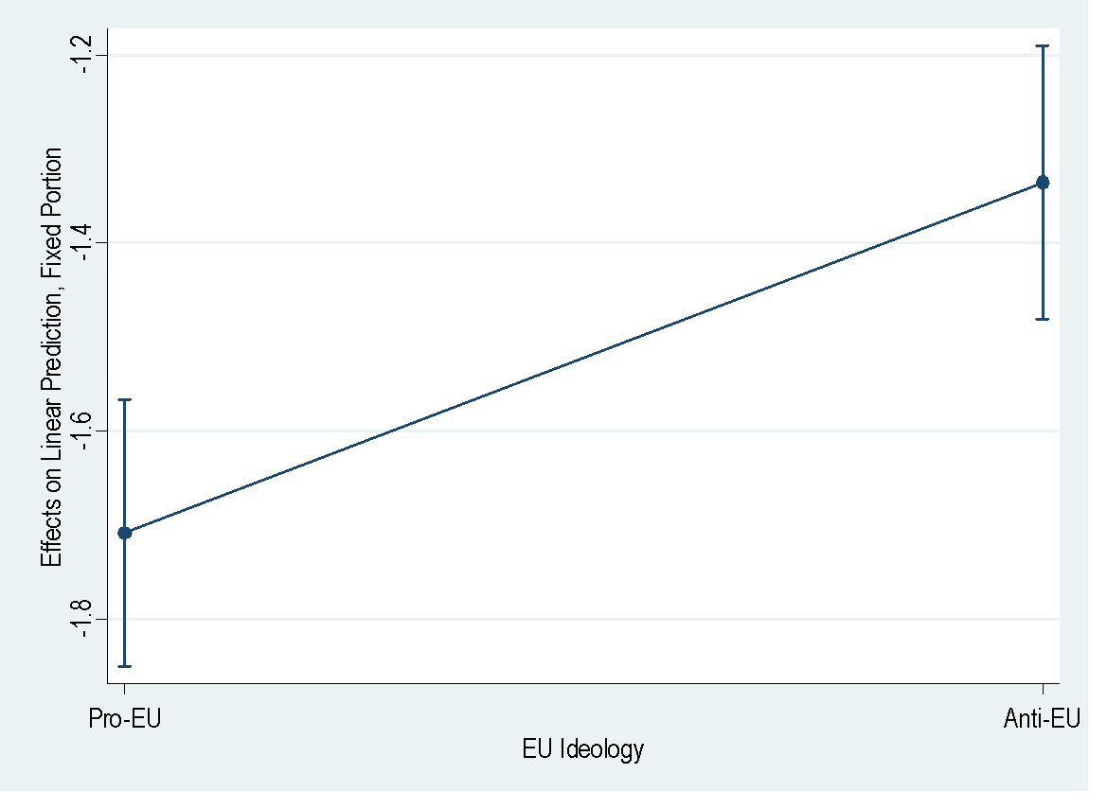

Figure A4.2: Average marginal effects of EU distance at different levels of EU CHES salience (95 per cent CIs)
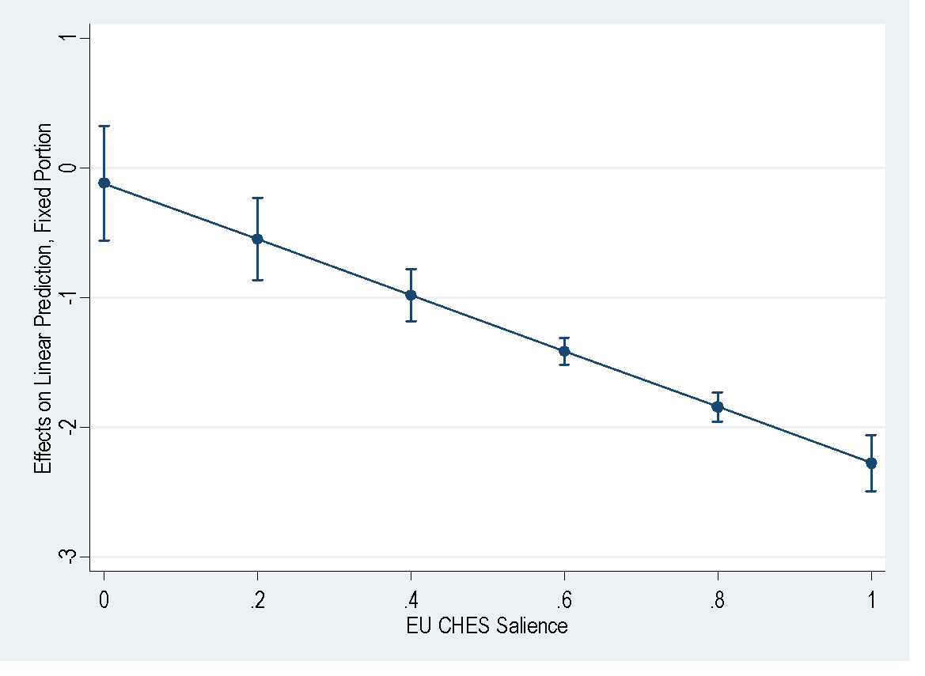

Appendix 5: Robustness Test by Omitting the Economic Redistribution Positional Distance.

In this section we present further empirical tests to validate the results presented in the main text of the article. In Table A5, we replicated the same models by performing a series of OLS linear regression models, omitting the economic redistribution distance variable. Results are consistent with the findings reported in the main text (see also: Figure A5.1, A5.2 and A5.3)

Table A5: Linear regression models by omitting the economic redistribution distance variable (standard errors in parentheses).

 | Model A6.1 | Model A6.2 | Model A6.3 | Model A6.4 | Model A6.5
Party Closeness | 5.232***  (0.050) | 5.232***  (0.050) | 5.208***  (0.051) | 5.235***  (0.050) | 5.137***  (0.051)
Gender | 0.726***  (0.093) | 0.710***  (0.093) | 0.716***  (0.093) | 0.725***  (0.094) | 0.722***  (0.094)
Age | 0.854***  (0.058) | 0.862***  (0.058) | 0.853***  (0.058) | 0.854***  (0.058) | 0.861***  (0.057)
Education | 0.485***  (0.043) | 0.494***  (0.043) | 0.475***  (0.043) | 0.483***  (0.043) | 0.461***  (0.043)
Religiosity | 0.730***  (0.040) | 0.734***  (0.040) | 0.726***  (0.040) | 0.729***  (0.040) | 0.733***  (0.039)
Town Size | 0.464***  (0.073) | 0.452***  (0.073) | 0.464***  (0.073) | 0.462***  (0.073) | 0.459***  (0.073)
EU Positional Distance | -1.422***  (0.056) | -1.281***  (0.135) | -1.747***  (0.090) | -1.448***  (0.071) | 0.199  (0.274)
Immigration Positional Distance | -1.588***  (0.065) | -1.635***  (0.065) | -1.511***  (0.065) | -1.592***  (0.065) | -1.590***  (0.0649)
Left-Right Positional Distance | -2.710***  (0.080) | -2.652***  (0.080) | -2.853***  (0.085) | -2.733***  (0.081) | -2.827***  (0.081)
Party Size | 0.0368***  (0.0017) | 0.0361***  (0.002) | 0.0375***  (0.002) | -0.037***  (0.002) | 0.0341***  (0.002)
Pro-EU vs Anti-EU  (1=Anti-EU) |  |  | -0.0144  (0.067)
Twitter Salience |  |  |  | 0.777***  (0.218)
CHES Salience
Interaction Terms |  |  |  |  | 2.942***  (0.189)
Italy*EU Distance |  | 0
Austria*EU Distance _ |  | -1.052***  (0.214)
Germany*EU Distance |  | -1.389***  (0.210)
France*EU Distance _ |  | 0.0993  (0.174)
Netherlands*EU Distance |  | 0.220  (0.156)
 |  |  | 0
EU ideology*EU Distance |  |  | 0.504***  (0.137)
Twitter Salience*EU distance |  |  |  | 0.206  (0.356)
CHES Salience*EU distance |  |  |  |  | -2.625***  (0.385)
Italy | 0 | 0 | 0 | 0 | 0
Austria | 0.381***  (0.075) | 0.778***  (0.118) | 0.413***  (0.075) | 0.380***  (0.075) | 0.444***  (0.075)
Germany | 0.553***  (0.076) | 1.053***  (0.119) | 0.584***  (0.076) | 0.583***  (0.076) | 0.636***  (0.076)
France | 0.329***  (0.080) | 0.277*  (0.115) | 0.332***  (0.080) | 0.291***  (0.080) | 0.233**  (0.080)
Netherlands | 0.156*  (0.069) | 0.0670  (0.103) | 0.166*  (0.069) | 0.138*  (0.069) | 0.351***  (0.069)
_cons | 3.975*** | 3.923***  (0.098) | 4.005***  (0.080) | 3.935***  (0.080) | 2.176***  (0.143)
N | 45872 | 45872 | 45872 | 45872 | 45872
R² | 0.308 | 0.310 | 0.309 | 0.309 | 0.314
* p < 0.05, ** p < 0.01, *** p < 0.001

7

Figure A5.1: Predictive effects of the EU distance on PTVs in Italy, Austria, Germany France, Netherlands (95% CIs)
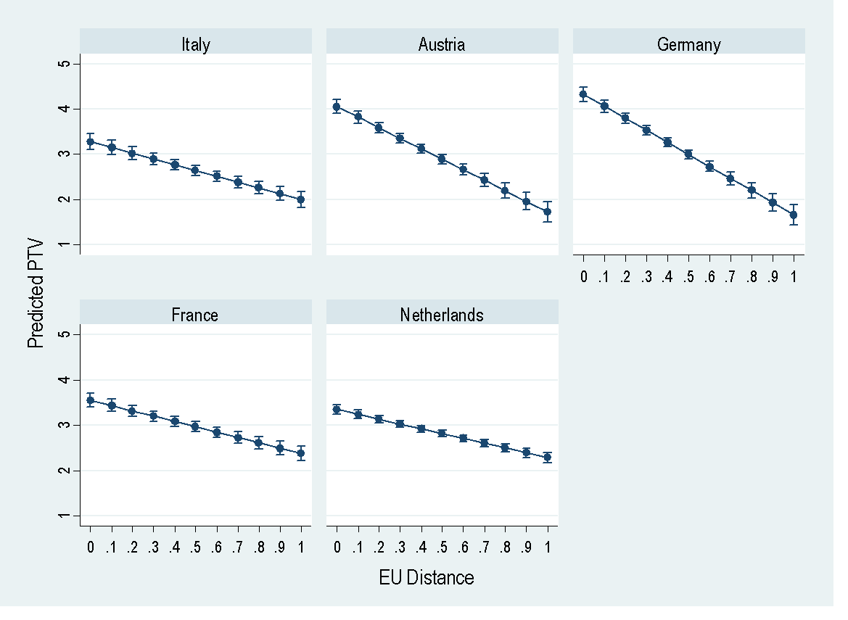

Figure A5.2: Average Marginal Effects of EU Distance by EU Party Ideology (95% CIs)
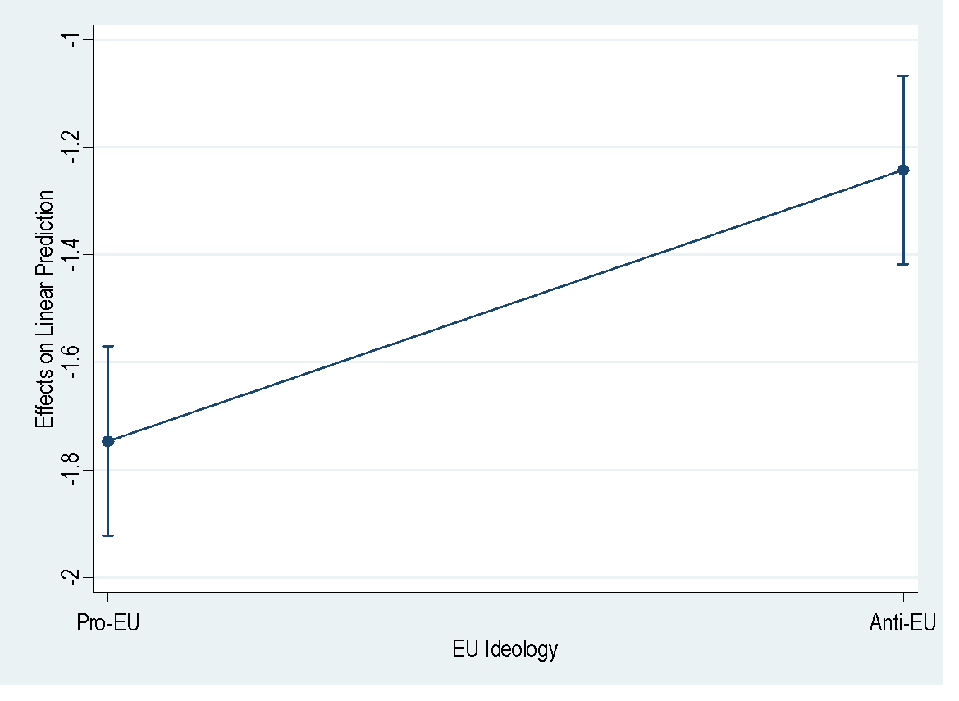
Figure A5.3: Average marginal effects of EU distance at different levels of EU CHES salience (95 per cent CIs)
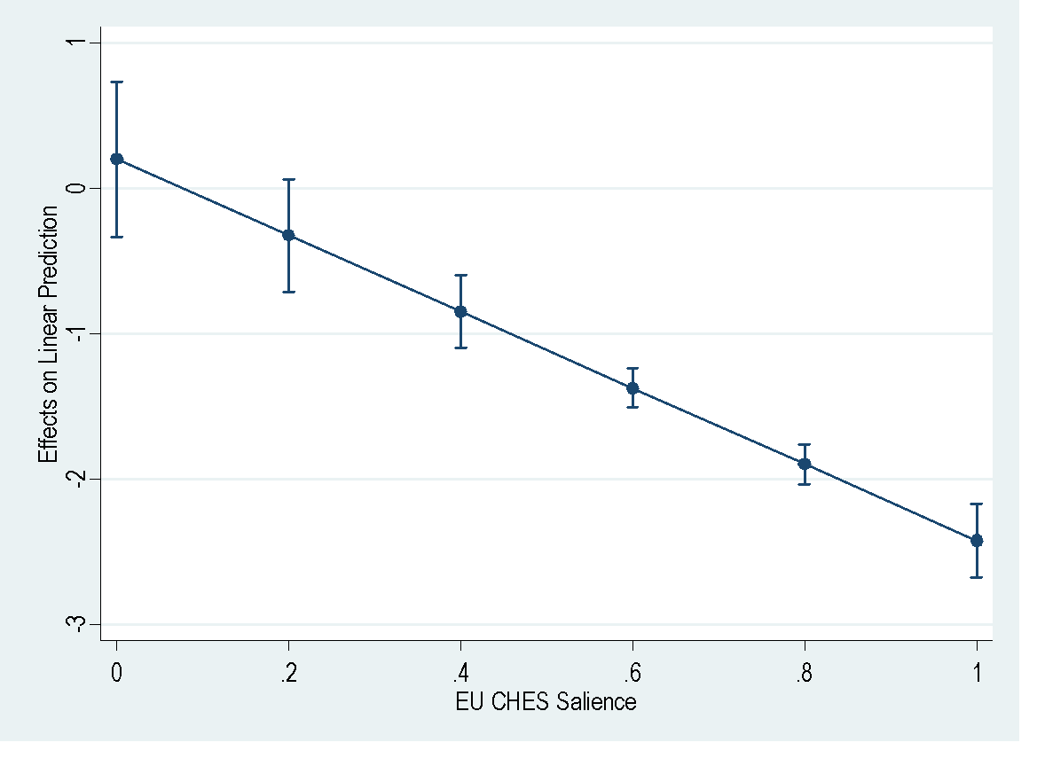

Appendix 6: Robustness Test by Omitting the Immigration Positional Distance.

In this section, we present further empirical tests to validate the results presented in the main text of the article. In Table A6, we replicated the same models by performing a series of OLS linear regression models, omitting the immigration distance variable. Results are consistent with the findings reported in the main text (see also: Figure A6.1, A6.2 and A6.3)

Table A6: Linear regression models by omitting the immigration distance variable (standard errors in parentheses).
 | Model A6.1 | Model A6.2 | Model A6.3 | Model A6.4 | Model A6.5
Party Closeness | 5.316***  (0.051) | 5.320***  (0.051) | 5.257***  (0.051) | 5.320***  (0.0509) | 5.216***  (0.051)
Gender | 0.695***  (0.092) | 0.683***  (0.092) | 0.686***  (0.092) | 0.692***  (0.0923) | 0.690***  (0.092)
Age | 0.837***  (0.058) | 0.843***  (0.058) | 0.835***  (0.058) | 0.834***  (0.0580) | 0.842***  (0.058)
Education | 0.547***  (0.045) | 0.553***  (0.045) | 0.529***  (0.044) | 0.545***  (0.0445) | 0.522***  (0.044)
Religiosity | 0.704***  (0.040) | 0.707***  (0.040) | 0.700***  (0.040) | 0.701***  (0.0399) | 0.707***  (0.039)
Town Size | 0.556***  (0.077) | 0.548***  (0.077) | 0.551***  (0.076) | 0.557***  (0.0767) | 0.552***  (0.077)
EU Positional Distance | -1.529***  (0.058) | -1.284***  (0.144) | -1.906***  (0.091) | -1.481***  (0.0729) | 0.164  (0.274)
Economic Redistribution Positional Distance | -0.817***  (0.072) | -0.798***  (0.072) | -0.787***  (0.072) | -0.956***  (0.0770) | -0.887***  (0.073)
Left-Right Positional Distance | -2.912***  (0.082) | -2.879***  (0.083) | -3.127***  (0.086) | -2.924***  (0.0824) | -3.020***  (0.082)
Party Size | 0.045***  (0.002) | 0.045***  (0.002) | 0.046***  (0.002) | 0.0458***  (0.00172) | 0.043***  (0.002)
Pro-EU vs Anti-EU  (1=Anti-EU)  Twitter Salience |  |  | 0.143*  (0.069) | 1.620***  (0.220)
CHES Salience |  |  |  |  | 3.077***  (0.189)
Interaction Terms

Italy*EU distance |  | 0
Austria*EU distance |  | -1.165***  (0.226)
Germany*EU distance |  | -1.127***  (0.220)
France* EU distance |  | 0.0231  (0.183)
Netherlands*EU distance |  | -0.0197  (0.165)
Anti-EU*  EU distance |  |  | 0.499***  (0.137)
Twitter Salience*EU distance |  |  |  | -0.526  (0.354)
CHES Salience*EU distance |  |  |  |  | -2.738***  (0.385)
Italy | 0 | 0 | 0 | 0 | 0
Austria | 0.315***  (0.076) | 0.756***  (0.122) | 0.375***  (0.076) | 0.317***  (0.0759) | 0.379***  (0.076)
Germany | 0.546***  (0.076) | 0.962***  (0.121) | 0.612***  (0.076) | 0.603***  (0.0768) | 0.633***  (0.076)
France | 0.375***  (0.080) | 0.357**  (0.117) | 0.369***  (0.080) | 0.321***  (0.0798) | 0.274***  (0.080)
Netherlands | 0.184**  (0.069) | 0.197  (0.104) | 0.187**  (0.069) | 0.158*  (0.0690) | 0.386***  (0.069)
Intercept | 3.674***  (0.075) | 3.556***  (0.098) | 3.700***  (0.079) | 3.606***  (0.078) | 1.810***  (0.385)
N | 45768 | 45768 | 45768 | 45768 | 45768
R² | 0.297 | 0.299 | 0.300 | 0.299 | 0.303
* p < 0.05, ** p < 0.01, *** p < 0.001

Figure A6.1: Predictive effects of the EU distance on PTVs in Italy, Austria, Germany France, Netherlands (95% CIs)
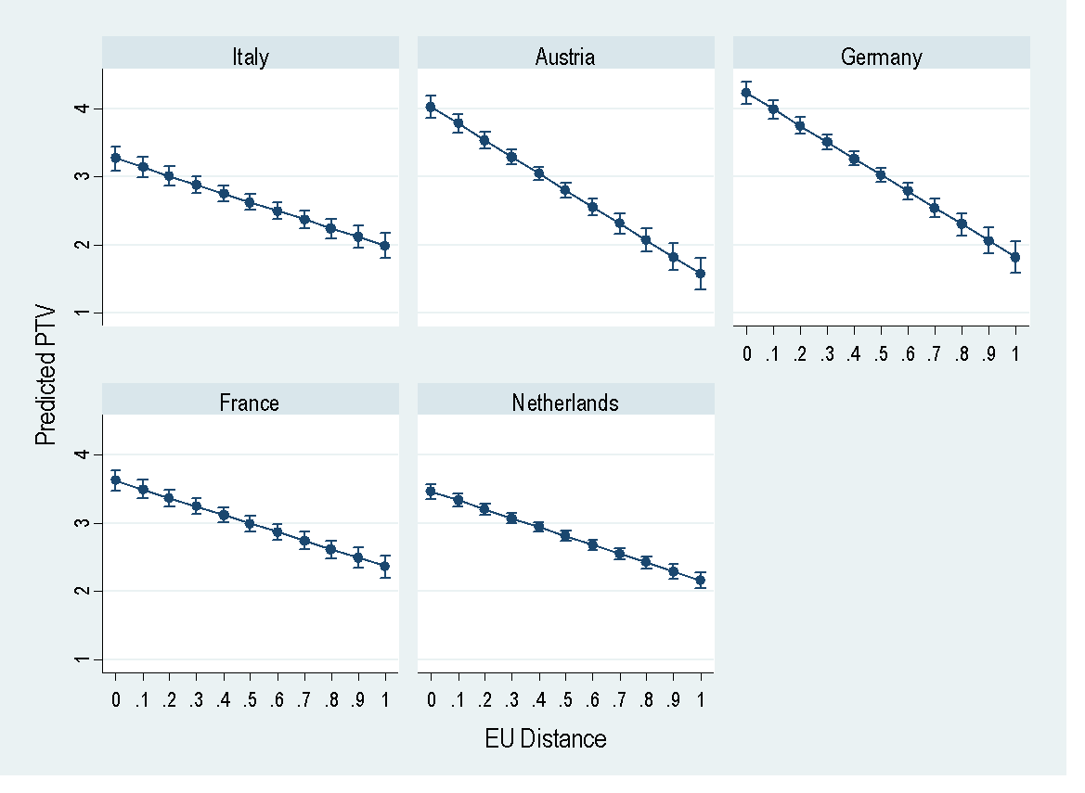

Figure A6.2: Average Marginal Effects of EU Distance by EU Party Ideology (95% CIs)
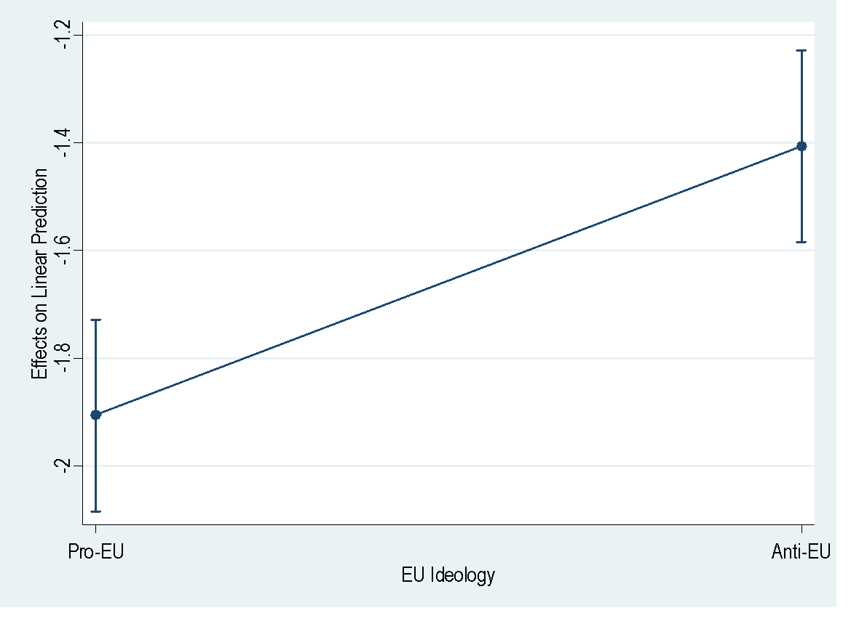

Figure A6.3: Average marginal effects of EU distance at different levels of EU CHES salience (95 per cent CIs)
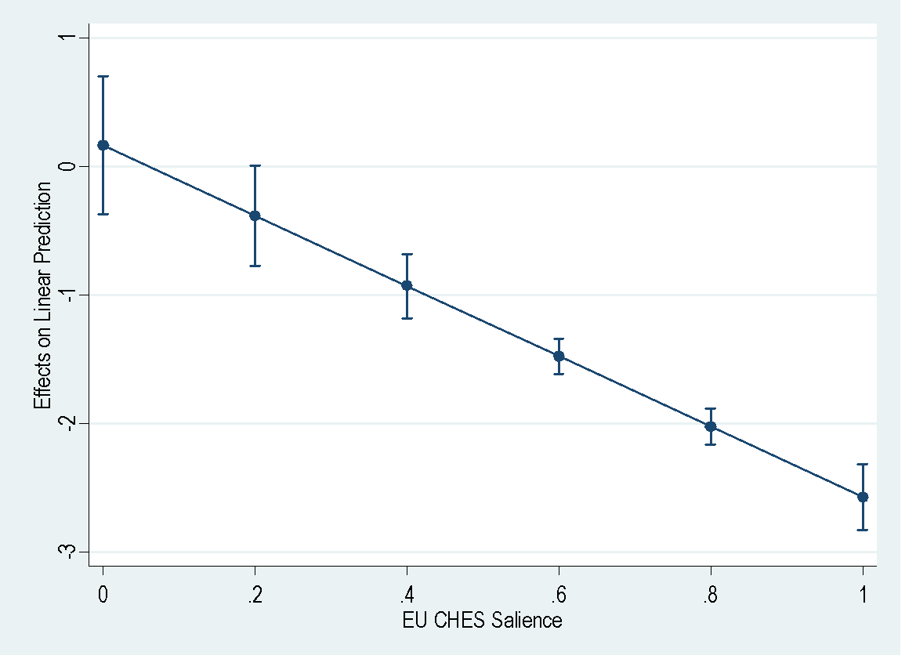

Appendix 7: Robustness by including a squared EU distance measure

In table A7, we performed a regression model including a squared EU distance measure, rather than the absolute one. As shown by Figure A7, plotting the average marginal effects of the EU distance on the PTVs (at different levels of the EU distance), the voter utility falls linearly as the distance increases. This confirms that the linear proximity function is substantially preferable than the quadratic function, as argued in the article.

Table A7: Linear regression models by (standard errors in parentheses).

 | Model A7.1
Party Closeness | 5.194***  (0.050)
Gender | 0.709***  (0.092)
Age | 0.830***  (0.058)
Education | 0.488***  (0.043)
Religiosity | 0.719***  (0.040)
Town Size | 0.479***  (0.073)
EU Positional Distance | -1.729***  (0.169)
EU Positional Distance* EU Positional Distance | 0.355*  (0.167)
Immigration Distance | -1.635***  (0.065)
Economic Redistribution Distance | -0.911***  (0.073)
Left-Right Distance | -2.526***  (0.082)
Party Size | 0.039***  (0.002)
Italy | 0
Austria | 0.365***  (0.076)
Germany | 0.552***  (0.076)
France | 0.310***  (0.080)
Netherlands | 0.139*  (0.069)
Intercept | 4.282***  (0.083)
N | 45630
R² | 0.311
Standard errors in parentheses
* p < 0.05, ** p < 0.01, *** p < 0.001

Figure A7: Average marginal effects of EU distance on PTVs at different values of EU distance (95 per cent CIs)
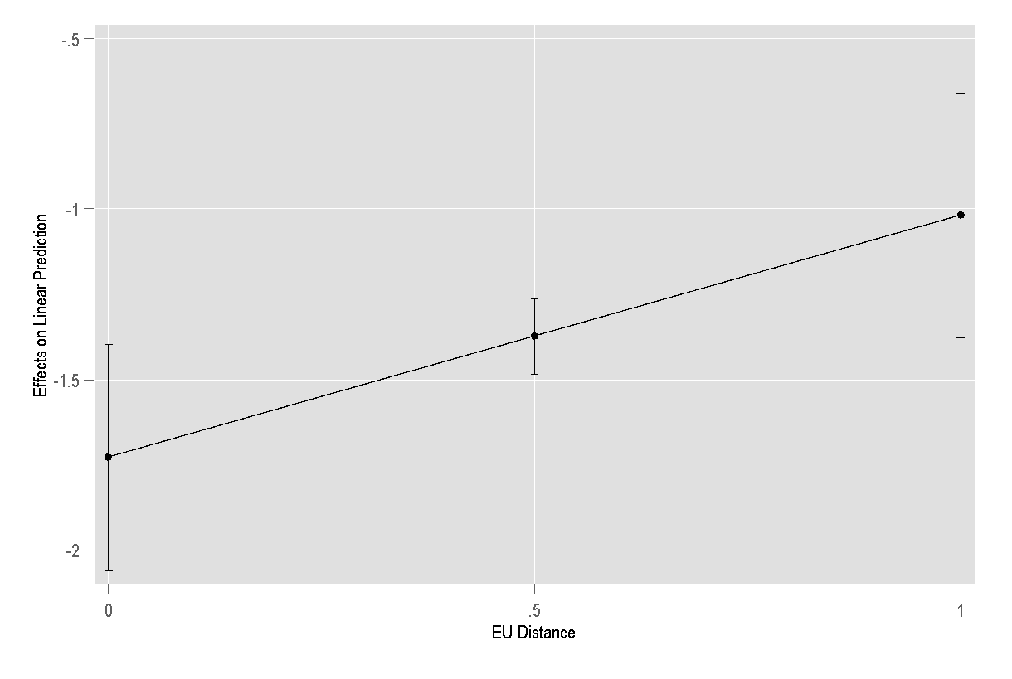

The positions of the Christian Democratic Union of Germany-Christian Social Union of Bavaria (CDU-CSU) are estimated by calculating the arithmetic mean positioning of the two parties in this electoral alliance, the Christian Democratic Union of Germany (CDU) and Christian Social Union of Bavaria (CSU).
The positions of Free and Equals are estimated by calculating the arithmetic mean position of the two parties in this electoral alliance, Article 1 – Democratic and Progressive Movement (MDP) and Italian Left (SI).
More Europe (+Europa) positions have been obtained by using the positions of the Democratic Centre (CD), which merged in the +EUROPA before the 2018 general elections.

