Online Appendix

The following contains information about the additional models and robustness checks that were referred to in the main text of the article.
Table 1 shows the results for models, which included a region dummy as well as an interaction term between region and the three components of closure. Keeping in mind the limited number of cases, none of the models show any evidence suggesting that closure has a different effect in Eastern Europe as opposed to the rest of Europe.
Table 2 shows analyses with 67 cases, considering the ruptures in 1994 in Italy, in 1977 in Belgium, in 1990 in Germany, in 1902 in France, in 2004 in Ukraine, in 1971 in Turkey, in 1917 in Spain, in 2001 in North Macedonia and in 1909 in Greece as separating distinct party systems. The results do not differ from the analyses reported for the 58 cases in the main text of the article.
Table 3 shows the results from models where alternation has been replaced with ministerial volatility (equivalent to total change in seat shares of ministers between parties in two consecutive governments). Ministerial volatility shows no negative association with liberalism in general and rule of law in particular. Furthermore, in such a model the positive effect of formula is much weaker, being just above the 0.05 level of statistical significance. Also, the model fit is much lower in comparison to the model that includes alternation instead of ministerial volatility. This suggests that the alternation variable captures the relevant characteristics of party interaction better than simple ministerial volatility.
Table 4 shows a test regarding which component of alternation – wholesale alternation or no alternation – accounts for the negative association with rule of law. For this purpose, the alternation variable in the model was replaced by two indicators, which show the proportion of years in the yearly data set where either no alternation (ministerial volatility less than or equal to 10%) or wholesale alternation (ministerial volatility more than or equal to 90%) took place. The models show that a higher incidence of no alternation is related to lower values of rule of law, while the frequency of wholesale alternation is not related to any aspect of democracy.
Table 5 shows the results of a model from which cases that could be considered influential are removed. This decreases the number of cases to 49. The overall results of the models remain unchanged.
Figures 1 and 2 show the stability of the results of the main model with respect to removing cases one at a time from the analysis. Figure 1 shows the stability in the case of the main data set (n=58), while Figure 2 shows the stability when the influential cases have been removed (n=49). It is evident that the results are more stable in the latter case.

Table 1. Relationship between the components of closure and measures of democracy, interactions with region. Standardized coefficients.
 | Dependent variable:
 | Liberal democracy | Electoral democracy | Liberal component | Rule of law | Judicial constraints | Legislative constraints
 | (1) | (2) | (3) | (4) | (5) | (6)
Region (ref = East) | 0.051 | 0.007 | -0.112 | -0.284* | 0.169 | -0.136
 | (0.139) | (0.139) | (0.146) | (0.125) | (0.178) | (0.169)
Alternation | -0.269 | -0.205 | -0.489** | -0.507** | -0.294 | -0.500*
 | (0.170) | (0.170) | (0.179) | (0.152) | (0.217) | (0.206)
Formula | 0.206 | 0.239 | 0.396 | 0.610** | 0.319 | 0.115
 | (0.198) | (0.198) | (0.209) | (0.178) | (0.254) | (0.240)
Access | -0.311 | -0.269 | -0.466* | -0.464** | -0.585* | -0.058
 | (0.187) | (0.187) | (0.197) | (0.168) | (0.239) | (0.227)
Fragmentation | 0.064 | 0.087 | -0.091 | -0.092 | 0.015 | -0.091
 | (0.144) | (0.144) | (0.152) | (0.129) | (0.185) | (0.175)
Polarization | -0.146 | -0.078 | -0.136 | -0.074 | -0.250 | -0.037
 | (0.133) | (0.133) | (0.140) | (0.119) | (0.170) | (0.161)
Volatility | -0.204 | -0.237 | -0.270 | -0.267* | -0.420* | -0.031
 | (0.130) | (0.130) | (0.137) | (0.116) | (0.166) | (0.158)
Type of regime | 0.085 | 0.061 | 0.097 | 0.028 | 0.190 | 0.077
 | (0.105) | (0.105) | (0.111) | (0.094) | (0.135) | (0.128)
Log10 GDP | 0.770*** | 0.736*** | 0.567** | 0.546*** | 0.423* | 0.497*
 | (0.161) | (0.161) | (0.170) | (0.144) | (0.206) | (0.195)
Age | 0.144 | 0.041 | 0.366* | 0.271 | 0.119 | 0.470*
 | (0.158) | (0.158) | (0.166) | (0.142) | (0.202) | (0.192)
Region x alternation | 0.062 | 0.073 | 0.002 | -0.028 | 0.058 | -0.124
 | (0.125) | (0.126) | (0.132) | (0.113) | (0.161) | (0.152)
Region x formula | -0.069 | -0.015 | -0.235 | -0.117 | -0.219 | -0.247
 | (0.206) | (0.206) | (0.217) | (0.184) | (0.263) | (0.250)
Region x access | 0.082 | 0.057 | 0.214 | 0.081 | 0.306 | 0.251
 | (0.181) | (0.182) | (0.191) | (0.163) | (0.232) | (0.220)
Constant | -0.021 | -0.030 | -0.003 | 0.013 | -0.049 | 0.018
 | (0.094) | (0.095) | (0.100) | (0.085) | (0.121) | (0.115)
Observations | 58 | 58 | 58 | 58 | 58 | 58
R² | 0.687 | 0.686 | 0.653 | 0.748 | 0.487 | 0.539
Adjusted R² | 0.595 | 0.593 | 0.550 | 0.674 | 0.335 | 0.403
Note: | *p<0.05; **p<0.01; ***p<0.001

Table 2. Relationship between the components of closure and measures of democracy, with split party systems (n=67). Standardized coefficients.
 | Dependent variable:
 | Liberal democracy | Electoral democracy | Liberal component | Rule of law | Judicial constraints | Legislative constraints
 | (1) | (2) | (3) | (4) | (5) | (6)
Alternation | -0.209 | -0.140 | -0.376* | -0.421** | -0.171 | -0.403*
 | (0.133) | (0.137) | (0.146) | (0.124) | (0.178) | (0.175)
Formula | 0.210 | 0.191 | 0.382** | 0.548*** | 0.287 | 0.195
 | (0.124) | (0.127) | (0.135) | (0.115) | (0.166) | (0.163)
Access | -0.263 | -0.175 | -0.466** | -0.439** | -0.573** | -0.130
 | (0.151) | (0.155) | (0.165) | (0.140) | (0.202) | (0.198)
Fragmentation | 0.049 | 0.108 | -0.057 | 0.011 | 0.006 | -0.122
 | (0.105) | (0.108) | (0.115) | (0.097) | (0.140) | (0.138)
Polarization | -0.102 | -0.060 | -0.137 | -0.135 | -0.182 | -0.027
 | (0.088) | (0.091) | (0.097) | (0.082) | (0.118) | (0.116)
Volatility | -0.236 | -0.218 | -0.345* | -0.295* | -0.566*** | -0.041
 | (0.121) | (0.125) | (0.133) | (0.113) | (0.162) | (0.159)
Type of regime | 0.108 | 0.063 | 0.103 | -0.026 | 0.253* | 0.073
 | (0.085) | (0.087) | (0.092) | (0.079) | (0.113) | (0.111)
Log10 GDP | 0.715*** | 0.709*** | 0.590*** | 0.647*** | 0.332* | 0.555***
 | (0.119) | (0.123) | (0.131) | (0.111) | (0.160) | (0.157)
Age | 0.158 | 0.069 | 0.227 | 0.061 | 0.190 | 0.302*
 | (0.106) | (0.109) | (0.115) | (0.098) | (0.141) | (0.139)
Constant | 0.000 | 0.000 | -0.000 | 0.000 | 0.000 | 0.000
 | (0.071) | (0.073) | (0.077) | (0.066) | (0.095) | (0.093)
Observations | 67 | 67 | 67 | 67 | 67 | 67
R² | 0.710 | 0.693 | 0.654 | 0.750 | 0.481 | 0.500
Adjusted R² | 0.664 | 0.645 | 0.599 | 0.710 | 0.399 | 0.421
Note: | *p<0.05; **p<0.01; ***p<0.001

Table 3. Relationship between the components of closure and measures of democracy, using ministerial volatility instead of alternation. Standardized coefficients.
 | Dependent variable:
 | Liberal democracy | Electoral democracy | Liberal component | Rule of law | Judicial constraints | Legislative constraints
 | (1) | (2) | (3) | (4) | (5) | (6)
Ministerial volatility | 0.211 | 0.135 | 0.225 | 0.028 | 0.253 | 0.386*
 | (0.134) | (0.135) | (0.150) | (0.140) | (0.174) | (0.167)
Formula | 0.281 | 0.263 | 0.376 | 0.407 | 0.412 | 0.273
 | (0.206) | (0.208) | (0.230) | (0.216) | (0.267) | (0.257)
Access | -0.367 | -0.287 | -0.542* | -0.453* | -0.636* | -0.274
 | (0.191) | (0.193) | (0.213) | (0.200) | (0.247) | (0.238)
Fragmentation | 0.185* | 0.211* | 0.184 | 0.278** | 0.108 | 0.153
 | (0.088) | (0.089) | (0.098) | (0.092) | (0.114) | (0.110)
Polarization | -0.079 | -0.056 | -0.080 | -0.080 | -0.153 | 0.069
 | (0.097) | (0.097) | (0.108) | (0.101) | (0.125) | (0.120)
Volatility | -0.323* | -0.315* | -0.445** | -0.380** | -0.560** | -0.251
 | (0.124) | (0.125) | (0.138) | (0.130) | (0.161) | (0.155)
Type of regime | 0.084 | 0.055 | 0.055 | -0.051 | 0.202 | 0.025
 | (0.098) | (0.099) | (0.109) | (0.103) | (0.127) | (0.122)
Log10 GDP | 0.728*** | 0.720*** | 0.552*** | 0.537*** | 0.370* | 0.564**
 | (0.130) | (0.131) | (0.144) | (0.135) | (0.168) | (0.161)
Age | 0.135 | 0.026 | 0.220 | 0.035 | 0.184 | 0.284
 | (0.124) | (0.125) | (0.138) | (0.129) | (0.160) | (0.154)
Constant | 0.000 | 0.000 | 0.000 | 0.000 | 0.000 | 0.000
 | (0.081) | (0.081) | (0.090) | (0.084) | (0.104) | (0.100)
Observations | 58 | 58 | 58 | 58 | 58 | 58
R² | 0.682 | 0.677 | 0.606 | 0.653 | 0.468 | 0.508
Adjusted R² | 0.623 | 0.616 | 0.532 | 0.588 | 0.369 | 0.415
Note: | *p<0.05; **p<0.01; ***p<0.001

Table 4. Relationship between the components of closure and measures of democracy, with proportions of no and wholesale alternation. Standardized coefficients. The variables “no alternation %” and “wholesale alternation %” indicate the proportion of yearly values across the duration of the system that correspond to no alternation (ministerial volatility <= 10%) and to wholesale alternation (ministerial volatility >= 90%).
 | Dependent variable:
 | Liberal democracy | Electoral democracy | Liberal component | Rule of law | Judicial constraints | Liberal democracy
 | (1) | (2) | (3) | (4) | (5) | (6)
No alternation % | -0.311* | -0.217 | -0.462** | -0.408* | -0.350 | -0.584**
 | (0.154) | (0.157) | (0.167) | (0.153) | (0.200) | (0.187)
Wholesale alternation % | 0.054 | 0.036 | -0.017 | -0.186 | 0.100 | 0.040
 | (0.117) | (0.120) | (0.127) | (0.117) | (0.152) | (0.142)
Formula | 0.266 | 0.263 | 0.378 | 0.467* | 0.404 | 0.219
 | (0.184) | (0.188) | (0.199) | (0.183) | (0.239) | (0.223)
Access | -0.390* | -0.310 | -0.600** | -0.555** | -0.665** | -0.305
 | (0.183) | (0.186) | (0.197) | (0.181) | (0.237) | (0.221)
Fragmentation | 0.102 | 0.151 | 0.015 | 0.047 | 0.031 | -0.026
 | (0.121) | (0.123) | (0.131) | (0.120) | (0.157) | (0.146)
Polarization | -0.129 | -0.091 | -0.176 | -0.200 | -0.199 | -0.043
 | (0.105) | (0.107) | (0.114) | (0.105) | (0.137) | (0.128)
Volatility | -0.289* | -0.294* | -0.383** | -0.310* | -0.531** | -0.166
 | (0.124) | (0.127) | (0.134) | (0.123) | (0.161) | (0.150)
Type of regime | 0.094 | 0.062 | 0.071 | -0.031 | 0.213 | 0.042
 | (0.097) | (0.099) | (0.105) | (0.096) | (0.126) | (0.117)
Log10 GDP | 0.801*** | 0.775*** | 0.677*** | 0.678*** | 0.454* | 0.697***
 | (0.136) | (0.139) | (0.147) | (0.135) | (0.177) | (0.165)
Age | 0.188 | 0.063 | 0.316* | 0.148 | 0.236 | 0.399*
 | (0.128) | (0.131) | (0.139) | (0.128) | (0.167) | (0.156)
Constant | 0.000 | 0.000 | 0.000 | 0.000 | 0.000 | 0.000
 | (0.079) | (0.081) | (0.086) | (0.079) | (0.103) | (0.096)
Observations | 58 | 58 | 58 | 58 | 58 | 58
R² | 0.699 | 0.686 | 0.648 | 0.703 | 0.492 | 0.557
Adjusted R² | 0.635 | 0.619 | 0.573 | 0.639 | 0.384 | 0.463
Note: | *p<0.05; **p<0.01; ***p<0.001

Table 5. Relationship between the components of closure and measures of democracy, influential cases excluded (n=49). Standardized coefficients. The analysis additionally excludes Czechoslovakia, France I, Montenegro, Russia, Ukraine, Kosovo, Turkey III, Greece I, Malta.
 | Dependent variable:
 | Liberal democracy | Electoral democracy | Liberal component | Rule of law | Judicial constraints | Legislative constraints
 | (1) | (2) | (3) | (4) | (5) | (6)
Alternation | -0.263 | -0.248 | -0.359* | -0.563*** | -0.143 | -0.115
 | (0.149) | (0.154) | (0.152) | (0.158) | (0.219) | (0.182)
Formula | 0.159 | 0.196 | 0.180 | 0.505*** | -0.033 | -0.044
 | (0.133) | (0.137) | (0.136) | (0.142) | (0.197) | (0.163)
Access | -0.414* | -0.394* | -0.449* | -0.507* | -0.524 | -0.057
 | (0.178) | (0.184) | (0.182) | (0.190) | (0.263) | (0.218)
Fragmentation | 0.093 | 0.101 | 0.133 | -0.035 | 0.253 | 0.316*
 | (0.122) | (0.126) | (0.124) | (0.130) | (0.180) | (0.149)
Polarization | -0.185* | -0.154 | -0.187* | -0.232** | -0.169 | -0.010
 | (0.079) | (0.081) | (0.080) | (0.084) | (0.116) | (0.096)
Volatility | -0.405** | -0.431** | -0.441** | -0.281 | -0.626** | -0.302
 | (0.139) | (0.143) | (0.141) | (0.148) | (0.205) | (0.170)
Type of regime | 0.110 | 0.069 | 0.089 | 0.032 | 0.167 | 0.070
 | (0.083) | (0.086) | (0.085) | (0.089) | (0.123) | (0.102)
Log10 GDP | 0.959*** | 0.955*** | 0.870*** | 0.894*** | 0.595** | 0.769***
 | (0.114) | (0.118) | (0.117) | (0.122) | (0.169) | (0.140)
Age | -0.002 | -0.116 | 0.104 | -0.029 | 0.213 | 0.038
 | (0.120) | (0.123) | (0.122) | (0.127) | (0.176) | (0.146)
Constant | -0.000 | -0.000 | -0.000 | -0.000 | -0.000 | -0.000
 | (0.068) | (0.070) | (0.069) | (0.072) | (0.100) | (0.083)
Observations | 49 | 49 | 49 | 49 | 49 | 49
R² | 0.816 | 0.804 | 0.809 | 0.792 | 0.600 | 0.726
Adjusted R² | 0.774 | 0.759 | 0.765 | 0.744 | 0.507 | 0.662
Note: | *p<0.05; **p<0.01; ***p<0.001

Figure 1. Sensitivity to the exclusion of single cases.
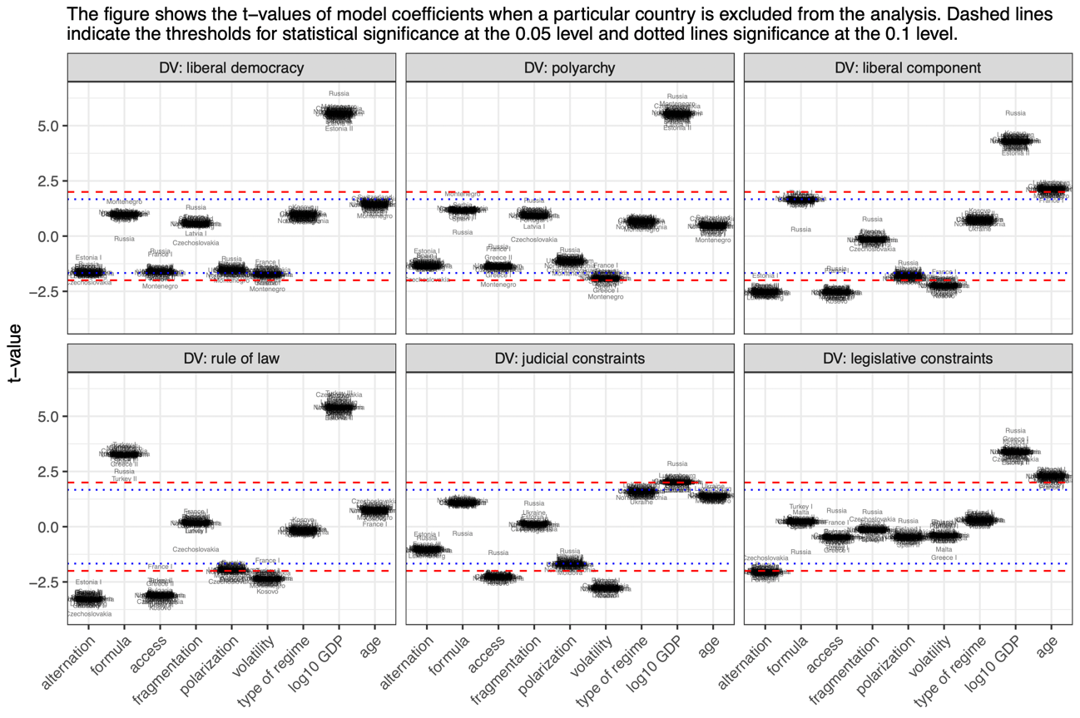

Figure 2. Sensitivity to the exclusion of single cases, influential cases excluded (n=49). The analysis additionally excludes Czechoslovakia, France I, Montenegro, Russia, Ukraine, Kosovo, Turkey III, Greece I, Malta.
