Appendix

Table A1 – Original question wordings in Italian for issues
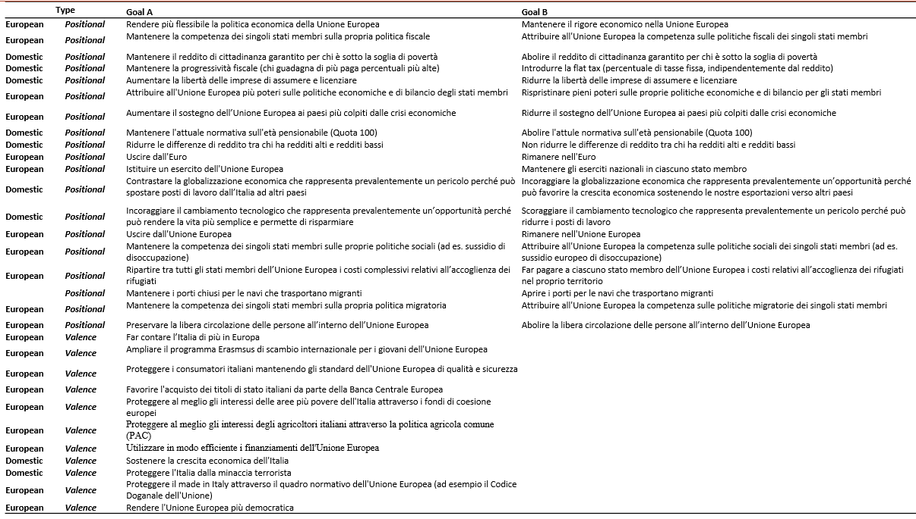

Table A2 – Logistic regression analyses. DVs: defections at general and European elections
 | Gen. Elections |  |  | EP Elections
 | Logit | SE |  | Logit | SE
Issues
Flexibility of EU economic policy | 0.153 | (0.404) |  | -0.978* | (0.385)
Fiscal policy EU | -0.267 | (0.397) |  | -0.0593 | (0.396)
Basic income | 0.188 | (0.376) |  | 0.347 | (0.351)
Flat tax | -1.100** | (0.398) |  | -0.504 | (0.387)
Job market regulation | -0.633 | (0.386) |  | -0.390 | (0.375)
Budgetary policy EU | -0.555 | (0.436) |  | -0.662 | (0.411)
EU support to countries hit by the crisis | -0.660 | (0.414) |  | -0.479 | (0.393)
Reform of the pension system | -0.424 | (0.401) |  | -0.758* | (0.363)
Income differences | 0.460 | (0.389) |  | 0.0837 | (0.373)
Euro | -0.309 | (0.411) |  | -0.259 | (0.387)
Common EU army | 0.221 | (0.454) |  | -0.233 | (0.423)
Globalization | -0.548 | (0.439) |  | -0.222 | (0.406)
Technological Change | -0.0814 | (0.454) |  | 0.540 | (0.422)
EU membership | -0.146 | (0.438) |  | -0.0277 | (0.403)
EU welfare system | 0.195 | (0.430) |  | 0.364 | (0.410)
Costs of refugee crisis | 0.564 | (0.435) |  | -0.115 | (0.406)
Immigration ("Porti chiusi") | 0.589 | (0.434) |  | 0.396 | (0.427)
EU immigration policy | -0.469 | (0.435) |  | -0.436 | (0.412)
Free movement in the EU | 0.0595 | (0.446) |  | 0.0149 | (0.416)
Make Italy count more in Europe | -0.664 | (0.406) |  | -0.0120 | (0.377)
Enlarge the Erasmus program | -0.361 | (0.413) |  | -0.889* | (0.381)
Introduce EU quality standards to protect consumers | 0.498 | (0.457) |  | -0.293 | (0.423)
Purchase of government bonds by the ECB | 0.434 | (0.433) |  | 0.283 | (0.413)
Protect the poorest areas through EU funds | -0.955* | (0.429) |  | -0.912* | (0.404)
PAC | 0.267 | (0.420) |  | 0.500 | (0.399)
Efficiently use EU funds | 0.150 | (0.410) |  | 0.198 | (0.396)
Support the economic growth of Italy | -0.339 | (0.402) |  | -0.354 | (0.376)
Protect Italy from terrorist attacks | -0.318 | (0.419) |  | 0.365 | (0.411)
Protect Italian products through EU norms | -0.189 | (0.443) |  | -0.143 | (0.401)
Make the EU more democratic | -0.409 | (0.388) |  | -0.0603 | (0.367)
Party
Fdi | Baseline |  |  | Baseline
FI | -7.478* | (3.666) |  | -1.500 | (3.388)
League | -5.793⁺ | (3.324) |  | -3.580 | (2.871)
M5S | -5.582 | (3.502) |  | -2.921 | (3.065)
PD | -5.073 | (3.563) |  | -4.934 | (3.264)
+EU | -4.310 | (3.785) |  | -3.236 | (3.546)
Left | -9.772* | (4.542) |  | -3.632 | (5.210)
Socio-demographics
Gender (Female) | -0.00104 | (1.085) |  | -1.028 | (0.994)
Age | -0.0431 | (0.0328) |  | -0.0117 | (0.0279)
Education | -1.051⁺ | (0.563) |  | -0.922⁺ | (0.508)
Party*Gender
Fdi * Gender | - | - |  | - | -
FI * Gender | 1.312 | (1.382) |  | 1.312 | (1.336)
League * Gender | 0.813 | (1.204) |  | 2.127⁺ | (1.105)
M5S * Gender | 1.850 | (1.336) |  | 1.226 | (1.157)
PD * Gender | 0.0925 | (1.290) |  | 2.021 | (1.290)
+EU* Gender | 1.066 | (1.704) |  | 0.959 | (1.483)
Left * Gender | 1.523 | (1.637) |  | 1.317 | (1.721)
Party*Age
Fdi * Age | - | - |  | - | -
FI * Age | 0.0551 | (0.0423) |  | -0.0494 | (0.0409)
League * Age | 0.0391 | (0.0364) |  | -0.00573 | (0.0310)
M5S * Age | 0.00633 | (0.0399) |  | -0.0136 | (0.0344)
PD* Age | 0.0242 | (0.0379) |  | 0.0120 | (0.0357)
+EU* Age | 0.0256 | (0.0452) |  | -0.0180 | (0.0401)
Left * Age | 0.0691 | (0.0530) |  | 0.0534 | (0.0524)
Party *Education
Fdi * Education | - | - |  | - | -
FI * Education | 1.397* | (0.673) |  | 0.961 | (0.652)
League * Education | 0.834 | (0.609) |  | 0.685 | (0.546)
M5S * Education | 0.801 | (0.649) |  | 0.511 | (0.589)
PD * Education | 1.049 | (0.638) |  | 0.657 | (0.598)
+EU* Education | 0.334 | (0.806) |  | 0.788 | (0.758)
Left * Education | 1.616* | (0.766) |  | 0.500 | (0.834)
Constant | 6.847* | (3.204) |  | 5.718* | (2.772)
Observations | 723 |  |  | 723
Pseudo R² | 0.338 |  |  | 0.350
Adjusted Count | 0.209 |  |  | 0.257
⁺ p < .10, * p < .05, ** p < .01, *** p < .001. Notes: Fdi=Brothers of Italy; FI=Go Italy; Legaue=The League; M5S=Five Star Movement; PD=Democratic Party; +EU=More Europe; Left=The left.

