APPENDIX 1

CONFIRMATORY FACTOR ANALYSIS (OBLIMIN) ON SELECTED ITEMS OF POLITICAL PARTICIPATION
 | Factor 1 | Factor 2 | Facto 3 | Factor 4 | Uniqueness
Voting national election | 0.8083 | 0.0194 | -0.0060 | 0.0314 | 0.3463
Voting local election | 0.8097 | -0.0199 | 0.0053 | -0.0233 | 0.3434
Work in a party | 0.0299 | -0.0314 | -0.0405 | 0.4861 | 0.7763
Work in action group | -0.0147 | 0.0773 | 0.0364 | 0.4865 | 0.7280
Sign a petition | 0.0449 | 0.3232 | 0.1704 | 0.0008 | 0.8155
Demonstration | 0.0272 | 0.0234 | 0.6512 | -0.0432 | 0.5661
Boycotting | 0.0111 | 0.5053 | -0.0364 | -0.0720 | 0.7683
Buycotting | -0.0157 | 0.6391 | -0.0100 | -0.0092 | 0.6012
Donate money | 0.0033 | 0.3810 | 0.0062 | 0.0998 | 0.8237
Strike | -0.0322 | -0.0136 | 0.6629 | 0.0332 | 0.5634
Party membership | -0.0420 | 0.2149 | 0.0135 | 0.1231 | 0.9223
Cronbach’s alpha | 0.8430 | 0.4640 | 0.7209 | 0.6867

Note: Extraction method: Principal component analysis
Rotation method: Promax with Kaiser’s normalization
Items were selected from the following question ‘In the following, we name some political activities. For each of them could you please tell me if you have done it during the last 12 months?’. Listed items were: Worked in a political party; Worked in a political action group; Signed a petition; Taken part in a public demonstration; Boycotted certain products; Deliberately bought certain products for political reasons; Donated money to a political organization or group; Taken part in a strike. Together with these 10 items, we added a further one concerning membership in political parties.

APPENDIX 2

INDEPENDENT VARIABLES OPERATIONALISATION

Age is a continuous variable ranging from 18 to 34 years old, and nationality is a dichotomous variable coded as one when the respondent holds Italian citizenship. Education is a categorical variable coded as zero for those having achieved below secondary education, one for those with a secondary education, and two for those with a tertiary education. As for social capital, we took into consideration both existing conceptualisations - by measuring the number of friends (none, less than two friends or more than two) - and civic engagement - union membership and civil society membership, coded as one for members (past and present) and zero for youth who have never been members. Financial resources are taken into account with a proxy. Financial difficulties are measured with a dichotomous variable based on a question asking how difficult it is to cope with one’s current income. Financial difficulty is coded as one when the respondent finds it difficult to cope with current income and zero otherwise. Regarding time availability, we took into account the amount of time spent at home looking after relatives. Finally a set of eight items captures the political dimension. Political interest is measured by asking whether the respondent is interested in politics (four-point scale, dichotomized). Internal political efficacy is measured through a question asking whether persons like themselves have an influence on politics (agreement with the sentence using a four-point scale, dichotomized). Political cynicism is based on a question asking whether political parties are only interested in the respondent’s vote (agreement with the sentence using a four-point scale, dichotomized). Political understanding is measured through a question asking ‘There are times in which politics is so complicated that people like me don’t understand what’s going (agreement with the sentence using a four-point scale, dichotomized). Political trust measures if the respondent has any trust in the political system, considering six institutions: three government tiers (national, regional or local level) and both the legislative assembly and the government. Therefore an eleven-point scale was dichotomized, scoring one for those holding a trust level higher than six and zero otherwise, for each institution. The final score is a dummy variable valuing one if the respondent trusted at least one institution out of six, zero otherwise. The political dimension is completed by a measure of participants’ satisfaction with Italian democracy (ten-point scale, dichotomized).

APPENDIX 3
SUMMARY STATISTICS FOR CONTROL AND EXPLANATORY VARIABLES
 | Regular workers |  |  |  | Precarious workers
 | mean | sd | min | max | mean | sd | min | max
Voting | 0.88 | 0.32 | 0 | 1 | 0.95 | 0.22 | 0 | 1
Party politics | 0.00 | 0.00 | 0 | 0 | 0.02 | 0.13 | 0 | 1
Consumerism | 0.18 | 0.38 | 0 | 1 | 0.24 | 0.43 | 0 | 1
Collective action | 0.34 | 0.47 | 0 | 1 | 0.34 | 0.48 | 0 | 1
Age | 24.14 | 3.38 | 18 | 34 | 23.29 | 2.98 | 18 | 34
Gender | 0.58 | 0.49 | 0 | 1 | 0.61 | 0.49 | 0 | 1
Education level | 2.07 | 0.63 | 1 | 3 | 2.07 | 0.58 | 1 | 3
Citizenship | 0.97 | 0.17 | 0 | 1 | 0.98 | 0.13 | 0 | 1
Living with Partner | 0.14 | 0.34 | 0 | 1 | 0.05 | 0.22 | 0 | 1
Trade union membership | 0.02 | 0.15 | 0 | 1 | 0.00 | 0.05 | 0 | 1
Associational membership | 0.05 | 0.22 | 0 | 1 | 0.07 | 0.25 | 0 | 1
Number of friends | 0.85 | 0.76 | 0 | 2 | 0.79 | 0.80 | 0 | 2
Financial difficulties | 0.17 | 0.37 | 0 | 1 | 0.18 | 0.38 | 0 | 1
Caring of someone at home | 0.03 | 0.18 | 0 | 1 | 0.03 | 0.17 | 0 | 1
Political interest | 0.26 | 0.44 | 0 | 1 | 0.46 | 0.50 | 0 | 1
Internal political efficacy | 0.17 | 0.37 | 0 | 1 | 0.20 | 0.40 | 0 | 1
Political cynicism | 0.84 | 0.36 | 0 | 1 | 0.84 | 0.37 | 0 | 1
Understands politics | 0.34 | 0.48 | 0 | 1 | 0.26 | 0.44 | 0 | 1
Trust | 0.73 | 0.44 | 0 | 1 | 0.82 | 0.38 | 0 | 1
Satisfaction with democracy | 0.49 | 0.50 | 0 | 1 | 0.48 | 0.50 | 0 | 1
Extreme self- positioning | 0.30 | 0.46 | 0 | 1 | 0.28 | 0.45 | 0 | 1
Quadratic self- positioning | 37.78 | 33.36 | 0 | 110 | 39.79 | 34.31 | 0 | 110
Political self positioning | 4.92 | 2.95 | 0 | 10 | 5.11 | 2.93 | 0 | 10
Observations | 296 |  |  |  | 337

Note:
(+) Precarious occupational status includes the following types of contracts: fix-term contract, temporary contract, seasonal contract, on-call contract, ‘on project’ collaboration. Interviewees working with an open-ended contract have been labelled ‘regular’ workers and treated as a control group in the analysis. See full questionnaire for further details.
(++) The list of civil society organizations used to build the dummy variable includes: religious organizations, cooperatives, social movement organizations, and other civil society organizations. See full questionnaire for further details.
(*) We derived ‘Interest in politics’ dummy from the question ‘How interested would you say you are in politics?’. Possible answers ranged in a 4 point scale from 1= ‘Not interested at all’ to 4= ‘Very interested’ with intermediate positions being 2= ‘Not very interested’, 3= ‘Fairly interested’. We collapsed modalities 3-4 into 1= ‘medium-high interest’ and answers 1-2 into 0= ‘medium-low interest’.
(**) We derived ‘Internal political efficacy’ dummy from the question ‘People like me definitely have an influence on governmental politics’. Possible answers ranged in a 4 point scale from 1= ‘Totally disagree’ to 4= ‘Totally agree ‘with intermediate positions being 2= ‘Disagree’, 3= ‘Agree. We collapsed modalities 3-4 into 1= ‘Feeling efficacious’ and answers 1-2 into 0= ‘Feeling inefficacious’
(***) We derived ‘Understand politics’ dummy from the question ‘Sometimes politics is so complicated that people like me do not understand anymore what is going on’. Possible answers ranged in a 4 point scale from 1= ‘Totally disagree’ to 4= ‘Totally agree ‘with intermediate positions being 2= ‘Disagree’, 3= ‘Agree. We collapsed modalities 3-4 into 1= ‘understanding’ and answers 1-2 into 0= ‘no understanding’.
APPENDIX 4
LOGISTIC REGRESSION MODEL ON VOTING
 | Baseline model |  | Partial Model A |  | Partial Model B |  | Model 1 |  | Model 2
Precarious workers | 1.933* | (0.648) | 1.966* | (0.661) | 1.913⁺ | (0.644) | 1.949* | (0.658) | 1.395 | (0.974)
Age | 0.895⁺ | (0.0558) | 0.901 | (0.0571) | 0.895⁺ | (0.0559) | 0.901⁺ | (0.0572) | 0.897⁺ | (0.0574)
Gender | 1.759⁺ | (0.593) | 1.798⁺ | (0.608) | 1.767⁺ | (0.596) | 1.805⁺ | (0.610) | 1.818⁺ | (0.615)
Education (ref. Lower secondary)
Secondary | 1.065 | (0.453) | 1.030 | (0.441) | 1.079 | (0.461) | 1.044 | (0.448) | 1.035 | (0.446)
Tertiary | 1.273 | (0.659) | 1.281 | (0.664) | 1.297 | (0.675) | 1.304 | (0.679) | 1.300 | (0.679)
Citizenship | 1 | (.) | 1 | (.) | 1 | (.) | 1 | (.) | 1 | (.)
Living with Partner | 0.880 | (0.542) | 0.848 | (0.524) | 0.897 | (0.555) | 0.864 | (0.537) | 0.882 | (0.549)
Trade union membership
Associational membership
Number of close friends | 1.335 | (0.296) | 1.341 | (0.299) | 1.330 | (0.295) | 1.336 | (0.298) | 1.338 | (0.298)
Financial difficulties | 0.559 | (0.217) | 0.545 | (0.213) | 0.566 | (0.221) | 0.552 | (0.217) | 0.546 | (0.215)
Caring of someone at home | 0.252* | (0.174) | 0.240* | (0.167) | 0.246* | (0.171) | 0.235* | (0.164) | 0.245* | (0.172)
Political interest | 4.427** | (2.121) | 4.312** | (2.068) | 4.507** | (2.174) | 4.375** | (2.110) | 4.422** | (2.137)
Internal political efficacy | 0.380* | (0.153) | 0.387* | (0.157) | 0.383* | (0.155) | 0.390* | (0.158) | 0.383* | (0.156)
Political cynicism | 0.459 | (0.269) | 0.457 | (0.268) | 0.454 | (0.266) | 0.452 | (0.265) | 0.455 | (0.266)
Understands politics | 0.808 | (0.275) | 0.819 | (0.280) | 0.811 | (0.276) | 0.822 | (0.281) | 0.831 | (0.284)
Trust | 1.701 | (0.611) | 1.701 | (0.611) | 1.705 | (0.612) | 1.704 | (0.613) | 1.712 | (0.616)
Satisfaction with democracy | 0.773 | (0.259) | 0.774 | (0.261) | 0.756 | (0.259) | 0.759 | (0.261) | 0.757 | (0.260)
Extreme self-positioning |  |  | 1.303 | (0.479) |  |  | 1.298 | (0.477) | 1.269 | (0.469)
Political self-positioning |  |  |  |  | 1.018 | (0.0561) | 1.017 | (0.0583) | 0.996 | (0.0689)
Interaction Precarious
Political self-positioning |  |  |  |  |  |  |  |  | 1.066 | (0.127)
chi2 (df_m) | 44.22 | (15)*** | 44.75 | (16)*** | 44.33 | (16)*** | 44.84 | (17)*** | 45.13 | (18)***
N | 564 |  | 564 |  | 564 |  | 564 |  | 564
aic | 325.5 |  | 327.0 |  | 327.4 |  | 328.9 |  | 330.6
bic | 394.9 |  | 400.7 |  | 401.1 |  | 406.9 |  | 413.0
Exponentiated coefficients; Standard errors in parentheses
⁺ p < 0.10, * p < 0.05, ** p < 0.01, *** p < 0.001

LOGISTIC REGRESSION MODEL ON POLITICAL CONSUMERISM
 | Baseline model |  | Partial Model A |  | Partial Model B |  | Model 1 |  | Model 2
Precarious workers | 1.194 | (0.276) | 1.143 | (0.267) | 1.287 | (0.301) | 1.223 | (0.288) | 1.322 | (0.573)
Age | 1.041 | (0.0428) | 1.033 | (0.0428) | 1.053 | (0.0439) | 1.045 | (0.0439) | 1.046 | (0.0440)
Gender | 1.494⁺ | (0.356) | 1.441 | (0.346) | 1.441 | (0.346) | 1.379 | (0.334) | 1.380 | (0.334)
Education (ref. Lower secondary)
Secondary | 0.876 | (0.301) | 0.924 | (0.320) | 0.861 | (0.298) | 0.916 | (0.319) | 0.916 | (0.319)
Tertiary | 1.504 | (0.587) | 1.551 | (0.609) | 1.390 | (0.547) | 1.395 | (0.553) | 1.398 | (0.555)
Citizenship | 0.882 | (0.744) | 0.968 | (0.825) | 0.763 | (0.637) | 0.853 | (0.719) | 0.864 | (0.730)
Living with Partner | 1.331 | (0.573) | 1.380 | (0.596) | 1.302 | (0.563) | 1.340 | (0.585) | 1.334 | (0.582)
Trade union membership | 0.817 | (0.781) | 0.823 | (0.779) | 0.767 | (0.742) | 0.718 | (0.689) | 0.716 | (0.686)
Associational membership | 6.144*** | (2.675) | 5.982*** | (2.598) | 6.267*** | (2.746) | 6.246*** | (2.777) | 6.255*** | (2.786)
Number of close friends | 0.857 | (0.123) | 0.850 | (0.124) | 0.883 | (0.128) | 0.879 | (0.129) | 0.879 | (0.128)
Financial difficulties | 1.015 | (0.286) | 1.035 | (0.294) | 1.022 | (0.288) | 1.030 | (0.294) | 1.031 | (0.294)
Caring of someone at home | 1.308 | (0.839) | 1.468 | (0.942) | 1.467 | (0.954) | 1.709 | (1.123) | 1.697 | (1.117)
Political interest | 2.531*** | (0.582) | 2.653*** | (0.618) | 2.223*** | (0.522) | 2.346*** | (0.556) | 2.353*** | (0.559)
Internal political efficacy | 1.032 | (0.296) | 1.039 | (0.298) | 1.004 | (0.291) | 1.025 | (0.297) | 1.027 | (0.298)
Political cynicism | 1.180 | (0.367) | 1.212 | (0.380) | 1.209 | (0.375) | 1.273 | (0.400) | 1.277 | (0.402)
Understands politics | 0.907 | (0.222) | 0.905 | (0.222) | 0.873 | (0.215) | 0.854 | (0.212) | 0.852 | (0.212)
Trust | 1.669⁺ | (0.496) | 1.744⁺ | (0.523) | 1.677⁺ | (0.502) | 1.784⁺ | (0.539) | 1.783⁺ | (0.539)
Satisfaction with democracy |  | 0.749 | (0.172) | 0.737 | (0.170) | 0.820 | (0.193) | 0.827 | (0.196) | 0.826
Extreme self-positioning |  |  | 0.584* | (0.153) |  |  | 0.452** | (0.132) | 0.455** | (0.134)
Political self-positioning |  |  |  |  | 0.895** | (0.0359) | 0.857** | (0.0412) | 0.867* | (0.0622)
Interaction Precarious
Political self-positioning |  |  |  |  |  |  |  |  | 0.982 | (0.0851)
chi2 (df_m) | 72.51 | (18)*** | 76.93 | (19)*** | 80.36 | 19)*** | 88.52 | (20)*** | 88.56 | (21)***
N | 612 |  | 612 |  | 612 |  | 612 |  | 612
aic | 593.2 |  | 590.8 |  | 587.3 |  | 581.2 |  | 583.1
bic | 677.1 |  | 679.1 |  | 675.7 |  | 673.9 |  | 680.3
Exponentiated coefficients; Standard errors in parentheses
⁺ p < 0.10, * p < 0.05, ** p < 0.01, *** p < 0.001

LOGISTIC REGRESSION MODEL ON COLLECTIVE ACTION

 | Baseline Model |  | Partial Model 1 |  | Partial Model 2 |  | Model 1 |  | Model 2
Precarious workers | 0.841 | (0.170) | 0.856 | (0.174) | 0.936 | (0.195) | 0.944 | (0.198) | 1.528 | (0.571)
Age | 0.856*** | (0.0352) | 0.861*** | (0.0355) | 0.868*** | (0.0365) | 0.870*** | (0.0366) | 0.871** | (0.0367)
Gender | 1.296 | (0.265) | 1.347 | (0.279) | 1.223 | (0.257) | 1.245 | (0.264) | 1.246 | (0.265)
Education (ref. Lower secondary)
Secondary | 1.743⁺ | (0.571) | 1.672 | (0.549) | 1.746⁺ | (0.592) | 1.714 | (0.582) | 1.735 | (0.592)
Tertiary | 5.145*** | (2.012) | 5.053*** | (1.975) | 4.647*** | (1.871) | 4.643*** | (1.870) | 4.719*** | (1.909)
Citizenship | 0.0695*** | (0.0455) | 0.0633*** | (0.0418) | 0.0568*** | (0.0377) | 0.0547*** | (0.0365) | 0.0581*** | (0.0388)
Living with Partner | 0.559 | (0.258) | 0.545 | (0.251) | 0.568 | (0.264) | 0.561 | (0.261) | 0.545 | (0.252)
Trade union membership | 11.59* | (11.85) | 11.56* | (11.87) | 10.30* | (10.74) | 10.50* | (10.97) | 10.21* | (10.60)
Associational membership | 2.064 | (0.914) | 2.120⁺ | (0.945) | 2.110⁺ | (0.950) | 2.120⁺ | (0.954) | 2.154⁺ | (0.979)
Number of close friends | 1.511** | (0.192) | 1.517** | (0.193) | 1.648*** | (0.219) | 1.649*** | (0.219) | 1.658*** | (0.221)
Financial difficulties | 0.638⁺ | (0.173) | 0.623⁺ | (0.169) | 0.624⁺ | (0.172) | 0.620⁺ | (0.171) | 0.622⁺ | (0.173)
Caring of someone at home | 1.607 | (0.947) | 1.490 | (0.880) | 2.006 | (1.235) | 1.936 | (1.189) | 1.888 | (1.150)
Political interest | 2.825*** | (0.588) | 2.802*** | (0.584) | 2.304*** | (0.496) | 2.297*** | (0.495) | 2.342*** | (0.508)
Internal political efficacy | 0.488** | (0.132) | 0.481** | (0.131) | 0.430** | (0.120) | 0.425** | (0.120) | 0.432** | (0.123)
Political cynicism | 0.515* | (0.136) | 0.502** | (0.134) | 0.548* | (0.148) | 0.539* | (0.146) | 0.544* | (0.148)
Understands politics | 0.857 | (0.180) | 0.853 | (0.180) | 0.847 | (0.183) | 0.847 | (0.183) | 0.827 | (0.179)
Trust | 0.810 | (0.194) | 0.779 | (0.188) | 0.806 | (0.198) | 0.790 | (0.195) | 0.779 | (0.193)
Satisfaction with democracy | 0.559** | (0.115) | 0.561** | (0.115) | 0.664⁺ | (0.141) | 0.663⁺ | (0.141) | 0.656* | (0.140)
Extreme self-positioning |  |  | 1.369 | (0.294) |  |  | 1.177 | (0.271) | 1.208 | (0.280)
Political self-positioning |  |  |  |  | 0.825*** | (0.0301) | 0.829*** | (0.0306) | 0.880* | (0.0457)
Interaction Precarious
Political self-positioning |  |  |  |  |  |  |  |  | 0.897 | (0.0624)
chi2 (df_m) | 117.2 (18)*** |  | 119.4 (19)*** |  | 147.0 (19)*** |  | 147.5 (20)*** |  | 149.9 (21)***
N | 615 |  | 615 |  | 615 |  | 615 |  | 615
aic | 707.8 |  | 707.6 |  | 680.0 |  | 681.5 |  | 681.1
bic | 791.8 |  | 796.1 |  | 768.4 |  | 774.4 |  | 778.4

Exponentiated coefficients; Standard errors in parentheses
⁺ p < 0.10, * p < 0.05, ** p < 0.01, *** p < 0.001

APPENDIX 5
ROBUSTNESS TEST FOR THE CURVILINEAR HYPOTHESIS, QUADRATIC TERM
 | Voting 1 |  | Voting 2 |  | Consumerism 1 |  | Consumerism 2 |  | Collective action 1 |  | Collective action 2
Precarious workers | 1.899⁺ | (0.640) | 1.297 | (0.862) | 1.249 | (0.293) | 1.389 | (0.591) | 0.937 | (0.196) | 1.498 | (0.559)
Age | 0.891⁺ | (0.0564) | 0.887⁺ | (0.0567) | 1.045 | (0.0439) | 1.045 | (0.0440) | 0.868*** | (0.0367) | 0.869*** | (0.0368)
Gender | 1.751⁺ | (0.593) | 1.768⁺ | (0.599) | 1.401 | (0.338) | 1.402 | (0.338) | 1.227 | (0.260) | 1.229 | (0.261)
Education (ref. Lower secondary)
Secondary | 1.097 | (0.471) | 1.084 | (0.467) | 0.878 | (0.305) | 0.880 | (0.306) | 1.741 | (0.591) | 1.762⁺ | (0.601)
Tertiary | 1.296 | (0.675) | 1.292 | (0.674) | 1.381 | (0.546) | 1.386 | (0.548) | 4.647*** | (1.871) | 4.722*** | (1.909)
Citizenship |  |  |  |  | 0.862 | (0.725) | 0.876 | (0.739) | 0.0562*** | (0.0375) | 0.0597*** | (0.0399)
Living with Partner | 0.913 | (0.568) | 0.937 | (0.584) | 1.327 | (0.579) | 1.319 | (0.575) | 0.566 | (0.263) | 0.550 | (0.255)
Trade union membership |  |  |  |  | 0.741 | (0.711) | 0.738 | (0.707) | 10.35* | (10.79) | 10.07* | (10.44)
Associational membership |  |  |  |  | 6.250*** | (2.755) | 6.261*** | (2.765) | 2.111⁺ | (0.950) | 2.146⁺ | (0.977)
Number of friends | 0.570 | (0.223) | 0.562 | (0.220) | 1.023 | (0.290) | 1.025 | (0.291) | 0.624⁺ | (0.172) | 0.626⁺ | (0.173)
Financial difficulties | 1.324 | (0.294) | 1.324 | (0.294) | 0.867 | (0.126) | 0.867 | (0.126) | 1.649*** | (0.219) | 1.659*** | (0.221)
Caring of someone at home | 0.254* | (0.177) | 0.266⁺ | (0.187) | 1.708 | (1.120) | 1.690 | (1.109) | 1.986 | (1.228) | 1.935 | (1.187)
Political interest | 4.568** | (2.215) | 4.642** | (2.257) | 2.318*** | (0.549) | 2.325*** | (0.551) | 2.301*** | (0.496) | 2.345*** | (0.509)
Internal political efficacy | 0.381* | (0.155) | 0.374* | (0.152) | 1.025 | (0.297) | 1.028 | (0.298) | 0.429** | (0.120) | 0.436** | (0.123)
Political cynicism | 0.455 | (0.267) | 0.458 | (0.266) | 1.224 | (0.383) | 1.230 | (0.385) | 0.546* | (0.148) | 0.552* | (0.150)
Understands politics | 0.805 | (0.275) | 0.815 | (0.278) | 0.858 | (0.212) | 0.855 | (0.212) | 0.847 | (0.183) | 0.828 | (0.180)
Trust | 1.710 | (0.615) | 1.723 | (0.620) | 1.772⁺ | (0.535) | 1.770⁺ | (0.534) | 0.802 | (0.199) | 0.790 | (0.196)
Satisfaction with democracy | 0.755 | (0.258) | 0.752 | (0.256) | 0.825 | (0.195) | 0.823 | (0.194) | 0.664⁺ | (0.141) | 0.657* | (0.140)
Political self positioning | 1.077 | (0.188) | 1.063 | (0.188) | 1.131 | (0.142) | 1.144 | (0.150) | 0.812⁺ | (0.0890) | 0.850 | (0.0977)
Quadratic term of political positioning | 0.994 | (0.0162) | 0.993 | (0.0162) | 0.975* | (0.0127) | 0.975⁺ | (0.0128) | 1.002 | (0.0109) | 1.003 | (0.0110)
Interaction Precarious
Political self positioning |  |  | 1.076 | (0.120) |  |  | 0.975 | (0.0822) |  |  | 0.899 | (0.0630)
chi2 (df_m) | 44.44 | (17)*** | 44.87 | (18)*** | 84.43 | (20)*** | 84.52 | (21)*** | 147.0 ** | (20)* | 149.3 | (21)***
N | 564 |  | 564 |  | 612 |  | 612 |  | 615 |  | 615
aic | 329.3 |  | 330.9 |  | 585.3 |  | 587.2 |  | 682.0 |  | 681.7
bic | 407.3 |  | 413.2 |  | 678.0 |  | 684.4 |  | 774.8 |  | 779.0
Exponentiated coefficients; Standard errors in parentheses
⁺ p < 0.10, * p < 0.05, ** p < 0.01, *** p < 0.001
Figure A1. Predicted probabilities of voting by political self-positioning (curvilinear relationship)
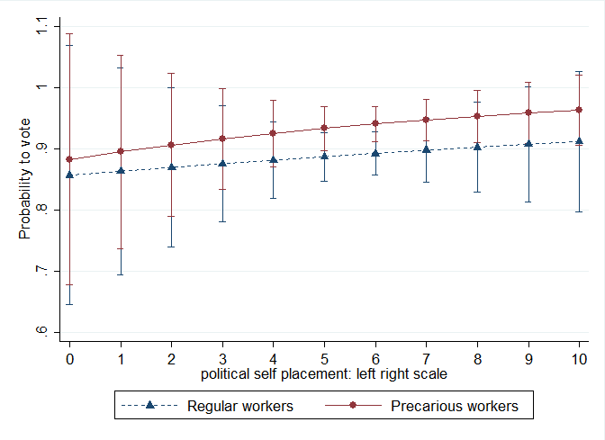
Source: AME are calculated based on annex 5, Model 2 (with all controls and interaction terms)
Figure A2. Predicted probabilities of engaging in political consumerism by political self-positioning (curvilinear relationship)
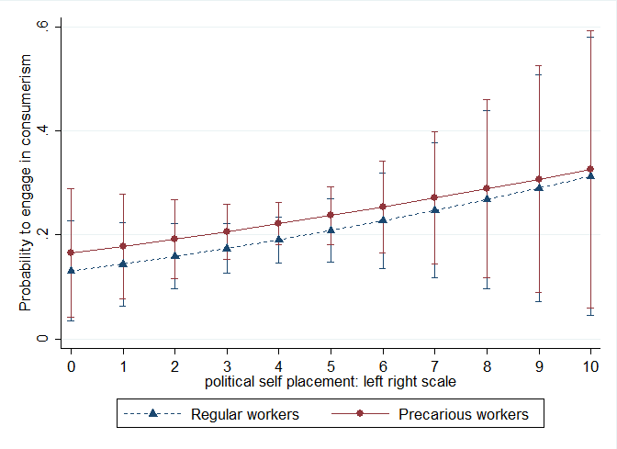
Source: AME are calculated based on annex 5, Model 2 (with all controls and interaction terms)
Figure A3. Predicted probabilities of engaging in collective action by political self-positioning (curvilinear relationship)
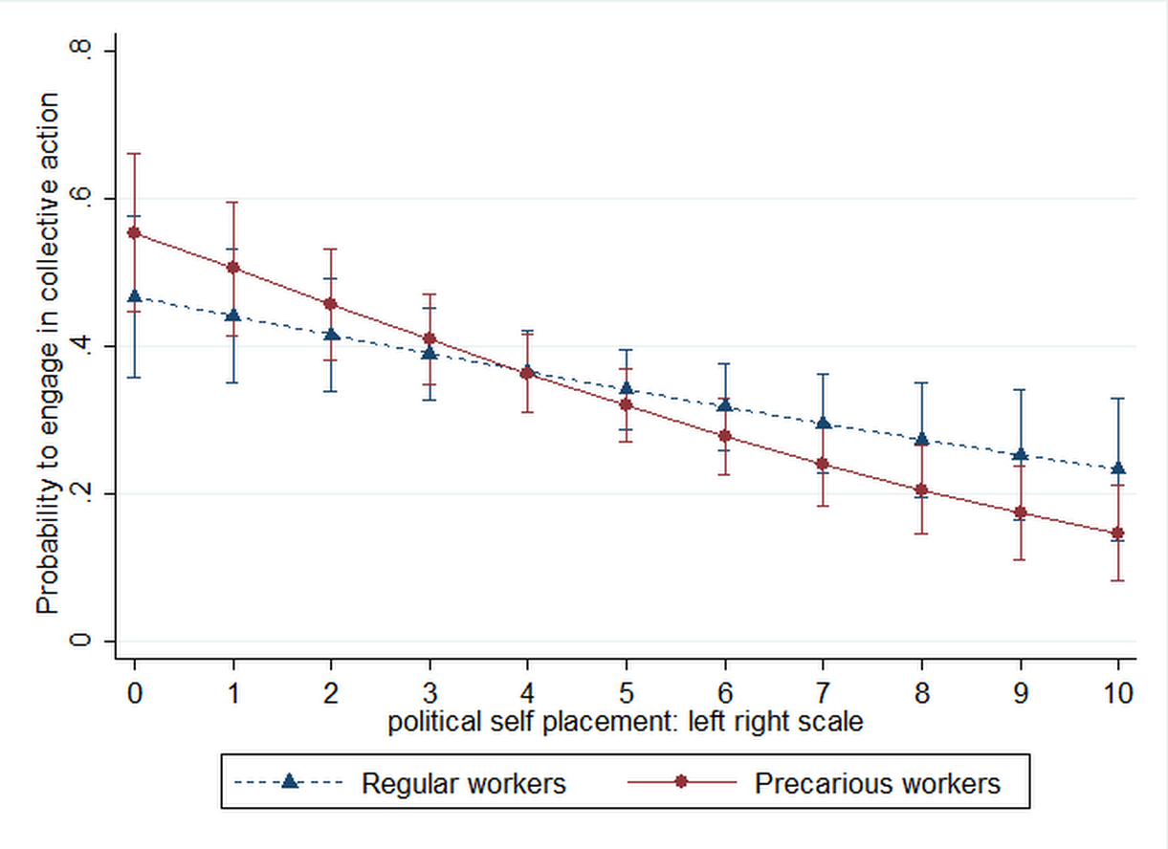
Source: AME are calculated based on annex 5, Model 2 (with all controls and interaction terms)

APPENDIX 6
LOGISTIC REGRESSION MODEL
INTERACTION BETWEEN JOB STATUS AND EDUCATIONAL ATTAINMENTS
 | Voting |  | Consumerism |  | Collective action
Precarious workers | 0.795 | (0.602) | 0.822 | (0.517) | 0.531 | (0.337)
Age | 0.895⁺ | (0.0573) | 1.048 | (0.0444) | 0.876** | (0.0373)
Gender | 1.782⁺ | (0.603) | 1.350 | (0.329) | 1.181 | (0.253)
Education
(ref. Lower secondary)
Secondary | 0.718 | (0.394) | 0.637 | (0.322) | 0.984 | (0.459)
Tertiary | 0.856 | (0.555) | 1.290 | (0.692) | 5.201** | (2.697)
Citizenship |  |  | 0.862 | (0.729) | 0.0551*** | (0.0368)
Living with Partner | 0.905 | (0.567) | 1.385 | (0.608) | 0.606 | (0.289)
Trade union membership |  |  | 0.777 | (0.751) | 11.60* | (12.27)
Associational membership |  |  | 6.239*** | (2.776) | 2.202⁺ | (0.993)
Number friends | 1.372 | (0.307) | 0.886 | (0.131) | 1.652*** | (0.222)
Financial difficulties | 0.572 | (0.226) | 1.048 | (0.301) | 0.652 | (0.182)
Caring of someone at home | 0.210* | (0.148) | 1.575 | (1.040) | 1.761 | (1.098)
Political interest | 4.504** | (2.180) | 2.324*** | (0.555) | 2.253*** | (0.490)
Internal political efficacy | 0.378* | (0.154) | 1.033 | (0.299) | 0.437** | (0.123)
Political cynicism | 0.446 | (0.265) | 1.294 | (0.407) | 0.560* | (0.154)
Understands politics | 0.777 | (0.269) | 0.838 | (0.209) | 0.828 | (0.181)
Trust | 1.627 | (0.592) | 1.755⁺ | (0.532) | 0.766 | (0.192)
Satisfaction with democracy | 0.776 | (0.267) | 0.838 | (0.199) | 0.670⁺ | (0.144)
Extreme self positioning | 1.273 | (0.469) | 0.457** | (0.134) | 1.219 | (0.283)
Self positioning | 1.016 | (0.0583) | 0.856** | (0.0412) | 0.825*** | (0.0308)
Interaction
Precarious workers # Secondary | 2.874 | (2.516) | 1.905 | (1.322) | 2.840 | (1.934)
Precarious workers # Tertiary | 3.418 | (3.645) | 1.150 | (0.859) | 0.763 | (0.568)
chi2 (df_m) | 46.52 (19)*** |  | 89.98 (22)*** |  | 156.3 (22)***
N | 564 |  | 612 |  | 615
aic | 331.2 |  | 583.7 |  | 676.7
bic | 417.9 |  | 685.3 |  | 778.4
Exponentiated coefficients; Standard errors in parentheses
⁺ p < 0.10, * p < 0.05, ** p < 0.01, *** p < 0.001

