Supplementary Material file for
Housing affordability and poverty in Europe:
On the deteriorating position of market renters
Figure 1.1. Trends in average housing cost burden 2005-2018, excluding mortgage principal
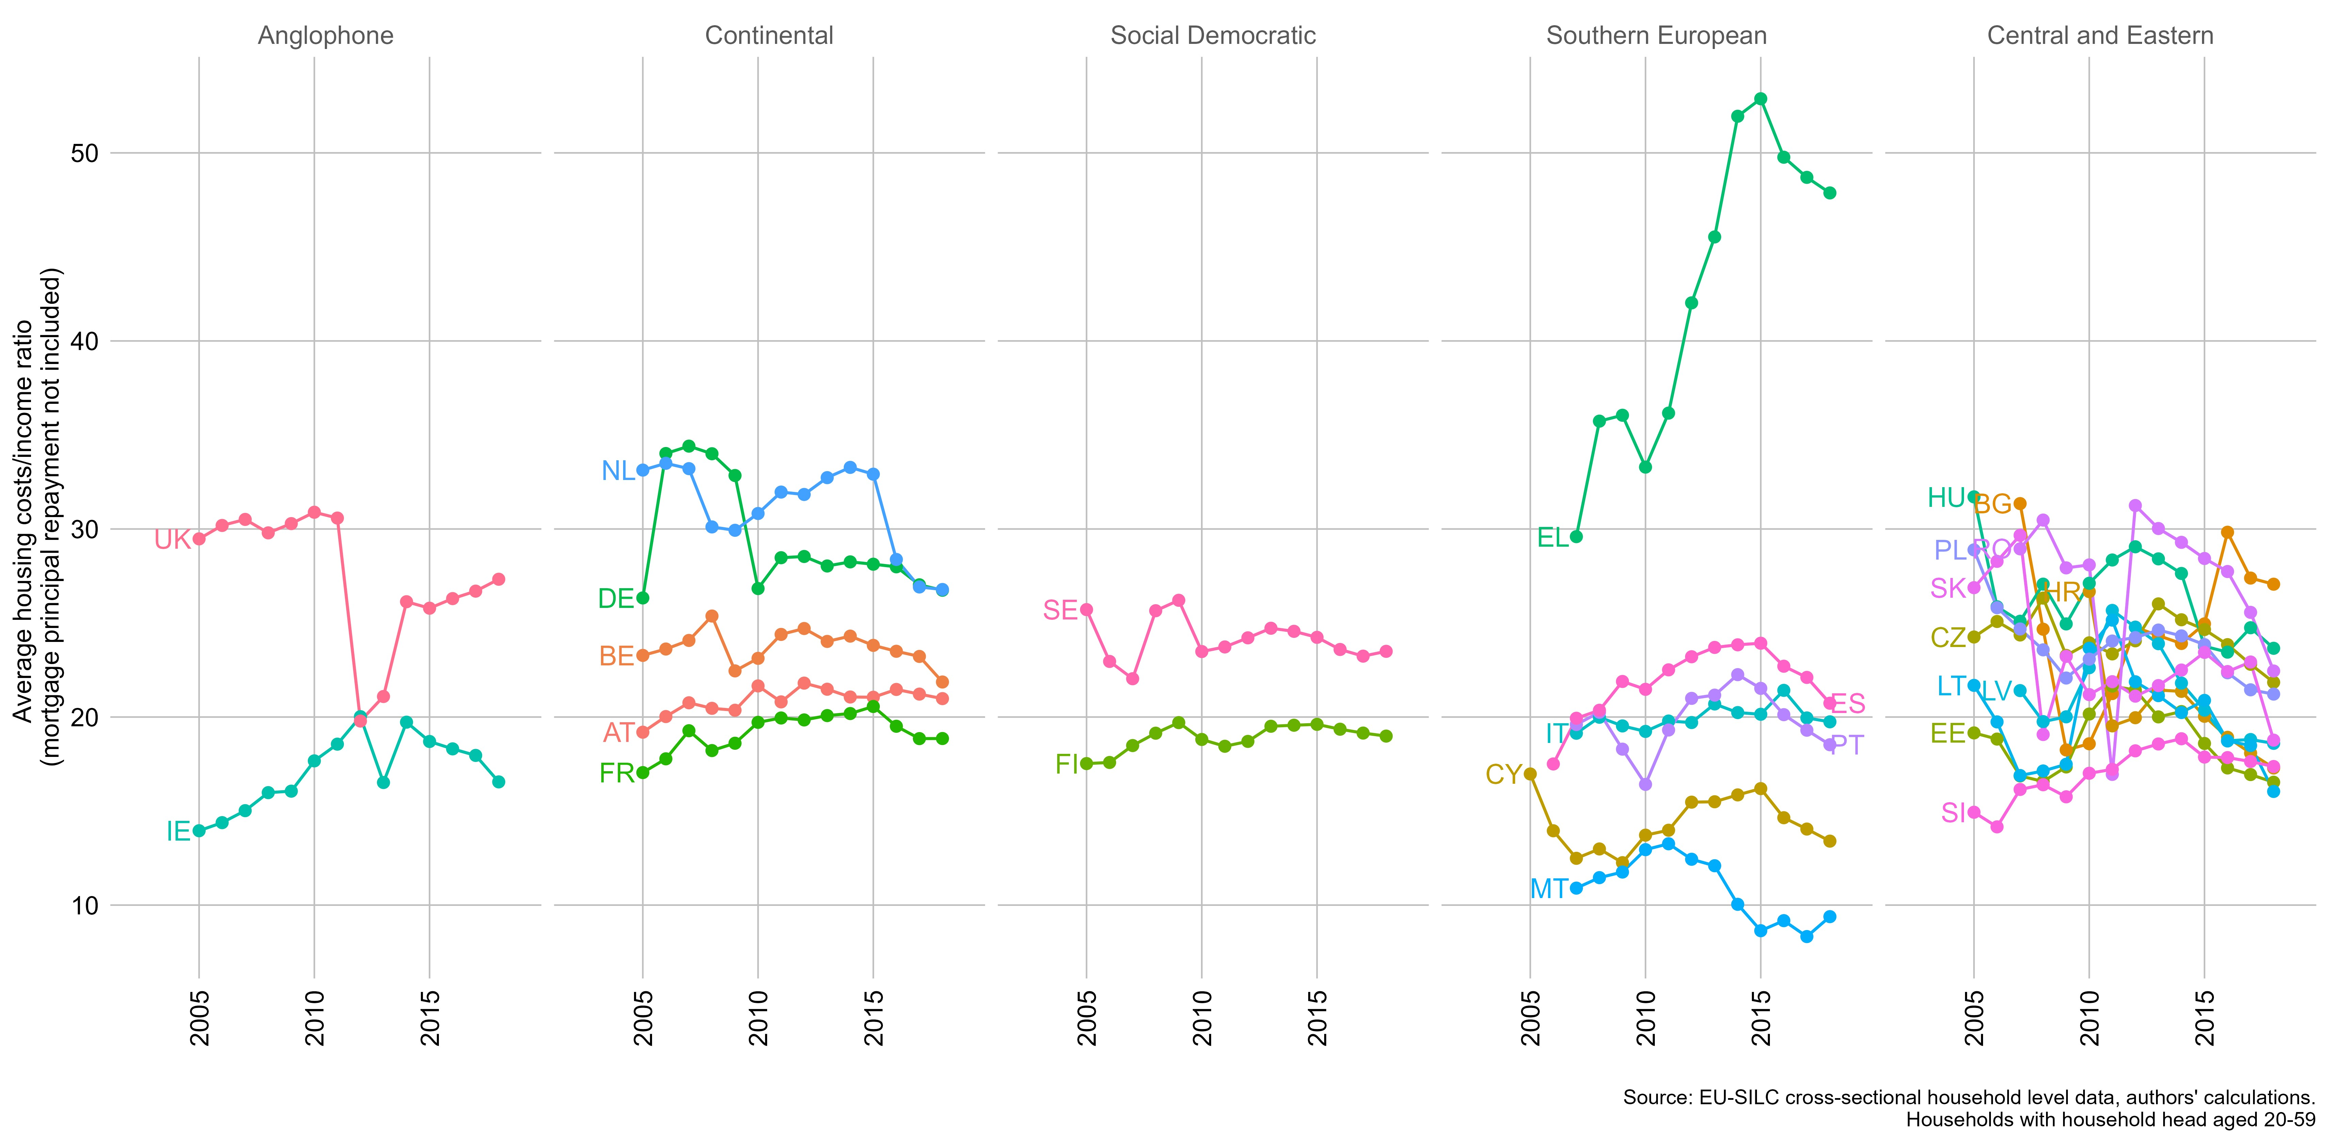
Figure 1.2 Trends in EU Housing Cost Overburden
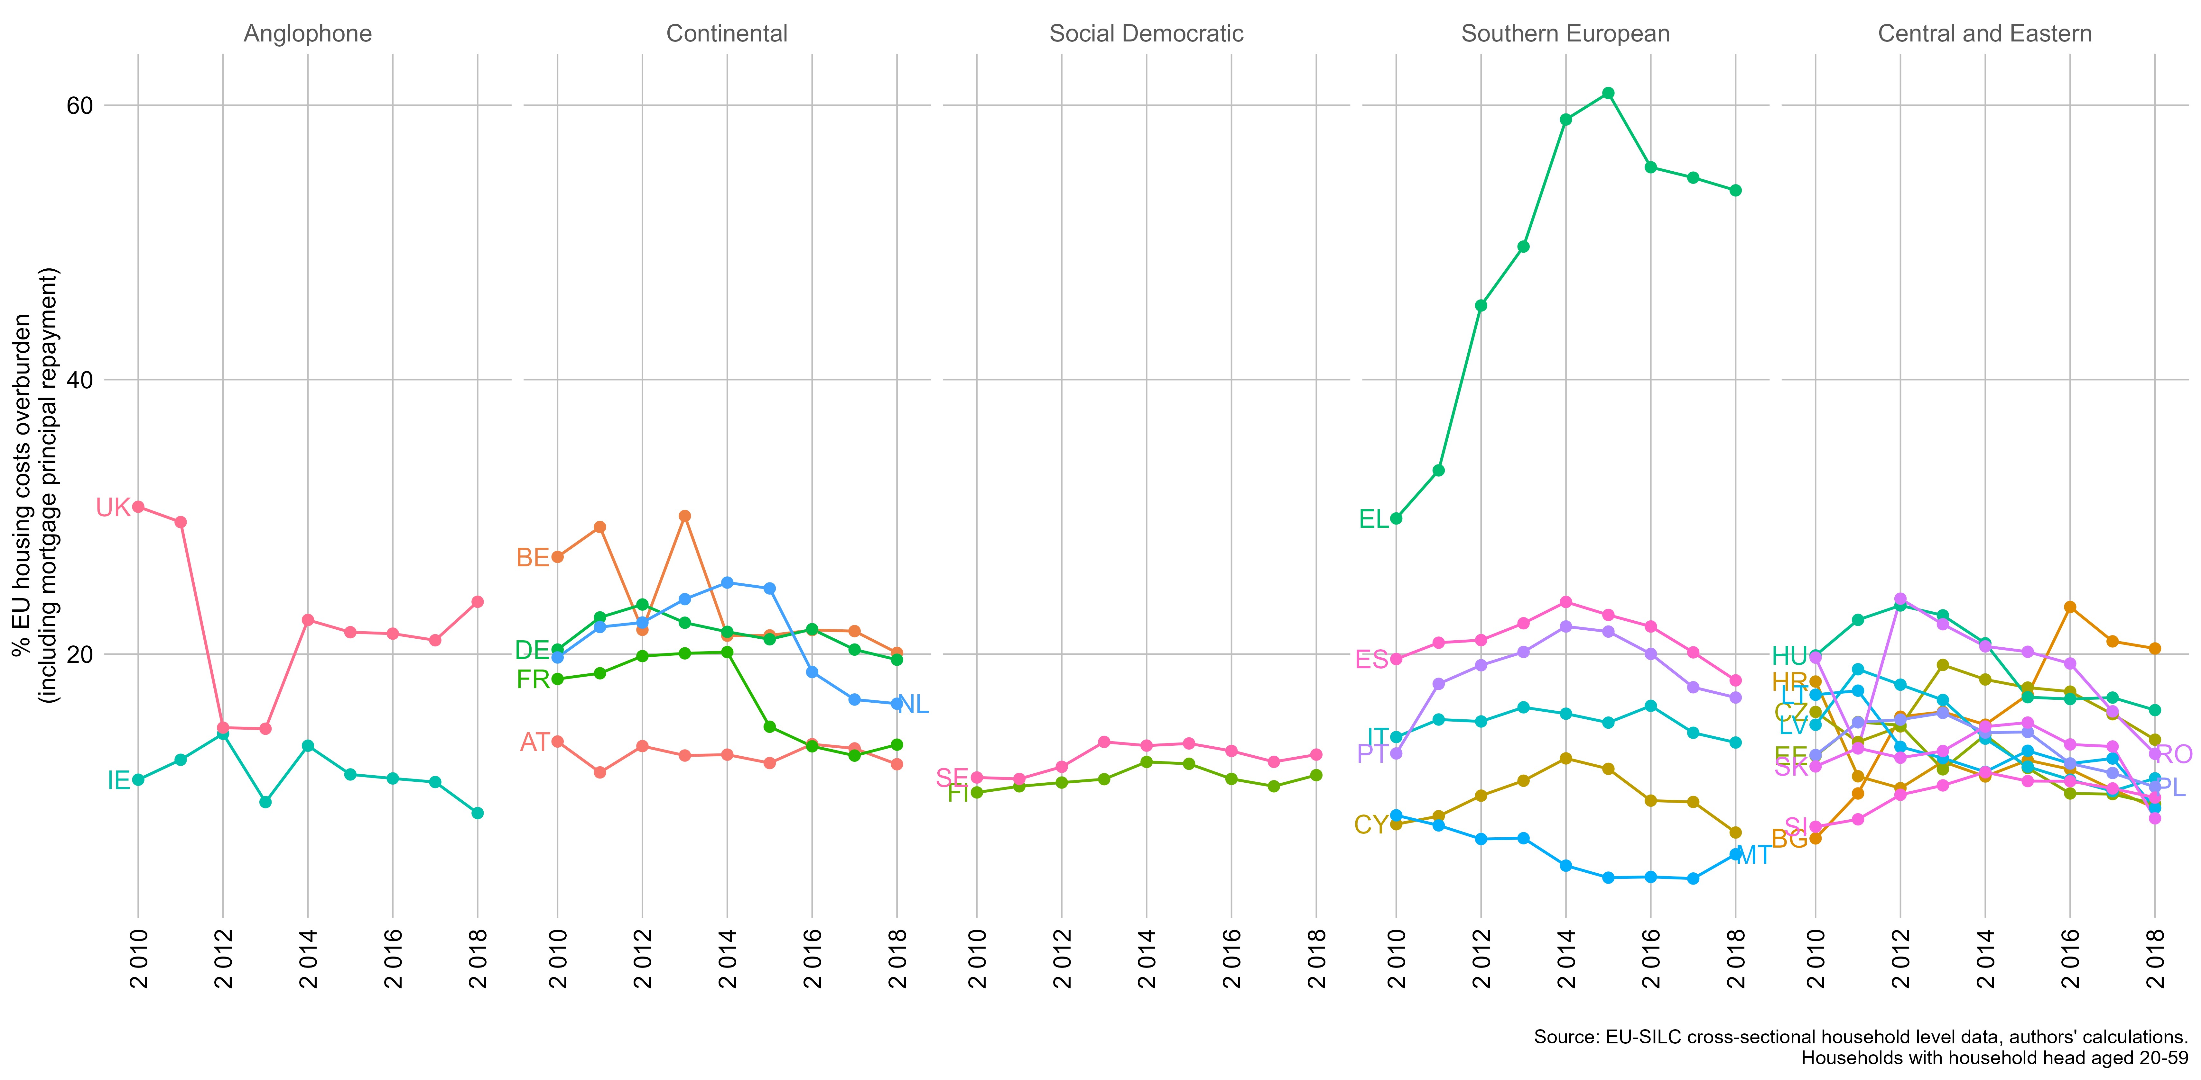

Figure 1.3 Trends in High Cost Low Income measure of housing affordability (joint experience of EU Housing Cost Overburden and AHC poverty)
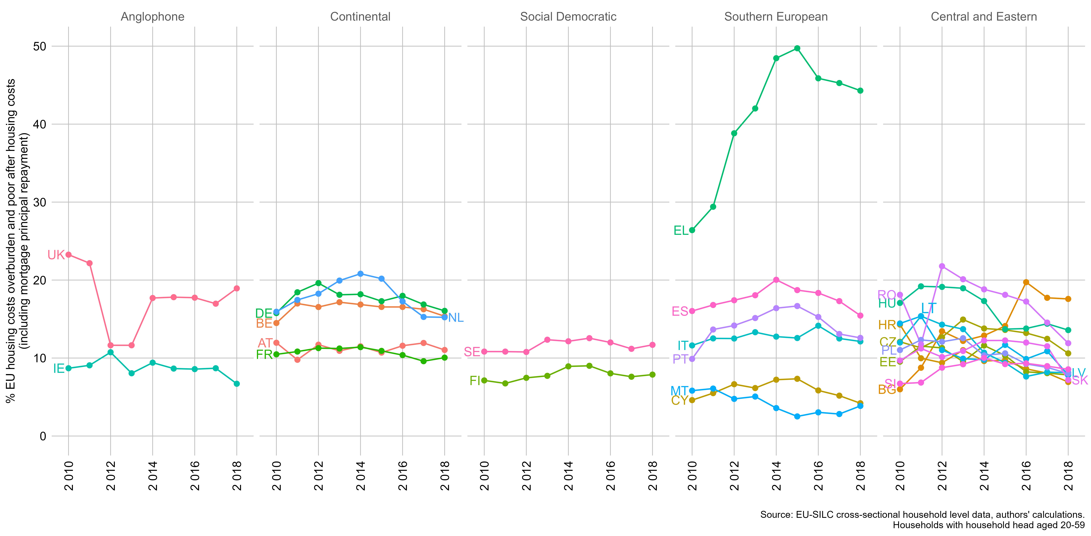
Figure 1.4. Percentage of respondents claiming that housing costs are ‘a heavy burden’
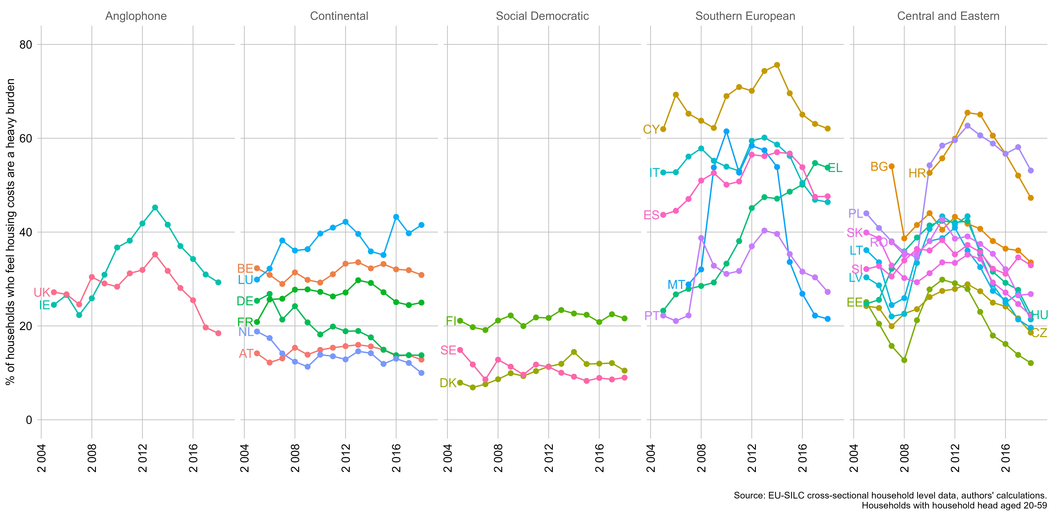

Figure 2.1. Overlap between dependent variables by country and tenure
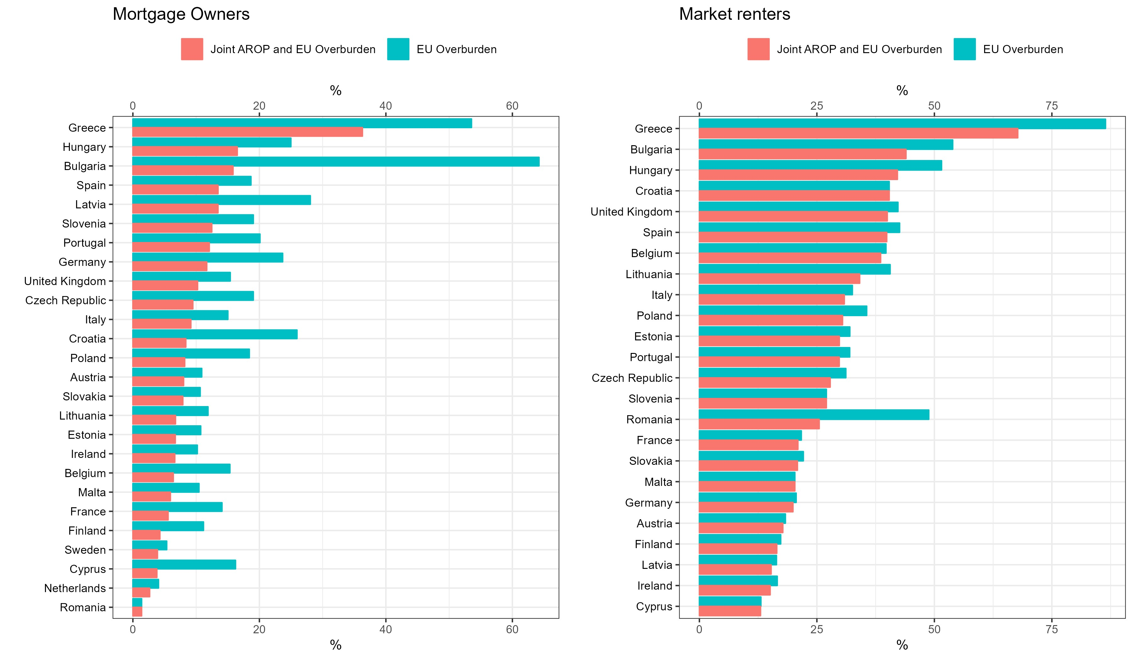
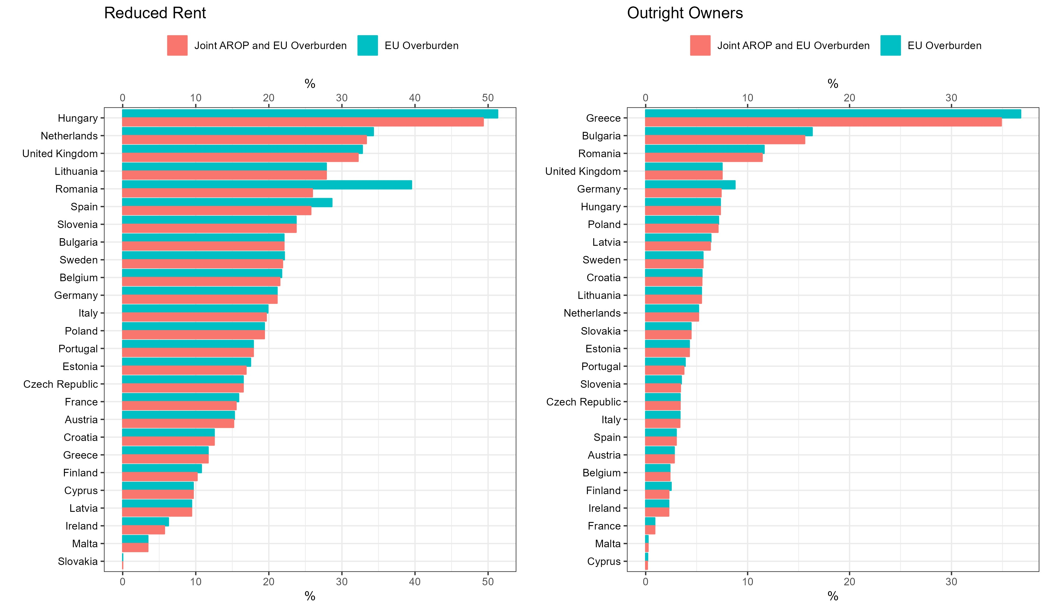

Figure 3.1. Decomposition of median housing cost burdens, incomes and housing costs – all hhs
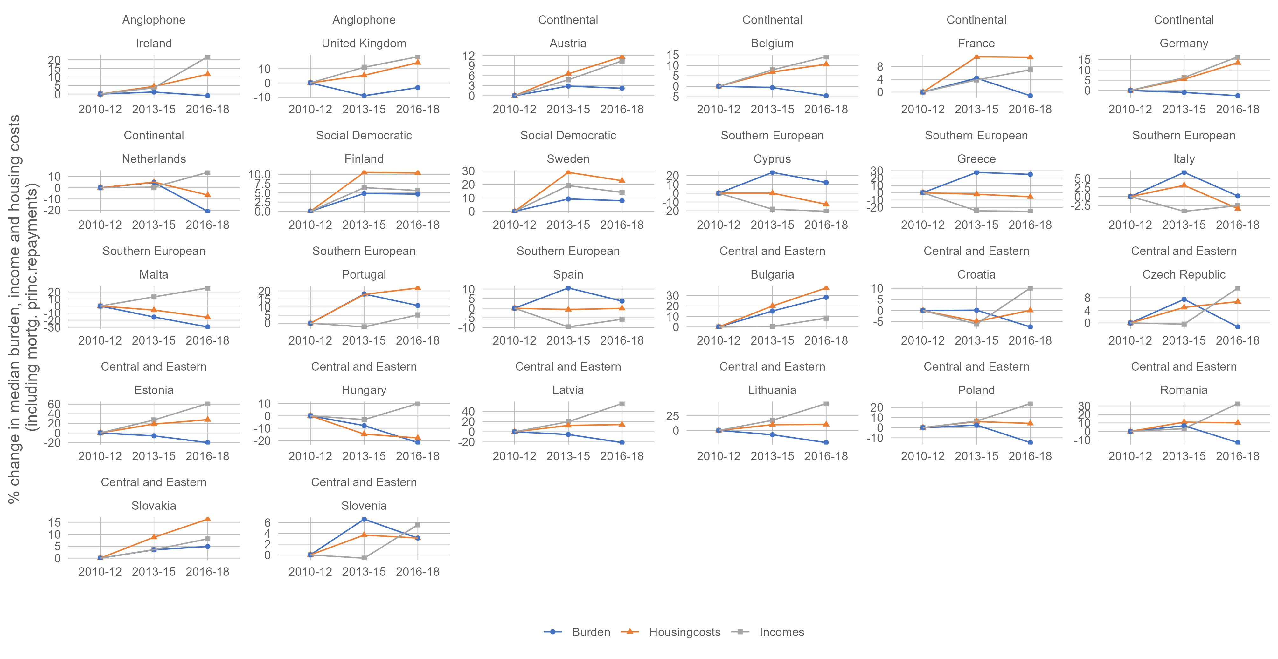
Figure 3.2. Decomposition of mean housing cost burdens, incomes and housing costs – all hhs
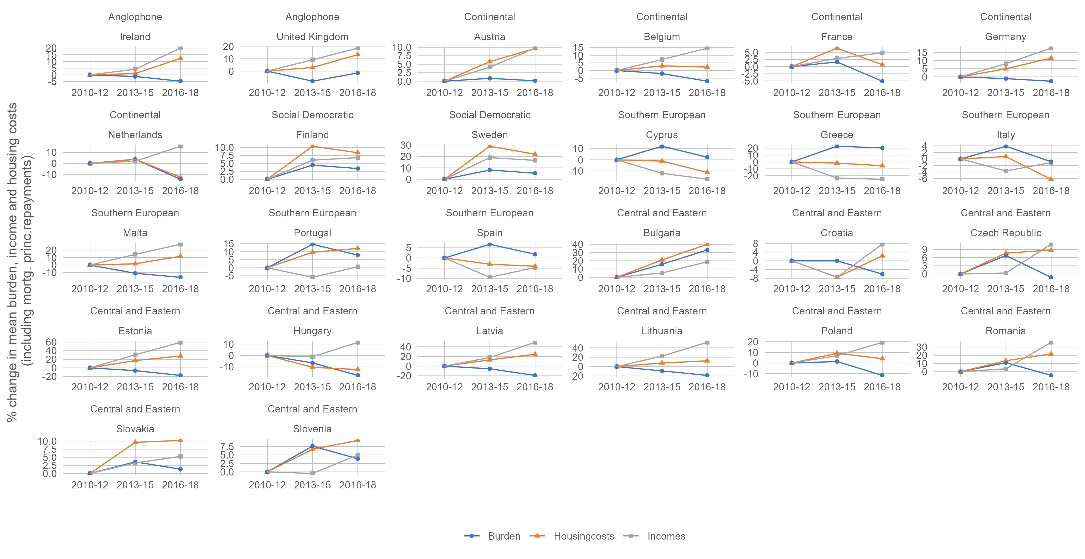
MICRO ANALYSIS
Table 1.1. Multi-level logistic regression model estimating incidence of High Cost Low Income measure of housing affordability
 | M1 |  | M2 |  | M3 |  | M3b
Predictors | Log-Odds |  | Log-Odds |  | Log-Odds |  | Log-Odds
(Intercept) | -2.01 *** |  | -1.52 *** |  | -2.21 *** |  | -2.15 ***
2014 (ref: 2010) | 0.15 *** |  | 0.15 *** |  | 0.12 ** |  | 0.08
2018 | -0.10 * |  | -0.10 * |  | -0.17 *** |  | -0.31 ***
Market-rate tenant (ref: Mortgaged homeowner) | 1.13 *** |  | 1.04 *** |  | 0.82 *** |  | 0.64 ***
Outright owner | -0.82 *** |  | -0.86 *** |  | -0.95 *** |  | -0.95 ***
Rent free | -0.60 *** |  | -0.74 *** |  | -1.04 *** |  | -1.03 ***
Below-market rate tenant | 0.81 *** |  | 0.67 *** |  | 0.45 *** |  | 0.44 ***
Semi-detached (ref: Detached) |  |  | -0.23 *** |  | -0.24 *** |  | -0.23 ***
Apartment in a building  with<10 dwellings |  |  | -0.21 *** |  | -0.30 *** |  | -0.30 ***
Apartment  or flat in a building  with>=10 dwellings |  |  | -0.29 *** |  | -0.40 *** |  | -0.39 ***
Number of rooms (recoded) |  |  | -0.19 *** |  | -0.01 *** |  | -0.01 ***
Intermediate area (ref: Densely-populated) |  |  | -0.07 *** |  | -0.05 *** |  | -0.05 ***
Thinly-populated |  |  | 0.01 |  | 0.03 *** |  | 0.03 ***
Area info missing |  |  | 0.51 *** |  | 0.40 *** |  | 0.40 ***
Single person  HH (ref: Two adults, no children) |  |  |  |  | 1.17 *** |  | 1.17 ***
Single parent  HH |  |  |  |  | 1.02 *** |  | 1.02 ***
Two adults, children |  |  |  |  | 0.11 *** |  | 0.11 ***
Other HH, no  children |  |  |  |  | -0.49 *** |  | -0.50 ***
Other HH, children |  |  |  |  | -0.33 *** |  | -0.33 ***
Household size |  |  |  |  | -0.01 |  | -0.01
EU national (ref: National) |  |  |  |  | 0.53 *** |  | 0.53 ***
Non-EU national |  |  |  |  | 0.70 *** |  | 0.70 ***
Household head 20-29 (ref: 40-49) |  |  |  |  | 0.51 *** |  | 0.52 ***
Household head 30-39 |  |  |  |  | -0.04 *** |  | -0.04 ***
Household head 50-59 |  |  |  |  | 0.14 *** |  | 0.14 ***
Market-rate tenant*2014 |  |  |  |  |  |  | 0.14 ***
Market-rate tenant*2018 |  |  |  |  |  |  | 0.47 ***
Observations |  | 1160581 |  | 1123082 |  | 1114515 |  | 1114515
Marginal R² / Conditional R² |  | 0.126 / 0.206 |  | 0.135 / 0.207 |  | 0.204 / 0.315 |  | 0.206 / 0.315
AIC |  | 822614 |  | 717590 |  | 678077 |  | 677567
* p<0.1 ** p<0.05 *** p<0.01
Note: All models are run on data using 27 countries (level 3) and 9 years (level 2). Period dummies for each year included in the models but, aside from 2014 and 2018, are supressed here.

MACRO ANALYSIS
Table A2. Descriptive statistics for macro-level variables
