Appendix for online publication at authors host institution.
Paper: Legitimate child protection interventions and the dimension of confidence: A comparative analysis of the populous views in six countries

Part I

Table A. Overview of attitudes towards Child Protection Systems. N (percent)
Values | Norway | England | Finland | Poland | Romania | Czechia | Total
Competency
Very much disagree | 92  (9.15 %) | 30  (2.97 %) | 34  (3.39 %) | 31  (3.06 %) | 74  (7.39 %) | 23  (2.28 %) | 284  (4.70 %)
Disagree | 190  (18.89 %) | 159  (15.74 %) | 120  (11.95 %) | 144  (14.20 %) | 277  (27.67 %) | 121  (12.00 %) | 1011  (16.73 %)
Agree | 389  (38.67 %) | 477  (47.23 %) | 558  (55.58 %) | 578  (57.00 %) | 428  (42.76 %) | 566  (56.15 %) | 2996  (49.58 %)
Very much agree | 144  (14.31 %) | 162  (16.04 %) | 156  (15.54 %) | 121  (11.93 %) | 103  (10.29 %) | 88  (8.73 %) | 774  (12.81 %)
Do not know | 191  (18.99 %) | 182  (18.02 %) | 136  (13.55 %) | 140  (13.81 %) | 119  (11.89 %) | 210  (20.83 %) | 978  (16.18 %)
Fair
Very much disagree | 92  (9.15 %) | 34  (3.37 %) | 43  (4.28 %) | 34  (3.35 %) | 70  (6.99 %) | 46  (4.56 %) | 319  (5.28 %)
Disagree | 217  (21.57 %) | 152  (15.05 %) | 213  (21.22 %) | 269  (26.53 %) | 317  (31.67 %) | 223  (22.12 %) | 1391  (23.02 %)
Agree | 375  (37.28 %) | 438  (43.37 %) | 478  (47.61 %) | 445  (43.89 %) | 396  (39.56 %) | 446  (44.25 %) | 2578  (42.66 %)
Very much agree | 112  (11.13 %) | 150  (14.85 %) | 88  (8.76 %) | 70  (6.90 %) | 80  (7.99 %) | 62  (6.15 %) | 562  (9.30 %)
Do not know | 210  (20.87 %) | 236  (23.37 %) | 182  (18.13 %) | 196  (19.33 %) | 138  (13.79 %) | 231  (22.92 %) | 1193  (19.74 %)
Respectful
Very much disagree | 102  (10.14 %) | 29  (2.87 %) | 42  (4.18 %) | 34  (3.35 %) | 70  (6.99 %) | 38  (3.77 %) | 315  (5.21 %)
Disagree | 199  (19.78 %) | 177  (17.52 %) | 204  (20.32 %) | 232  (22.88 %) | 291  (29.07 %) | 198  (19.64 %) | 1301  (21.53 %)
Agree | 354  (35.19 %) | 409  (40.50 %) | 441  (43.92 %) | 471  (46.45 %) | 403  (40.26 %) | 436  (43.25 %) | 2514  (41.60 %)
Very much agree | 132  (13.12 %) | 135  (13.37 %) | 80  (7.97 %) | 84  (8.28 %) | 81  (8.09 %) | 73  (7.24 %) | 585  (9.68 %)
Do not know | 219  (21.77 %) | 260  (25.74 %) | 237  (23.61 %) | 193  (19.03 %) | 156  (15.58 %) | 263  (26.09 %) | 1328  (21.98 %)
Discriminate
Very much disagree | 98  (9.74 %) | 27  (2.67 %) | 41  (4.08 %) | 40  (3.94 %) | 64  (6.39 %) | 27  (2.68 %) | 584  (9.66 %)
Disagree | 184  (18.29 %) | 121  (11.98 %) | 177  (17.63 %) | 215  (21.20 %) | 278  (27.77 %) | 115  (15.38 %) | 1581  (26.16 %)
Agree | 328  (32.60 %) | 426  (42.18 %) | 441  (43.92 %) | 469  (46.25 %) | 389  (38.86 %) | 407  (40.38 %) | 1671  (27.65 %)
Very much agree | 101  (10.04 %) | 191  (18.91 %) | 101  (10.06 %) | 96  (9.47 %) | 86  (8.59 %) | 68  (6.75 %) | 616  (10.19 %)
Do not know | 333  (33.10 %) | 277  (27.43 %) | 321  (31.97 %) | 229  (22.58 %) | 160  (15.98 %) | 271  (26.88 %) | 1591  (26.33 %)
Moral alignment
Very much disagree | 125  (12.43 %) | 121  (11.98 %) | 51  (5.08 %) | 108  (10.65 %) | 116  (11.59 %) | 63  (6.25 %) | 297  (4.91 %)
Disagree | 215  (21.37 %) | 226  (22.38 %) | 164  (16.33 %) | 333  (32.84 %) | 366  (36.56 %) | 277  (27.48 %) | 1130  (18.70 %)
Agree | 215  (21.37 %) | 261  (25.84 %) | 352  (35.06 %) | 276  (27.22 %) | 263  (26.27 %) | 304  (30.16 %) | 2460  (40.71 %)
Very much agree | 118  (11.73 %) | 125  (12.38 %) | 116  (11.55 %) | 229  (22.58 %) | 96  (9.59 %) | 93  (9.23 %) | 643  (10.64 %)
Do not know | 295  (29.32 %) | 245  (24.26 %) | 244  (24.30 %) | 194  (19.13 %) | 184  (18.38 %) | 351  (34.82 %) | 1513  (25.04 %)
The table shows the distribution of responses to the five variables (x1_competency, x2_fair, x3_respect, x4_discriminate, x5_samesense) for each individual country and for the total sample. The table shows the share of respondents (%) and the number of respondents (N) on each of the response alternatives 1=very much disagree, 2 = disagree, 3 = agree, 4 = very much agree, and “Do not know”. Percentages are calculated based on the total N, including NAs. Data: Survey developed by authors and responses collected by Faktum Markedsanalyse. RStudio: frq-function from sjmisc-package

Table B. Overview of attitudes towards Child Protection Systems. N (percent)
Values | Norway | England | Finland | Poland | Romania | Czechia | Total
Competency
Disagree | 282  (34.60 %) | 189  (22.83 %) | 154  (17.74 %) | 175  (20.02 %) | 351  (39.80 %) | 144  (18.05 %) | 1295  (25.57 %)
Agree | 533  (65.40 %) | 639  (77.17 %) | 714  (82.26 %) | 699  (79.98 %) | 531  (60.20 %) | 654  (81.95 %) | 3770  (74.43 %)
Fair
Disagree | 309  (38.82 %) | 186  (24.03 %) | 256  (31.14 %) | 303  (37.04 %) | 387  (44.84 %) | 269  (34.62 %) | 1710  (35.26 %)
Agree | 487  (61.18 %) | 588  (75.97 %) | 566  (68.86 %) | 515  (62.96 %) | 476  (55.16 %) | 508  (65.38 %) | 3140  (64.74 %)
Respectful
Disagree | 301  (38.25 %) | 206  (27.47 %) | 246  (32.07 %) | 266  (32.40 %) | 361  (42.72 %) | 236  (31.68 %) | 1616  (34.27 %)
Agree | 486  (61.75 %) | 544  (72.53 %) | 521  (67.93 %) | 555  (67.60 %) | 484  (57.28 %) | 509  (68.32 %) | 3099  (65.73 %)
Discriminate
Disagree | 340  (50.52 %) | 347  (47.34 %) | 215  (31.48 %) | 441  (56.18 %) | 482  (57.31 %) | 340  (46.13 %) | 2165  (48.63 %)
Agree | 333  (49.48 %) | 386  (52.66 %) | 468  (68.52 %) | 344  (43.82 %) | 359  (42.69 %) | 397  (53.87 %) | 2287  (51.37 %)
Moral alignment
Disagree | 282  (39.66 %) | 148  (19.35 %) | 218  (28.68 %) | 255  (31.10 %) | 342  (41.86 %) | 182  (27.70 %) | 1427  (31.50 %)
Agree | 429  (60.34 %) | 617  (80.65 %) | 542  (71.32 %) | 565  (68.90 %) | 475  (58.14 %) | 475  (72.30 %) | 3103  (68.50 %)
The table shows the distribution of responses to the five variables (x1_competency, x2_fair, x3_respect, x4_discriminate, x5_samesense) for each individual country and for the total sample. The table shows the share of respondents (%) and the number of respondents (n) on each of the combined response alternatives 0=disagree and 1=agree. We have excluded “Do not know”-responses in the total N. Data: Survey developed by authors and responses collected by Faktum Markedsanalyse. RStudio: frq-function from sjmisc-package (Lüdecke 2018).

Table C: Vignette scenario and response alternatives, including three treatments
We randomly assigned respondents to three types of parental behaviours with an experimental vignette that distinguished between parent(s) having: X1, learning disability; X2, mental health problems; and X3, substance abuse problems:
Case scenario | Response alternatives
Please consider the following situation: Jon (11) and Mira (9) are living with their parents. The school is concerned about the children because both mother and father have a learning disability/mental health problems/substance abuse problem. A psychologist has examined the children and has concluded that Jon and Mira have serious learning problems and lack basic social skills. The psychologist states that this is due to lack of stimuli and help from the parents, and the children need a lot of help and support. The parents do not want any help and cannot teach and show their children how to behave towards friends and other adults. The psychologist concludes that Mira and Jon are at significant risk of developing permanent social and emotional problems.  Based on the condensed information in this case, which option would you recommend the child protection authorities to take? | 1. They should not get involved at all  2. They should monitor/visit the family, but not interfere unless the situation worsens  3. They should provide in-home services for the family, even if the parents do not want it  4. They should prepare for a care order to temporarily place the children with another family  5. They should prepare for a care order to permanently place the children with another family

Table D. Mean, SD and valid N for each statement by country
 | Competency |  |  | Fair |  |  | Respect |  |  | Discriminate |  |  | Moral alignment |  |  | Latent
 | Mean | SD | N | Mean | SD | N | Mean | SD | N | Mean | SD | N | Mean | SD | N | Mean | SD | N
NO | 2.72 | 0.88 | 815 | 2.64 | 0.86 | 796 | 2.66 | 0.91 | 787 | 2.48 | 0.99 | 673 | 2.61 | 0.89 | 711 | 2.64 | 0.74 | 523
EN | 2.93 | 0.73 | 828 | 2.91 | 0.75 | 774 | 2.87 | 0.74 | 750 | 2.53 | 0.96 | 733 | 3.02 | 0.74 | 765 | 2.88 | 0.56 | 531
FI | 2.96 | 0.69 | 868 | 2.74 | 0.71 | 822 | 2.73 | 0.72 | 767 | 2.78 | 0.81 | 683 | 2.79 | 0.73 | 760 | 2.81 | 0.58 | 550
PO | 2.90 | 0.66 | 874 | 2.67 | 0.69 | 818 | 2.74 | 0.69 | 821 | 2.39 | 0.83 | 785 | 2.76 | 0.72 | 820 | 2.69 | 0.53 | 634
RO | 2.63 | 0.80 | 882 | 2.56 | 0.77 | 863 | 2.59 | 0.78 | 845 | 2.40 | 0.86 | 841 | 2.61 | 0.78 | 817 | 2.57 | 0.58 | 672
CZ | 2.90 | 0.61 | 789 | 2.67 | 0.71 | 777 | 2.73 | 0.70 | 745 | 2.58 | 0.82 | 737 | 2.79 | 0.68 | 657 | 2.73 | 0.45 | 491
Tot. | 2.84 | 0.74 | 5065 | 2.70 | 0.76 | 4850 | 2.71 | 0.77 | 4715 | 2.52 | 0.89 | 4452 | 2.76 | 0.77 | 4530 | 2.71 | 0.59 | 3401

Table E. Coding of background variables
Variable name | Description of recoding
Gender | Woman = 0  Man = 1
Age | Age
Age group | 1 = 18-22  2 = 23-35  3 = 36-55  4 = 56-80
Region | 11 regions in Norway and UK, 14 regions in Czechia, 5 regions in Finland, 6 regions in Poland, 8 regions in Romania
Income | 6-point scale: 1 = lowest income level, 6 = highest income level  Original coding: 6-point scale in Norway, England, and Finland, 10-point scale in Czechia, 13-point scale in Poland and 17-point scale in Romania. For polish respondents, the alternative values indicated monthly income level, whilst the remaining five countries had alternatives denoting annual income levels. Because the values across countries are incomparable, and all the countries’ income alternatives were recoded to a 6-point scale, the inconsistency in monthly and annual income is not of much trouble. Additionally, the countries with more than 6 values were recoded into a 6-point scale in order to have a consistent scale across all six countries.
Size city | 1 = Rural area/village with less than 5000 inhabitants  2 = Rural area/village with 5000-49.999 inhabitants  3 = City with 5000-49.999 inhabitants  4 = City with 50.000 inhabitants or more  5 = Capital city area
Employment | 0 = Not working (including respondents who are student/apprentice, unemployed (looking for job), unemployed (receiving disability benefits), and retired)  1 = Working (including respondents who are permanently employed fulltime, permanently employed parttime, on temporary contracts and freelancers)  Original coding: Permanently employed, fulltime = 1, Permanently employed, parttime = 2, Temporary contract = 3, Freelancer = 4, Student/apprentice = 5, Unemployed, looking for job = 6, Unemployed, receiving disability benefits = 7, Retired = 8
Political orientation | 0-3 = Left  4-6 = Centre  7-10 = Right  Original coding: 11-point scale: 0 = Left, 5 = Centre, 10 = Right
Marital status | 0 = Not married (including respondents who responded not married, divorced, separated and widowed)  1 = Married/partnership (including respondents who are legally married or in a legal partnership/civil union)  Original coding: Not married = 1, In a legal partnership/civil union = 2, Legally married = 3, Divorced = 4, Separated = 5, Widowed = 6
Children in household | 0 = No children  1 = Children  Original coding: No children = 1, 1 child = 2, 2 children = 3, 3 children = 4, 4 children = 5, 5 or more children = 6
Education | 1 = Low (including whose who have not completed any education, primary education, secondary education and occupational/vocational education)  2 = Medium (including those with higher education 1-3 years)  3 = High (including those with higher education 4 years or more)  Original coding: I have not completed any education = 1, Primary education = 2, Secondary education = 3, Occupational/vocational education = 4, Higher education, 1-3 years = 5, Higher education, 4 years or more = 6

Table F. Overall Confidence (latent) in the Child Protection System by Socio-Demographic Characteristics (Mean, SD, t/F-test, 95 %)
 | Mean | SD | t/F = Pr(t/F)
Gender
Female | 2.71 | 0.60 | t(-0.58904)= 0.555
Male | 2.72 | 0.58
Age
18-22 | 2.70 | 0.51 | F(0.555)= 0.456
23-35 | 2.72 | 0.56
36-55 | 2.69 | 0.62
56-80 | 2.74 | 0.59
Education
Low | 2.70 | 0.58 | F(2.05)= 0.152
Medium | 2.72 | 0.60
High | 2.77 | 0.58
Marital status
Not married | 2.70 | 0.60 | t(-1.1305)= 0.258
Married/partnership | 2.72 | 0.58
Employment
Not working | 2.66 | 0.62 | t(-3.7604) =0.00***
Working | 2.74 | 0.57
Children
No children | 2.69 | 0.60 | t(-2.0758) =0.037**
Children | 2.75 | 0.58
Size of home area
Rural < 5000 | 2.73 | 0.55 | F(0.494) =0.482
Rural 5000-49.999 | 2.70 | 0.60
City 5000-49.999 | 2.73 | 0.59
City > 50.000 | 2.71 | 0.61
Capital area | 2.69 | 0.58
Political orientation
Left | 2.71 | 0.61 | F(0.41) =0.522
Centre | 2.71 | 0.58
Right | 2.73 | 0.59

A sub-section on the latent variable
Figure 1 below illustrate the strength and direction of the correlations between each of the five statement variables. As we can see, four out of the five items (x1, x2, x3, and x5) are relatively highly correlated (well over 0.5 for all correlations), whilst the fourth item (x4) has lower correlation coefficients than the others (ranging from 0.1321 to 0.1843). We believe that these correlation coefficients, and the Cronbach’s alpha test are sufficient to justify the creation of a latent variable of level of confidence. The latent variable is an operationalisation of an underlying concept, confidence, that may be difficult to measure due to its highly abstract and unobservable nature (Fariss et al., 2020). We thus construct a latent trait variable taking the mean value of each respondent’s response to the five statements. The latent variable is a numeric variable that goes from 1 to 4 by 0.2, as seen in table 1 below.

Figure 1 Correlation table
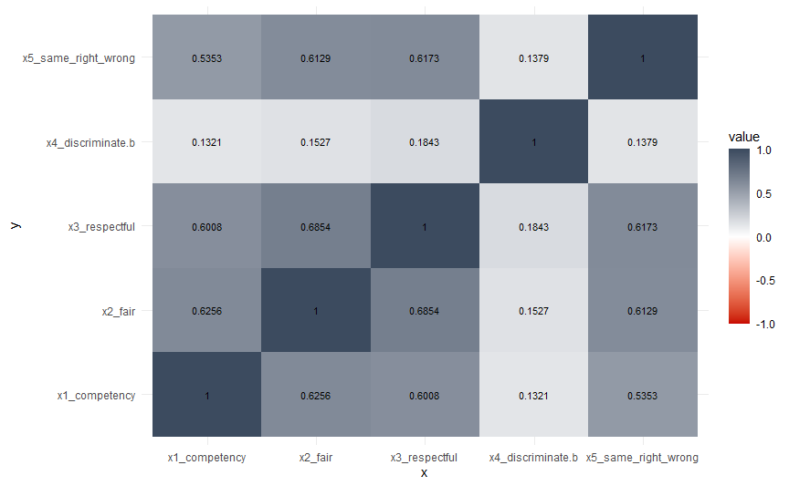

Many problems in the social sciences involve making inferences about quantities that are not directly observable. Here I refer to these quantities as latent states or latent variables. In each instance, the available data are manifestations (or indicators) of the latent quantity and the inferential problem can be stated as follows: Conditional on observable data y, what should we believe about latent quantities x? (Jackman, 2008, pp. 1-2).

A latent trait refers to a set of observable variables are manifestations of an underlying conceptual process that is not perfectly observable or knowable (Fariss et al., 2020, p. 1). There are no hard rules for deciding when a scale measure z is reliable on the basis of Cronbach’s alpha, however, reliabilities less than .5 are often considered less than acceptable in many settings. In some disciplines, such as psychology and educational testing, higher reliability coefficients are normally applied (e.g., see Jackman (2008); Ping and Xitao (2003); Viswesvaran and Ones (2000)). When disaggregating the results to country level, we do find some variations in the Cronbach’s alpha, see table 2 in the article. The country with the highest score here is Norway (0.86), followed by Finland (0.81) and Romania (0.77). At the bottom we find Czechia with 0.65. The Cronbach’s alpha test for Czechia also show that the x4_discriminate variable is negatively correlated with two other items (x5_same_sense_right_wrong and x2_fair), even after it has been inverted to align with the direction of the scales in the other variables.

Tabell 1 Descriptive statistics of Confidence variable
Value | N | Raw % | Valid % | Cum. %
1.00 | 37 | 0.61 | 1.09 | 1.09
1.20 | 40 | 0.66 | 1.18 | 2.26
1.40 | 33 | 0.55 | 0.97 | 3.23
1.60 | 97 | 1.61 | 2.85 | 6.09
1.80 | 107 | 1.77 | 3.15 | 9.23
2.00 | 224 | 3.71 | 6.59 | 15.82
2.20 | 276 | 4.57 | 8.12 | 23.93
2.40 | 262 | 4.34 | 7.70 | 31.64
2.60 | 280 | 4.63 | 8.23 | 39.87
2.80 | 618 | 10.23 | 18.17 | 58.04
3.00 | 667 | 11.04 | 19.61 | 77.65
3.20 | 328 | 5.43 | 9.64 | 87.30
3.40 | 213 | 3.52 | 6.26 | 93.56
3.60 | 87 | 1.44 | 2.56 | 96.12
3.80 | 64 | 1.06 | 1.88 | 98.00
4.00 | 68 | 1.13 | 2.00 | 100.00
NA | 2642 | 43.72 | NA | NA

Figure 2. Latent variable, average score per country and standard deviation
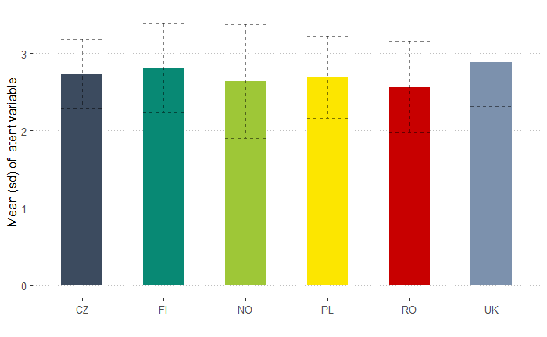

Fariss, C. J., Reuning, K., & Kenwick, M. R. (2020). Measurement Models. In L. Curini & R. J. Franzese (Eds.), SAGE Handbook of Research Methods is Political Science & International Relations (pp. 353-370). SAGE Press.
Jackman, S. (2008). Measurement. In J. M. Box-Steffensmeier, H. E. Brady, & D. Collier (Eds.), The Oxford Handbook of Political Methodolody (pp. 121-152). Oxford University Press. https://doi.org/10.1093/oxfordhb/9780199286546.003.0006
Ping, Y., & Xitao, F. (2003). Assessing the Reliability of Beck Depression Inventory Scores: Reliability Generalization Across Studies. In B. Thompson (Ed.), Score Reliability (pp. 219-234). SAGE Publications, Inc. https://doi.org/10.4135/9781412985789
Viswesvaran, C., & Ones, D. S. (2000). Perspectives on models of job performance. International Journal of Selection and Assessment, 8(4), 216-226. https://doi.org/10.1111/1468-2389.00151

