Appendix A: list and description of arguments within controversies
Argument label | Position towards UBI | Tweet (excerpt) example | Day 1 | Day 2 | Day 3
Welfare conditionality
free money | neutral (frame) | Municipalities plan to hand out 'free money' to welfare recipients. | 0.14 | 0.07 | 0.17
unconditional | neutral (frame) | A basic income that is discussed, is unconditional. See also: http://t.co/cJhO2MAfoF | 0 | 0.08 | 0.18
control | neutral (problem) | Is basic income the same as our social assistance without the municipal bully-policy? #Tegenlicht | 0.02 | 0.12 | 0.16
consumption | pro | Finance a #basicincome with a green tax system - two birds with one stone http://t.co/IQ8iT1R44K | 0.02 | 0 | 0
freedom | pro | #basicincome can be living in freedom for many | 0.15 | 0.06 | 0.04
participation | pro | The #basicincome seems to me an indispensable step to realising the idea of the #participationsociety. | 0.12 | 0.15 | 0.04
stigma | pro | Simply belonging also without paid labour, what a relief! #freemoney #basicincome #Tegenlicht | 0.01 | 0.01 | 0
trust | pro | I dream of a society based on #trust. In #Utrecht they will try it out. Are we worth #basicincome | 0.09 | 0.11 | 0.11
wellbeing | pro | Less stress and psychological diseases because of #basicincome #mincomeproject More happiness | 0.24 | 0.15 | 0.04
freeriding | con | Would a basic income make people lazy (…)? #Tegenlicht | 0.13 | 0.2 | 0.41
immigration | con | Besides, this will attract even more immigrants #basicincome | 0.05 | 0.01 | 0.04
responsibility | con | Why would you want basic income? Why not in principal take your individual responsibility (…)? #tegenlicht | 0.17 | 0.07 | 0.04
Economic redistribution
redistributive | neutral (frame) | Oooh, now I understand. They want to use #basicincome to #level incomes (…). | 0.11 | 0.11 | 0.07
capitalism | neutral (problem) | #basicincome. What capitalism owes you in expenses | 0.03 | 0.05 | 0
social benefits | neutral (frame) | isn't #basicincome the same as social assistance? #tegenlicht | 0.05 | 0.05 | 0.28
universal | neutral (frame) | Idea of #basicincome is that all Dutch people will receive it! (…) ..https://t.co/QihaEJ9Eyh | 0 | 0 | 0.09
inequality | neutral (problem) | The income inequality has become obscene #basicincome | 0.04 | 0.07 | 0.02
precariat | neutral (problem) | About 'precariat' and basic income: https://t.co/xZCNccatKJ | 0.01 | 0.02 | 0
affordable | pro | Exactly. No idea where all this money is supposed to come from. (…) | 0.22 | 0.13 | 0.11
fair | pro | Every human being has the right to a basic income, just like education, safety, healthcare, etc. | 0.06 | 0.04 | 0.03
security | pro | NL : Free money effective against poverty (…) http://dlvr.it/6z625M | 0.14 | 0.13 | 0.08
vlaktaks | con | The basic income. First a flat-rate income tax. Then we will continue talking #tegenlicht | 0.03 | 0.01 | 0
socialist | con | Ah, fortunately #NPO2 - a basic income for everyone. That is also a resounding success in Cuba, N-Korea, Venezuela etc. *ahem* | 0.06 | 0.06 | 0.03
liberal | con | Exactly, like this it is a libertarian attempt to abolish all social security | 0.02 | 0.05 | 0.05
need | con | Also directly indicates that people who cannot do something extra [red: in addition to UBI] will end up in a position of poverty #basicincome #tegenlicht | 0.08 | 0.18 | 0.04
resources | pro | The polluter can pay the #basicincome though #ecotax as earth-dividend. | 0.03 | 0.09 | 0
wage subsidy | con | If there are decent jobs you don’t need that basic income. It will mostly lead to lousy jobs next to BI. | 0 | 0.01 | 0.01
inflation | con | This will become a stagflation scenario. Shrinking consumption and still rising prices | 0.07 | 0.08 | 0.02
Welfare state efficiency
innovation | neutral (frame) | In a minute #tegenlicht the #basicincome. The most important social innovation of the coming 50 years. | 0.01 | 0.11 | 0.01
bureaucracy | neutral (problem) | That entire benefit- and deduction system needs to go. Basic income is an excellent idea. | 0.21 | 0.09 | 0.14
poverty trap | neutral (problem) | Basic income solves poverty trap (…). #tegenlicht | 0.03 | 0.05 | 0.07
deregulation | pro | The basic income. Interesting. #Tegenlicht Definitely saves a lot of hassle. And "fraud". Which often isn’t fraud but mistake. | 0.34 | 0.31 | 0.39
minimum wage | pro | With additional advantage: wages can go down. That version is still interesting. Canadian setup is nonsense. | 0.03 | 0.07 | 0.01
activation | pro | Exactly. Basic income actually stimulates work. #tegenlicht | 0.1 | 0.11 | 0.19
entrepreneurs | pro | Because of basic income people become more entrepreneurial (…) #Tegenlicht | 0.2 | 0.04 | 0.02
Automation and structural unemployment
automation | pro | Soon not everybody can work for their money because the jobs are done by robots or cut out #basisinkomen | 0.68 | 0.72 | 0.4
leisure | pro | The hunter-gatherer only worked 3 hours per day and lived in #abundance. #basicincome #Tegenlicht | 0.17 | 0.09 | 0.02
revolutionary | pro | Can #basic income offer a solution to a new economy in a new age? #tegenlicht | 0.22 | 0.1 | 0.02
structural unemployment | pro | There simply aren't jobs for everyone, let alone a prosperous future. There are just too many pigs at the trough. | 0.15 | 0.19 | 0.58
Miscellaneous
crowdfunding | neutral | Crowdfunding action for 'free salary' inhabitant Groningen #basicincome http://t.co/wtfCl2L3fT | 0 | 0.25 | 0
experiment | neutral | Experiment! That’s a good idea. (Woerden?) | 0.25 | 0.22 | 0.52
evidenced | pro | Free money works! #basicincome #Tegenlicht | 0.2 | 0.08 | 0.06
growth | pro | #Tegenlicht With a #basicincome people will also save less, basic income is their anyway. Positive for economy. | 0.03 | 0.03 | 0.04
political support | pro | Supporting basic income. Now [to convince] the politicians. #tegenlicht | 0.07 | 0.12 | 0.24
popular | pro | Nice documentary. Basic income is totally back in the picture! | 0.08 | 0.08 | 0.04
synthesis | pro | #basicincome is new dimension: social-liberal / liberal-social… neither socialism nor capitalism suffices as ideology | 0.02 | 0.02 | 0.03
unrealistic | con | We already have a show for this. Its called Utopia. (…) #tegenlicht #basisinkomen | 0.18 | 0.16 | 0.11
Note: twitter handles have been removed for reasons of readability and privacy. The parenthesized dots (…) indicate that we present an excerpt, filtering out additional arguments in the tweet. The percentages in the right-hand columns are day totals, i.e. they sum to one over the column.

Appendix B
This appendix elaborates on the technical procedure followed to identify discursive positions. Briefly, we first construct a two-mode network of actor-concept relations. Second, we transform this network into a weighted and signed network of actor (dis)agreement relations – figure 3 provides an example of the actor network and its relation to the underlying two-mode network. Third, we use spin-glass community detection to cluster actors based on their degree of agreement and disagreement across arguments. Fourth and lastly, we compute the discursive positions of each cluster by summing the positive and negative references to each argument of all actors assigned to that cluster. The main advantage of this approach over other classification techniques such as latent class analysis (Vermunt & Magdison 2004) is that it retains the positions of individual actors in the discussion, allowing us to see which political elites endorse which position. Moreover, this approach explicitly models the many unmentioned concepts in a meaningful way, namely as a lack of (dis)agreement or as silence with respect to these concepts, which variable-centered clustering techniques would exclude as missing data.
We first construct an unweighted two-mode adjacency matrix of actor-concept relations, in which each actor is positively or negatively connected to their mentioned concepts. For each tweet we note (a) to what concepts the tweets refers (b) what position (positive or negative) is taken regarding the concept and (c) the username of the actor. For example in figure 3, the tweet “UBI is a liberating idea” relates to the concept of freedom in a positive way. This information is arranged in a matrix where each row denotes an actor and each column represents a concept. The matrix contains the elements {1, 0, -1} for a positive, negative or no reference to each concept. Note that we hereby do not consider the number of times an actor references any single concept – we filter out duplicate concept references to make actors’ positions (and interrelations) independent from their vocality.
This two-mode network is transformed into a (weighted and signed) one-mode actor network, in which actors are connected based on their tendency to (dis)agree across all concepts. By multiplying the two-mode adjacency matrix with its transpose, which contains both agreement and disagreement connections, the agreements and disagreements between actors are multiplied for each concept and summed across concepts. For example, the relation ε between the actors A and B in figure 3 equals $ε_{AB}=\left(1*-1\right)+\left(1*-1\right)= -2$. Consequently, a stronger positive (or negative) connection between two actors represents more agreement (or disagreement) across concepts. Note that actor relations are ambivalent when the number of agreements equals the number of disagreements. This method thereby equates fully ambivalent relations – i.e. an equal number of agreements and disagreements – to a lack of (dis)agreement. This network operationalization combines agreement and disagreement relations in a single network, effectively in the way described by Leifeld (2017:313) as the “subtract” method of normalizing networks.
Finally, after constructing the actor network, we employ a simple normalization procedure to correct the strength of connections for user activity levels (see Leifeld 2017:312). To do so, each connection between two actors is weighted by the average number of concepts they adopt. In our example, the weight ω equals $ω_{AB}=\frac{( 2+2 )}{2}= 2$, and the weighted connection equals $\frac{ε_{AB}}{ω_{AB}}= -1$. Normalized connections can thus be interpreted as the degree of similarity in discursive position, where connections of strength +1 indicate strong agreement between actors, and connections of strength -1 indicate strong disagreement. The connection values cannot exceed these limits, because we divide the connection strength by the total number of shared concept references (which in our case is equal to the unique number of shared concept references). Note that software such as the Discourse Network Analyzer uses a slightly different procedure to normalizing the edge weights – creating and normalizing the congruence and conflict networks separately and then subtracting the conflict weights from the congruence weights. However, sensitivity checks (available in the data package) show that the resulting edge weights are the same.
To identify discursive positions in the UBI debate, we cluster actors using the spin-glass algorithm (Reichardt & Bornholdt 2006; Traag & Bruggeman 2009). This algorithm groups actors by minimizing disagreement within clusters and agreement between clusters. It is based on social balance theory (e.g. Cartwright & Harary 1956), which posits for example that “a friend of a friend is also my friend”, or “a friend of my enemy is also my enemy”. In the context of actor-argument relations, actors belonging to the same discursive position tend to agree – i.e. maintain the same position towards the same concepts – while actors belonging to different discursive positions tend to disagree – i.e. holding inverse positions on the same concepts. Similar to a conventional social network (e.g. Altafini 2012), a perfectly balanced concept network is thus divided into completely coherent and opposing factions, wherein everyone tends to agree with those inside their cluster and tends to disagree with those outside their cluster.
In reality, perfectly polarized systems rarely occur. Actors are grouped together in spite of some internal conflict and external agreement. Instead, simply put, the spin-glass algorithm finds the optimal solution by maximizing internal agreement (cohesion) and external disagreement (adhesion). Actors are placed in different communities over a number of iterations, evaluating the cohesion and adhesion after each move. Cohesion becomes more strongly positive when a particular partitioning results in stronger positive ties and weaker negative ties within each community, compared to a randomly configured baseline model. Formally, the cohesion c for each community s is defined as the difference between the sum of all positive tie strengths $m_{ss}^{+}$ and the (absolute) sum of all negative tie strengths $m_{ss}^{-}$, subtracting that same difference $\left[m_{ss}^{+}\right]-[m_{ss}^{-}]$ in a randomly rewired baseline network.
$$c={(m}_{ss}^{+}-m_{ss}^{-})-(\left[m_{ss}^{+}\right]-[m_{ss}^{-}])$$
Adhesion a becomes more strongly negative when negative ties outweigh positive ties between clusters in the observed graph, again evaluated against a random baseline configuration. Although the algorithm optimizes towards most the strongly negative between-group relations, adhesion will be positive when between-group agreement exceeds between-group disagreement. Formally, given two clusters r and s, adhesion a is the difference between the sum of all agreement relations m+ and the (absolute) sum of all disagreement relations m-, subtracted from that same difference $\left[m_{rs}^{+}\right]-\left[m_{rs}^{-}\right]$ in a randomly rewired network.
$$a={(m}_{rs}^{+}-m_{rs}^{-})-(\left[m_{rs}^{+}\right]-[m_{rs}^{-}])$$
Based on these measures, a modularity metric Q is computed. Known as the ‘clustering coefficient’, modularity summarizes the degree to which a network can be partitioned into isolated components, where Q=1 equals a perfectly modular network. The spin-glass algorithm calculates modularity based on both the absence of positive links between clusters and negative links within clusters. A perfectly modular network is one with no disagreement within clusters and no agreement between clusters. In our application (the default) we attribute equal weight to positive and negative connections.
Finally, we assess the discursive position of the detected communities. Since the spin-glass algorithm groups actors based on their overall level of (dis)agreement, the clusters only become substantively informative when we disentangle their positions towards various arguments. To do so, we sum the positive and negative references to each argument for all members of a community. These community-level profiles represent the substantive positions of “discursive coalitions” in the debate.

Appendix C: frequency of support and opposition for each argument
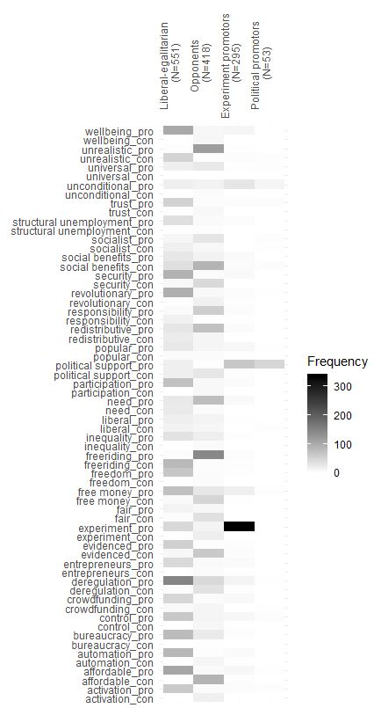
Note: this is a supplement to figure 4. We derive ambivalence by comparing the frequencies for proposing and opposing the same argument within a cluster (pro/con). Amongst liberal-egalitarians, ambivalence is highest for the arguments ‘liberal’ (19/15), ‘need’ (26/24), ‘political support’ (19/18), ‘redistributive’ (29/23), ‘social benefits’ (28/37), and ‘socialist’ (10/18). Amongst opponents, ambivalence is highest for the arguments ‘deregulation’ (44/34), ‘free money’ (28/49), ‘liberal’ (14/10), and ‘experiment’ (13/20).

Appendix D: relative activity of political party elites during the 2010 parliamentary campaign and the UBI debate on peak events
 | Political campaign |  | UBI debate
 | Elites | Tweets | Elites | Tweets
vvd | 0.189 | 0.287 | 0.104 | 0.163
pvda | 0.165 | 0.123 | 0.104 | 0.039
pvv | 0.044 | 0.023 | 0.000 | 0.000
cda | 0.209 | 0.145 | 0.125 | 0.064
sp | 0.044 | 0.034 | 0.188 | 0.443
d66 | 0.131 | 0.102 | 0.125 | 0.099
gl | 0.087 | 0.129 | 0.354 | 0.192
cu | 0.083 | 0.102 | 0.000 | 0.000
pvdd | 0.034 | 0.042 | 0.000 | 0.000
sgp | 0.015 | 0.012 | 0.000 | 0.000
Total N | 206 | 28045 | 48 | 203
Note: the data from the 2010 parliamentary campaign is based on Graham, Jackson & Broersma (2016) and includes only national-level political elites. The data from the UBI debate includes also municipal elites.

Appendix E: Actor graphs and substantive positions per day
Day one: Dutch Twitter response to second Tegenlicht documentary “money for free”(2014-09-21)
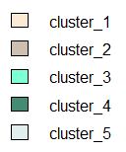  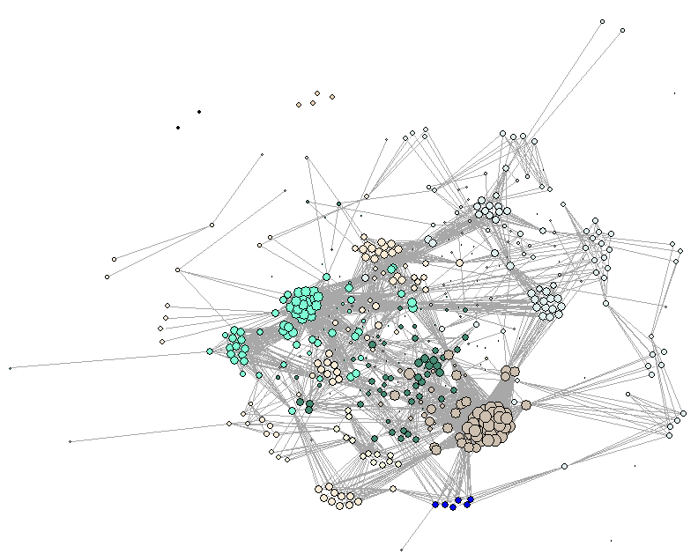 | 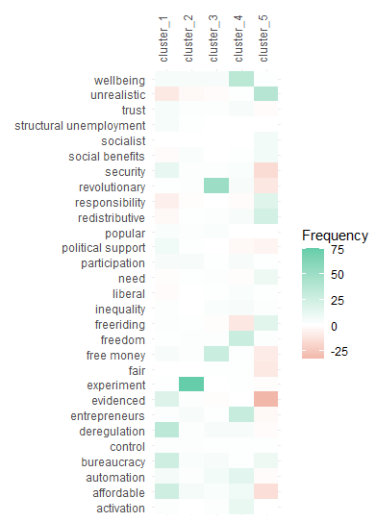
Note: Discussion on day one features 493 actors and 46 concepts. Graph modularity Q = .446. Substantive positions of clusters larger than 30 actors (5 out of 9) are displayed on the right. For purposes of visualization the graph is based on agreement ties only. Node size is proportional to tie strength – larger nodes represent participants in stronger agreement with others. The graph layout is based on the Fruchterman-Reingold algorithm, where nodes in stronger agreement are placed closer together. Only ties with strength greater than the threshold .60 are plotted.

Day two: Twitter response to third Tegenlicht documentary “experimenting with ‘free money’” (2015-04-12)
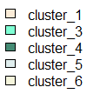  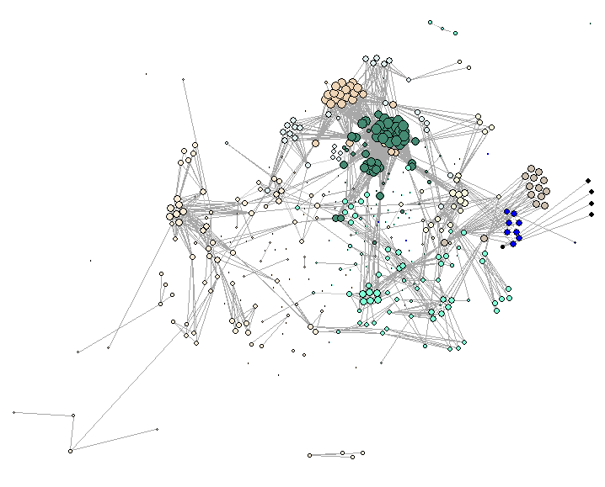 | 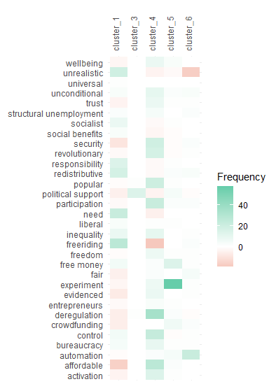
Note: Discussion on day one features 435 actors and 51 concepts. Graph modularity Q = .433. Substantive positions of clusters larger than 30 actors (5 out of 9) are displayed on the right. For purposes of visualization the graph is based on agreement ties only. Node size is proportional to tie strength – larger nodes represent participants in stronger agreement with others. The graph layout is based on the Fruchterman-Reingold algorithm, where nodes in stronger agreement are placed closer together. Only ties with strength greater than the threshold .60 are plotted.

Day three: Twitter response to public announcement of local experiments with unconditional social assistance (2015-08-05)
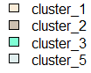  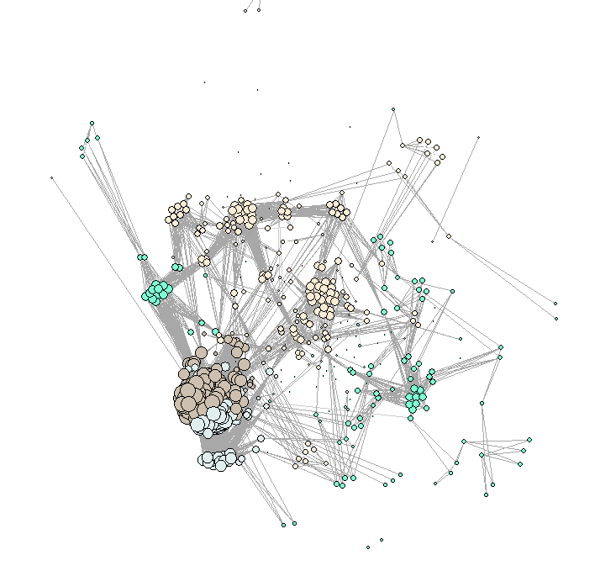 | 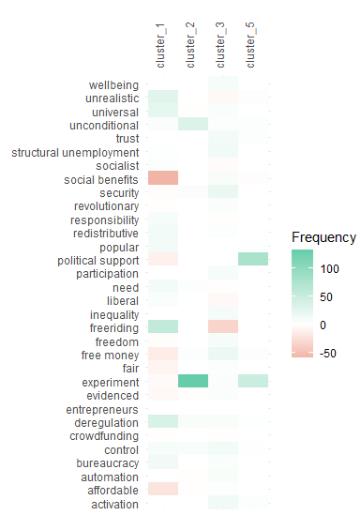
Note: Discussion on day one features 581 actors and 51 concepts. Graph modularity Q = .314. Substantive positions of clusters larger than 30 actors (4 out of 5) are displayed on the right. For purposes of visualization the graph is based on agreement ties only. Node size is proportional to tie strength – larger nodes represent participants in stronger agreement with others. The graph layout is based on the Fruchterman-Reingold algorithm, where nodes in stronger agreement are placed closer together. Only ties with strength greater than the threshold .60 are plotted.

http://www.twitter.com/user/status/560084343780302851

