Appendix 1: Formula for the decomposition of the change in the poverty rate

Changes in the child poverty rate over time can be decomposed into two separate effects, compositional and incidence effects (Sutherland et al, 2003; Brewer et al, 2006).

The compositional effect reflects the fact that the share of children in the population who live in households with different characteristics changes over time. For example if parental employment rates increase, and the poverty rate associated with having no adult in paid work is higher than that in households where at least one adult works, then the overall child poverty rate would fall for compositional reasons, without any change in the rate of poverty for children in one group or another. The extent to which compositional changes affect the overall poverty rate will depend on both the scale of the compositional change and how far the poverty rate for a given group differs from the overall poverty rate. In the formula we use, following Brewer et al (2006), we calculate the compositional effect for each group as the change in that group’s population share over the period multiplied by the amount by which the group poverty rate exceeds/falls short of the overall rate (averaged across the start and end of the period).

The incidence effect reflects the change in the rate of poverty for a specific group; for example a fall in the poverty rate associated with having parents out of work due to an increase in the generosity of out-of-work benefits. The contribution of the incidence effect to the overall poverty rate will depend on the size of the group affected as well as the scale of the change in poverty rate. We take the average population share at the start and end of the period to capture the size of the group affected.

Decomposition formula:

Total effect = Compositional Effect + Incidence Effect

$$P_{overall, t+1}- P_{overall, t}= \sum_{i}{\left(v_{i, t+1}- v_{i, t}\right)\left(\frac{P_{i,t}- P_{overall, t}+ P_{i, t+1}- P_{overall, t+1}}{2}\right)+ \sum_{i}{\left(\frac{v_{i,t}+ v_{i, t+1}}{2}\right)(P_{i, t+1}- P_{i, t})}}$$
where:

$P_{i, t}$ is the poverty rate amongst group i at time t;

$P_{overall, t}$ is the overall poverty rate at time t;

$v_{i,t}$ is the proportion of the population made up by group i at time t.

Appendix 2 Trends in poverty by family size using alternative poverty lines
(Before Housing Costs, left hand panel; After Housing Costs, right hand panel)
- Against a poverty line of 50% of equivalised median income
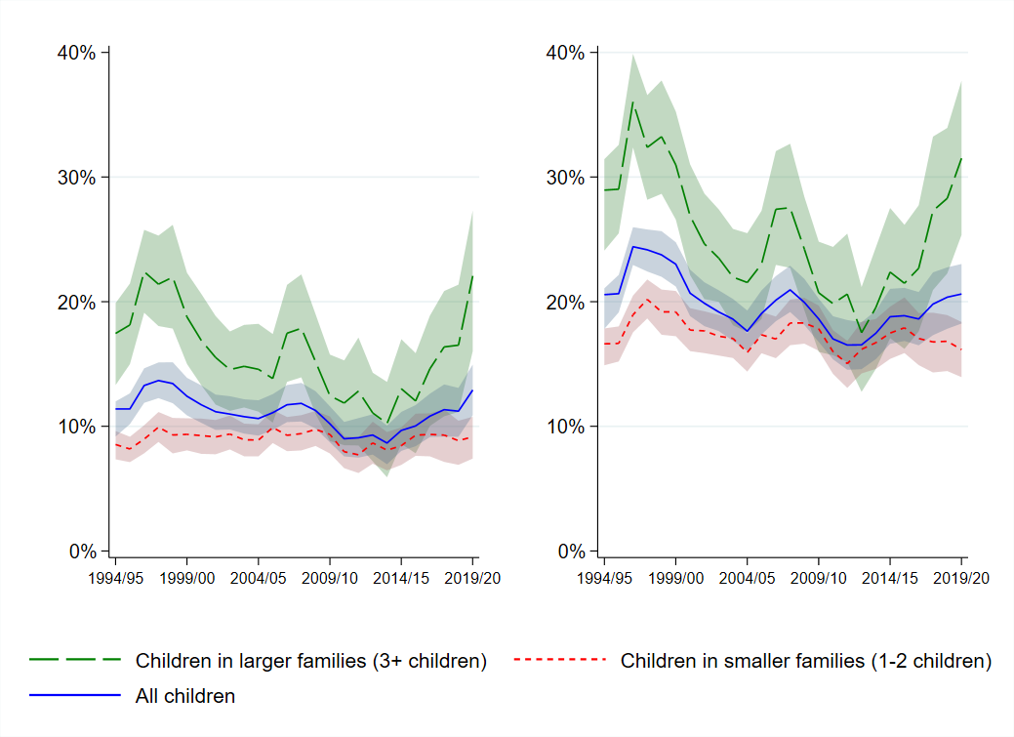
- Against a poverty line of 60% median income, equivalised using a square root scale

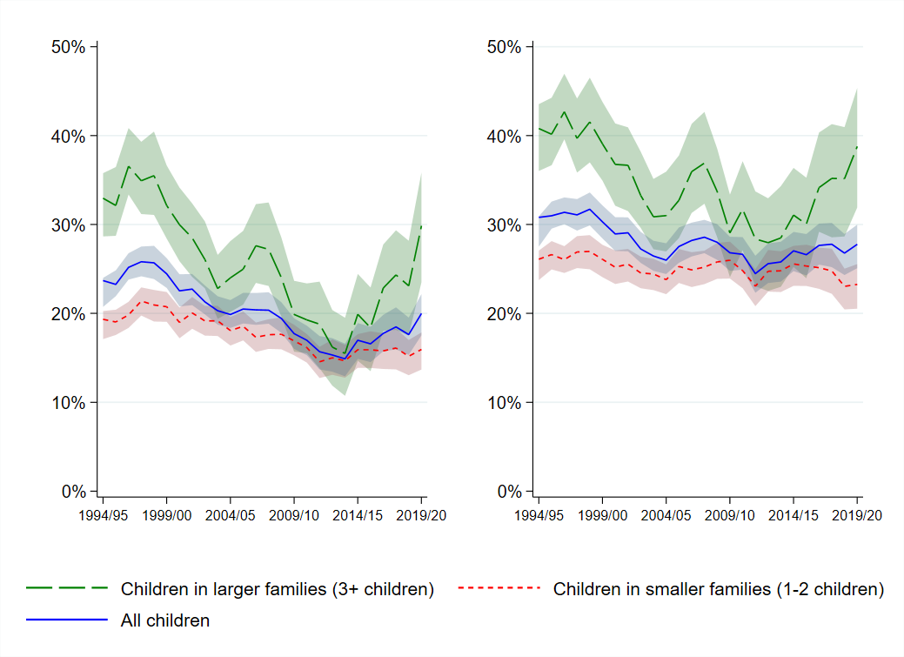
- Against a fixed income poverty line of 60% equivalised household income in 2010/11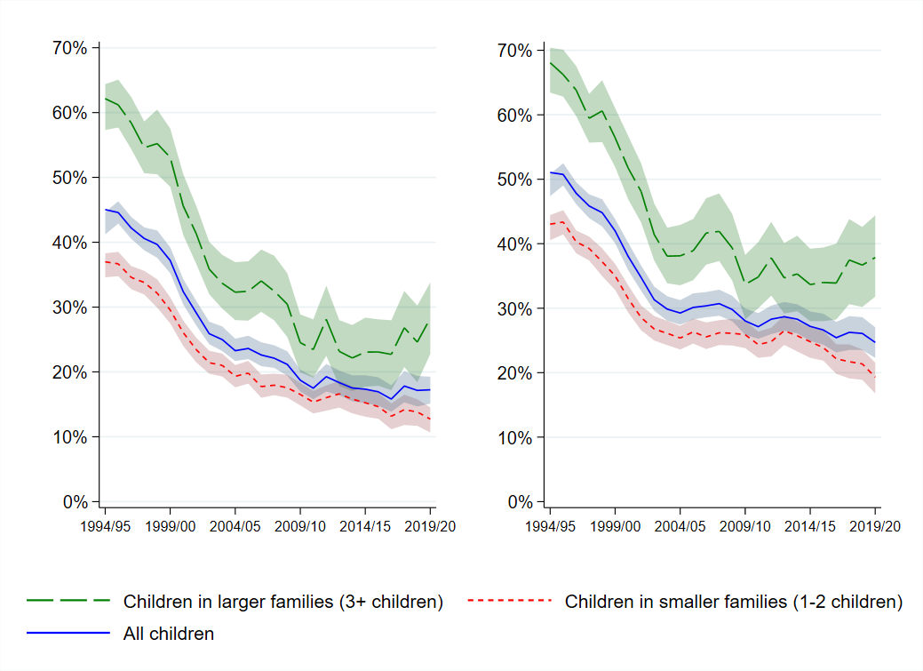

Appendix 3: The share of children living in families of different sizes

 | As a share of all children, percentage living in families with: |  |  |  |  |  |  |  | As a share of children in larger families:
 | 3+ children | 4+  children |  | 5+  children |  | 3 children |  |  |  | 4 children |  | 5+ children
1994/95 | 32.0 |  | 9.8 |  | 2.8 |  |  | 69.4 |  |  | 21.8 |  | 8.8
1995/96 | 32.3 |  | 9.9 |  | 3.1 |  |  | 69.5 |  |  | 20.9 |  | 9.7
1996/97 | 32.0 |  | 10.7 |  | 2.8 |  |  | 66.5 |  |  | 24.7 |  | 8.8
1997/98 | 32.6 |  | 10.3 |  | 2.9 |  |  | 68.4 |  |  | 22.7 |  | 8.9
1998/99 | 32.6 |  | 10.5 |  | 3.2 |  |  | 67.8 |  |  | 22.3 |  | 9.9
1999/00 | 32.5 |  | 10.7 |  | 3.1 |  |  | 67.1 |  |  | 23.3 |  | 9.6
2000/01 | 32.3 |  | 10.0 |  | 2.7 |  |  | 69.2 |  |  | 22.4 |  | 8.4
2001/02 | 31.7 |  | 10.4 |  | 2.3 |  |  | 67.3 |  |  | 25.4 |  | 7.3
2002/03 | 31.0 |  | 9.5 |  | 2.9 |  |  | 69.3 |  |  | 21.5 |  | 9.2
2003/04 | 31.4 |  | 10.0 |  | 3.0 |  |  | 68.3 |  |  | 22.1 |  | 9.6
2004/05 | 30.4 |  | 10.1 |  | 2.9 |  |  | 66.7 |  |  | 23.6 |  | 9.7
2005/06 | 30.1 |  | 9.8 |  | 2.6 |  |  | 67.6 |  |  | 23.7 |  | 8.7
2006/07 | 29.9 |  | 10.1 |  | 2.8 |  |  | 66.1 |  |  | 24.5 |  | 9.4
2007/08 | 28.7 |  | 9.7 |  | 3.3 |  |  | 66.1 |  |  | 22.6 |  | 11.4
2008/09 | 27.9 |  | 9.1 |  | 2.7 |  |  | 67.5 |  |  | 22.9 |  | 9.6
2009/10 | 27.4 |  | 8.9 |  | 2.5 |  |  | 67.4 |  |  | 23.6 |  | 9.0
2010/11 | 26.5 |  | 7.8 |  | 1.9 |  |  | 70.5 |  |  | 22.2 |  | 7.3
2011/12 | 26.8 |  | 9.1 |  | 2.5 |  |  | 66.1 |  |  | 24.8 |  | 9.2
2012/13 | 26.4 |  | 8.8 |  | 2.3 |  |  | 66.5 |  |  | 24.7 |  | 8.8
2013/14 | 26.9 |  | 8.7 |  | 2.7 |  |  | 67.7 |  |  | 22.3 |  | 10.0
2014/15 | 26.8 |  | 8.6 |  | 2.5 |  |  | 67.8 |  |  | 23.0 |  | 9.3
2015/16 | 27.1 |  | 8.8 |  | 2.5 |  |  | 67.6 |  |  | 23.2 |  | 9.2
2016/17 | 27.8 |  | 8.7 |  | 2.5 |  |  | 68.6 |  |  | 22.5 |  | 8.9
2017/18 | 28.8 |  | 9.5 |  | 3.3 |  |  | 67.2 |  |  | 21.4 |  | 11.4
2018/19 | 30.9 |  | 9.6 |  | 2.9 |  |  | 69.0 |  |  | 21.7 |  | 9.3
2019/20 | 29.1 |  | 9.8 |  | 3.0 |  |  | 66.3 |  |  | 23.5 |  | 10.2

Source: Authors’ calculations using HBAI 15th edition (DWP, 2021).

Appendix 4: The proportion of larger and smaller families headed by lone parents
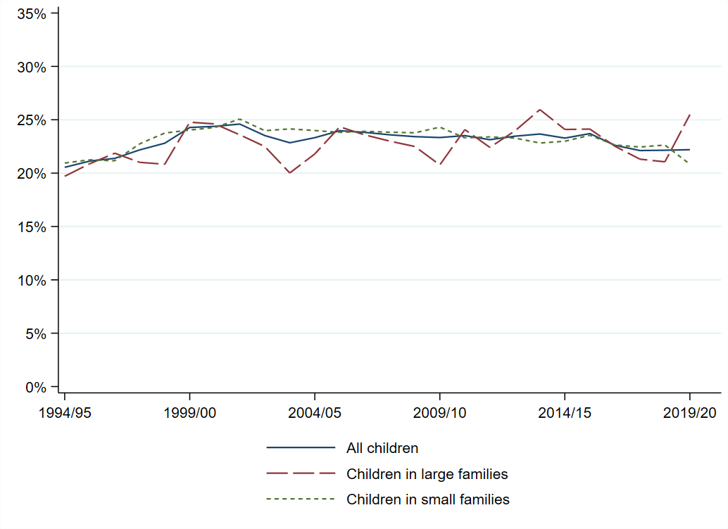
Source: Authors’ calculations using HBAI 15th edition (DWP, 2021).

