Appendices
Appendix 1: Summary of inspection frameworks
Appendix 1 table 1. Summary of inspections over time
Inspection framework |  | Time period** | Summary | Domains | Sub-domains
Safeguarding and Looked After Children Inspection (SLAC) |  | August 2009 – August 2012 | - | Safeguarding Overall effectiveness* | -
 |  |  |  | Looked After Children Overall Effectiveness
Child Protection Inspections (CPI) |  | July 2012 – August 2013 | Overall Effectiveness* | - | -
Targeted Looked After Children Inspection (TLAC) |  | August 2013 | Overall Effectiveness | - | -
Single Inspection Framework (SIF) |  | February 2014 – August 2018 | Overall Judgement | Children who need help and protection* | -
 |  |  |  | Children looked after and achieving permanence | Adoption Performance  Experiences and progress of care leavers
 |  |  |  | Leadership, management and governance | -
Inspection of Local Authority Children’s Services (ILACS) |  | March 2018 – September 2019 | Overall effectiveness | Impact of leaders | -
 |  |  |  | Experiences and progress of children who need help and protection*
 |  |  |  | Experiences and progress of children in care and care leavers
* Shaded cells represent the judgement category used as the exposure in our analyses
** Based on inspection report publication dates.

Appendix 1 table 2. Summary of inspection processes
Inspection | Time period* | Notice | Duration | Inspection process (for inspections resulting in four-point judgements)
Safeguarding and Looked After Children Inspection (SLAC) | Aug 09 – Aug 12 | ~10 working days | 10 working days | Review case files  Assess documents and data held by Ofsted and provided by the local authority  Conduct meetings or focus group discussions with key stakeholders including children, young people, their parents and carers  Evaluate the effectiveness of the Local Safeguarding Children Board  Consider findings of the separate unannounced inspection of front door arrangements  Evaluate progress against recommendations of any serious case reviews  Conduct survey of children
Child Protection Inspections (CPI) | Jul 12 – Aug 13 | None | 14 days | Review case files and meet with children, young people, parents and carers for a sample of cases  Shadow staff carrying out day-to-day work  Observe of multiagency meetings  Assess of documents and data held by Ofsted and provided by the local authority
Single Inspection Framework (SIF) | Feb 14 – Aug 18 | 1 day | ~ 9 days onsite | Evaluate a sample of children’s cases – alongside discussion with relevant professionals  Test decision-making at all stages of a child’s journey  Meet with children, young people, parents and carers  Shadow staff in day-to-day work  Observe multiagency meetings  Obtain and assess local authority data and performance information
Inspection of Local Authority Children’s Services (ILACS) | Mar 18 – Sept 19 | ~ 5 working days | Standard inspection:  3 weeks (2 of fieldwork)  Short inspection:  2 weeks (1 of fieldwork) | Obtain and assess local authority data, performance information and audits  Evaluate a sample of children’s cases – alongside discussion with relevant professionals  When possible and appropriate, meet with children, young people, parents and carers.  Shadow staff in day-to-day work  When possible and appropriate, observe multi-agency/single-agency meetings  Assess whether the local authority’s annual self-evaluation is accurate
* Based on inspection report publication dates.

Appendix 2: Summary of missing data
Appendix 2 table 1. Summary of missing data, 2010-2014 (complete data across all variables from 2015)
 |  | Year
 | Outcome | 2010 | 2011 | 2012 | 2013 | 2014
Missing observations; N (%) | CLA | 0 (0%) | 0 (0%) | 0 (0%) | 0 (0%) | 0 (0%)
 | CPP | 0 (0%) | 0 (0%) | 2 (1.4%) | 1 (0.7%) | 0 (0%)
 | CIN | 8 (5.4%) | 7 (4.8%) | 2 (1.4%) | 1 (0.7%) | 2 (1.4%)

Appendix 3: Model formulae
Let:
- ${Pr⁡(Y_{ij}=y}_{}) \sim Poisson(λ_{ij})$
- $λ_{ij}$denote the mean count of child welfare interventions in LA i in year j conditional of covariate values
- $x_{0ij}$ denote the child population in LA i in year j
- $x_{1ij}$denote inspection, coded as a binary variable and dependent on LA i and year j. The reference level is no inspection ($x_{1ij}=0$).
- $x_{2ij}$denote inspection judgement, coded as a categorical variable and dependent on LA i and year j. The reference level is no inspection ($x_{2ij}=0$).
- $x_{3i}$ denote the weighted rank of deprivation dependent on LA i, a continuous variable ranging from 0 to 1, from least to most deprived.
- $x_{4j}$ denote calendar time in years; a continuous variable centred at 2010
- $\left(U, V\right)\sim MVN(0,S)$ denote random intercept and slope for LA i
- $ε_{ij}\sim N (0, {s_{ε}}_{})$ denote the overdispersion random effect for LA i in year j, equivalent to the residual variance
- Regression model using binary inspection occurrence as the main exposure
  - Child welfare outcome: children entering care
$${log(λ}_{ij})= β_{0} {+ {log(x}_{0ij})+β}_{1}x_{ij}+ β_{3}x_{3i}+β_{4a}x_{4j}+{β_{4b}x_{4j}^{2}+ U}_{i} {+ V}_{i}x_{4j}+ε_{ij}$$
  - Child welfare outcome: children being placed in a child protection plan
$${log⁡(λ}_{ij})= β_{0} {+ {log⁡(x}_{0ij})+β}_{1}x_{1ij}+ β_{3}x_{3i}+β_{4a}x_{4j}+{β_{4b}x_{4j}^{2}+ U}_{i} {+ V}_{i}x_{4j}+ε_{ij}$$
  - Child welfare outcome: children beginning an episode of need placed in a child protection plan
$${log(λ}_{ij})= β_{0} {+ {log(x}_{0ij})+β}_{1}x_{1ij}+ β_{3}x_{3i}+β_{4a}x_{4j} {+{ U}_{i}+V}_{i}x_{4j}+ε_{ij}$$
- Regression model using categorical inspection judgement as the main exposure:
  - Child welfare outcome: children entering care
$${log(λ}_{ij})= β_{0} {+ {log(x}_{0ij})+ β}_{2}x_{2ij}+ β_{3}x_{3i}+β_{4a}+{β_{4b}x_{4j}^{2}+ U}_{i} {+ V}_{i}x_{4j}+ε_{ij}$$
  - Child welfare outcome: children being placed in a child protection plan
$${log(λ}_{ij})= β_{0} {+ {log(x}_{0ij})+ β}_{2}x_{2ij}+ β_{3}x_{3i}+β_{4a}+{β_{4b}x_{4j}^{2}+ U}_{i} {+ V}_{i}x_{4j}+ε_{ij}$$
  - Child welfare outcome: children beginning an episode of need placed in a child protection plan
$${log(λ}_{ij})= β_{0} {+ {log(x}_{0ij})+β}_{2}x_{2ij}+ β_{3}x_{3i}+β_{4a}x_{4j}+U_{i} {+ V}_{i}x_{4j}+ε_{ij}$$

- Regression model using categorical inspection judgement as the main exposure, and including an interaction between inspection judgement and deprivation
  - Child welfare outcome: children entering care
$${log(λ}_{ij})= β_{0} {+ {log(x}_{0ij})+ β}_{2}x_{2ij}+ β_{3}x_{3i}+β_{4a}x_{4j}+{β_{4b}x_{4j}^{2}+ β_{5}x_{2ij}x_{3i}+U}_{i} {+ V}_{i}x_{4j}+ε_{ij}$$
  - Child welfare outcome: children being placed in a child protection plan
$${log(λ}_{ij})= β_{0} {+ {log(x}_{0ij})+ β}_{2}x_{2ij}+ β_{3}x_{3i}+β_{4a}x_{4j}+{β_{4b}x_{4j}^{2}+ β_{5}x_{2ij}x_{3i}+U}_{i} {+ V}_{i}x_{4j}+ε_{ij}$$
  - Child welfare outcome: children beginning an episode of need placed in a child protection plan
$${log(λ}_{ij})= β_{0} {+ {log(x}_{0ij})+ β}_{2}x_{2ij}+ β_{3}x_{3i}+β_{4a}x_{4j}+{β_{5}x_{2ij}x_{3i}+U}_{i} {+ V}_{i}x_{4j}+ε_{ij}$$

Appendix 4: Trends in exposure
Appendix 4 figure 1 shows trends in inspection frequency, coloured by inspection judgement. It highlights the greater frequency of inspection between 2012 and 2013. The most common inspection judgement is ‘Requires improvement to be good’, followed by ‘Good’ and ‘Inadequate’ judgements. ‘Outstanding’ judgements are rare. This led us to group ‘Outstanding’ and ‘Good’ into a single category in our models.
Appendix 4 figure 1. Trends in inspection frequency, coloured by inspection judgement
Appendix 4 figure 2 shows the same plot, this time faceted by multiple deprivation quintile where quintile 1 is the least and quintile 5 the most deprived. Overall, the burden of inspection appears to fall relatively evenly across local authorities based on deprivation.
Appendix 4 figure 2. Trends in inspection frequency by multiple deprivation quintile, coloured by inspection judgement and faceted by year (1 = least deprived, and 5 = most deprived)
However, in appendix 4 figure 3, the horizontal line plot for the most deprived quintile of local authorities shows that, in the most deprived quintile of local authorities, there is a clear pattern of inspection judgement downgrading. Very few local authorities exhibit an ‘improvement journeys’. This is in contrast to all other quintiles, for which uprating and downgrading are both common.
Appendix 4 figure 3. Horizontal line plots showing trends in inspection judgement, faceted by local authority deprivation quintile. Each horizontal line represents a local authority. Colours represent inspection judgements. Within deprivation quintiles, lines are ordered by inspection judgement trajectory.
Appendix 5: Trends in outcomes
Appendix 5 figure 1 shows the social gradient across child welfare outcomes. Inequalities appear to be increasing for the more acute child welfare outcomes. There is no clear, consistent change in the trend in inequalities among children beginning an episode of need.
Appendix 5 figure 1. Trends in child welfare outcomes, by local authority deprivation quintile 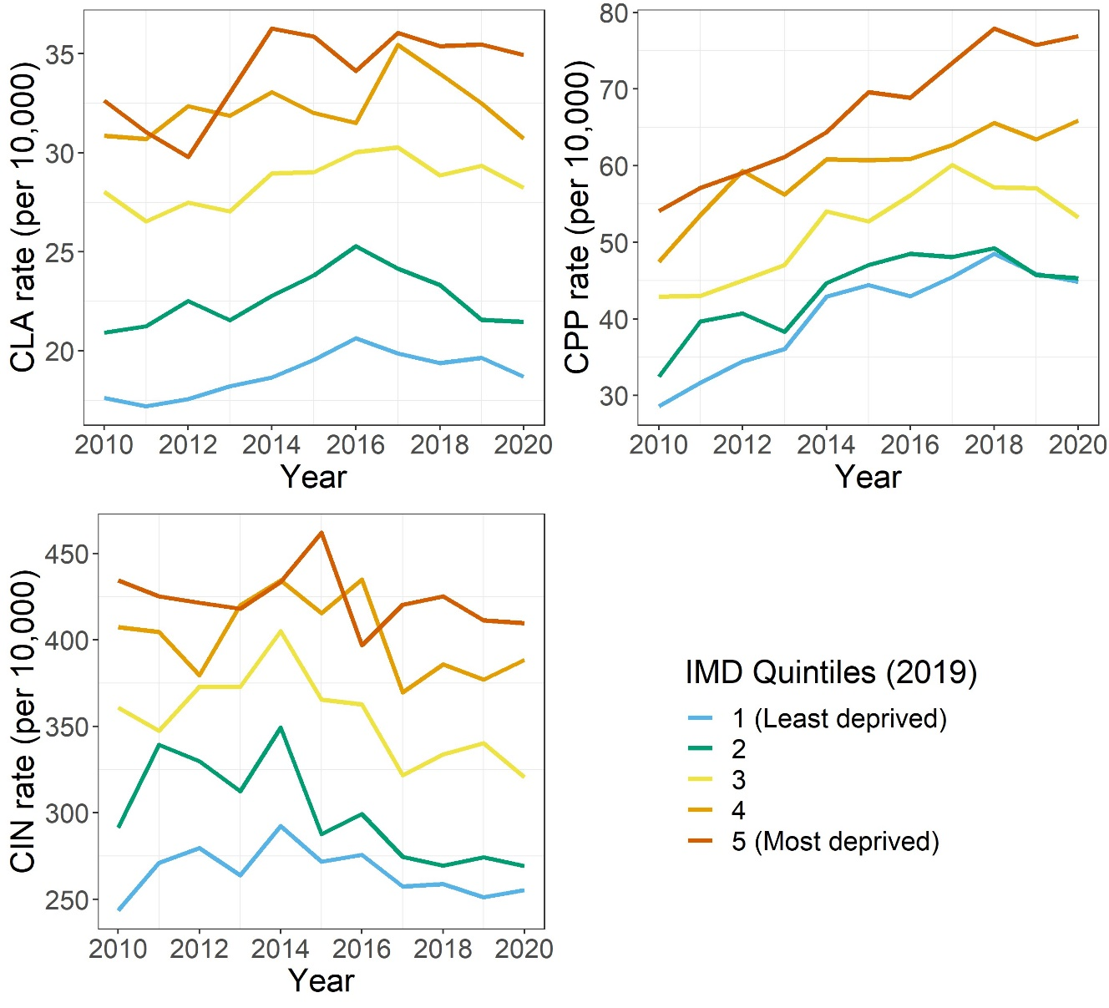
Appendix 6: Full model output
Appendix 6 table 1. Output of the Poisson models estimating the relative change in CLA rate, logged
 | Model 1 |  | Model 2 |  | Model 3
Parameter | Estimate | Std. Err. | Estimate | Err. | Estimate | Err.
Fixed part
${ β}_{0}$ Intercept | -6.478** | 0.039 | -6.478** | 0.039 | -6.469** | 0.039
${ β}_{1}$ Inspected | 0.023* | 0.008 | - | - | - | -
${ β}_{2a}$ Outstanding / Good | - | - | -0.004 | 0.015 | -0.026 | 0.034
${ β}_{2b}$ Requires improvement | - | - | 0.031** | 0.012 | 0.014 | 0.027
${ β}_{2c}$ Inadequate | - | - | 0.045* | 0.019 | -0.027 | 0.040
${ β}_{3}$ Deprivation | 0.838** | 0.057 | 0.836** | 0.057 | 0.822** | 0.058
${ β}_{4a}$ Year | 0.041** | 0.005 | 0.041** | 0.005 | 0.041** | 0.005
${ β}_{4b}$ Year squared | -0.003** | 0.000 | -0.003** | 0.000 | -0.003** | 0.000
${ β}_{5a}$ Outstanding / Good × Deprivation | - | - | - | - | 0.041 | 0.057
${ β}_{5b}$ Requires improvement × Deprivation | - | - | - | - | 0.030 | 0.042
${ β}_{5c}$ Inadequate × Deprivation | - | - | - | - | 0.125* | 0.061
Parameter | Estimate | Std. Dev. | Estimate | Std. Dev. | Estimate | Std. Dev.
Random part: LA level
Intercept variance | 0.064 | 0.253 | 0.064 | 0.253 | 0.064 | 0.254
Slope variance | 0.001 | 0.030 | 0.001 | 0.030 | 0.001 | 0.030
Intercept-slope correlation | -0.64 |  | -0.64 |  | -0.64
Random part: observation level
Intercept variance | 0.019 | 0.137 | 0.019 | 0.136 | 0.019 | 0.136
Deviance | 15973.7 |  | 15968.5 |  | 15963.6
Log likelihood | -7986.8 |  | -7984.3 |  | -7981.8
Number of local authorities | 147 |  | 147 |  | 147
Number of observations | 1617 |  | 1617 |  | 1617
Note: the outcome is the log of the relative change in the CLA rate per 10,000 children.
Note: * p < 0.05, ** p < 0.01

Appendix 6 table 2. Output of the Poisson models estimating the relative change in CPP rate, logged
 | Model 1 |  | Model 2 |  | Model 3
Parameter | Estimate | Std. Err. | Estimate | Err. | Estimate | Err.
Fixed part
${ β}_{0}$ Intercept | -5.952** | 0.042 | -5.950** | 0.042 | -5.949** | 0.043
${ β}_{1}$ Inspected | 0.030** | 0.011 | - | - | - | -
${ β}_{2a}$ Outstanding / Good | - | - | -0.026 | 0.019 | -0.018 | 0.041
${ β}_{2b}$ Requires improvement | - | - | 0.041** | 0.015 | 0.024 | 0.032
${ β}_{2c}$ Inadequate | - | - | 0.094** | 0.023 | 0.121* | 0.048
${ β}_{3}$ Deprivation | 0.739** | 0.064 | 0.737** | 0.063 | 0.737** | 0.064
${ β}_{4a}$ Year | 0.088** | 0.006 | 0.087** | 0.006 | 0.087** | 0.006
${ β}_{4b}$ Year squared | -0.005** | 0.001 | -0.005** | 0.001 | -0.005** | 0.001
${ β}_{5a}$ Outstanding / Good × Deprivation | - | - | - | - | -0.016 | 0.069
${ β}_{5b}$ Requires improvement × Deprivation | - | - | - | - | 0.031 | 0.051
${ β}_{5c}$ Inadequate × Deprivation | - | - | - | - | -0.046 | 0.075
Parameter | Estimate | Std. Dev. | Estimate | Std. Dev. | Estimate | Std. Dev.
Random part: LA level
Intercept variance | 0.062 | 0.249 | 0.062 | 0.249 | 0.062 | 0.249
Slope variance | 0.001 | 0.033 | 0.001 | 0.033 | 0.001 | 0.033
Intercept-slope covariance | -0.50 |  | -0.51 |  | -0.51
Random part: observation level
Intercept variance | 0.034 | 0.184 | 0.034 | 0.183 | 0.034 | 0.183
Deviance | 18574.5 |  | 18556.1 |  | 18555.9
Log likelihood | -9287.3 |  | -9278.4 |  | -9278.0
Number of local authorities | 147 |  | 147 |  | 147
Number of observations | 1614 |  | 1614 |  | 1614
Note: the outcome is the log of the relative change in the CPP rate per 10,000 children.
Note: * p < 0.05, ** p < 0.01

Appendix 6 table 3. Output of the Poisson models estimating the relative change in CIN rate, logged
 |  | Model 1 |  | Model 2 |  | Model 3
Parameter |  | Estimate | Std. Err. | Estimate | Err. | Estimate | Err.
Fixed part
${ β}_{0}$ Intercept |  | -3.744** | 0.041 | -3.744** | 0.042 | -3.749** | 0.042
${ β}_{1}$ Inspected |  | 0.051** | 0.012 | - | - | - | -
${ β}_{2a}$ Outstanding / Good |  | - | - | 0.015 | 0.021 | 0.017 | 0.056
${ β}_{2b}$ Requires improvement |  | - | - | 0.052** | 0.017 | 0.033 | 0.035
${ β}_{2c}$ Inadequate |  | - | - | 0.110** | 0.026 | 0.252** | 0.055
${ β}_{3}$ Deprivation |  | 0.686** | 0.058 | 0.684** | 0.058 | 0.694** | 0.059
${ β}_{4a}$ Year |  | -0.007 | 0.004 | -0.007 | 0.004 | -0.007 | 0.004
${ β}_{4b}$ Year squared |  | - | - | - | - | - | -
${ β}_{5a}$ Outstanding / Good × Deprivation |  | - | - | - | - | -0.003 | 0.076
${ β}_{5b}$ Requires improvement × Deprivation |  | - | - | - | - | 0.035 | 0.065
${ β}_{5c}$ Inadequate × Deprivation |  | - | - | - | - | -0.249** | 0.085
Parameter |  | Estimate | Std. Dev. | Estimate | Std. Dev. | Estimate | Std. Dev.
Random part: LA level
Intercept variance |  | 0.089 | 0.298 | 0.091 | 0.301 | 0.091 | 0.301
Slope variance |  | 0.001 | 0.038 | 0.001 | 0.038 | 0.001 | 0.038
Intercept-slope covariance |  | -0.77 |  | -0.77 |  | -0.77
Random part: observation level
Intercept variance |  | 0.046 | 0.215 | 0.046 | 0.214 | 0.046 | 0.213
Deviance |  | 24692.0 |  | 24683.8 |  | 24674.4
Log likelihood |  | -12346.0 |  | -12341.9 |  | -12337.2
Number of local authorities |  | 147 |  | 147 |  | 147
Number of observations |  | 1597 |  | 1597 |  | 1597
Note: the outcome is the log of the relative change in the CIN rate per 10,000 children.
Note: * p < 0.05, ** p < 0.01

Appendix 7: Visualising model 3 interactions for CIN
Appendix 7 figure 1. Model 3 inspection judgement by deprivation interactions for CIN, reference year 2010