Welfare Attitudes in Crisis:
The Role of Ideology in Healthcare Satisfaction in Portugal and Ireland
Online Appendix

Table 1. Fieldwork period, response rates, total number of observations and valid observations in the seven ESS modules in Ireland and Portugal

 | Module | Field work started |  |  | Fieldwork ended |  |  | Response Rates | Observations | Valid observations
 |  | Day | Month | Year | Day | Month | Year
Ireland | 3 | 2 | Jan | 2006 | 15 | Nov | 2007 | 51.6 | 1,800 | 1,218
Ireland | 4 | 11 | Sep | 2009 | 12 | Mar | 2010 | 64.5 | 1,764 | 1,580
Ireland | 5 | 1 | Aug | 2011 | 5 | Feb | 2012 | 65.2 | 2,576 | 2,034
Ireland | 6 | 22 | Oct | 2012 | 9 | Feb | 2013 | 67.9 | 2,628 | 2,120
Ireland | 7 | 4 | Sep | 2014 | 31 | Jan | 2015 | 60.7 | 2,390 | 1,802
Portugal | 3 | 12 | Oct | 2006 | 28 | Feb | 2007 | 75.7 | 2,222 | 1,458
Portugal | 4 | 22 | Oct | 2008 | 8 | Mar | 2009 | 68.8 | 2,367 | 1,499
Portugal | 5 | 6 | Nov | 2010 | 25 | Mar | 2011 | 67.1 | 2,150 | 1,367
Portugal | 6 | 7 | Oct | 2012 | 20 | Mar | 2013 | 77.1 | 2,151 | 1,412
Portugal | 7 | 8 | Feb | 2015 | 29 | Nov | 2015 | 43.0 | 1,265 | 1,070

Table 2. OLS models of healthcare satisfaction in Portugal and Ireland

 | PORTUGAL |  |  | IRELAND
 | M1 | M2 | M3 | M4 | M5 | M6
IE:2009, PT:2008 | 0.000 | 0.000 | 0.000 | 0.000 | 0.000 | 0.000
 | (.) | (.) | (.) | (.) | (.) | (.)
IE:2011, PT:2010 | 0.417*** | 0.915* | 1.239 | 0.086 | 0.447 | 0.857
 | (0.095) | (0.417) | (0.916) | (0.081) | (0.343) | (0.718)
IE:2012, PT:2012 | 0.225* | 0.696 | 1.885* | -0.019 | 0.694* | 1.827*
 | (0.098) | (0.445) | (0.880) | (0.082) | (0.340) | (0.715)
IE:2014, PT:2015 | 0.272* | 0.134 | 0.913 | -0.575*** | 0.189 | 1.943**
 | (0.111) | (0.445) | (0.834) | (0.089) | (0.351) | (0.715)
Subjective income | -0.214*** | -0.193* | 0.083 | -0.183*** | -0.092 | 0.595*
 | (0.056) | (0.090) | (0.224) | (0.038) | (0.081) | (0.292)
Ideology (L-R) | 0.057** | 0.091* | 0.235* | 0.048** | 0.113** | 0.375***
 | (0.020) | (0.037) | (0.115) | (0.018) | (0.037) | (0.102)
Female | -0.125 | -0.128 | -0.128 | -0.313*** | -0.313*** | -0.308***
 | (0.077) | (0.077) | (0.076) | (0.061) | (0.061) | (0.061)
Age | 0.006 | 0.005 | 0.005 | -0.003 | -0.003 | -0.003
 | (0.003) | (0.003) | (0.003) | (0.003) | (0.003) | (0.002)
Education
Low education = baseline | 0.000 | 0.000 | 0.000 | 0.000 | 0.000 | 0.000
 | (.) | (.) | (.) | (.) | (.) | (.)
Middle education | -0.122 | -0.127 | -0.120 | -0.148 | -0.148* | -0.140
 | (0.108) | (0.108) | (0.108) | (0.076) | (0.076) | (0.076)
High education | 0.046 | 0.045 | 0.048 | -0.145 | -0.148 | -0.140
 | (0.109) | (0.108) | (0.108) | (0.078) | (0.078) | (0.078)
Health Status
Very good = baseline | 0.000 | 0.000 | 0.000 | 0.000 | 0.000 | 0.000
 | (.) | (.) | (.) | (.) | (.) | (.)
Good | -0.230 | -0.218 | -0.219 | -0.069 | -0.075 | -0.064
 | (0.125) | (0.125) | (0.125) | (0.064) | (0.064) | (0.064)
Fair | -0.211 | -0.196 | -0.194 | -0.200 | -0.207* | -0.193
 | (0.140) | (0.140) | (0.140) | (0.103) | (0.103) | (0.103)
Bad | -0.712*** | -0.696*** | -0.694*** | -0.248 | -0.250 | -0.255
 | (0.195) | (0.195) | (0.195) | (0.238) | (0.238) | (0.238)
Very bad | -1.414*** | -1.384*** | -1.379*** | -0.575 | -0.552 | -0.667
 | (0.341) | (0.339) | (0.339) | (0.592) | (0.594) | (0.540)
Illness impediments | 0.272* | 0.269* | 0.273* | 0.059 | 0.061 | 0.065
 | (0.119) | (0.119) | (0.118) | (0.096) | (0.095) | (0.095)
Married (0/1) | 0.048 | 0.050 | 0.051 | -0.070 | -0.068 | -0.061
 | (0.082) | (0.082) | (0.082) | (0.066) | (0.066) | (0.066)
Kids at home (0/1) | 0.039 | 0.033 | 0.032 | 0.027 | 0.030 | 0.032
 | (0.083) | (0.084) | (0.083) | (0.066) | (0.067) | (0.066)
Migrant | 0.405* | 0.408* | 0.408* | 0.611*** | 0.613*** | 0.613***
 | (0.164) | (0.163) | (0.162) | (0.091) | (0.090) | (0.090)
Employment status
Paid work = baseline | 0.000 | 0.000 | 0.000 | 0.000 | 0.000 | 0.000
 | (.) | (.) | (.) | (.) | (.) | (.)
In education | 0.665*** | 0.669*** | 0.672*** | 0.309* | 0.312* | 0.308*
 | (0.163) | (0.163) | (0.163) | (0.124) | (0.124) | (0.123)
Unemployed | 0.163 | 0.173 | 0.168 | 0.420*** | 0.419*** | 0.418***
 | (0.127) | (0.127) | (0.127) | (0.099) | (0.099) | (0.099)
Retired | 0.162 | 0.167 | 0.165 | 0.478*** | 0.476*** | 0.471***
 | (0.132) | (0.132) | (0.132) | (0.106) | (0.106) | (0.106)
Permanently sick/disabled | 0.011 | -0.011 | -0.010 | 0.109 | 0.103 | 0.115
 | (0.369) | (0.366) | (0.366) | (0.232) | (0.233) | (0.231)
Other status | 0.248 | 0.252 | 0.248 | -0.063 | -0.059 | -0.069
 | (0.164) | (0.165) | (0.165) | (0.089) | (0.089) | (0.089)
Government partisan | 0.435*** | 0.419*** | 0.424*** | 0.073 | 0.060 | 0.058
 | (0.079) | (0.085) | (0.085) | (0.061) | (0.061) | (0.061)
Satisfaction with economy | 0.242*** | 0.242*** | 0.242*** | 0.368*** | 0.368*** | 0.369***
 | (0.022) | (0.022) | (0.022) | (0.016) | (0.016) | (0.016)
Redistributive values | -0.173** | -0.174** | -0.174** | -0.099*** | -0.102*** | -0.100***
 | (0.053) | (0.053) | (0.053) | (0.030) | (0.030) | (0.030)
IE:2009, PT:2008 # Subjective income |  | 0.000 | 0.000 |  | 0.000 | 0.000
 |  | (.) | (.) |  | (.) | (.)
IE:2011, PT:2010 # Subjective income |  | -0.038 | -0.168 |  | -0.105 | -0.377
 |  | (0.130) | (0.362) |  | (0.099) | (0.344)
IE:2012, PT:2012 # Subjective income |  | -0.174 | -0.651* |  | -0.180 | -0.764*
 |  | (0.133) | (0.329) |  | (0.100) | (0.346)
IE:2014, PT:2015 # Subjective income |  | 0.139 | -0.174 |  | -0.024 | -0.911**
 |  | (0.139) | (0.318) |  | (0.107) | (0.348)
IE:2009, PT:2008 # Ideology (L-R) |  | 0.000 | 0.000 |  | 0.000 | 0.000
 |  | (.) | (.) |  | (.) | (.)
IE:2011, PT:2010 # Ideology (L-R) |  | -0.084 | -0.154 |  | -0.029 | -0.105
 |  | (0.052) | (0.167) |  | (0.050) | (0.132)
IE:2012, PT:2012 # Ideology (L-R) |  | -0.009 | -0.257 |  | -0.068 | -0.289*
 |  | (0.054) | (0.167) |  | (0.049) | (0.130)
IE:2014, PT:2015 # Ideology (L-R) |  | -0.038 | -0.201 |  | -0.142** | -0.485***
 |  | (0.056) | (0.158) |  | (0.050) | (0.131)
Subjective income # Ideology (L-R) |  |  | -0.058 |  |  | -0.136*
 |  |  | (0.044) |  |  | (0.054)
IE:2009, PT:2008 # Subjective income # Ideology (L-R) |  |  | 0.000 |  |  | 0.000
 |  |  | (.) |  |  | (.)
IE:2011, PT:2010 # Subjective income # Ideology (L-R) |  |  | 0.029 |  |  | 0.052
 |  |  | (0.066) |  |  | (0.064)
IE:2012, PT:2012 # Subjective income # Ideology (L-R) |  |  | 0.100 |  |  | 0.116
 |  |  | (0.063) |  |  | (0.064)
IE:2014, PT:2015 # Subjective income # Ideology (L-R) |  |  | 0.066 |  |  | 0.176**
 |  |  | (0.061) |  |  | (0.065)
Constant | 4.196*** | 3.994*** | 3.298*** | 3.889*** | 3.386*** | 2.023***
 | (0.354) | (0.429) | (0.667) | (0.225) | (0.316) | (0.601)
Observations | 5466 | 5466 | 5466 | 7637 | 7637 | 7637
AIC | 23881.727 | 23879.288 | 23882.277 | 33585.668 | 33578.694 | 33565.398
R² | 0.107 | 0.110 | 0.110 | 0.162 | 0.164 | 0.166
Standard errors in parentheses
Post-stratification weights applied
* p < 0.05, ** p < 0.01, *** p < 0.001

Table 3. Summary Statistics of the Irish and Portuguese sample

 | IRELAND |  |  |  |  | PORTUGAL
 | Mean | Standard Deviation | Min | Max |  | Mean | Standard Deviation | Min | Max
Healthcare Satisfaction | 4.125 | 2.420 | 0 | 10 |  | 4.388 | 2.277 | 0 | 10
Subjective income
Living comfortably | 0.255 | 0.436 | 0 | 1 |  | 0.076 | 0.266 | 0 | 1
Coping | 0.480 | 0.500 | 0 | 1 |  | 0.501 | 0.5 | 0 | 1
Difficult | 0.188 | 0.390 | 0 | 1 |  | 0.311 | 0.311 | 0 | 1
Very difficult | 0.078 | 0.269 | 0 | 1 |  | 0.112 | 0.315 | 0 | 1
Ideology (L-R) | 5.082 | 1.758 | 0 | 10 |  | 4.892 | 2.185 | 0 | 10
Employment status

Employed | 0.425 | 0.494 | 0 | 1 |  | 0.407 | 0.491 | 0 | 1
In education | 0.067 | 0.250 | 0 | 1 |  | 0.051 | 0.220 | 0 | 1
Unemployed | 0.117 | 0.322 | 0 | 1 |  | 0.093 | 0.290 | 0 | 1
Retired | 0.195 | 0.396 | 0 | 1 |  | 0.342 | 0.475 | 0 | 1
Sick/disabled | 0.031 | 0.174 | 0 | 1 |  | 0.015 | 0.122 | 0 | 1
Other | 0.165 | 0.371 | 0 | 1 |  | 0.091 | 0.288 | 0 | 1
Education
Low | 0.363 | 0.481 | 0 | 1 |  | 0.697 | 0.460 | 0 | 1
Middle | 0.311 | 0.463 | 0 | 1 |  | 0.172 | 0.378 | 0 | 1
High | 0.326 | 0.469 | 0 | 1 |  | 0.131 | 0.337 | 0 | 1
Subjective health status
Very good | 0.381 | 0.486 | 0 | 1 |  | 0.108 | 0.311 | 0 | 1
Good | 0.431 | 0.495 | 0 | 1 |  | 0.405 | 0.491 | 0 | 1
Fair | 0.158 | 0.364 | 0 | 1 |  | 0.357 | 0.479 | 0 | 1
Bad | 0.026 | 0.159 | 0 | 1 |  | 0.108 | 0.311 | 0 | 1
Very bad | 0.061 | 0.062 | 0 | 1 |  | 0.022 | 0.146 | 0 | 1
Female | 0.523 | 0.500 | 0 | 1 |  | 0.577 | 0.494 | 0 | 1
Age | 48.646 | 17.731 | 15 | 101 |  | 53.426 | 18.646 | 15 | 97
Illness impediments | 0.179 | 0.383 | 0 | 1 |  | 0.199 | 0.399 | 0 | 1
Married (0/1) | 0.543 | 0.498 | 0 | 1 |  | 0.594 | 0.491 | 0 | 1
Kids at home (0/1) | 0.386 | 0.487 | 0 | 1 |  | 0.338 | 0.473 | 0 | 1
Migrant | 0.134 | 0.340 | 0 | 1 |  | 0.057 | 0.232 | 0 | 1
Government support | 0.385 | 0.487 | 0 | 1 |  | 0.304 | 0.460 | 0 | 1
Observations | 7637 |  |  |  |  | 5466

Figure 1. Predicted levels and changes in healthcare satisfaction in Germany, by income and ideology
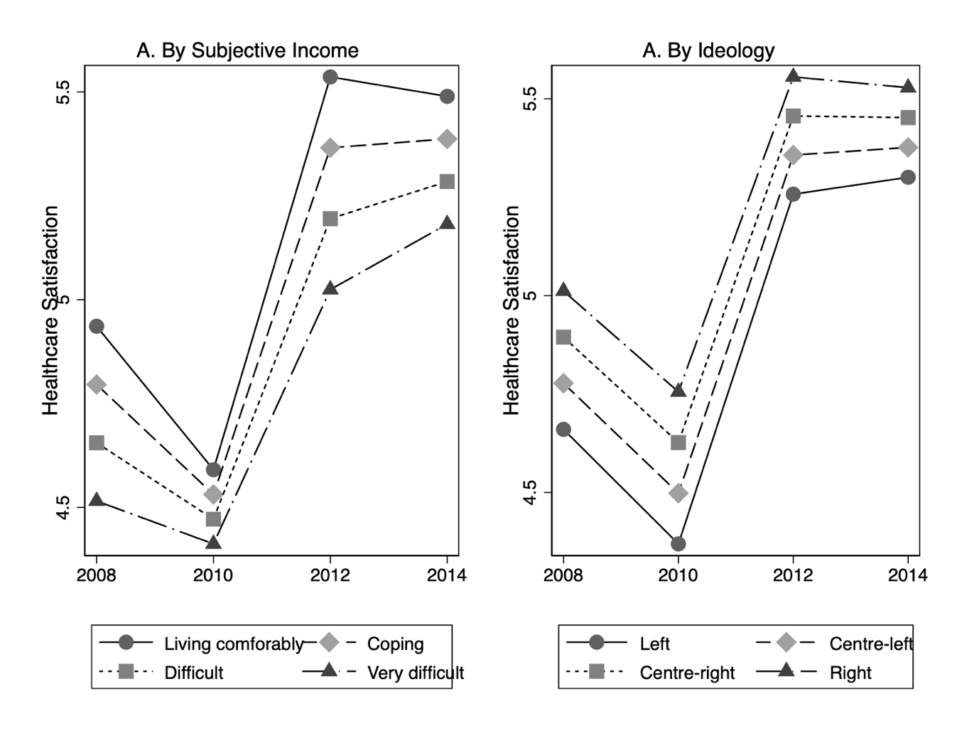
Note: Predicted probabilities and marginal changes calculated based on OLS regression of healthcare satisfaction on ideology, subjective income and same set as control variables as in the main analysis.

Figure 2. Predicted healthcare satisfaction for the high and low income groups in Germany, by ideological position.
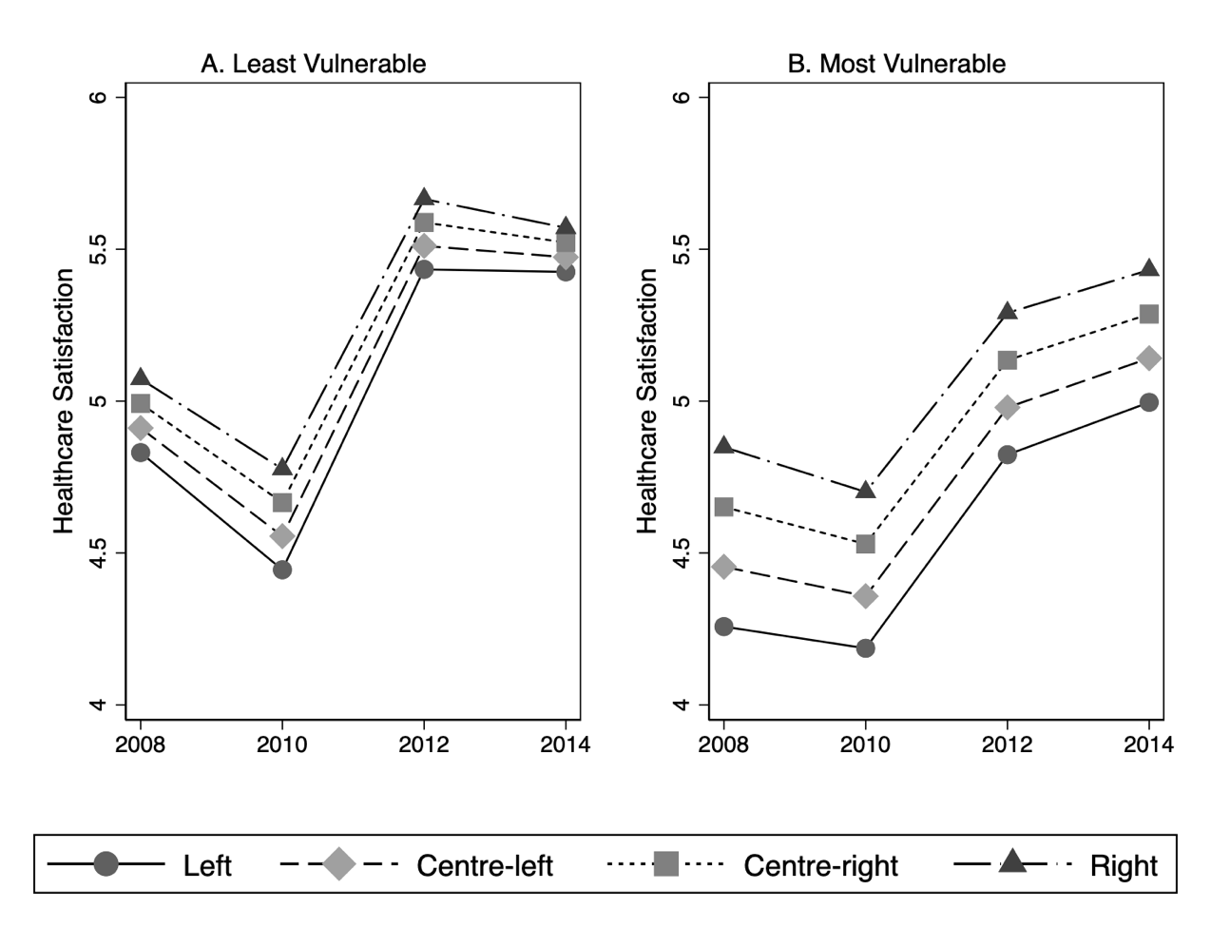
Note: Predicted probabilities and marginal changes calculated based on OLS regression of healthcare satisfaction on ideology, subjective income and same set as control variables as in the main analysis.
Figure 3. Income Distribution in Ireland and Portugal (2008-2015)
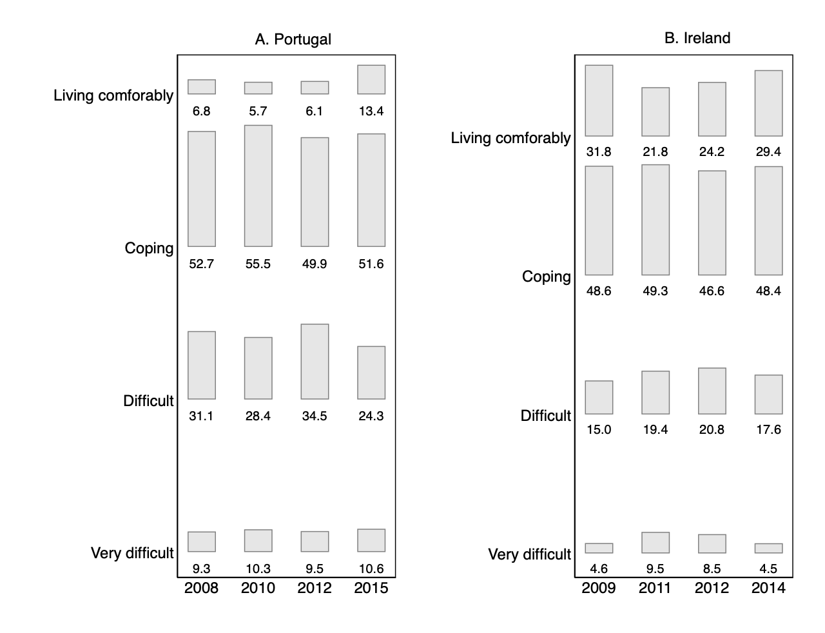
Figure 4. Ideology Distribution in Ireland and Portugal (2008-2015)
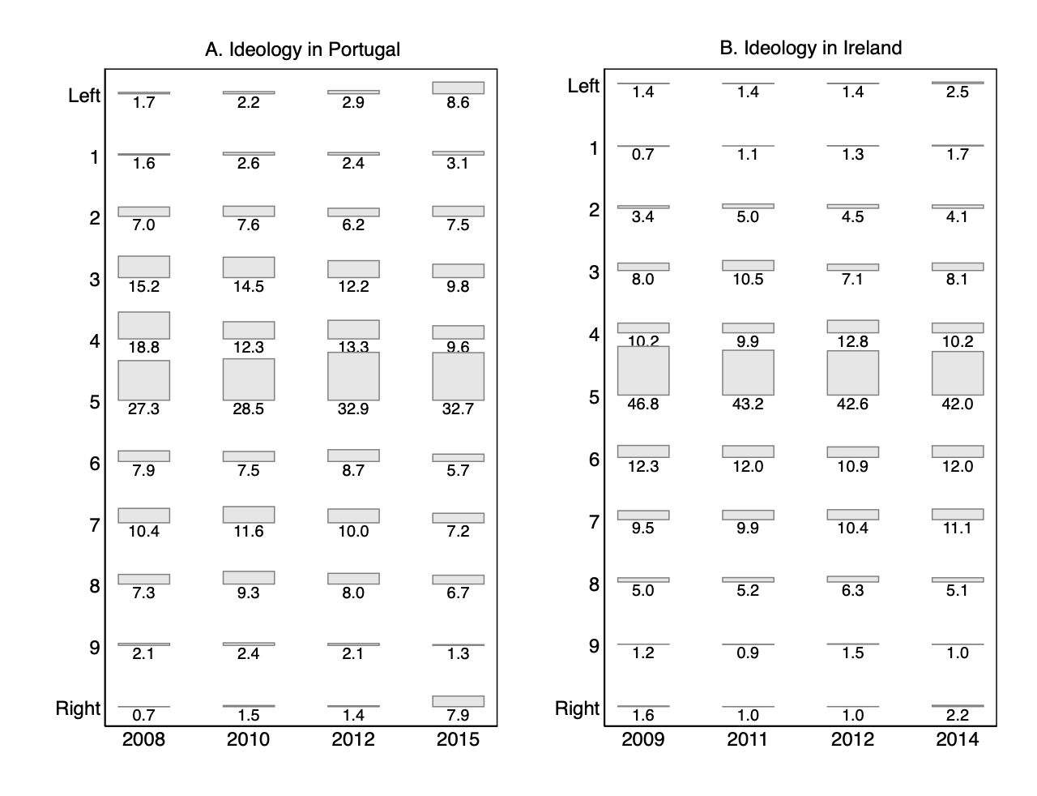
Figure 5. Predicted healthcare satisfaction in Ireland & Portugal, by health status
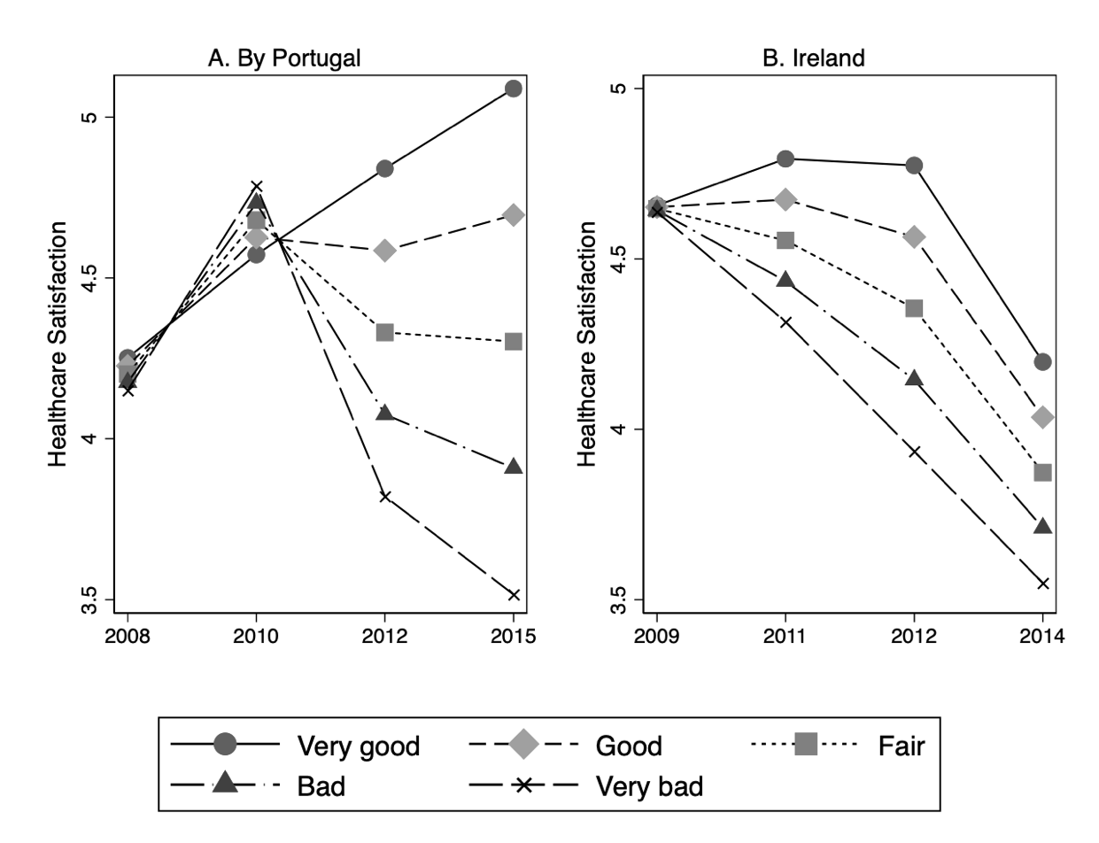
Note: Predicted probabilities and marginal changes calculated based on OLS regression of healthcare satisfaction on ideology, subjective health and same set as control variables as in the main analysis.

Figure 6. Predicted healthcare satisfaction for the groups with good and bad health in Portugal, by ideological position.
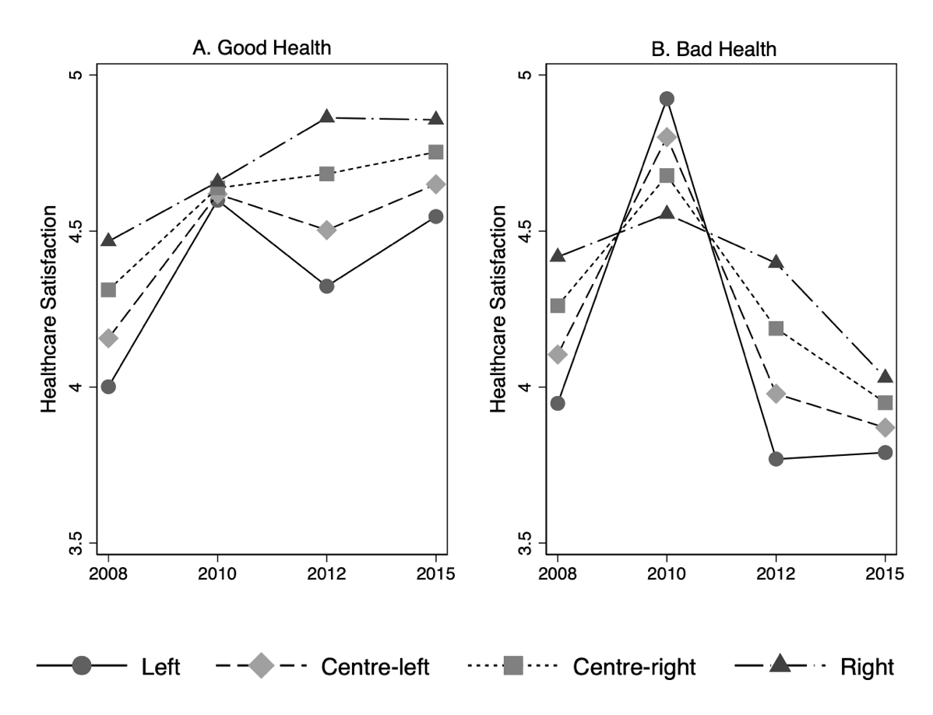
Note: Predicted probabilities and marginal changes calculated based on OLS regression of healthcare satisfaction on ideology, subjective income and same set as control variables as in the main analysis.

Figure 7. Predicted healthcare satisfaction for the groups with good and bad health in Ireland, by ideological position.
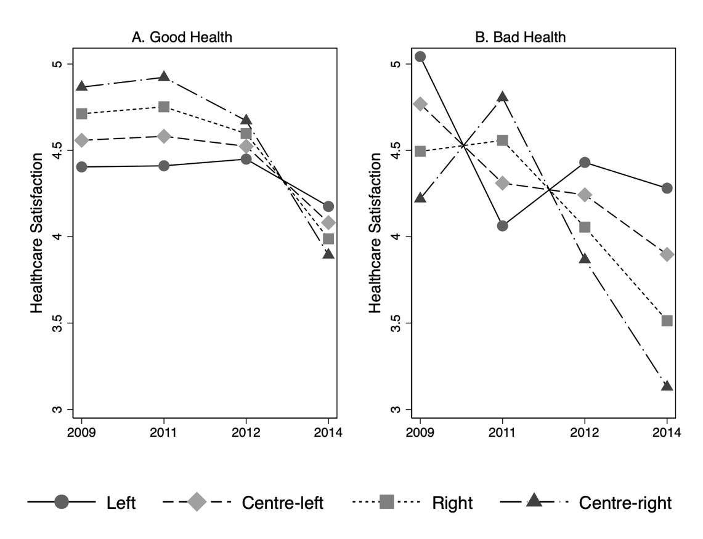
Note: Predicted probabilities and marginal changes calculated based on OLS regression of healthcare satisfaction on ideology, subjective income and same set as control variables as in the main analysis.

