ONLINE SUPPLEMENTARY MATERIAL
I. Comparison of sample characteristics (n=119) with characteristics of all Flemish municipalities (n=300)
Figure 1. Municipality size (number of residents)

Note: We define small municipalities as municipalities with less than 20 000 residents, medium municipalities with between 20 000 and 40 000 residents and large municipalities with more than 40 000 residents.

Source: Flemish statistical agency (2020). Structuur van de bevolking [Data file]. Retrieved from https://statistieken.vlaanderen.be/QvAJAXZfc/notoolbar.htm?document=SVR%2FSV-Demografie-Stand-Bevolking_fusie2019.qvw&host=QVS%40cwv100154&anonymous=true

Figure 2. Social assistance beneficiaries per 1000 residents in the municipality

Source: Federal Planning Service (PPS) Social Integration (2020). Verdeling van de gemeenten volgens het aantal LL per 1000 inwoners [Data file]. Retrieved from https://stat.mi-is.be/nl/dashboard/ris_cities?menu=map
Figure 3: Median income in the municipality
Source: Belgian statistical office (Statbel) (2017). Fiscale inkomens: inkomstenjaar 2016 [Data file]. Retrieved from https://statbel.fgov.be/nl/themas/huishoudens/fiscale-inkomens#panel-13

Figure 4: Percentage of foreigners in the municipality

Source: Flemish statistical agency (2020). Structuur van de bevolking: % vreemdelingen [Data file]. Retrieved from https://statistieken.vlaanderen.be/QvAJAXZfc/notoolbar.htm?document=SVR%2FSV-Demografie-Stand-Bevolking_fusie2019.qvw&host=QVS%40cwv100154&anonymous=true

II. Vignettes used in online questionnaire
Vignette J.
Jacob is a 22-year old man with the Belgian nationality. He moved to your municipality a few months ago, because he occasionally did interim work here and found a cheap studio to rent. In the meantime, it has been two months since an interim agency contacted him, and his reserves are running out. At the moment, he still has 100 euros in his account. He missed last month's rent (300 euros), and the next payment is coming up. Jacob's parents receive social assistance benefits (two times a benefit for cohabiting persons) in a neighboring municipality. Jacob decided one year ago, after several attempts with part-time learning, to quit high school. In that year he occasionally did interim work, but did not succeed in keeping a job for a longer period of time. The relationship with his parents is rather good, but he is convinced that going back home is not an option. His parents live in a small apartment.
Jacob comes to your welfare office and wants to apply for a social benefit.
[…]
A home visit takes place at Jacob’s studio. During this visit a woman is present who is painting Jacob's bedroom. Jacob declares that she is a good friend of him. The woman has a large backpack with her. She says it contains some extra clothes and an extra pair of shoes. Furthermore, there are no elements in the house that explicitly indicate that the woman is living with Jacob.

Vignette V.:
A neighboring school contacts your welfare office. They tell you about a family with three children whose parents have recently divorced. The school only has contact with the mother, Vanessa (24 years old). The children are 5, 3 and 1 years old. The school worries about the children: they do not wear a winter coat and do not always bring food to school. The school doesn't know much about the mother, but it seems she is on her own. When confronted with unpaid bills, she says she has no money. The school advised Vanessa to visit the local welfare office which Vanessa refused because she already heard a lot of negative stories about going to the welfare office.
The school contacts your welfare office for advice about what to do next.
[…]
A home visit takes place with Vanessa. During the home visit, Vanessa does not open the door after calling several times.
[…]
The social investigation is finished. It was however not possible to meet Vanessa during a home visit before the next decision committee.

III. Description of the items and aspects of social assistance provision used
Table 1. Aspects of social assistance provision and questions
Aspect | Indicator variable | Description | Response scale/coding | Proportion | Mean (SD)
Information provision | Info intake | Which of the following documents does claimant J. receive during his intake conversation? †  - List of documents he needs to collect and hand in  - List of important dates (e.g. date next appointment)  - Contact information social worker | 1: none of the 3 documents  2: one or two of the 3 documents  3: all three documents | .038  .389  .573
 | Info language | In which of the following ways is information about the services of the welfare office distributed? ‡  - Via leaflets in other languages  - Via the website in other languages | Count variable [0-2] |  | 0 (.027)
 | Standardized documents | For which elements of the social investigation does the welfare office provide standardized documents? ‡  - Intake  - Application form  - Permission to request information from third parties  - The home visit  - Description of the means of subsistence  - Description of expenses  - Personal information  - Checklist with (other) social rights  - Standardized social report | Count variable [0-9] |  | 5 (.164)
Accessibility | Late opening | Can clients go to the welfare office in the evening for information about its services? | 1: No  2: Yes, once per month  3: Yes, on appointment or once per week  4: Yes, multiple evenings per week  5:Yes, every evening | .130  .048  .177  .637  .010
 | Infrastructure | Which of the following elements is present in the building of your welfare office? ‡  - Rooms on the ground floor  - Wide doors and corridors  - A reception desk accessible with a wheelchair  - Automatic opening of doors  - Inclined plane for wheelchairs  - Elevator(s) | Count variable [0-6] |  | 4 (.130)
 | Feel welcome | How many of the following elements is present in the building of your welfare office?  - there is glass between the receptionist and claimant  - claimants have to ring the bell before entering the building | 1: both answers apply  2: one of the two answers apply  3: neither of the two answers apply | .038  .334  .628
 | Shared location | Where is the welfare office you are working, located? | 1: It is a separate building  2: It is located in a common building with different services, but has an own reception  3: it is located in a common building with different services with a common reception | .462  .230  .309
Trust | Unexpected event | During a home visit of a single person (J.) there are indications that the claimant lives together with a partner. Does this change the procedure for the home visit and application? † | 1: new application (for couples instead of singles) is necessary  2: another home visit is necessary  3: no impact, continue with current application | .017  .845  .138
 | Double check | Which of the following documents necessary for the social investigation do you double check (i.e. ask the respondent to provide and request yourself)? | 1: 15 documents or more  2: between 8 and 14 documents  3: between 1 and 7 documents  4: none | .014  .140  .541  .305
 | Missed home visit | It is not possible to visit claimant V. at home before the next decision committee. What consequences will this have for the claimant’s application? † | 1: the application is rejected  2: the decision regarding the application is postponed until a home visit is done  3: the application can continue and we will try to schedule a home visit later | .167  .511  .322
Locus of initiative | Outreach | A school in your municipality contacts you because she suspects that a single mother (V.) could use the help of the welfare agency. Which action is usually taken in this situation? † | 1: we give the school some advice on how to convince the mother to come to our office  2: we ask the school to convince the mother to call us or to assists her with calling us  3: we ask the school the mother’s phone number and try to contact her  4: we go to the school and try to meet the mother there  5: we go to visit the family at their house | .266  .410  .160  .062  .103
 | Closed door | During the home visit claimant V. does not open the door, what do you do? † | 1: nothing or only let know that I came by  2: I try to contact the claimant afterwards  3: I pass by another time | .004  .821  .175
 | Appointment | In which of the following ways can a new client make an appointment? ‡  - By registering at the reception desk  - By making an appointment by phone  - By sending an email  - Via an electronic application form  - A referring person (doctor, teacher, employer, volunteer...) can make an appointment on behalf of the client. | Count variable [0-4] |  | 4 (.063)
† This question is based on a vignette story in which we give more information about the household.
‡ Count variable created from the original variable.

IV. Exploratory Factor Analysis
Our survey collected ample information on implementation practices regarding different aspects of social assistance provision. In our paper we tried to identify different set of practices that clustered together using Exploratory Factor Analysis (EFA), followed by Confirmatory Factor Analysis (CFA).
In a first step, we performed EFA to identify the main latent factors (or underlying domains) of our set of items. To evaluate the adequacy of our sample for factor analysis the Kaiser-Meyer-Olkin (KMO) test and Bartlett’s test of sphericity were applied (Ferguson and Cox, 1993). With a sample of 163 observations, KMO was .60 and the Barlett’s test of sphericity was significant (χ2(190) = 358.142, p < .001) indicating that our sample was adequate for EFA. Using iterative factor analysis, four items were dropped based on the assessment of the item loadings and uniquenesses (Tabachnick et al., 2007). Table 1 shows the results of the EFA with the remaining 16 items. Although factor loadings were relatively low, we find several items to cluster logically together in latent factors. By examining the content of the items, we identified the following four factors with each factor underlying a set of three or four items: information provision (factor 1), accessibility (factor 2), locus of initiative (factor 3) and trust (factor 4). In addition, we found two items relating to the administrative procedure to cluster together as well (factor 5). Nevertheless, we decided not to retain this fifth factor because of two reasons. First, EFA was used as a starting point before CFA was performed, however in CFA and SEM a minimum of three items per factor is required to prevent identification problems (Brown, 2015; Hair Jr et al., 2006). Second, the items ‘number of contact moments’ and ‘total duration of contact moments’ capture more or less the same information as it follows logically that the duration of the process increases the more contact moments there are. Therefore, we decided to drop these two items, together with the item ‘number of initiatives to reduce waiting time for clients’ (as this latter item loaded on none of the five factors). The results of the final EFA with 13 items can be found in Table 2. This factor structure and sets of items were further examined using CFA (see Table 2 in paper).

Table 1. Results of the Exploratory Factor Analysis, 16 items (N = 163)
Item | Factor 1 | Factor 2 | Factor 3 | Factor 4 | Factor 5
Late_opening | -0.08 | 0.19 | -0.05 | -0.00 | -0.10
Info_intake | 0.51 | -0.00 | 0.13 | -0.19 | -0.09
Number_contactmoments | 0.02 | -0.01 | 0.02 | 0.02 | 0.81
Duration_contactmoments | -0.04 | 0.04 | -0.00 | -0.03 | 0.81
Documents_double-check | 0.10 | 0.01 | -0.02 | 0.15 | 0.12
Unexpected_event | -0.10 | 0.21 | 0.08 | 0.37 | 0.02
Outreach | 0.09 | -0.09 | 0.46 | 0.02 | 0.09
Closed_door | 0.18 | -0.13 | 0.14 | -0.10 | -0.04
Missed_home_visit | 0.01 | -0.12 | 0.01 | 0.36 | -0.16
Shared_location | -0.21 | 0.22 | -0.04 | -0.03 | 0.05
Info_languages | 0.34 | -0.27 | -0.10 | 0.04 | -0.02
Infrastructure | 0.01 | 0.48 | -0.09 | 0.04 | 0.09
Appointment | 0.11 | 0.03 | 0.29 | 0.09 | -0.02
Feel_welcome | -0.17 | 0.20 | -0.08 | -0.07 | 0.03
Reduction_waitingtime | 0.04 | 0.05 | -0.00 | 0.07 | 0.05
Standardized_documents | 0.60 | -0.01 | 0.01 | 0.06 | 0.00
Note: Extraction method; principal axis factoring; Rotation Method; Oblimin.

Table 2. Results of the Exploratory Factor Analysis, 13 items (N = 163)
Item | Factor1 | Factor2 | Factor3 | Factor4
Info_intake | 0.52 | -0.02 | 0.01 | 0.12
Standardized_documents | 0.56 | -0.00 | 0.07 | 0.02
Info_languages | 0.36 | -0.26 | 0.09 | -0.10
Shared_location | -0.21 | 0.24 | -0.02 | -0.04
Infrastructure | 0.00 | 0.49 | -0.03 | -0.08
Feel_welcome | -0.18 | 0.23 | -0.06 | -0.08
Late_opening | -0.07 | 0.20 | -0.40 | -0.05
Documents_doublecheck | 0.09 | 0.02 | 0.48 | -0.00
Unexpected_event | 0.10 | -0.20 | 0.13 | -0.09
Missed_home_visit | 0.01 | 0.12 | 0.24 | -0.00
Outreach | 0.08 | -0.09 | 0.03 | 0.46
Closed_door | 0.18 | -0.13 | 0.02 | 0.14
Appointment | 0.11 | 0.03 | -0.03 | 0.28
Note: Extraction method; principal axis factoring; Rotation Method; Oblimin.

V – Full structural model
Figure 5: Structural model with effect of municipal characteristics at the coherent set of practices
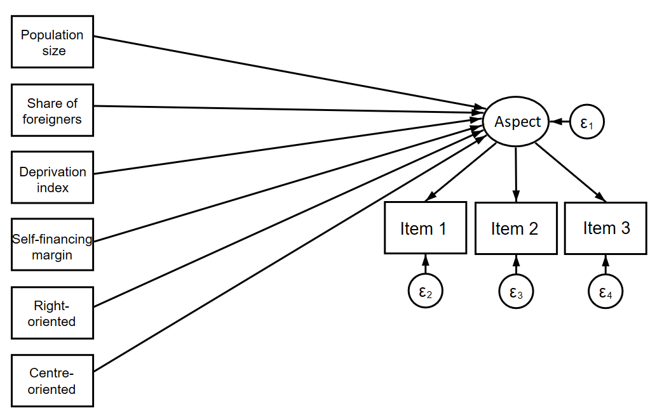

VI – Results of the structural equation models for each coherent set of practices separately: measurement and path model
Figure 6: Structural Model with information provision
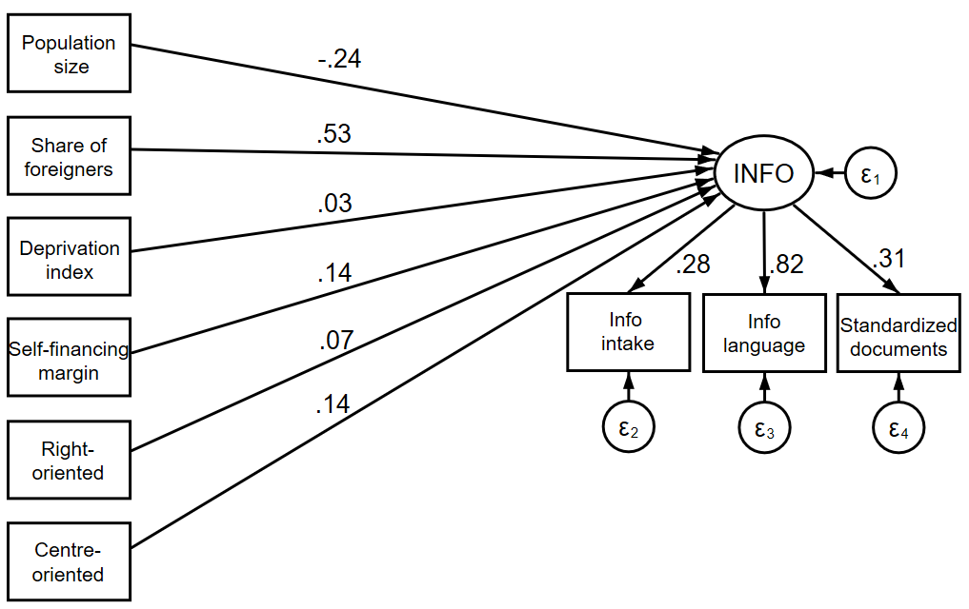

Figure 7: Structural model with accessibility
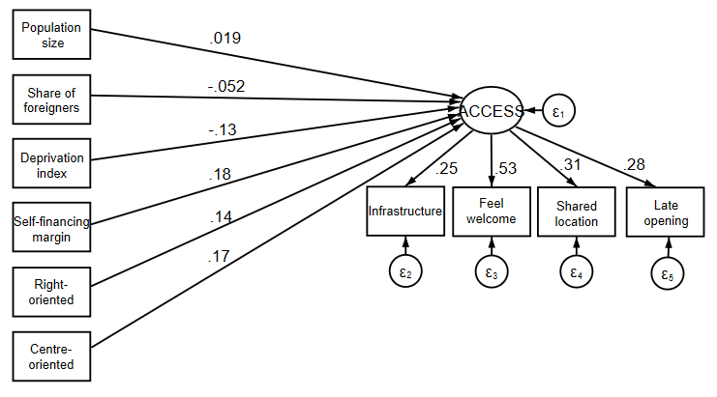
Figure 8: Structural model with locus of Initiative
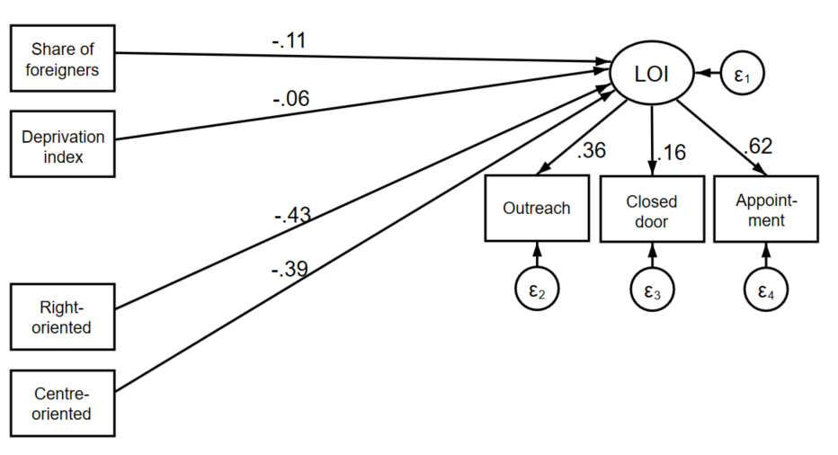

Figure 9: Structural model with trust
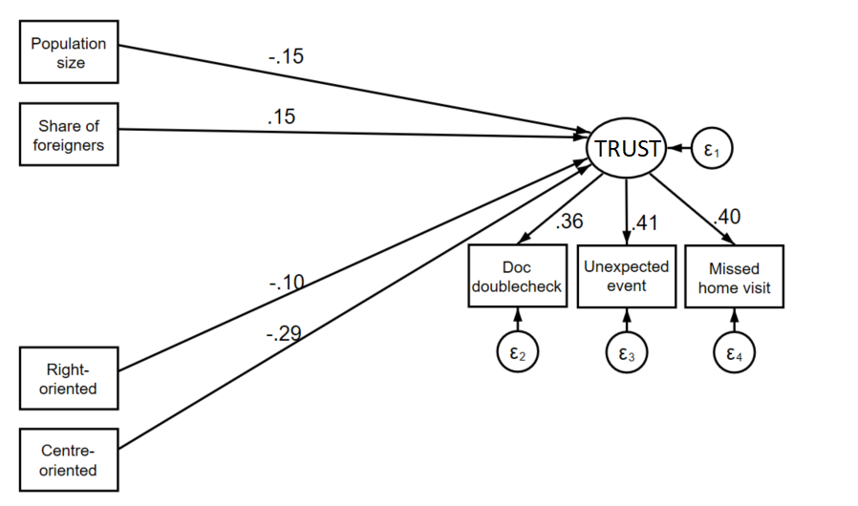

VII – Sensitivity analysis
As a sensitivity check for the validity of our results, we estimated additional structural equation models with locus of initiative and accessibility as the dependent variable, where we used the same items as indicators for the latent factors, but where we manipulated the original items in a slightly different way to test the impact of the recoding of the original items on the results. The figures below show that when we adjust the answer coding for some items (items with suffix ‘_S’) the standardized path coefficients for the direct effects of the municipal variables to the coherent set of practices are, with few exceptions, similar as when the original items are used.
Figure 10: Structural Model with locus of initiative with recoded items
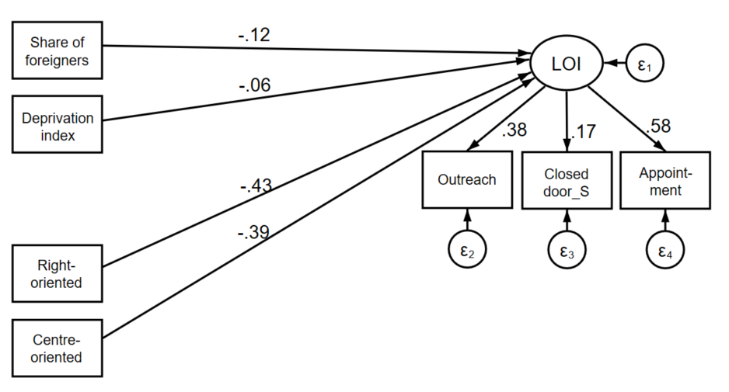

Figure 11: Structural model with accessibility with recoded items
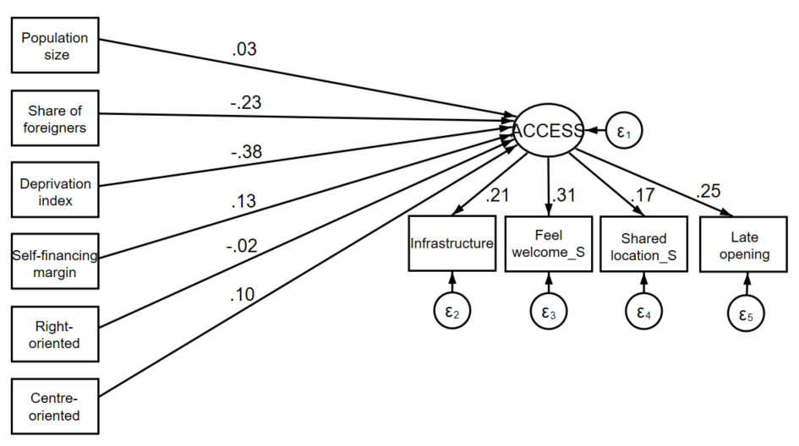
References
Brown TA. (2015) Confirmatory factor analysis for applied research: Guilford Publications.
Ferguson E and Cox T. (1993) Exploratory factor analysis: A users’ guide. International journal of selection and assessment 1: 84-94.
Hair Jr J, Black W, Babin B, et al. (2006) Multivariate Data Analysis, Sixth Edn Maxwell MacMillan International. New York.
Tabachnick BG, Fidell LS and Ullman JB. (2007) Using multivariate statistics: Pearson Boston, MA.

