**Appendix A: Estimated effect of perceived discrimination (index) on clearance rates**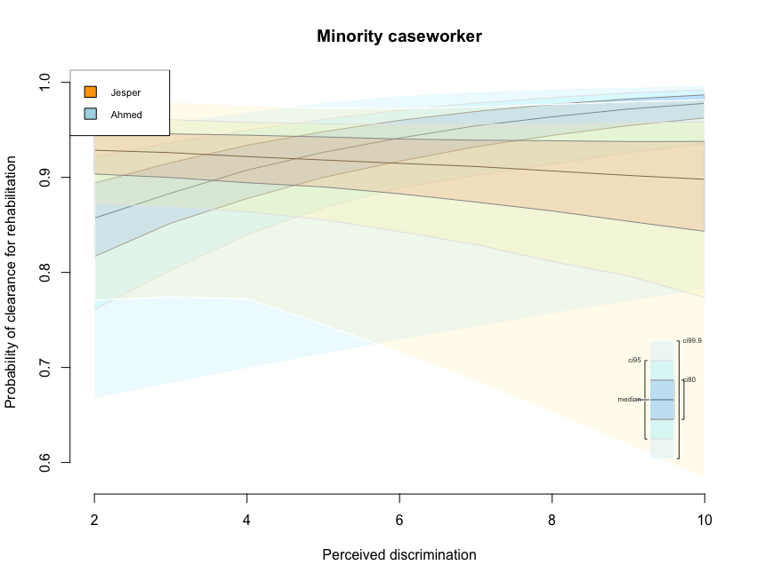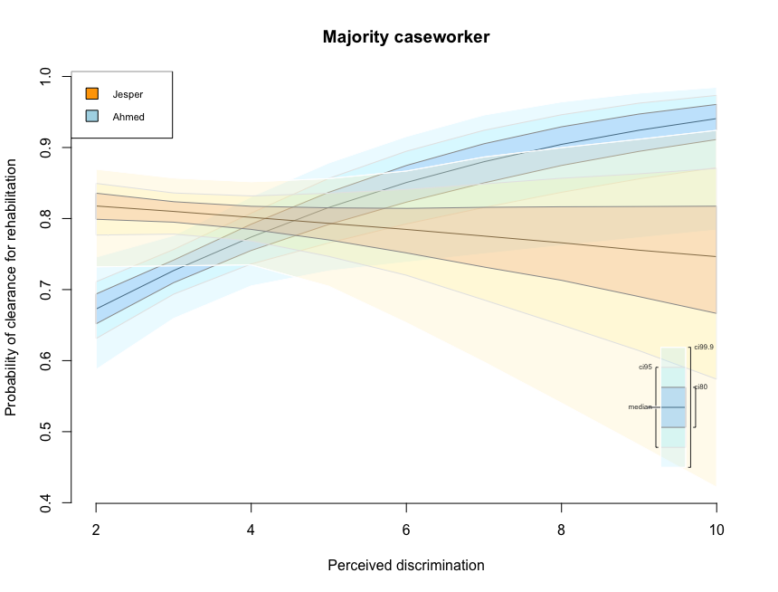

**Appendix B: Estimated effect of empathy (index) on clearance rates**

