Appendices
Appendix A. Country Sample
Continents | Countries
Africa | Algeria Angola Benin Botswana Burkina Faso Burundi Cabo Verde Cameroon C. African Republic Chad Congo, Dem. Rep. Congo, Rep. Cote d'Ivoire Djibouti Egypt, Arab Rep. Ethiopia Gambia, The Ghana Guinea Lesotho Liberia Madagascar Malawi Mali Mauritania Mauritius Morocco Mozambique Namibia Niger Nigeria Rwanda Senegal Sierra Leone South Africa Sudan Tanzania Togo Tunisia Uganda Zambia Zimbabwe Kenya
Asia and Australia | Azerbaijan Bahrain Bangladesh Bhutan Brunei Darussalam Cambodia China India Indonesia Iran, Islamic Rep. Israel Japan Jordan Kuwait Lao PDR Lebanon Malaysia Mongolia Myanmar Nepal Oman Pakistan Philippines Qatar Saudi Arabia Singapore Sri Lanka Tajikistan Thailand Vietnam Yemen, Rep. Cyprus Korea, Rep. Kyrgyz Republic Uzbekistan Australia New Zealand
Europe | Albania Armenia Austria Belgium Bulgaria Croatia Czech Republic Denmark Estonia Finland France Georgia Germany Greece Hungary Iceland Ireland Italy Lithuania Luxembourg Macedonia, N. Montenegro Netherlands Poland Portugal Romania Russian Federation Serbia Slovak Republic Slovenia Spain Sweden Switzerland Ukraine United- Kingdom Norway Belarus Kazakhstan Latvia Malta Moldova Turkey
South America | Argentina Bolivia Brazil Chile Colombia Ecuador Guyana Paraguay Peru Uruguay Venezuela, RB Mexico
North America | Canada United States Bahamas, The Barbados Belize Costa Rica Cuba Dominican Republic El Salvador Guatemala Honduras Jamaica Nicaragua Panama St. Lucia Trinidad & Tobago

Appendix B. Variables, Descriptions, and Sources
Variable Code | Description | Relation to concept | Source
CivilLib | Civil liberties | Proactive (+)  Reactive (+) | IDEA  & FHI
TotSocProt | Total social protection expenditure, including health (% of GDP) | Reactive (+) | ILO
SocSecPoli | Number of social security policy areas covered by a statutory programme | Reactive (+) | ILO
Undernourish | Prevalence of undernourishment (% of population) | Reactive (-) | WDI
ChildMortR | Mortality rate, under-5 (per 1,000 live births) | Reactive (-) | WDI
MaternalMortR | Maternal mortality ratio (per 100,000 live births) | Reactive (-) | WDI
OldPensCov | Social protection effective coverage by group of population (older persons) | Reactive (+) | ILO
HealthCovDf | Legal health coverage deficit, % of population without legal coverage | Reactive (+) | ILO
WorkPov | Working poverty rate (age 15+) | Reactive (-) | ILO
EducExp | Education expenditure (% of GNI) | Proactive (+) | WDI
EducIndex | Calculated using mean years of schooling and expected years of schooling | Proactive (+) | UN
PrepriSchEn | Gross enrolment ratio, pre-primary (% of preschool-age children) | Proactive (+) | WDI
GenDIndex | Gender development index | Proactive (+) | UN
InternetUsage | Individuals using the Internet (% of population) | Proactive (+) | WDI
TertiaryEd | School enrollment, tertiary (% gross) | Proactive (+) | WDI
MaternityLe | Length of maternity leave (weeks), paid leave only | Proactive (+) | ILO
RenEnergOut | Renewable energy output (% of total output) | Proactive (+) | WDI
LaborForcePR | Labour force participation rates of population at ages 15-64 (%) | Proactive (+) | ILO
LUnderutility | Combined rate of unemployment and potential labour force (LU3) %, total 15+ | Proactive (-) | ILO

Note: In section, ‘Relation to concept, ‘Reactive (+/-)’ and ‘Proactive (+/-)’ classification suggests that respective variables are positively or negatively related to a specific regime. For example, the higher is the ‘Total social protection expenditure, including health (% of GDP)’ the stronger is a country’s preference towards ‘Reactive’ welfare state policies.
Acronyms: ILO (International Labor Organization); WDI (World Development Indicators); UN (United Nations); FHI (Freedom House Index); IDEA (International Institute for Democracy and Electoral Assistance).

Appendix C. Summary Statistics of the Variables Measured
Indicator | N | Min | Mean | Max | St.Dev.
TotSocProt | 150 | 0.17 | 10.84 | 31.69 | 8.03
SocSecPoli | 150 | 1.00 | 6.63 | 8.00 | 1.52
CivilRights | 150 | 0.22 | 0.68 | 0.98 | 0.20
Undernourish | 150 | 2.50 | 11.13 | 67.30 | 12.06
ChildMortR | 150 | 2.30 | 29.83 | 130.80 | 31.73
MaternalMortR | 150 | 3.00 | 162.63 | 1360.00 | 237.22
OldPensCov | 150 | 0.00 | 56.74 | 100.00 | 38.53
HealthCovDf | 150 | 0.00 | 37.65 | 100.00 | 39.12
WorkPov | 150 | 0.00 | 13.32 | 73.43 | 17.59
EducExp | 150 | 0.70 | 4.48 | 15.52 | 2.09
EducIndex | 150 | 0.21 | 0.66 | 0.94 | 0.18
PrepriSchEn | 150 | 1.00 | 61.44 | 170.00 | 35.28
GenDIndex | 150 | 0.55 | 0.94 | 1.03 | 0.07
InternetUsage | 150 | 2.48 | 49.34 | 98.20 | 27.94
TertiaryEd | 150 | 0.77 | 40.45 | 126.38 | 28.75
MaternityLe | 150 | 0.00 | 16.70 | 60.00 | 8.96
RenEnergOut | 150 | 0.00 | 37.06 | 100.00 | 32.95
LaborForcePR | 150 | 42.18 | 69.88 | 88.76 | 9.74
LUnderutility | 150 | 1.70 | 12.40 | 34.60 | 7.19

Note: The summary statistics table shows the data ranges vary significantly (e.g. see the minimum and maximum value of the variables ‘Maternal Mortality Rate’ and ‘Child Mortality Rate’); hence, standardization of data is necessary since we look for relations among the variables.

Appendix D. Robustness Checks
After obtaining and assessing the cluster results, in this section, we test for their robustness. Literature suggests that biased cluster results typically originate from the presence of outlying observations in the dataset and the deviations from essential theoretical assumptions (Garcia-Escudero et al., 2010). In this study, both issues are important because we use data with highly diverse observations and introduce two novel concepts in welfare state research. For the model-based clustering approach, robustness methods, based on trimming, are highly praised and recommended (Fritz et al., 2012; Garcia-Escudero et al., 2010, 2011). Hence, we apply the trimming approach in our data, by excluding from the sample five percent of the potential extreme values. The trimmed results confirm that, predominantly, countries remain in the same clusters, as shown in the three above-listed tables.
Figure 3.
Robustness check: Trimmed Clusters

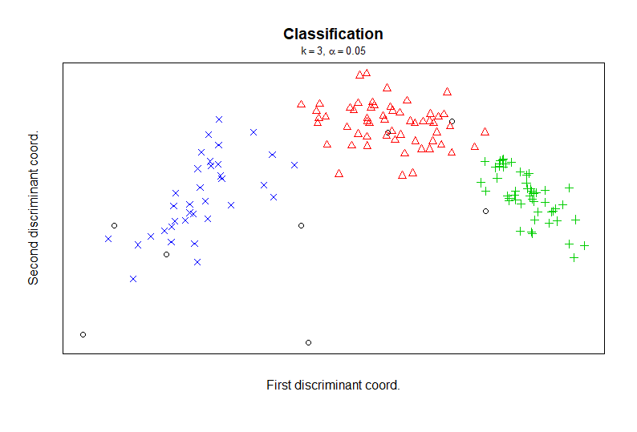

Note: This figure shows the cluster plots after the robustness check, using tclust in R Studio. The trimmed values are the ‘outlier countries’ shown in empty bullets ‘○’.
The second robustness check tests whether our theoretical and empirical approach also provides meaningful results when using specific subsamples. Accordingly, we apply our proposed approach to the subsample of countries from Cluster 3, namely, including the well-developed welfare states of Europe and North America, for which many typologies exist. Applied to this country subsample, model-based cluster analysis again reveals three clusters. A first cluster within the Reactive welfare states consists of countries with a relatively lower general level of welfare state engagement, e.g., most Eastern European countries but also several Latin-American states. The two remaining clusters consist of all West European and Anglo-Saxon countries. While these countries seem to be quite similar concerning the old risk policies, one group of countries, forming a distinct cluster, namely Austria, Canada, Denmark, Iceland, New Zealand, Norway, Sweden, and Switzerland, stand out having a stronger emphasis on new social risks. Thus, while the strength of our framework is to compare welfare states around the world, this subsample analysis demonstrates that the conceptual and empirical approach presented in this study can also be used to identify welfare state patterns with specific country groups or regions.

References
Fritz, H., Garc´ıa-Escudero, L. A. and Mayo-Iscar, A. (2012), ‘tclust: An R package for a trimming approach to cluster analysis’, Journal of Statistical Software, 47(12): 1-26.
García-Escudero, L. A., Gordaliza, A., Matrán, C. and Mayo-Iscar, A. (2010), ‘A review of robust clustering methods,’ Advances in Data Analysis and Classification, 4: 89-109.
García-Escudero, L., Gordaliza, A., Matràn, C. and Mayo-Iscar, A. (2011), ‘Exploring the number of groups in robust model-based clustering’, Statistics and Computing, 1-25.

Reactive and Proactive Welfare States.
Trimming approach excluded five percent of the most extreme observations. In this case, the excluded countries are Albania, Burundi, Central African Republic, Cuba, Lesotho, Liberia, Namibia, and Republic of Yemen.

