Appendix

Content

Table 3: Meta-regression of institutional factors on type of work exit.
Figure 5a: Social gradient in involuntary work exit with self-rated health as control variable.
Figure 5b: Social gradient in voluntary work exit with self-rated health as control variable.
Figure 5c: Social gradient in staying employed with self-rated health as control variable.
Table 4: Meta-regression of institutional factors on type of work exit with self-rated health as control variable.
Figure 6a: Social gradient in involuntary work exit among women.
Figure 6b: Social gradient in voluntary work exit among women.
Figure 6c: Social gradient in staying employed among women.
Figure 7a: Social gradient in involuntary work exit among men.
Figure 7b: Social gradient in voluntary work exit among men.
Figure 7c: Social gradient in staying employed among men.
Table 5: Meta-regression of institutional factors on type of work exit of women.
Table 6: Meta-regression of institutional factors on type of work exit of men.
Table 7: Meta-regression of average institutional factors on type of work exit.
Figure 8a: Social gradient in involuntary work exit without unemployed work exits.
Figure 8b: Social gradient in voluntary work exit without unemployed work exits.
Figure 8c: Social gradient in staying employed without unemployed work exits.
Table 8: Correlations between macro indicators.
Figure 9: Association between social gradient in involuntary work exit and older workers’ participation rate in lifelong learning, excluding Sweden.
Table 9: Meta-regression of institutional factors on type of work exit with PLMP and unemployment rate and ALMP and unemployment rate estimated in the same model.

Table 3: Meta-regression of institutional factors on type of work exit.
 |  | Involuntary work exit | Voluntary work exit | No work exit
Institutional factor | Indicator | Coef. | Coef. | Coef.
Pull | PLMP | -0.001 | -0.007 | 0.009
Push | Unemployment rate | 0.001 | -0.002 | 0.001
 | EPL-Index | 0.014** | -0.008 | -0.005
Need | Net replacement rate | 0.0001 | 0.0002 | -0.0002
Maintain | Lifelong learning | -0.0003* | 0.0001 | 0.0001
 | ALMP | -0.007 | -0.023* | 0.029**
 | Rehabilitation expenditures | -0.020 | -0.037 | 0.057*
*p<0.1, **p<0.5, ***p<0.01

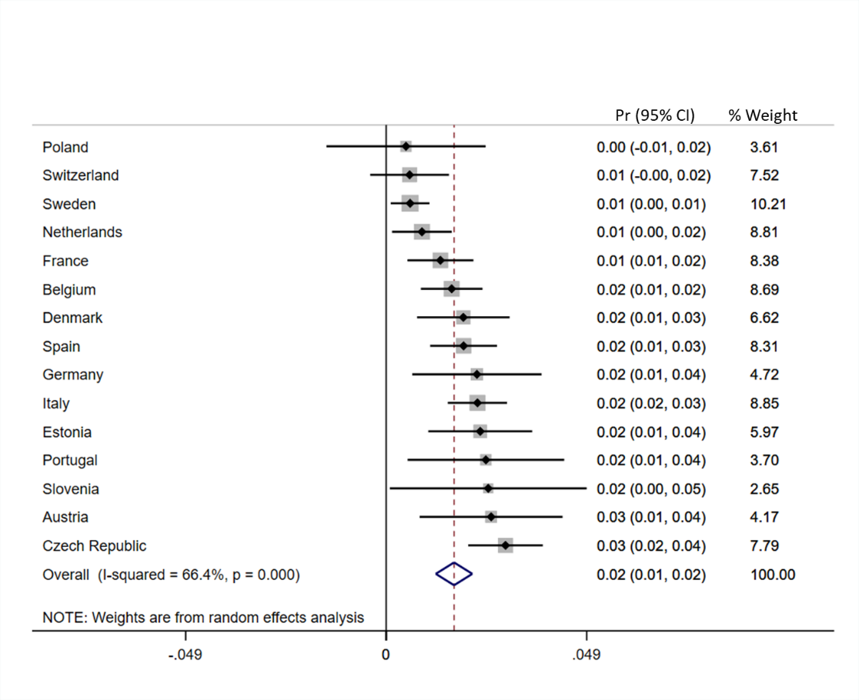
Figure 5a: Social gradient in involuntary work exit with self-rated health as control variable.
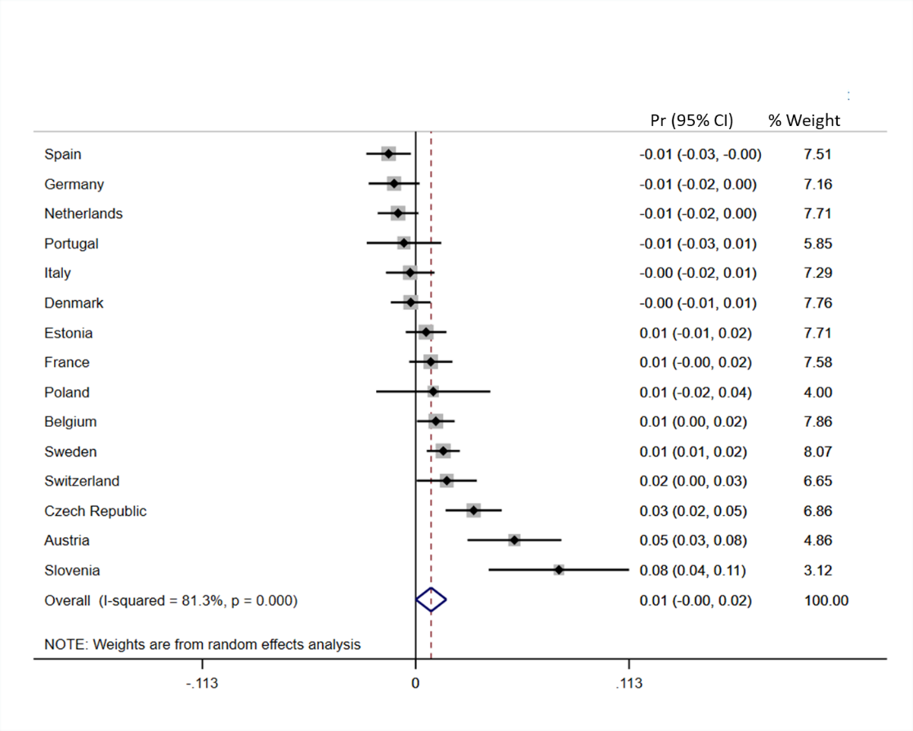
Figure 5b: Social gradient in voluntary work exit with self-rated health as control variable.

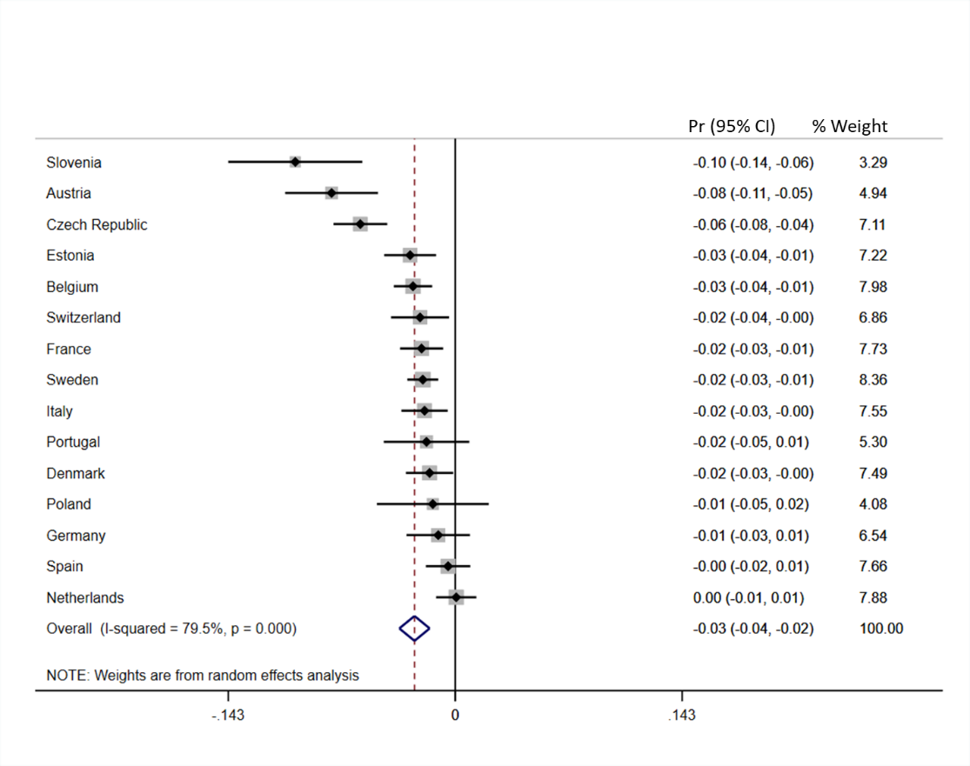
Figure 5c: Social gradient in staying employed with self-rated health as control variable.

Table 4: Meta-regression of institutional factors on type of work exit with self-rated health as control variable.
 |  | Involuntary work exit | Voluntary work exit | No work exit
Institutional factor | Indicator | Coef. | Coef. | Coef.
Pull | PLMP | -0.0006 | -0.011 | 0.010
Push | Unemployment rate | 0.002 | -0.005 | 0.003
 | EPL-Index | 0.011 | -0.012 | -0.005
Need | Net replacement rate | -0.0001 | 0.0004 | -0.0003
Maintain | Lifelong learning | -0.0004 | 0.0007 | 0.0004
 | ALMP | -0.003 | -0.028 | 0.030
 | Rehabilitation expenditures | -0.022 | -0.050 | 0.072

*p<0.1, **p<0.5, ***p<0.01
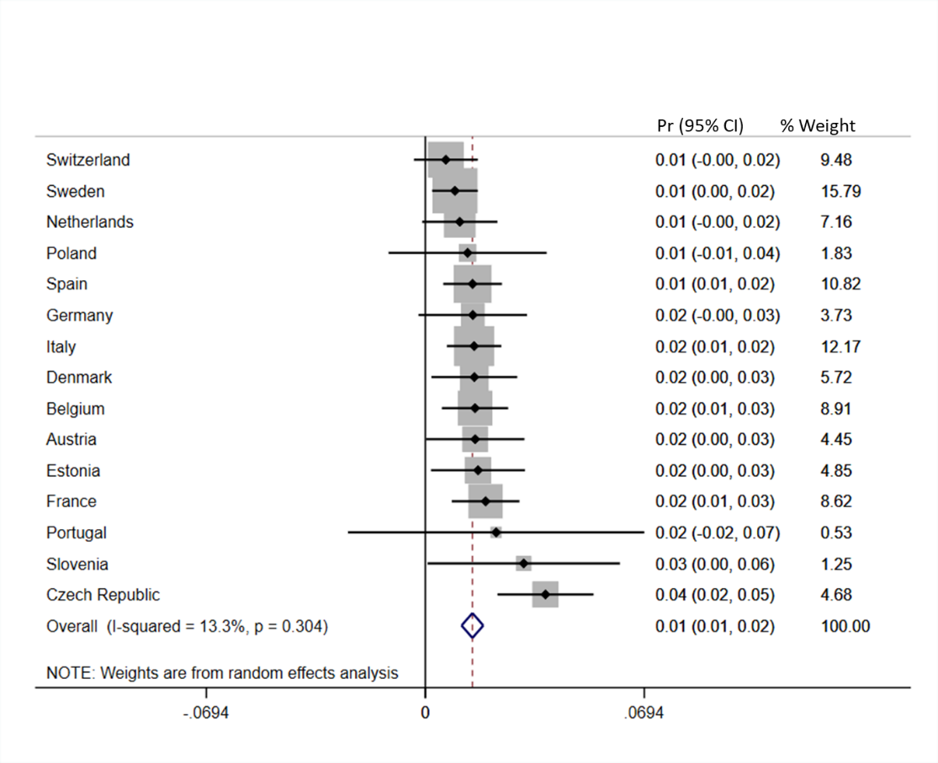
Figure 6a: Social gradient in involuntary work exit among women.
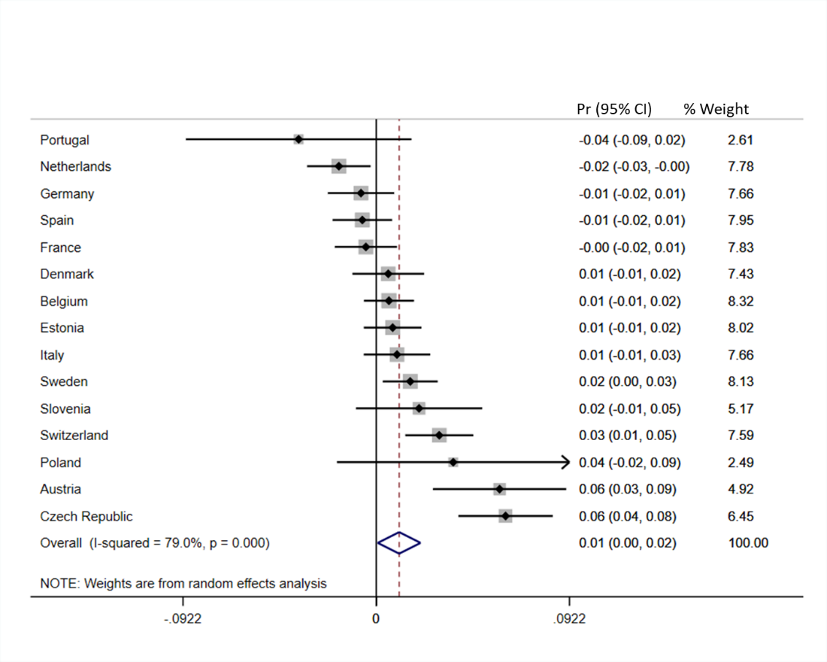
Figure 6b: Social gradient in voluntary work exit among women.
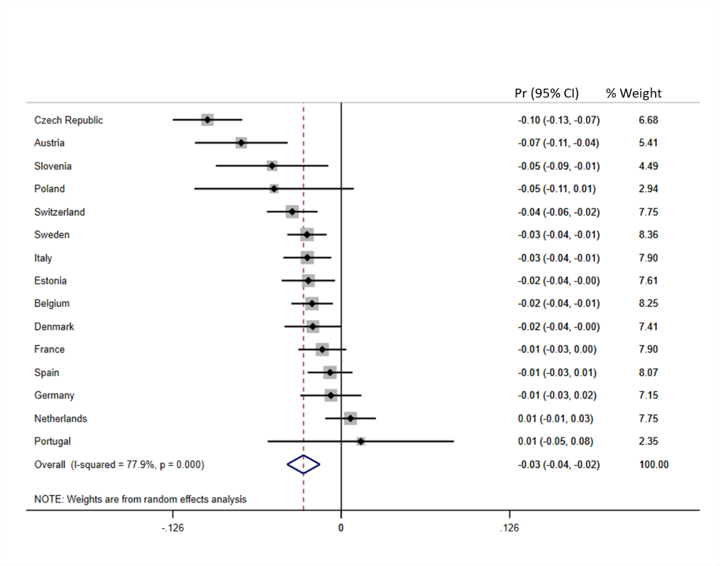
Figure 6c: Social gradient in staying employed among women.
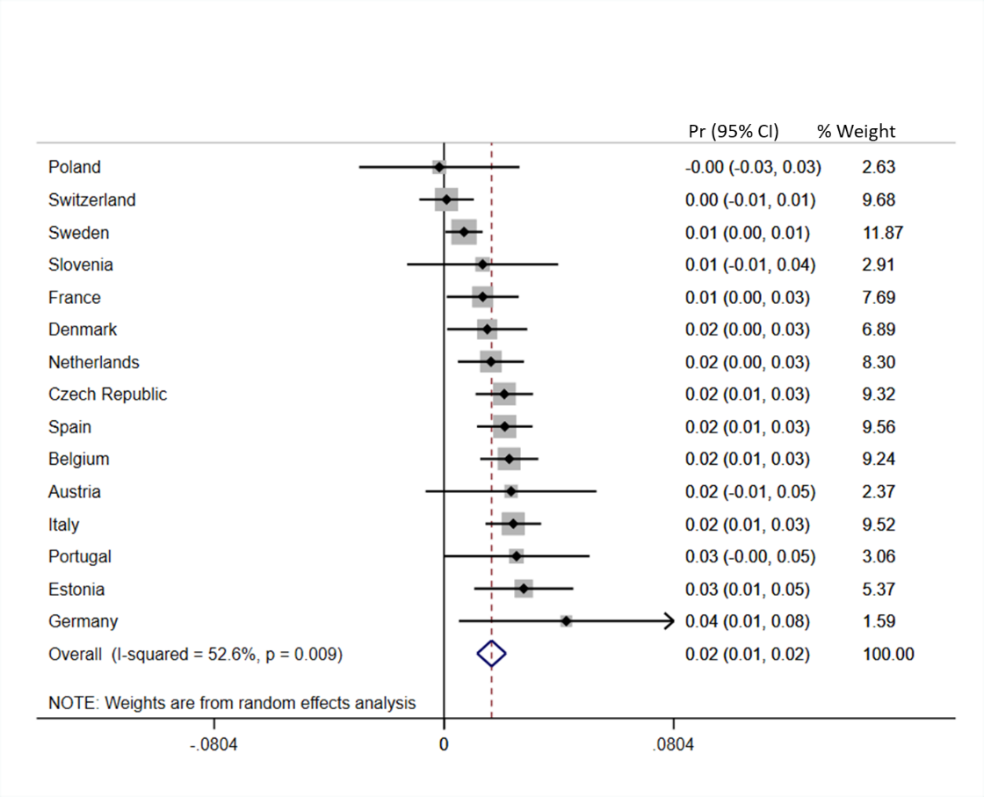
Figure 7a: Social gradient in involuntary work exit among men.
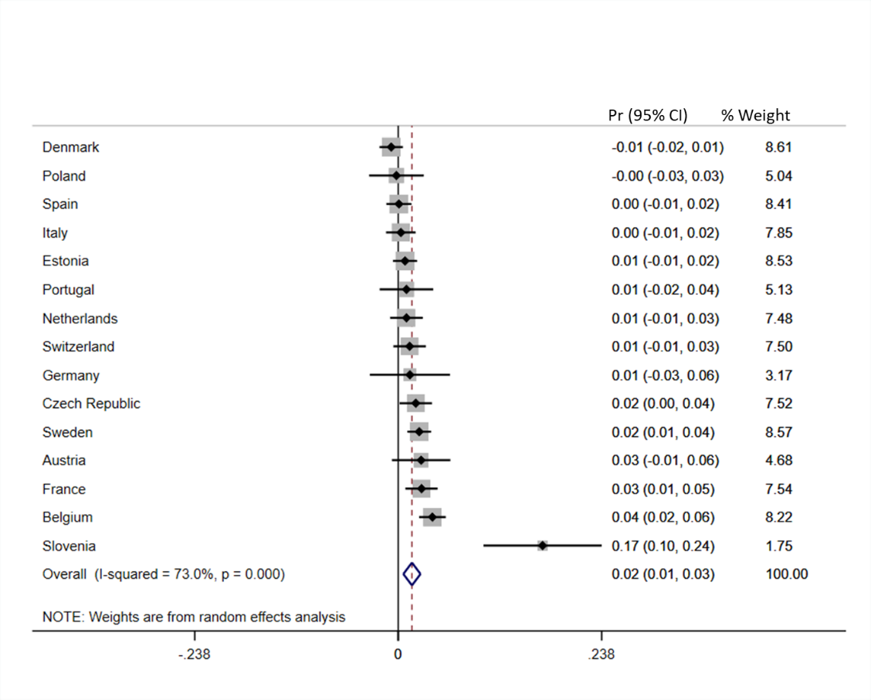
Figure 7b: Social gradient in voluntary work exit among men.
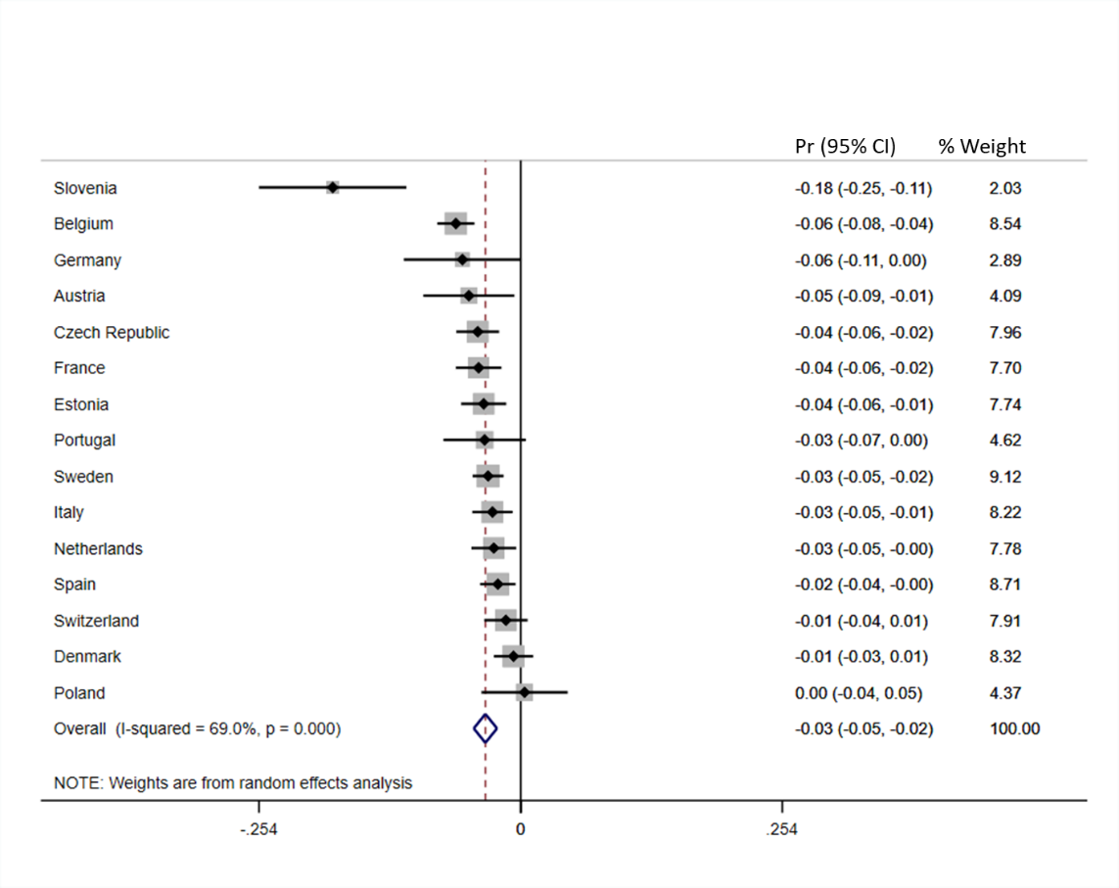
Figure 7c: Social gradient in staying employed among men.

Table 5: Meta-regression of institutional factors on type of work exit of women.
Women |  | Involuntary work exit | Voluntary work exit | No work exit
Institutional factor | Indicator | Coef. | Coef. | Coef.
Pull | PLMP | -0.002 | -0.017** | 0.020**
Push | Unemployment rate | 0.001 | -0.003 | 0.002
 | EPL-Index | 0.009 | -0.022 | 0.012
Need | Net replacement rate | -0.0001 | -0.0001 | 0.0001
Maintain | Lifelong learning | -0.0002* | 0.0003 | -0.0001
 | ALMP | -0.008 | -0.027* | 0.038**
 | Rehabilitation expenditures | -0.015 | -0.035 | 0.055
*p<0.1, **p<0.5, ***p<0.01

Table 6: Meta-regression of institutional factors on type of work exit of men.
Men |  | Involuntary work exit | Voluntary work exit | No work exit
Institutional factor | Indicator | Coef. | Coef. | Coef.
Pull | PLMP | -0.0004 | -0.0004 | 0.001
Push | Unemployment rate | 0.002 | -0.001 | -0.001
 | EPL-Index | 0.017** | 0.006 | -0.018
Need | Net replacement rate | 0.0001 | 0.0002 | -0.0003
Maintain | Lifelong learning | -0.001** | 0.00004 | 0.0003
 | ALMP | -0.006 | -0.015 | 0.022
 | Rehabilitation expenditures | -0.021 | -0.033 | 0.054
*p<0.1, **p<0.5, ***p<0.01

Table 7: Meta-regression of average institutional factors on type of work exit.
 |  | Involuntary work exit | Voluntary work exit | No work exit
Institutional factor | Indicator | Coef. | Coef. | Coef.
Pull | PLMP | -0.001 | -0.012 | 0.011
Push | Unemployment rate | 0.001 | -0.002 | 0.002
 | EPL-Index | 0.013* | -0.002 | -0.011
Need | Net replacement rate | 0.0001 | -0.0001 | -0.0002
Maintain | Lifelong learning | -0.0004*** | -0.0001 | 0.0004
 | ALMP | -0.007 | -0.023* | 0.029**
 | Rehabilitation expenditures | -0.018 | -0.031 | 0.050
*p<0.1, **p<0.5, ***p<0.01

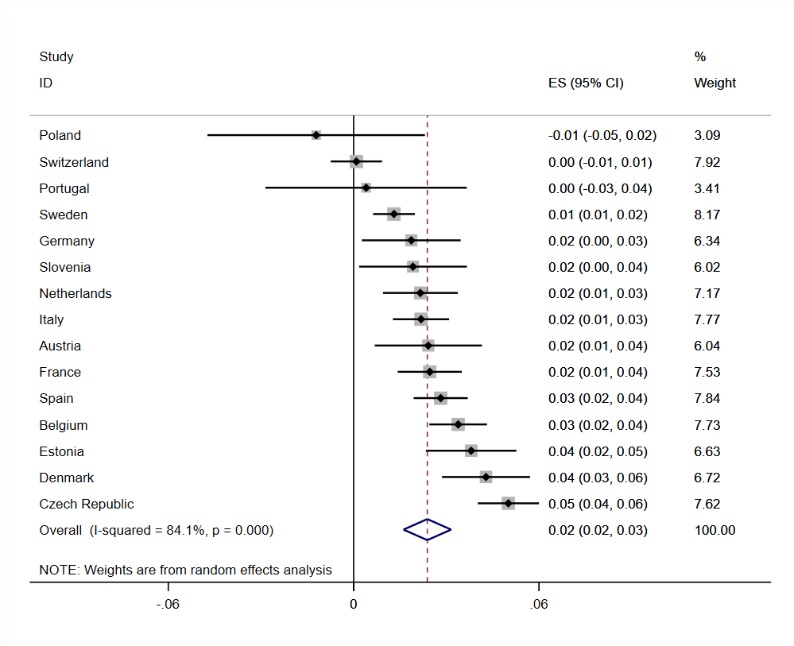
Figure 8a: Social gradient in involuntary work exit without unemployed work exits.
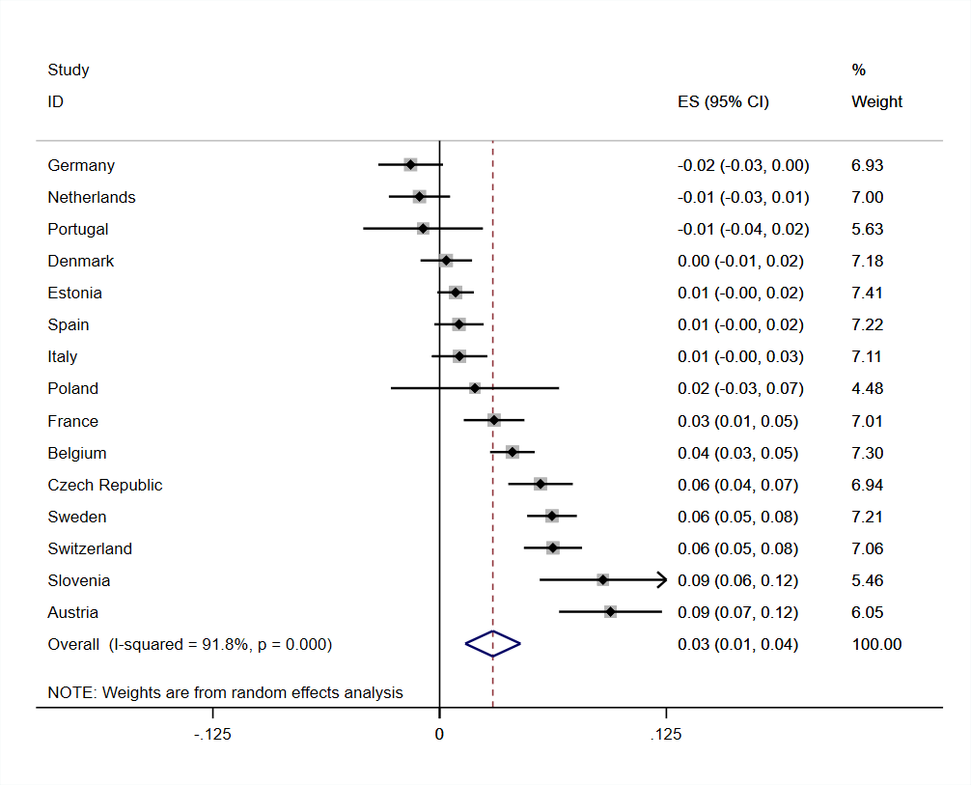
Figure 8b: Social gradient in voluntary work exit without unemployed work exits.
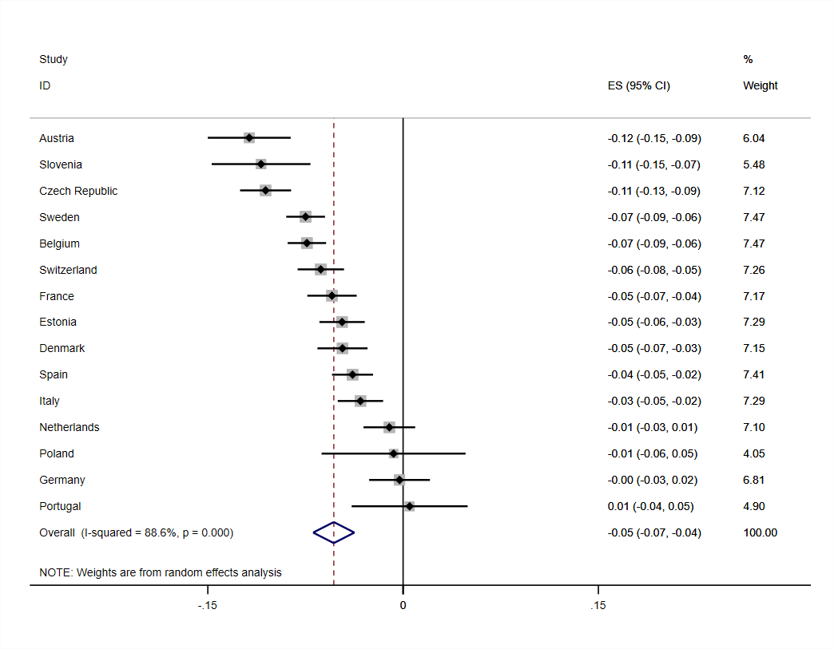
Figure 8c: Social gradient in staying employed without unemployed work exits.

Table 8: Correlations between macro indicators.
 | PLMP | Unemployment rate | EPL-Index | Net replacement rate | Lifelong learning | ALMP | Rehabilitation expenditures
PLMP | 1.000
Unemployment rate | 0.035 | 1.000
EPL-Index | 0.151 | 0.124 | 1.000
Net replacement rate | 0.120 | -0.185 | 0.318 | 1.000
Lifelong learning | 0.053 | -0.170 | -0.415 | -0.368 | 1.000
ALMP | 0.792 | -0.175 | 0.037 | -0.121 | 0.322 | 1.000
Rehabilitation expenditures | 0.484 | -0.345 | -0.156 | -0.243 | 0.350 | 0.796 | 1.000

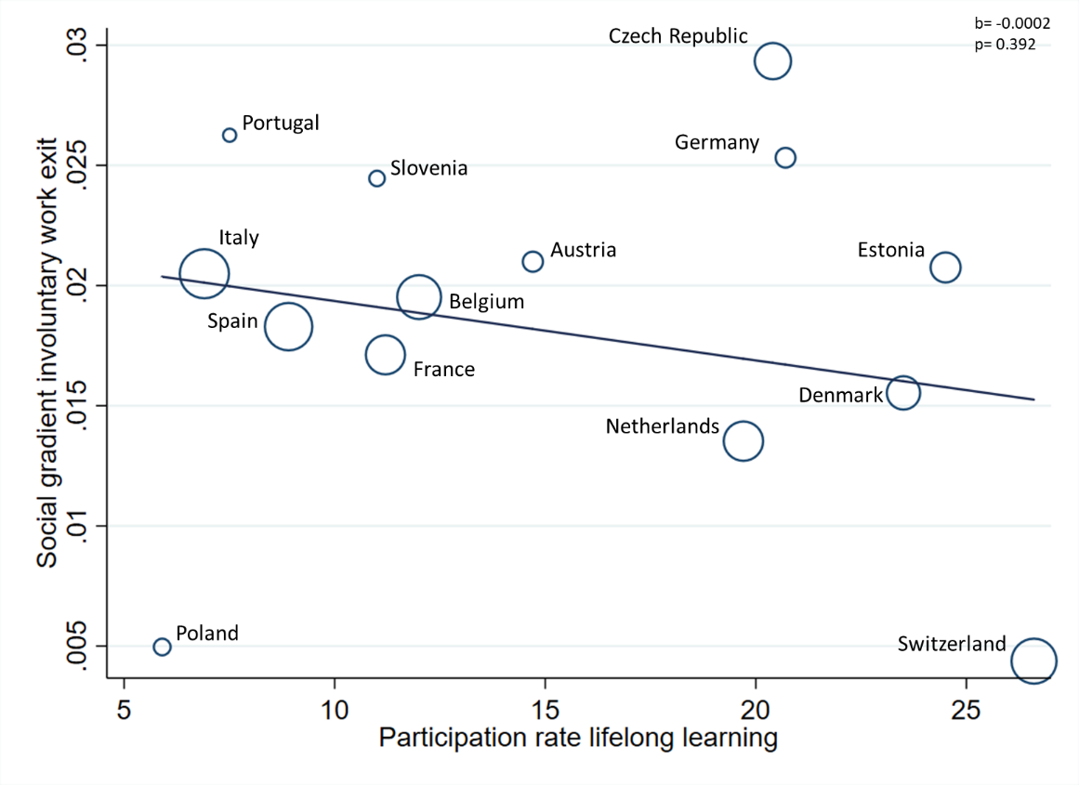

Figure 9: Association between social gradient in involuntary work exit and older workers’ participation rate in lifelong learning, excluding Sweden.

Table 9: Meta-regression of institutional factors on type of work exit with PLMP and unemployment rate and ALMP and unemployment rate estimated in the same model.

 |  | Involuntary work exit | Voluntary work exit | No work exit
Institutional factor | Indicator | Coef. | Coef. | Coef.
Pull | PLMP | -0.0009 | -0.009 | 0.01
 | Unemployment rate | 0.001 | 0.002 | 0.001
Maintain | ALMP | -0.006 | -0.025* | 0.031**
 | Unemployment rate | 0.0009 | -0.003 | 0.002
*p<0.1, **p<0.5, ***p<0.01

