SUPPLEMENTARY MATERIAL

Unit of analysis and definitions
There is a lack of clarity of the linkages and differences between the concept of social entrepreneurship, social enterprise, and social entrepreneur. In this article, we broadly define ‘social entrepreneurship’ as entrepreneurial activities, processes, orientations, and values that aim to create social value. We define ‘social enterprise’ as an organizational form in which social entrepreneurship activities are actualized, implemented and formalized. Certainly, social entrepreneurial activities can occur outside of the boundary of a formal organization. We define ‘social entrepreneur’ as the person who initiates and participates in social entrepreneurial activities. There are various typologies that classify different definitions and dimensions of social enterprises/social entrepreneurship such as those by Hoogendoorn et al (2012), Kerlin (2006, 2012), Defourny and Nyssens (2010), and Teasdale and Dey (2019), and Chandra and Paras (2020) but despite the differences in the definitions (e.g., American Tradition vs. European Tradition vs UK tradition or Asian Tradition) there is a commonality that characterize ‘social entrepreneurship/enterprise’ as a hybrid organization or organizing. That is, a process of combining multiple logics, goals and approaches.

The Selection Criteria for Ashoka, Schwab and Echoing Green Social Enterprises
The three social enterprise support organizations - Ashoka, Schwab and Echoing Green - use different approaches in selecting its social entrepreneurs. Ashoka uses 5-step selection process, from nomination, first and second opinion, panel interviews, to board review; and 5 criteria (newness of idea, creativity, entrepreneurial quality, social impact, and ethical fiber) (https://www.ashoka.org/en/recommend-ashoka-fellow).
Schwab uses referral and nomination from a global network of experts and partners and rely on several criteria including (market/tech/social) impact, potential to scale, ability to interact with top business and political leaders (https://www.schwabfound.org/selection-process).
Echoing Green uses unsolicited application approach with expert reviewers and interviews and 4 criteria which are innovation, importance of solutions, potential for impact, and a good business model (https://echoinggreen.org/fellowship/apply/).

Procedures to Include only Unique Cases
We first created a full list of all healthcare social enterprises from Ashoka in a spreadsheet and then used a random generator in R (a programming language) to generate random numbers to randomly select social enterprises. For example, we set R to give us a random of 5 samples out of a total 10 cases in the spreadsheet. And the result is 3, 4, 8, 9, and 2. Then, we select social enterprise number 2, 3, 4, 8 and 9 and retrieve their text file and conduct the coding.
In our sampling process, we found 5 fellows who were both Schwab and Ashoka Fellows, 1 fellow who was both Echoing Green and Ashoka Fellows, and 2 fellows who were both Echoing Green and Schwab Fellows (total of 8 fellows). After adjusting the samples to avoid duplication, we ended up with a total of 172 unique cases in this study.

Analytical strategy
Our analysis was not meant to show the differences among the social enterprises across regions (e.g., Asia vs. North America vs. Europe) nor to study the “trends” of the activities of social enterprises in a particular period versus other periods as this is not relevant to our research question. Rather, we are interested in how the social enterprises contribute to healthcare services provision generally and what we can learn from their activities to enrich and connect them with the New Public Governance literature.

Distribution of Samples Included in the Study
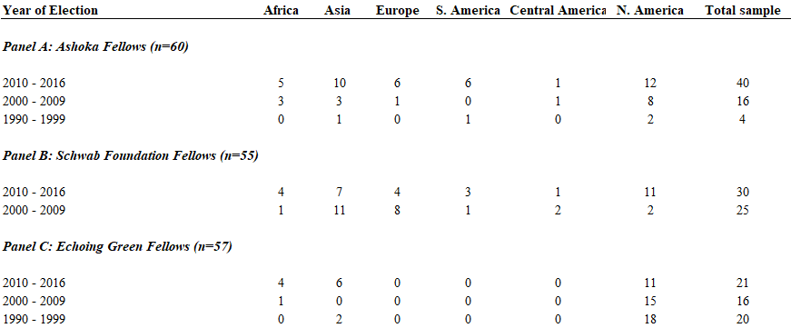

Detailed Break Down of Each Healthcare Social Enterprises in the Study
