Appendix

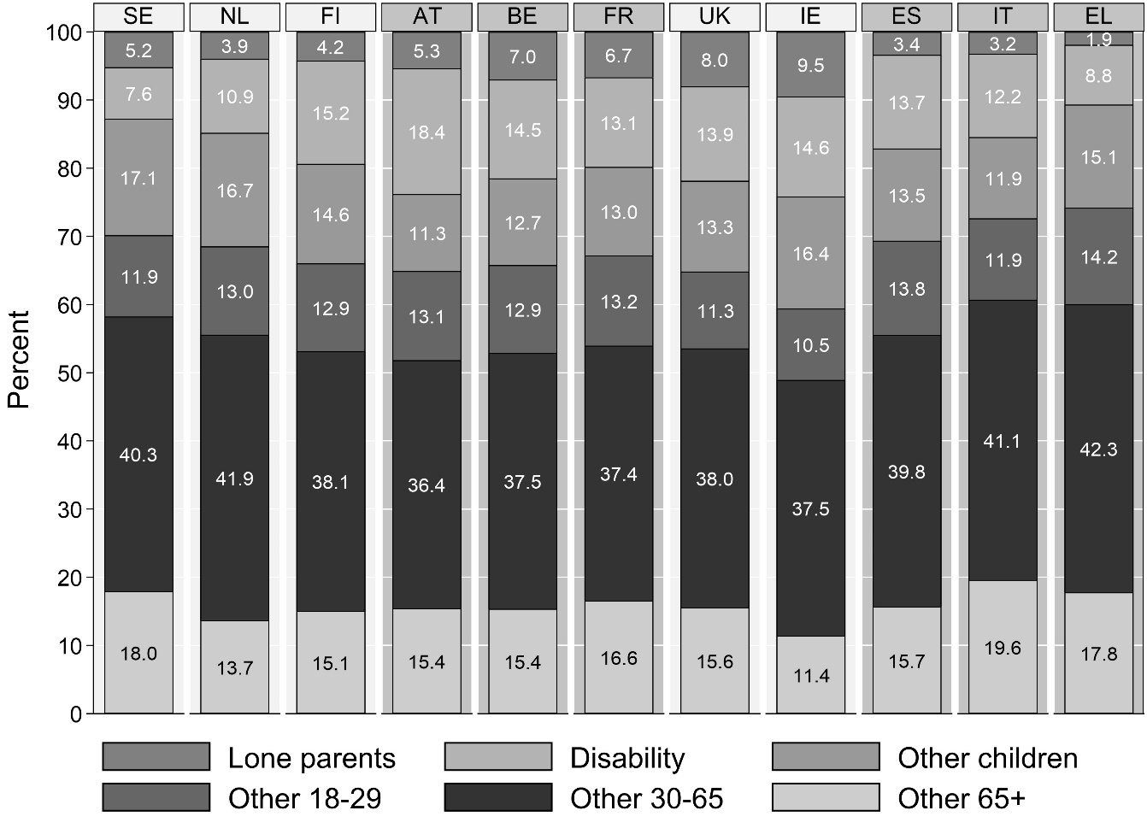
Figure A1 Social risk groups by country
Source: EU-SILC data, for 2005-06, 2008-09 and 2013-14.

