Web Appendix 1: The roll out of UC by area characteristics
First we look at the socio-demographic characteristics of the areas in which UC was rolled out. We find that UC seems to have been introduced in areas with: (1) slightly higher than average proportion of the working-age population on benefits, (2) slightly higher than average populations, (3) slightly higher than average number of food banks, and (4) slightly more deprived than the average.

UC available | Number of Postcode districts | Working Age population who are claimants  (%) | Households receiving food vouchers  (%) | Average population in postcode district | Number of food banks | Index of Material Deprivation  (Lower average rank equals more deprived)
Available in August 2015 | 1100 | 1.90 | 0.15 | 26634 | 0.53 | 12158
Available in September/October 2015 | 181 | 1.81 | 0.16 | 28572 | 0.64 | 12001
Available in November/December 2015 | 520 | 1.50 | 0.13 | 24745 | 0.47 | 14146
Available in January/March in 2016 | 483 | 1.63 | 0.13 | 21684 | 0.40 | 15237
Available in April/September 2016 | 231 | 1.48 | 0.10 | 13269 | 0.32 | 15271
Available in October 2016/December 2017 | 62 | 1.66 | 0.08 | 1543 | 0 | 9079
Not yet Active | 84 | 1.77 | 0.07 | 411 | 0 | 7872
All months | 2646 | 1.75 | 0.15 | 23053 | 0.46 | 13158

Next we consider whether this may influence the speed at which new claimants come on UC. Here we find that more deprived parts of the country saw faster growth in the proportion of households on UC than less deprived parts of the country.

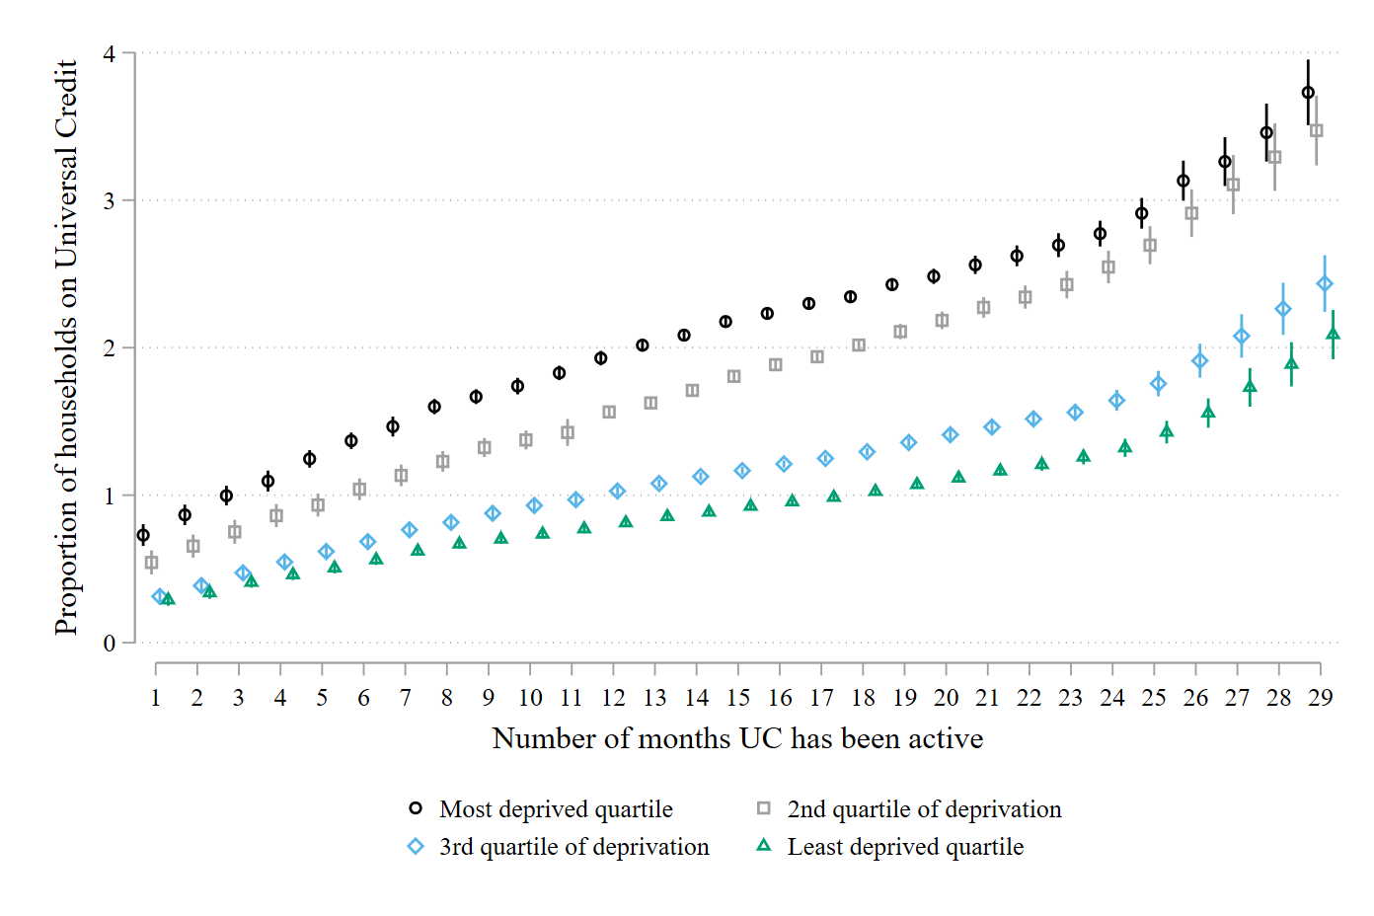
However, when we consider the speed at which new claimants come on UC by the time at which their areas implemented UC we see very similar trajectories, especially in the first year. The one exception is the small number of postcode districts which have implemented UC since late 2016, which were initially higher and which have not increased much since. For the vast majority of postcode districts, however, the roll-out has happened at a very similar pace, suggesting the timing of the roll-out will not influence our results.

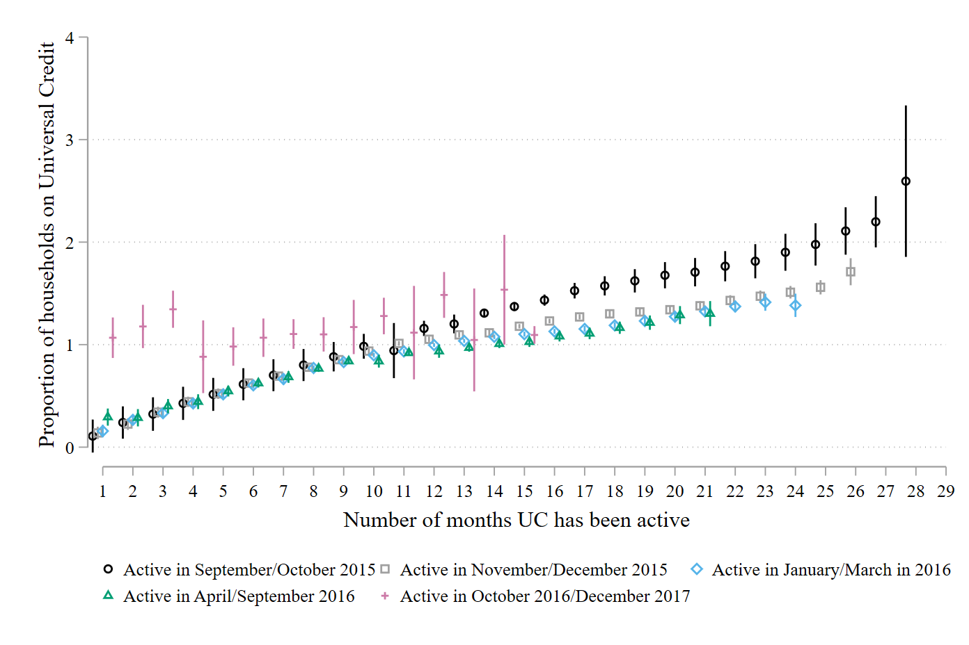

Web Appendix 2: Relationship between households claiming UC and receiving help from a food bank and the number of months UC has been active using a fixed-effects framework

Percentage of food bank vouchers redeemed per household
(95% CI)
 | (1)
1%-point increase in the proportion of households on UC | 0.0062  (0.0027)
Number of months UC has been active | 0.00089  (0.00013)
Increase in UC X number of months UC has been active | 0.00020  (0.000073)
Number of observations | 76,734
Notes: Standard errors are clustered for repeated observations within local authorities. Constant estimated but not reported. All models include postcode district fixed-effects. All models also control for the proportion of the working-age population that are job-seeking benefit claimants. Y = model controls for that variable.

Web Appendix 3: Multi-level model exploring the relationship between the level and change in households claiming UC in relation to the number of beneficiaries helped by food banks.

The models in table 2 and this web appendix are exactly the same except for two changes. First, our dependent variable in this model is the number of beneficiaries instead of the number parcels distributed for every 100 households (see Table 2). Second, the main predictor variable is now the number of UC claimants as opposed to the number of UC claimants per 100 households.

Percentage of food bank vouchers redeemed per household
(95% CI)
 | (1) | (2)
Per household increase in households claiming UC in the previous month | 0.035  (0.0067) | 0.00071  (0.0099)
Per additional household claiming UC over the last month | 0.013  (0.00074) | 0.0040  (0.0011)
Food bank in postcode district | 10.67  (0.32) | 8.40  (0.35)
Households claiming UC X food bank present | --- | 0.062  (0.013)
Change in households claiming UC X food bank present | --- | 0.014  (0.0012)
Lagged measure of food parcel distribution | Y | Y
Seasonality | Y | Y
Linear time trend | Y | Y
Regional identifiers | Y | Y
Postcode district-months | 68.376 | 68,376
Notes: Standard errors are clustered for repeated observations within local authorities. Constant estimated but not reported. We estimate multi-level models with random intercepts. All models also control for population size and the proportion of the working-age population that are job-seeking benefit claimants. Y = model controls for that variable. * p < 0.05, ** p < 0.01

Web Appendix 4: Matching analysis comparing postcode districts that implemented UC with those that did not.

First we create a sub-sample of the postcode districts. This sub-sample contains postcode districts which implemented UC and also includes observations from postcode districts that have not (or have not yet) implemented UC. To be in this group, postcode districts should not have implemented UC in January 2017, for example, and will not implement UC in the 2 months following month January 2017. This is illustrated in the table below. Area 1 would be included in our sample because it is an area that introduces UC. Area 2 would not be included in our matching sample because it introduces UC at the end of the 3 month window. Area 3 would be included because it does not introduce UC in the 3 month window.

 | December 2016 | January 2017 | February 2017 | March 2017
Area 1 |  | X | X | X
Area 2 |  |  |  | X
Area 3

Next, once we have created this sample of postcode districts that have and have not introduced UC, we estimate a matching model using coarsened exact matching. Coarsened Exact Matching (CEM) is a partial matching procedure. CEM splits all variables into bins or categories. CEM uses an algorithm to determine an appropriate number of bins or categories for linear or continuous variables. We match respondents on the following variables: the proportion of households receiving a food voucher in the previous month, the month, whether a food bank is present in the area, the size of the population, the proportion of people claiming JSA or UC in the previous month, and the region of the country in which the postcode district is located.
Adding all these variables together creates 2532 different possible combinations (or strata) and the CEM algorithm seeks to match the postcode districts with UC to those without UC. Only 345 strata have matched individuals. It is possible to have more than one match in each strata and so the matching is weighted to reflect the uneven distribution of the data across these strata. CEM is usually assessed using a global fit statistic ζ₁ (or L₁). This fit statistic tells us how imbalanced the data sets are before the matching procedure (1 = completely separable or no-overlap while 0 = perfectly balanced).
In our analysis, before the matching procedure, ζ₁ is 0.937 while after the matching procedure ζ₁ has fallen to 0.824, which we regard as a significant improvement. If we look at the differences between specific variables we can see that on all of the variables the matching has been somewhat successful, removing some of the differences between the distribution of these variables (e.g., the proportion of vouchers distributed in the previous month and population). On most variables the degree of imbalance has been almost completely eliminated (e.g., month, whether a food bank was present, region). The matching is not perfect, of course, but CEM is by definition an improvement over the imbalance observed in the raw data.

Web Table 4a: Balance between key covariates before and after matching
Variable | Variable specific measure of imbalance (ζ_{x}) | Difference in means before matching | Difference in means after matching
Vouchers distributed in previous month | 0.2674 | 0.054 | 0.017
Month | 0.3980 | -1.487 | <0.001
Food bank present | 0.1670 | 0.245 | <0.001
Population | 0.4246 | 12067 | 1071
Claimants in the previous month | 0.2046 | 0.0372 | 0.0097
Region | 0.2724 | 1.272 | <0.001

We then estimate the regression model with the matched data. The predictor is whether UC is active and the dependent variable is the proportion of households receiving UC in the first 3 months following UC implementation. We find more households receive UC in the 3 months following introduction than in otherwise similar postcode districts.

Web Figure 4b: Results from matching analysis.
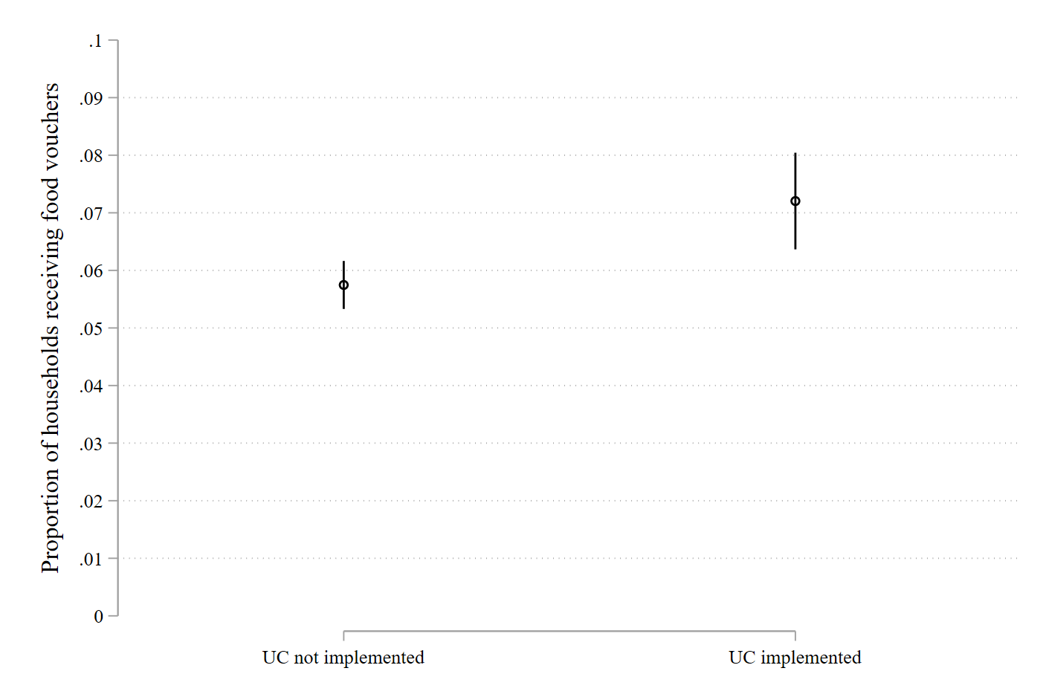

Web Appendix 5: Matching analysis of the introduction of Full Active UC
We use the same matching procedure described in Web Appendix 4, with two important differences. The first change is our intervention comparison is across Full Active and Not Full Active areas. The second change is we now also match on the proportion of households receiving UC, which simultaneously allows us to match on whether UC is active or not and, given that it is active, how far the roll-out has occurred.

Adding all these variables together creates 29,778 different possible combinations (or strata) and the CEM algorithm seeks to match the postcode districts with UC to those without UC. Only 215 strata have matched individuals. It is possible to have more than one match in each strata and so the matching is weighted to reflect the uneven distribution of the data across these strata. CEM is usually assessed using a global fit statistic ζ₁ (or L₁). This fit statistic tells us how imbalanced the data sets are before the matching procedure (1 = completely separable or no-overlap while 0 = perfectly balanced).
In our analysis, before the matching procedure, ζ₁ is 0.998 while after the matching procedure ζ₁ has fallen to 0.944. This is only a modest improvement and so we look in more detail at the imbalance across these variables. On many of the variables we see the degree of imbalance has been reduced to almost zero (e.g., the proportion of vouchers distributed in the previous month, month, whether a food bank was present, region, and the proportion of people claiming benefits). There are two variables where the imbalance is still higher than would be ideal (e.g., the proportion of households receiving UC and population). The matching is not perfect, of course, but CEM is by definition an improvement over the imbalance observed in the raw data.

Web Table 5a: Balance between key covariates before and after matching
Variable | Variable specific measure of imbalance (ζ_{x}) | Difference in means before matching | Difference in means after matching
Vouchers distributed in previous month | 0.0777 | 0.023 | -0.0137
Month | 0.5720 | 7.729 | <0.001
Food bank present | 0.0244 | 0.0444 | <0.001
Population | 0.0805 | -608.89 | -173.52
Claimants in the previous month | 0.2552 | 0.0496 | -0.0397
Region | 0.1466 | 0.0515 | <0.001
Proportion of households receiving UC | 0.2040 | 0.4155 | 0.0096

We then estimate the regression model with the matched data. The predictor is whether UC is full active or not and the dependent variable is the proportion of households receiving UC in the first 3 months following UC implementation. We find more households receive UC in the 3 months following introduction than in otherwise similar postcode districts.

Web Figure 5b: Results from matching analysis.

