SUPPLEMENTAL MATERIAL

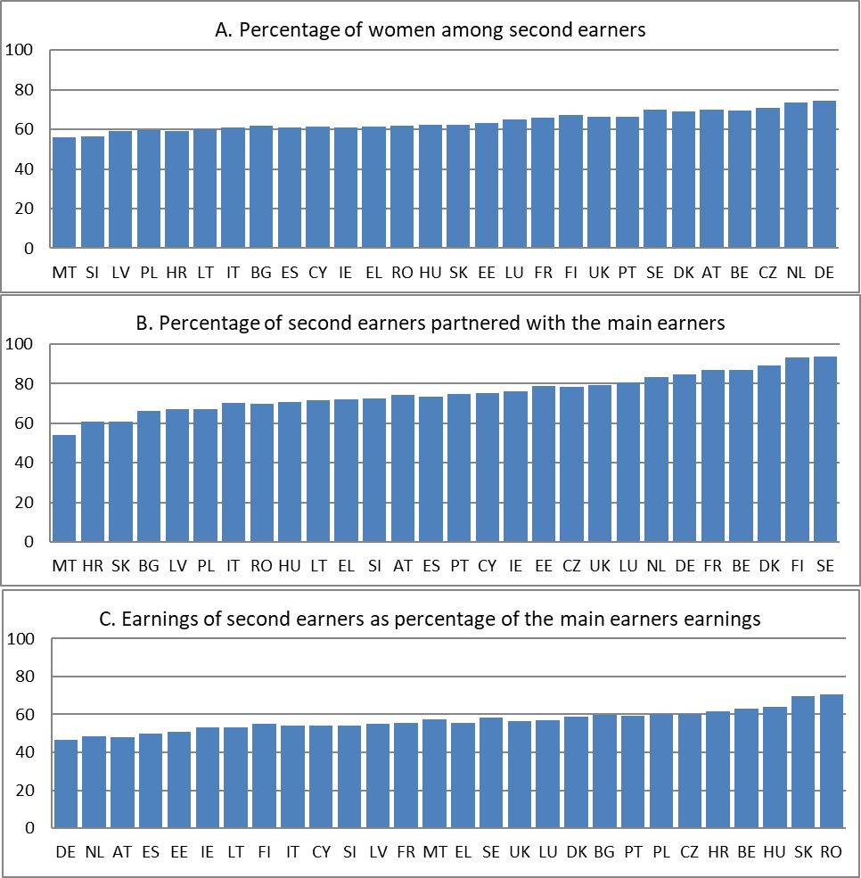
Figure A1: Characteristics of second earners: gender, partnership status and earnings, percent
Note: Countries are ordered by the percentages of second earners with the above characteristics. Here and in other figures the following acronyms are used: Belgium (BE), Bulgaria (BG), Czechia (CZ), Denmark (DK), Germany (DE), Estonia (EE), Ireland (IE), Greece (EL), Spain (ES), France (FR), Croatia (HR), Italy (IT), Cyprus (CY), Latvia (LV), Lithuania (LT), Luxembourg (LU), Hungary (HU), Malta (MT), Netherlands (NL), Austria (AT), Poland (PL), Portugal (PT), Romania (RO), Slovenia (SI), Slovakia (SK), Finland (FI), Sweden (SE). See: https://ec.europa.eu/eurostat/statistics-explained/index.php/Glossary:Country_codes.

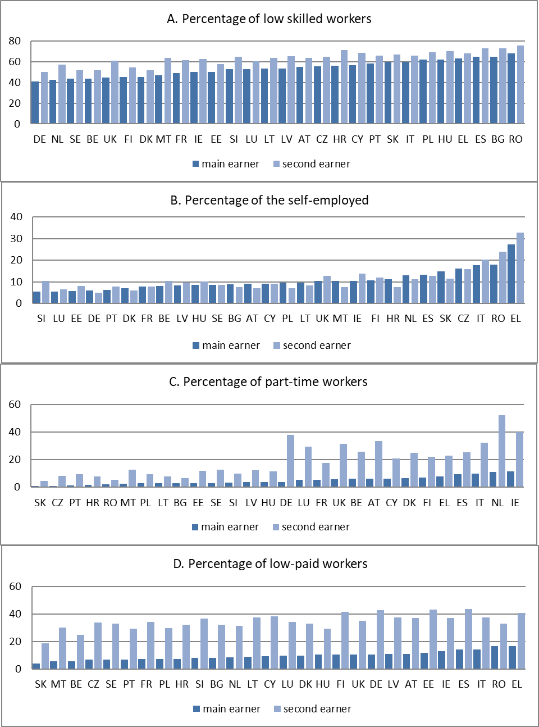
Figure A2: Labour market characteristics of second earners and main earners: prevalence of low skills, self-employment, part-time employment and low pay, percent
Note: Countries are ordered by the percentages of main earners with the above characteristics. See Figure A1 for the meaning of country acronyms.
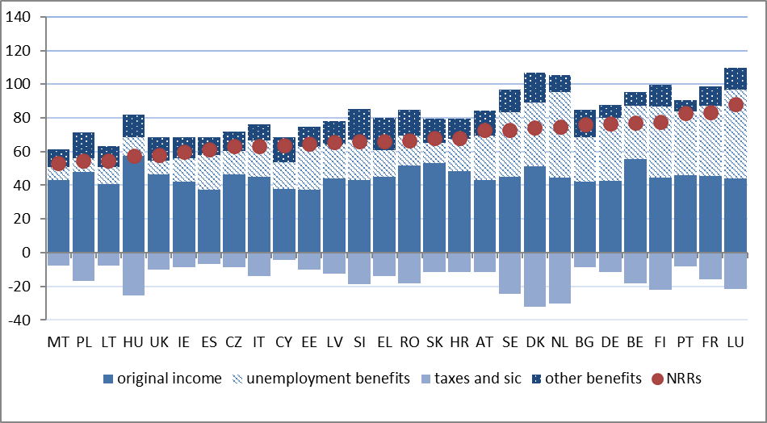
Figure A3: Decomposition of mean net replacement rates of main earners, percent
Note: Countries are ordered by mean net replacement rates of main earners. See Figure A1 for the meaning of country acronyms.

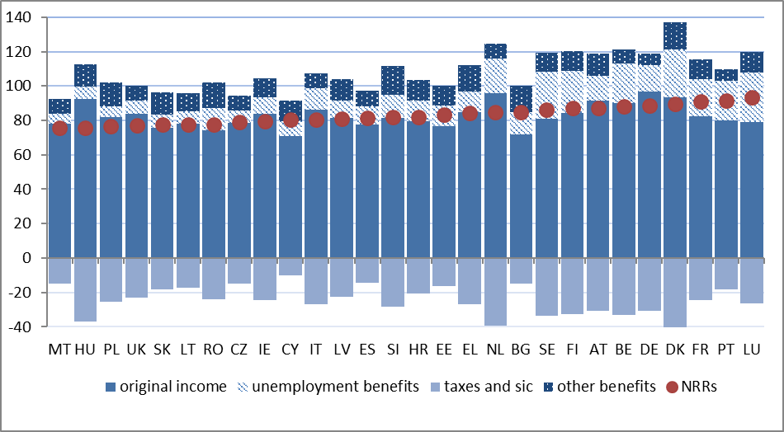
Figure A4: Decomposition of mean net replacement rates of second earners, percent
Note: Countries are ordered by mean net replacement rates of second earners. See Figure A1 for the meaning of country acronyms.

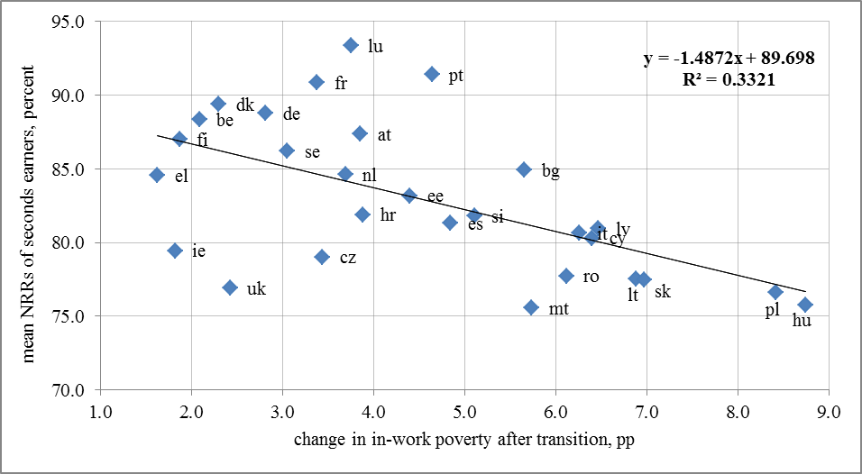
Figure A5: Mean NRRs of second earners vs. changes in in-work poverty rates due to transition
Note: See Figure A1 for the meaning of country acronyms.

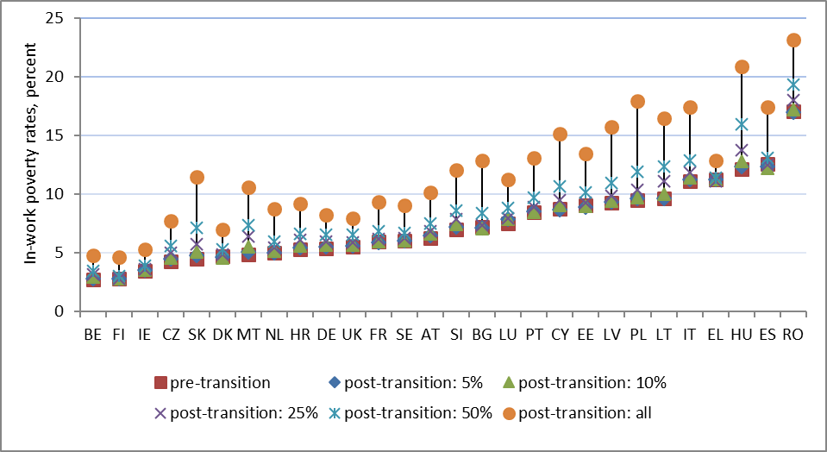
Figure A6: Pre– and post-transition in-work poverty rates under different types of shocks, percent of working age population
Note: Countries are ordered by pre-transition in-work poverty rates. See Figure A1 for the meaning of country acronyms.

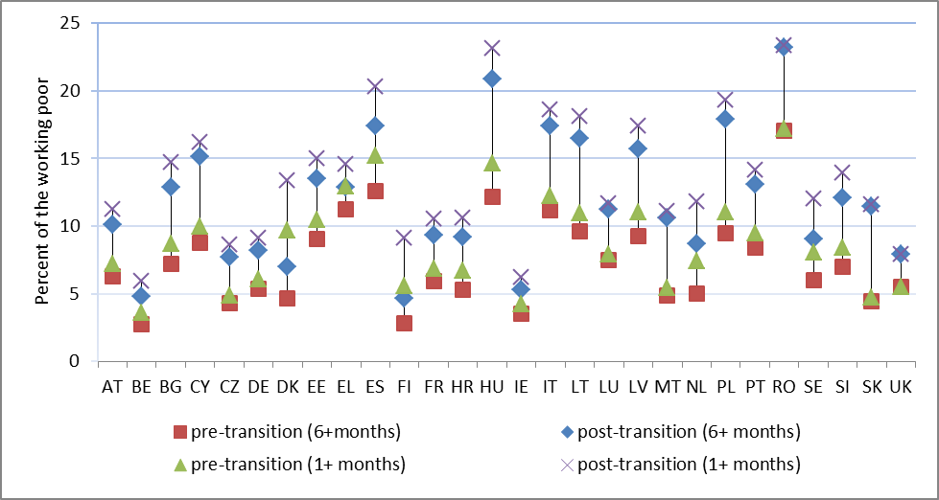
Figure A7: Pre– and post-transition in-work poverty rates under different definitions of employment, percent of working age population
Note: Countries are ordered alphabetically. See Figure A1 for the meaning of country acronyms.

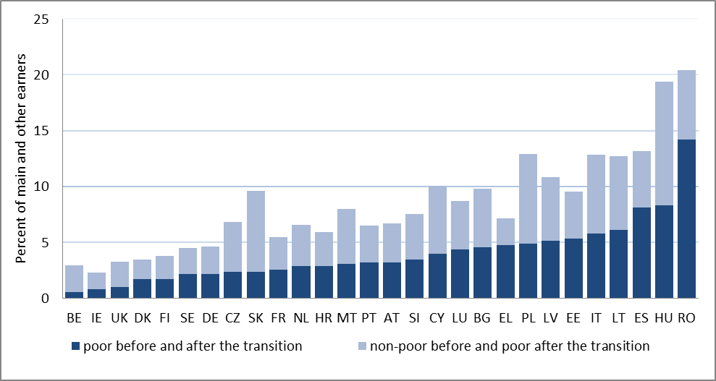
Figure A8: Pre– and post-transition in-work poverty status of earners, percent of earners in multi-earner households
Note: Countries are ordered by the percentage of earners who were poor before and after the transition of second earners to unemployment. See Figure A1 for the meaning of country acronyms.

Table A1: Descriptive statistics for variables used in the logistic regression of the probability of being working poor, pooled dataset for 28 EU countries
 | mean | sd | min | max
main earner | 0.368 |  | 0 | 1
secondary earner | 0.319 |  | 0 | 1
other earner | 0.0506 |  | 0 | 1
female | 0.474 |  | 0 | 1
age, years | 43.42 | 11.13 | 18 | 64
age squared, years/10 | 200.9 | 95.06 | 32.40 | 409.6
partnered | 0.720 |  | 0 | 1
low-skilled | 0.591 |  | 0 | 1
self-employed | 0.133 |  | 0 | 1
part-time job | 0.127 |  | 0 | 1
low-paid job | 0.181 |  | 0 | 1
number of children 0-3 years | 0.0953 | 0.318 | 0 | 4
number of children 3-5 years | 0.116 | 0.349 | 0 | 3
number of children 6-12 years | 0.283 | 0.597 | 0 | 7
number of children 13-17 years | 0.224 | 0.508 | 0 | 6
number of earners | 1.827 | 0.738 | 1 | 14
tenant | 0.164 |  | 0 | 1
ln of financial capital | 3.507 | 4.645 | -2.996 | 22.54
Observations | 216,355
Notes: N: All earners aged 18-64 years with non-zero earnings

Table A2: Descriptive statistics for variables used in the logistic regression of the probability of being a working poor before and after the transition of second earners to unemployment, pooled dataset for 28 EU countries
 | pre-transition in-work poverty |  |  |  | post-transition in-work poverty
 | Model 1 |  |  |  | Model 2 |  |  |  | Model 3
 | mean | sd | min | max | mean | sd | min | max | mean | sd | min | max
female | 0.337 |  | 0 | 1 | 0.337 |  | 0 | 1 | 0.335 |  | 0 | 1
age, years | 43.06 | 11.14 | 18 | 64 | 43.06 | 11.14 | 18 | 64 | 43.11 | 11.14 | 18 | 64
age squared, years/10 | 197.8 | 93.65 | 32.40 | 409.6 | 197.8 | 93.65 | 32.40 | 409.6 | 198.2 | 93.74 | 32.40 | 409.6
partnered | 0.833 |  | 0 | 1 | 0.833 |  | 0 | 1 | 0.834 |  | 0 | 1
low-skilled | 0.553 |  | 0 | 1 | 0.553 |  | 0 | 1 | 0.541 |  | 0 | 1
self-employed | 0.120 |  | 0 | 1 | 0.120 |  | 0 | 1 | 0.110 |  | 0 | 1
part-time job | 0.0656 |  | 0 | 1 | 0.0656 |  | 0 | 1 | 0.0603 |  | 0 | 1
low-paid job | 0.117 |  | 0 | 1 | 0.117 |  | 0 | 1 | 0.0970 |  | 0 | 1
number of children 0-3 years | 0.105 | 0.332 | 0 | 4 | 0.105 | 0.332 | 0 | 4 | 0.105 | 0.332 | 0 | 4
number of children 3-5 years | 0.128 | 0.364 | 0 | 3 | 0.128 | 0.364 | 0 | 3 | 0.127 | 0.362 | 0 | 3
number of children 6-12 years | 0.306 | 0.613 | 0 | 7 | 0.306 | 0.613 | 0 | 7 | 0.302 | 0.608 | 0 | 6
number of children 13-17 years | 0.247 | 0.527 | 0 | 4 | 0.247 | 0.527 | 0 | 4 | 0.240 | 0.520 | 0 | 4
number of earners | 2.219 | 0.702 | 1 | 14 | 2.219 | 0.702 | 1 | 14 | 2.228 | 0.696 | 1 | 14
tenant | 0.130 |  | 0 | 1 | 0.130 |  | 0 | 1 | 0.128 |  | 0 | 1
ln of financial capital | 3.639 | 4.686 | -2.996 | 22.14 | 3.639 | 4.686 | -2.996 | 22.14 | 3.718 | 4.712 | -2.996 | 22.14
net replacements rates, % |  |  |  |  | 83.09 | 11.11 | 4.490 | 165.8 | 82.74 | 10.65 | 4.680 | 149.9
Observations | 82,777 |  |  |  | 82,777 |  |  |  | 79,472
Notes:
N: Model 1 - main/other earners in households with 2+ earners before the transition; Model 2 - main/other earners in households with 2+ earners after the transition; Model 3 - main/other earners in households with 2+ earners after the transition that were not poor before the transition

