Online Supplementary Material

Appendix 1: Non-randomness of UC ‘Full Service’ rollout in respect to labour/housing market characteristics?

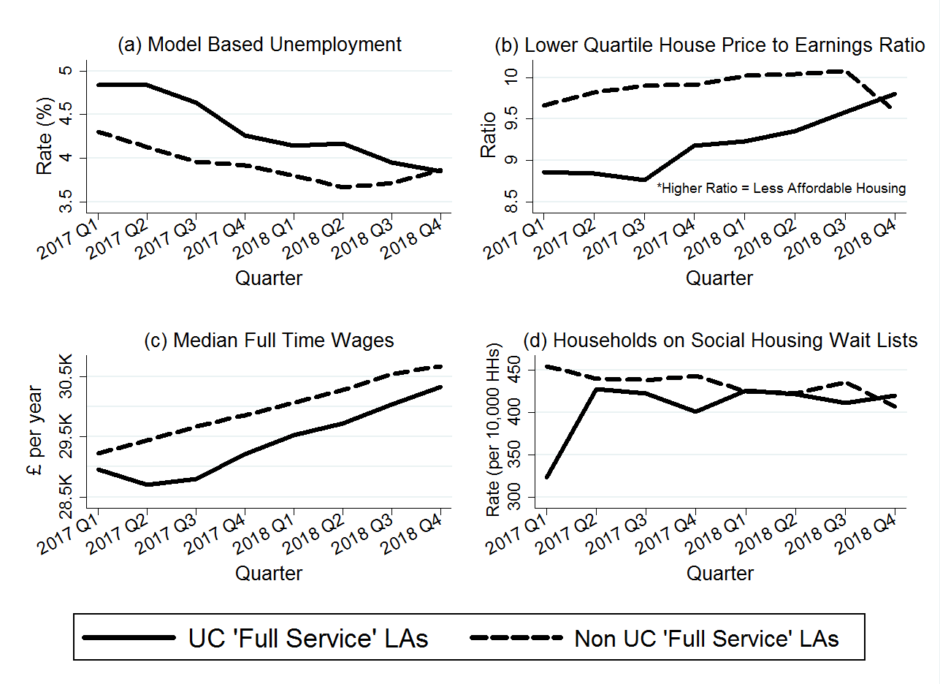
Web Figure 1. Quarterly trends in mean housing/labour market characteristics in UC ‘Full Service’ versus non UC ‘Full Service’ local authorities, 2017-2018. Notes: The number of local authorities that were UCFS areas gradually increased over time as rollout progressed – 10 percent of local authorities were UCFS areas by 2017 Q1, increasing to 17 percent by 2017 Q3, 37 percent by 2018 Q1, 65 percent by 2018 Q3 and 85 percent by 2018 Q4 (based on classification of ‘UC Full Service’ variable set out in the explanatory variables section).

Appendix 2: Repeated analysis using mortgage repossession rates as non-equivalent dependent variables (Falsification Test)

Web Table 1: Relationship between UC ‘Full Service’ rollout and mortgage lender repossession rates within 323 English local authorities, Q1 2012 – Q1 2019. Notes: Driscoll-Kraay standard errors shown in brackets under coefficients. All models include local authority and (quarterly) time fixed effects. N refers to the number of local authority quarters. Mortgage Lender repossession rates are per 10,000 owner occupied dwellings in the local authority. Mortgage repossession warrants and bailiff repossessions are not considered as these take much longer than in the case of landlord repossession, meaning the two are not comparable. +p<0.10, *p<0.05, **p<0.01, ***p<0.001.
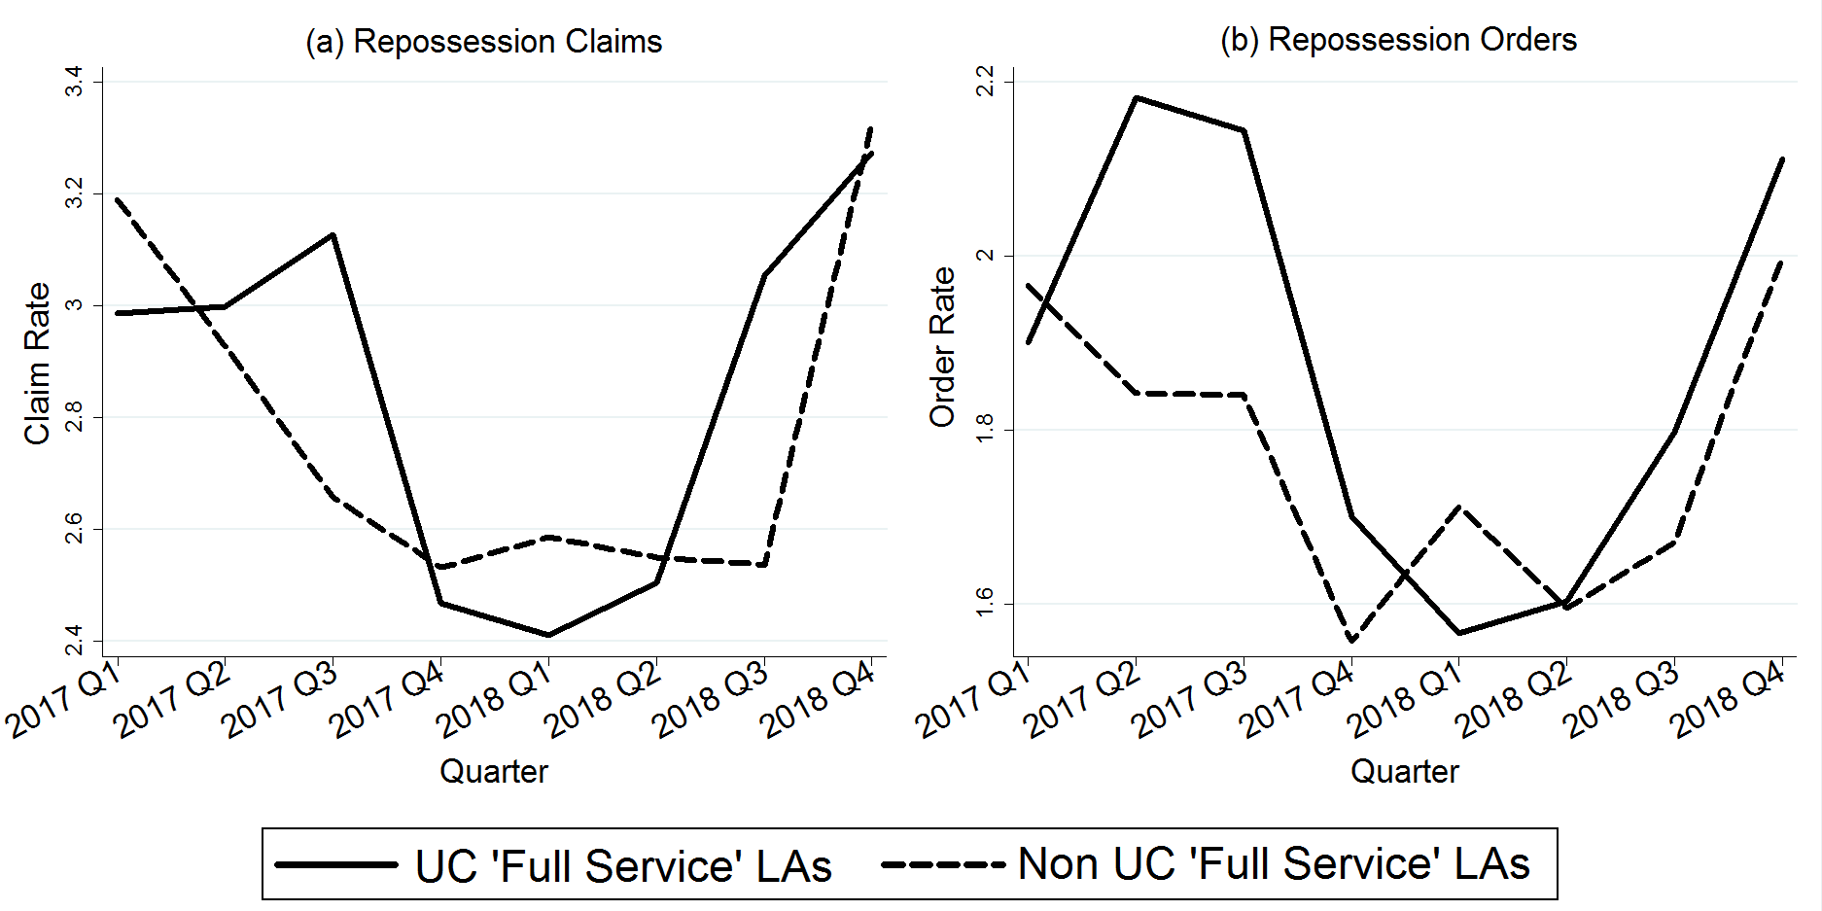
Web Figure 2. Quarterly trends in mean mortgage lender repossession rates in UC ‘Full Service’ versus non UC ‘Full Service’ local authorities, 2017-2018. Notes: The number of local authorities that were UCFS areas gradually increased over time as rollout progressed – 10 percent of local authorities were UCFS areas by 2017 Q1, increasing to 17 percent by 2017 Q3, 37 percent by 2018 Q1, 65 percent by 2018 Q3 and 85 percent by 2018 Q4 (based on classification of ‘UC Full Service’ variable set out in the explanatory variables section.

Web Figure 3. Quarterly trends in mean mortgage lender repossession rates (relative to the average across local authorities) in English local authorities, before and after UC ‘Full Service’ rollout. Notes: only includes data on the 136 local authorities with repossessions data available to the fourth quarter or more post ‘Full Service’ rollout. ‘Full Service’ rollout is the first quarter in which UC ‘Full Service’ was available in most Jobcentres in the local authority for most of the quarter. Y axes give the mean of the ratio between mortgage lender repossession rates and the average across the 136 local authorities in the given quarter.

