## Appendix

#### Comparison of JSA and ESA sanction rates

Figure A1 compares the JSA and ESA sanctions rate during the period of analysis. Due to recent changes in how the DWP publish claimant statistics, the rates themselves are only presented for four particular months during each year (February, May, August and November). JSA and ESA sanction rates are calculated using original adverse sanctions relating to claimants in England only, and measure sanctions as a proportion of JSA claimants and ESA WRAG claimants respectively. The different variations in rates of JSA and ESA sanctions implies that the analysis is not seriously affected by its omission of ESA sanctions at the local authority-level in the fixed effects regression models.

**Figure A1**: JSA and ESA sanctions rate (per cent of claimants), 2010-2015

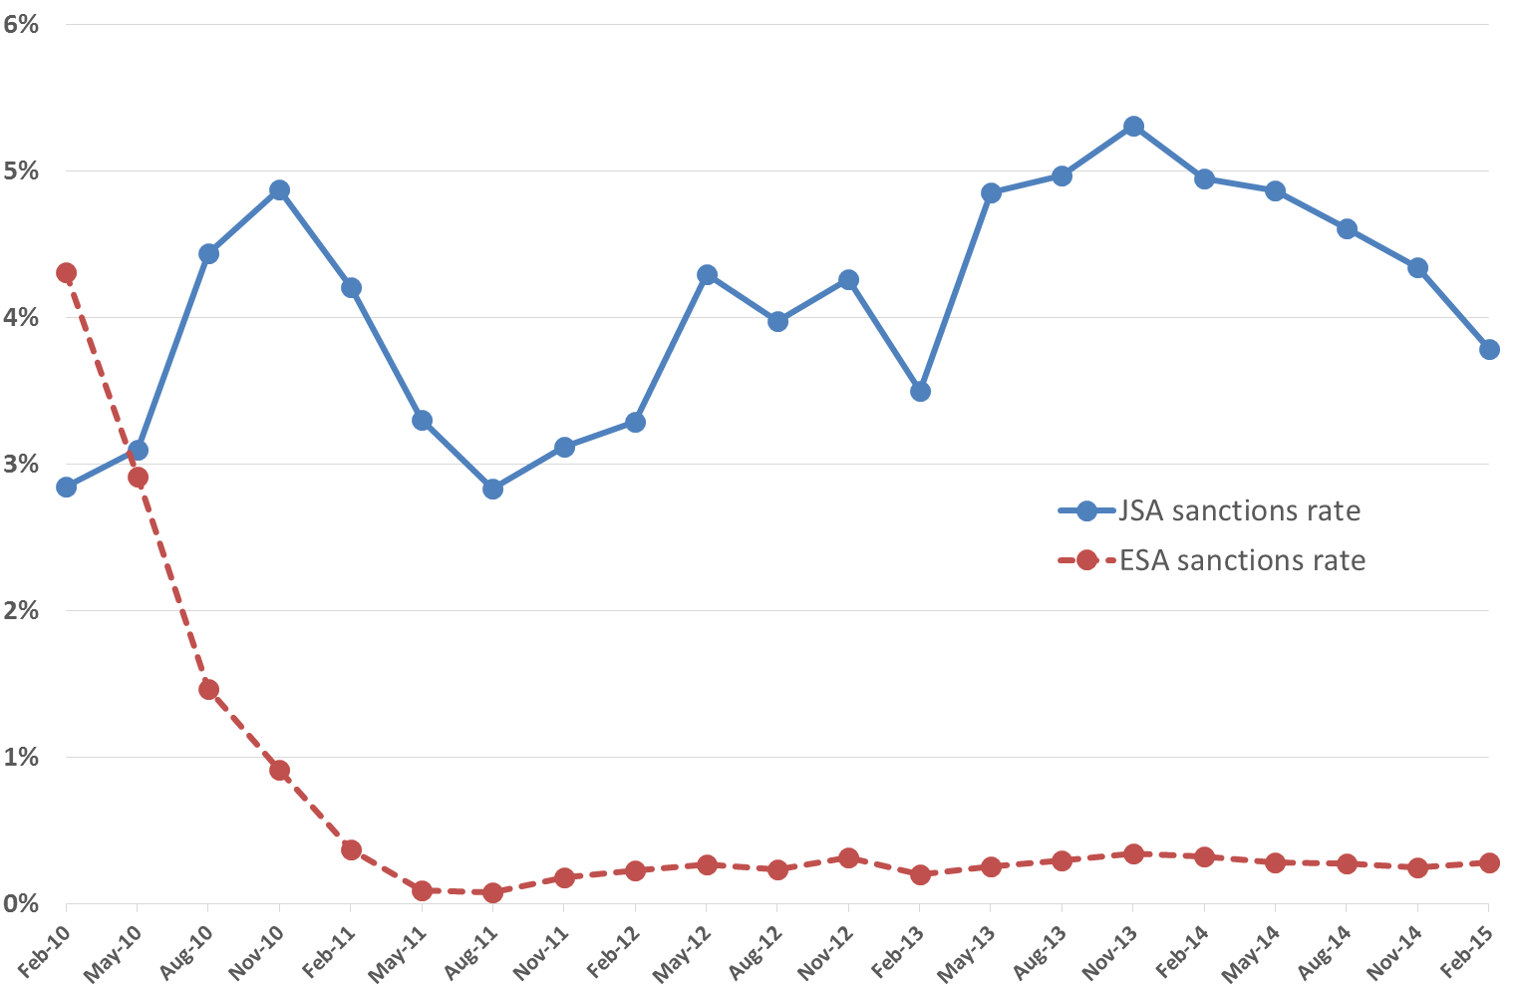

*Source*: author’s calculations using Stat-Xplore data

#### Summary statistics

|  |  |  |  |  |  |  |
| --- | --- | --- | --- | --- | --- | --- |
| **Table A1**: descriptive statistics for 324 local authorities, across 18 quarters (Q3 2010 – Q4 2014) | | | | | | |
|  | *N* | Mean | St.d Dev. | Min. | Max. | Source |
| *Dependent variable*: |  |  |  |  |  |  |
| SSRI prescribing | 5,754 | 12,946 | 3,411 | 5,114 | 28,830 | NHS Digital |
| *Sanctions variable*: |  |  |  |  |  |  |
| Original adverse | 5,754 | 223 | 139 | 9 | 969 | Stat-Xplore |
| *Control variables*: |  |  |  |  |  |  |
| Claimants | 5,754 | 1,851 | 964 | 287 | 6,033 | Nomis |
| Unemployment | 5,459 | 3,514 | 1,393 | 603 | 10,044 | Nomis |
| Economic Inactivity | 5,754 | 13,809 | 3,133 | 5,618 | 25,575 | Nomis |
| Employment | 5,754 | 45,363 | 3,587 | 28,553 | 59,802 | Nomis |
| Work Capability Assessments | 5,754 | 248 | 129 | 26 | 1,173 | Stat-Xplore |
| GVA | 5,754 | 22,886 | 14,435 | 11,876 | 235,244 | Nomis |
| GDHI | 5,754 | 18,105 | 4,374 | 10,728 | 59,879 | Nomis |
| Age |  |  |  |  |  | Nomis |
| 0-15 year olds | 5,754 | 18,586 | 1,837 | 13,712 | 26,967 |  |
| 16-29 year olds | 5,754 | 17,358 | 3,846 | 11,644 | 32,959 |  |
| 30-49 year olds | 5,754 | 27,132 | 2,817 | 18,670 | 37,897 |  |
| 50-64 year olds | 5,754 | 18,741 | 2,433 | 9,145 | 24,038 |  |
| 65 and above | 5,754 | 18,182 | 4,385 | 6,018 | 31,854 |  |
| Female | 5,754 | 50,829 | 697 | 45,813 | 52,562 | Nomis |
| White UK born | 5,754 | 82,636 | 15,482 | 13,921 | 99,042 | Nomis |
| Antibiotics prescribing | 5,754 | 17,347 | 3,117 | 8,788 | 38,915 | NHS Digital |
| Index of Multiple Deprivation |  |  |  |  |  | DCLG |
| Quintile 1 | 1,166 |  |  |  |  |  |
| Quintile 2 | 1,157 |  |  |  |  |  |
| Quintile 3 | 1,140 |  |  |  |  |  |
| Quintile 4 | 1,165 |  |  |  |  |  |
| Quintile 5 | 1,126 |  |  |  |  |  |
| Urban-Rural Classification |  |  |  |  |  | Defra |
| Predominantly rural | 1,620 |  |  |  |  |  |
| Urban with significant rural | 959 |  |  |  |  |  |
| Predominantly urban | 3,175 |  |  |  |  |  |
| *Falsification variable*: |  |  |  |  |  |  |
| Cardiovascular Prescribing | 5,754 | 144,487 | 36,595 | 58,061 | 288,986 | NHS Digital |
| *Note*: suppression of values for the APS unemployment estimates leads to the fall in the sample size. | | | | | | |

#### Initial modelling process

|  |  |  |  |
| --- | --- | --- | --- |
| **Table A2**: relationship between sanctions and SSRI prescribing | | | |
|  | Model A1: Fixed effects | Model A2: Fixed effects | Model A3: Random effects |
| Sanctions | 0.465* (0.206) | 0.371*** (0.079) | 0.478** (0.180) |
| Unemployment | -0.012 (0.015) | -0.013 (0.012) | -0.013 (0.013) |
| Economic Inactivity | 0.009*** (0.002) | 0.005* (0.002) | 0.009 (0.008) |
| WCAs | 0.440 (0.595) | 0.199 (0.412) | 0.528*** (0.162) |
| GVA | -0.054*** (0.013) | -0.021* (0.008) | -0.038** (0.013) |
| Age |  |  |  |
| 16–29 | -0.001 (0.067) | -0.168*** (0.035) | 0.104 (0.100) |
| 30–49 | -0.261* (0.090) | -0.589*** (0.075) | -0.147 (0.137) |
| 50–64 | -0.208** (0.071) | -0.519*** (0.072) | -0.020 (0.142) |
| 65 and over | 0.144** (0.047) | 0.011 (0.034) | 0.229* (0.095) |
| Female | 0.145 (0.108) | 0.558*** (0.069) | 0.083 (0.161) |
| White UK born | 0.002 (0.003) | -0.0001 (0.002) | 0.015* (0.006) |
| Antibiotic Prescribing | 0.111*** (0.019) | 0.086*** (0.015) | 0.133*** (0.021) |
| Index of Multiple Deprivation |  |  |  |
| Quintile 2 |  |  | 370.56 (368.396) |
| Quintile 3 |  |  | 1,268.77*** (371.098) |
| Quintile 4 |  |  | 2,215.73*** (398.461) |
| Quintile 5 |  |  | 3,052.26*** (469.230) |
| Urban-Rural Classification |  |  |  |
| Urban with significant rural |  |  | -419.259 (405.112) |
| Predominantly urban |  |  | -1224.087*** (362.712) |
| Index of Multiple Deprivation |  |  |  |
| Quintile 2 × Quarter |  | 37.508*** (2.112) |  |
| Quintile 3 × Quarter |  | 60.046*** (3.042) |  |
| Quintile 4 × Quarter |  | 75.667*** (4.671) |  |
| Quintile 5 × Quarter |  | 114.015*** (7.715) |  |
| Urban-Rural Classification |  |  |  |
| Urban with significant rural × Quarter |  | -22.709*** (2.189) |  |
| Predominantly urban × Quarter |  | -30.276*** (3.388) |  |
| *R*2 (within) | 0.866 | 0.889 | 0.865 |
| LA Quarters | 5,459 | 5,459 | 5,459 |
| *Note*: Robust standard errors in brackets. Model A1 and A2 include local authority and time fixed effects; Model A3 includes time fixed effects. Constant not shown. * p < 0.05, ** p < 0.01, *** p < 0.001 | | | |

#### Diagnostic tests

Various diagnostic checks are carried out to test that the fixed effects model assumptions are satisfied (Greene, 2008). The diagnostic checks presented here are for regression Model 1 in Table 1.

##### Normality of the residuals

Figure A2 depicts a histogram of the regression residuals to check for serious deviations from the assumption of normality. Clearly, the residuals do not deviate sufficiently from the ideal of normality to be of concern to the results of the analysis. Three formal tests of normality, a Skewness/Kurtosis test (p < 0.001), a Shapiro-Wilk test (p < 0.001) and a Shapiro-Francia test (p < 0.001) reject the null of normality. However, as Ghasemi and Zahedias (2012) outline, such tests are sensitive to even very small deviations from normality at large sample sizes. The rejection of normality by such tests is therefore not of concern to the analysis, given the distribution that is actually observed.

**Figure A2**: distribution of regression residuals compared against normal distribution curve



##### Cross-sectional independence, homoscedasticity, no serial correlation and stationarity

The tests carried out in this sub-section indicate that the fixed effects models suffer from cross-sectional dependence, heteroscedasticity and autocorrelation, though there are important caveats on the tests themselves that will be explained in more detail in the following discussion. Consequently, the fixed effects regression models estimated throughout the analysis use Driscoll-Kraay standard errors (Driscoll and Kraay, 1998), which are robust to cross-sectional dependence, heteroscedasticity and correlation through time within local authorities. These are implemented using the Stata command ‘xtscc’, developed by Hoechle (2007).

First, a check for cross-sectional dependence is carried out. The standard test of this issue is the Breusch-Pagan Lagrange multiplier (LM) test, as developed by Breusch and Pagan (1980). This test isn’t valid in panels with a large number of observations (*N*) but a small number of observations per cross-sectional unit (*T*), which is the case here (*N* = 324, *T* = 18). Instead, Pesaran’s (2004) cross-sectional dependence (CD) test is carried out, using the ‘xtcsd’ Stata command developed by De Hoyos and Sarafidis (2006), which is compatible with unbalanced datasets. The Pesaran (2004) CD test rejects the null hypothesis of no cross-sectional dependence (p < 0.05).

Next, in order to check for heteroscedasticity, a modified Wald test (Greene, 2008) is carried out that tests for group-wise heteroscedasticity in the residuals of fixed effect regression models, using the Stata command ‘xttest3’ developed by Baum (2001). The modified Wald test rejects the null of homoscedasticity (p < 0.001), which indicates that the residuals display heteroscedasticity. This test, however, has a very low power in the context of fixed effects with ‘large *N*, small *T*’ (Baum, 2001: 102) panels, as is the case here. The result of the modified Wald test should, therefore, be treated with caution. Indeed, a scatter plot of the regression residuals against predicted values, furthermore, suggests that the error term has an approximately constant variance, since there is no sign of a fanning out effect over different predicted values. This is depicted in Figure A3.

**Figure A3**: scatter plot of the regression residuals against predicted values



Next, in order to check for serial correlation, a Wooldridge (2002) test is carried out using the Stata command ‘xtserial’ developed by Drukker (2003). The Wooldridge (2002) test rejects the null of no autocorrelation (p < 0.001), though – like the modified Wald test – is very sensitive in the context of fixed effects with a large *N* and small *T* panel (Drukker, 2003).

Finally, in order to test for non-stationarity, Pesaran’s (2007) panel unit root test is carried out which – unlike many unit root tests – does not require the assumption of cross-sectional independence to be met. This is carried out using the Stata command ‘pescadf’ developed by Lewandowski (2007), which rejects the null of non-stationarity with or without a time trend included (p < 0.001).

##### Unusual and Influential Data

Next, checks for the influence of outliers and extreme observations are carried out. Firstly, observations with residuals that are two standard deviations from the mean in Model 1 are removed and the regression models re-estimated (Cousineau and Chartier, 2010). The results are shown in Table A3, Model A4. To check for the role of extreme observations, furthermore, the results from Model 1 were re-run with the top and bottom one percentiles removed for sanctions (Model A5). Finally, the results were re-run with the seaside areas discussed in the results section removed (Model A6). The results across the separate models in Table A3 remain similar to the estimated sanctions coefficient in Model 1.

|  |  |  |  |
| --- | --- | --- | --- |
| **Table A3**: relationship between sanctions and SSRI prescribing | | | |
|  | Model A4 | Model A5 | Model A6 |
| Sanctions | 0.344 *** (0.086) | 0.327** (0.109) | 0.409*** (0.083) |
| *R*2 (within) | 0.889 | 0.889 | 0.889 |
| LA Quarters | 5,265 | 5,362 | 5,369 |
| *Note*: Robust standard errors in brackets. Models include local authority and time fixed effects. Constant and additional control variables not shown. * p < 0.05, ** p < 0.01, *** p < 0.001 | | | |

References for diagnostic tests

Baum, C. F. (2001), ‘Residual diagnostics for cross-section time series regression models’, *Stata Journal*, 1, 1, 101-104.

Breusch, T. S., and Pagan, A. R. (1980), ‘The Lagrange multiplier test and its applications to model specification in econometrics’, *Review of Economic Studies*, 47, 1, 239-253.

Cousineau, D., and Chartier, S. (2010), ‘Outliers detection and treatment: A review’, *International Journal of Psychological Research*, 3, 1, 58-67.

de Hoyos, R. E., and Sarafidis, V. (2006), ‘Testing for cross-sectional dependence in panel-data models’, *Stata Journal*, 6, 4, 482-496.

Driscoll, J., and Kraay, A. C. (1998), ‘Consistent covariance matric estimation with spatially dependent data’, *Review of Economics and Statistics*, 80, 4, 549-560.

Drukker, D. M. (2003), ‘Testing for serial correlation in linear panel-data models’, *Stata Journal*, 3, 2, 168-177.

Ghasemi, A. and Zahedias, S. (2012), ‘Normality tests for statistical analysis: a guide for non-statisticians’, *International Journal of Endocrinology and Metabolism*, 10, 2, 486.

Greene, W. H. (2008), *Econometric Analysis (6th edition)*, New York: Prentice-Hall.

Hoechle, D. (2007), ‘Robust standard errors for panel regressions with cross-sectional dependence’, *Stata Journal*, 7, 3, 281-312.

Lewandowski, P. (2007), *PESCADF: Stata module to perform Pesaran’s CADF panel unit root test in presence of cross section dependence (Statistical Software Components No. S456732)*, Boston: Boston College Department of Economics.

Pesaran, M. H. (2004), *General diagnostic tests for cross section dependence in panels. Cambridge Working Papers in Economics No. 0435*, Cambridge: University of Cambridge.

Pesaran, M. H. (2007), ‘A simple panel unit root test in the presence of cross-section dependence’, *Journal of Applied Econometrics*, 22, 2, 265-312.

Wooldridge, J. M. (2002), *Econometric Analysis of Cross Section and Panel Data*, Cambridge, MA: MIT Press.

#### Falsification test

|  |  |  |
| --- | --- | --- |
| **Table A4**: relationship between sanctions and cardiovascular prescribing | | |
|  | Model A7 | Model A8 |
| Sanctions | 1.503 (1.288) | 1.478 (1.685) |
| Sanctions x Reform |  | 0.035 (1.575) |
| Unemployment | -0.037 (0.086) | -0.037 (0.086) |
| Economic Inactivity | -0.054 (0.057) | -0.054 (0.057) |
| WCAs | -2.463** (0.939) | -2.465** (0.937) |
| GVA | 0.099 (0.083) | 0.099 (0.082) |
| Age |  |  |
| 16–29 | 0.282 (1.154) | 0.282 (1.152) |
| 30–49 | 0.843 (1.710) | 0.842 (1.708) |
| 50–64 | 1.639 (1.587) | 1.639 (1.581) |
| 65 and over | 2.555* (1.039) | 2.555* (1.041) |
| Female | 2.811* (1.134) | 2.810* (1.130) |
| White UK born | -0.008 (0.041) | -0.008 (0.041) |
| Antibiotic Prescribing | 0.677*** (0.163) | 0.676*** (0.164) |
| Index of Multiple Deprivation |  |  |
| Quintile 2 × Quarter | 206.595* (84.586) | 206.465* (84.596) |
| Quintile 3 × Quarter | 100.641 (68.404) | 100.372 (70.299) |
| Quintile 4 × Quarter | 263.887*** (73.243) | 263.433*** (75.009) |
| Quintile 5 × Quarter | 283.358** (93.980) | 282.593** (105.256) |
| Urban-Rural Classification |  |  |
| Urban with significant rural × Quarter | -175.721* (77.698) | 175.766* (77.863) |
| Predominantly urban × Quarter | -192.588* (77.830) | 192.665* (78.036) |
| *R*2 (within) | 0.631 | 0.631 |
| LA Quarters | 5,459 | 5,459 |
| *Note*: Robust standard errors in brackets. Models include local authority and time fixed effects. Constant not shown. * p < 0.05, ** p < 0.01, *** p < 0.001 | | |