APPENDIX 6. Attitudes toward Social Europe explained by structural and attitudinal predictors – significant direct effects
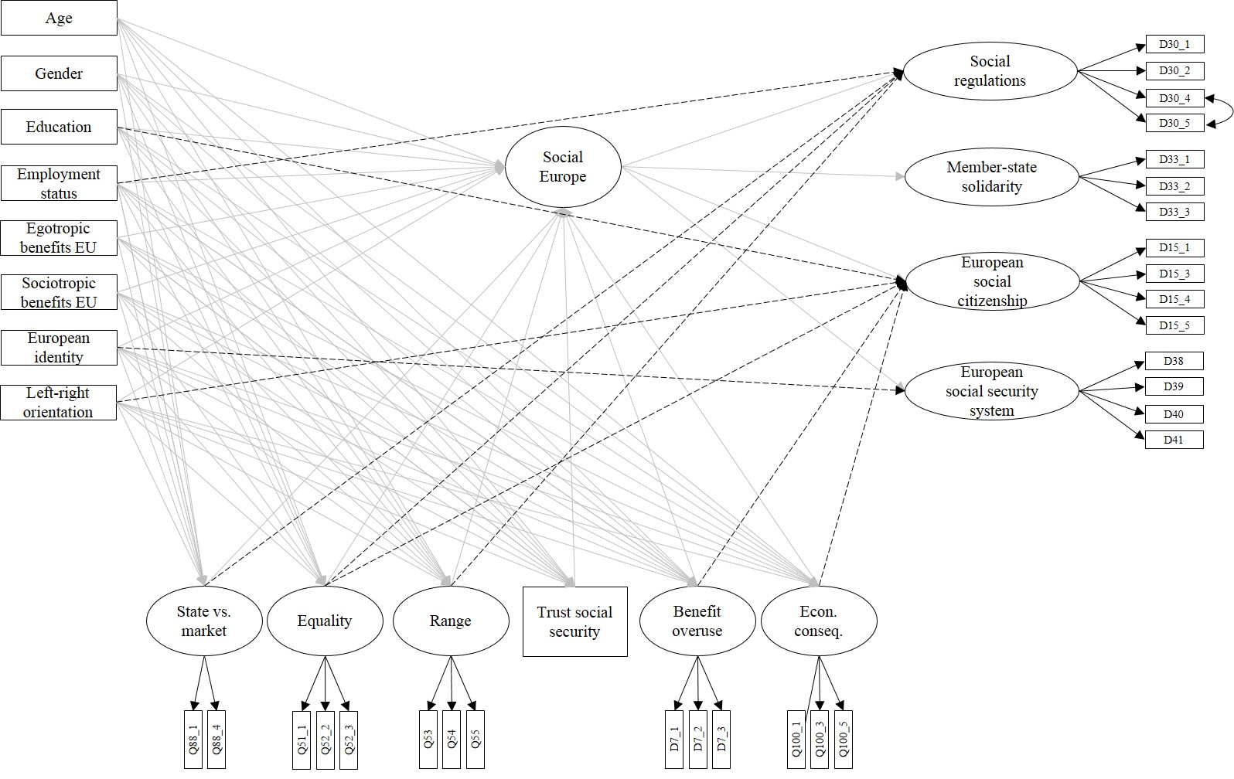
Note. The general effects are depicted by the arrows from the independent variables on the left side and in the bottom of the figure, pointing to the second-order latent factor ‘Social Europe’. Differential effects of predictors on first-order attitudinal dimensions are illustrated by dashed lines.

