APPENDIX 5. Measurement model of attitudes toward Social Europe (weighted by age, gender, and education)

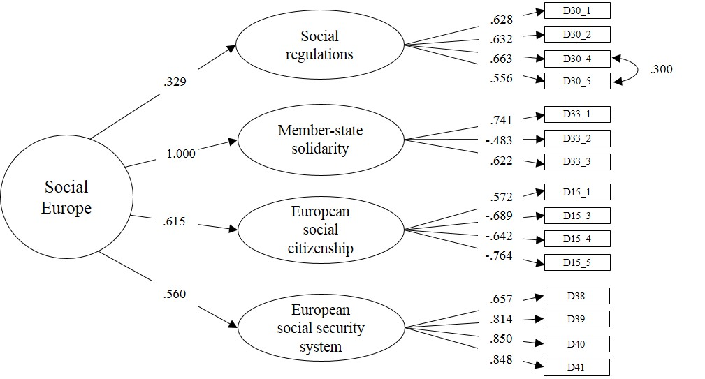

Note. χ²= 212.251; df=86; RMSEA=.032; CFI=.967; TLI=.960; SRMR=.043; n= 1401; estimator= MLR.

