Appendix A: Who receives cash benefits?
This appendix describes the individual characteristics of benefit recipients. We measure four family characteristics: highest level of parental education, maternal marital status when the child was 16 years old, and whether one or both parents have received social assistance or disability benefits at any point during their child’s life. Table A1 shows that 61 percent of benefit recipients are men. There is also a slight overrepresentation of first generation immigrants, as 8.7 percent of recipients have an immigrant origin versus 7.5 percent of those who have never received cash benefits.
TABLE A1. Descriptive statistics
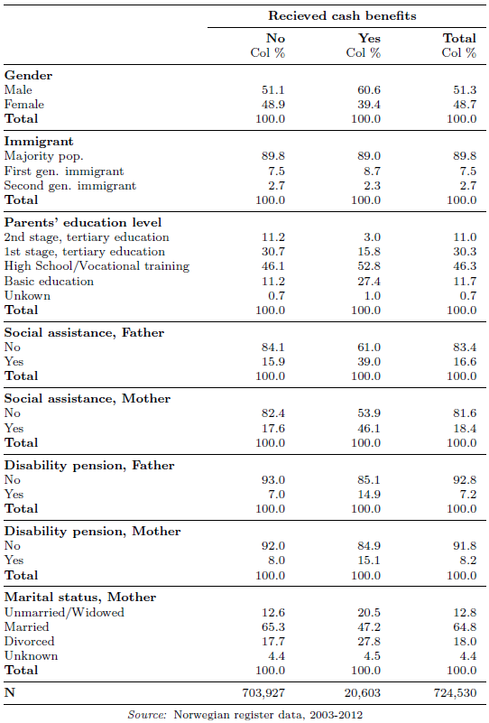
The information concerning the young people’s living conditions and upbringing, as measured by their parents’ social background, shows that young people who receive cash benefits are more often disadvantaged in terms of their family origins. The parents of the benefits recipients have a significantly lower education level. This is most evident in the differences in proportions among parents who have a tertiary and a basic education. Only 18 percent of benefit recipients have parents with a tertiary education, compared to 42 percent among the non-recipients. The share of young people whose parents have a basic education is more than 2.5 times as high among the benefit recipients.
The measures concerning social assistance and disability pensions show whether the mother or the father has received any transfers between 1992, which marks the start of the registers, and the first year we observe the young people. Among the benefit recipients, 39 percent have a father who has received social assistance at least once, while 46 percent have a mother who has received social assistance. The corresponding shares among non-recipients are 16 and 18 percent. The same pattern holds true for disability pensions: twice as many benefit recipients have a mother or father on a disability pension when compared with other young people. The final background characteristic is the mother’s marital status when the young person was 16 years old. Again, young people on benefits have a more vulnerable background, since 21 percent have a single mother (unmarried or widowed) and 28 percent have a divorced mother. The corresponding rates among non-recipients are 13 and 18 percent.
Table A2 shows the education level of young people aged 18 and 19. The school year is observed in December and the educational outcome is observed in June. Among those who are not registered as benefit recipients, the majority started the second or third year of high school when observed as 18 year olds. Among the benefit recipients, however, 48 percent are not registered in education. A high share is also registered in the first or second year of high school. For those who are 19 years old, the majority of non-recipients are in the last year of high school (50 percent). Those who are not registered in upper secondary education have likely started tertiary education, military service or are in employment (39 percent). Among the benefit recipients, only 15 percent have started the final year of high school, while fully 65 percent are not registered in upper secondary education.
TABLE A2. Education level of benefit recipients
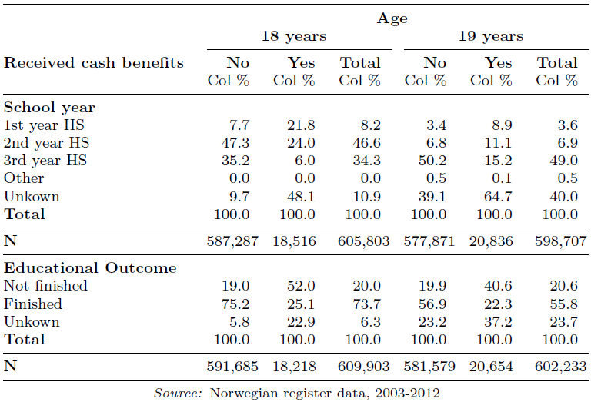
The figures concerning educational attainment confirm the difference between the two groups of young people. Among the non-recipients, 75 percent of 18 year olds and 57 percent of 19 year olds are registered as having finished education at their grade level. The corresponding rates for the IA benefit recipients are 25 percent and 22 percent. In other words, dropping out of school is a significant issue among those on IA subsistence support. This is not surprising given that young people who are under the auspices of NAV and who receive cash benefits have cancelled or postponed high school and education.

Appendix B: Placebo regression, 20-year age cut-off point

TABLE B1. RD estimates of the effect of higher benefits on programme participation (placebo regression)
 | (1) | (2) | (3)
 | Linear spline | Quadratic spline | Cubic spline
+/- 12 months | -0.000409*** | -0.000143*** | -0.000223***
 | (0.000) | (0.000) | (0.000)
+/- 6 months | -0.000936*** | -0.000237*** | -0.000123***
 | (0.000) | (0.000) | (0.000)
Robust standard errors in parentheses. *** p<0.01, ** p<0.05, * p<0.1. Placebo regression pretending the cut-off point to be at age 20.

Appendix C: Regression results for young people from families dependent on social assistance

TABLE C1. RD estimates of the effect of higher benefits on programme participation
 | (1) | (2) | (3)
 | Linear spline | Quadratic spline | Cubic spline
+/- 12 months | 0.000229*** | -0.000325*** | -0.000155***
 | (0.000) | (0.000) | (0.000)
+/- 6 months | -0.000055*** | -0.000752*** | -0.001175***
 | (0.000) | (0.000) | (0.000)
Robust standard errors in parentheses. *** p<0.01, ** p<0.05, * p<0.1.

Figure C1. Programme participation around the 19-year threshold

TABLE C2. RD estimates of the effect of higher benefits on employment
 | (1) | (2) | (3)
 | Linear spline | Quadratic spline | Cubic spline
+/- 12 months | -0.01613*** | 0.00190*** | 0.00167***
 | (0.000) | (0.000) | (0.000)
+/- 6 months | -0.00337*** | 0.00092*** | -0.00095***
 | (0.000) | (0.000) | (0.000)
Robust standard errors in parentheses. *** p<0.01, ** p<0.05, * p<0.1.

Figure C2. Employment around the 19-year threshold

