List of Web Figures
Web Figure A1 Monthly average rate of sanctions applied to claimants over quarter as a proportion of total Jobseeker’s Allowance claimants.
Web Figure A2 Relationship between Trussell Trust foodbanks and local authorities in Scotland, England, and Wales included in analytic longitudinal sample of local authorities.
Web Figure A3 Rates of adult food bank usage by when food banks established in local authorities and subsequent growth in Trussell Trust Foodbank Network.

List of Web Tables
Web Table A1 Descriptive statistics: the expansion of food banks and feeding in local authorities across UK (2012/13 to 2015/16).
Web Table A2 Interactions between level of food bank operations in local authorities and change in sanctions applied in relation to change in number of adult food bank users.
Web Table A3 Model matching Figure 3 interaction model using categorical number of distribution sites.
Web Table A4 Sensitivity analysis: relationship between sanctions applied and number of adult food bank users in local authorities with food banks after adjustment for employment and unemployment.
Web Table A5 Sensitivity analysis: dynamic relationship between numbers of sanctions applied from quarter-to-quarter and change in numbers using food banks excluding extreme observations.
Web Table A6 Relationship between sanctions applied and number of adult food bank users in English local authorities with food banks using random effects framework and accounting for additional measures of area deprivation and rural-urban classification, 2012-2015.

Web Figure A1 Relationship between Trussell Trust foodbanks and local authorities in Scotland, England, and Wales included in analytic longitudinal sample of local authorities.

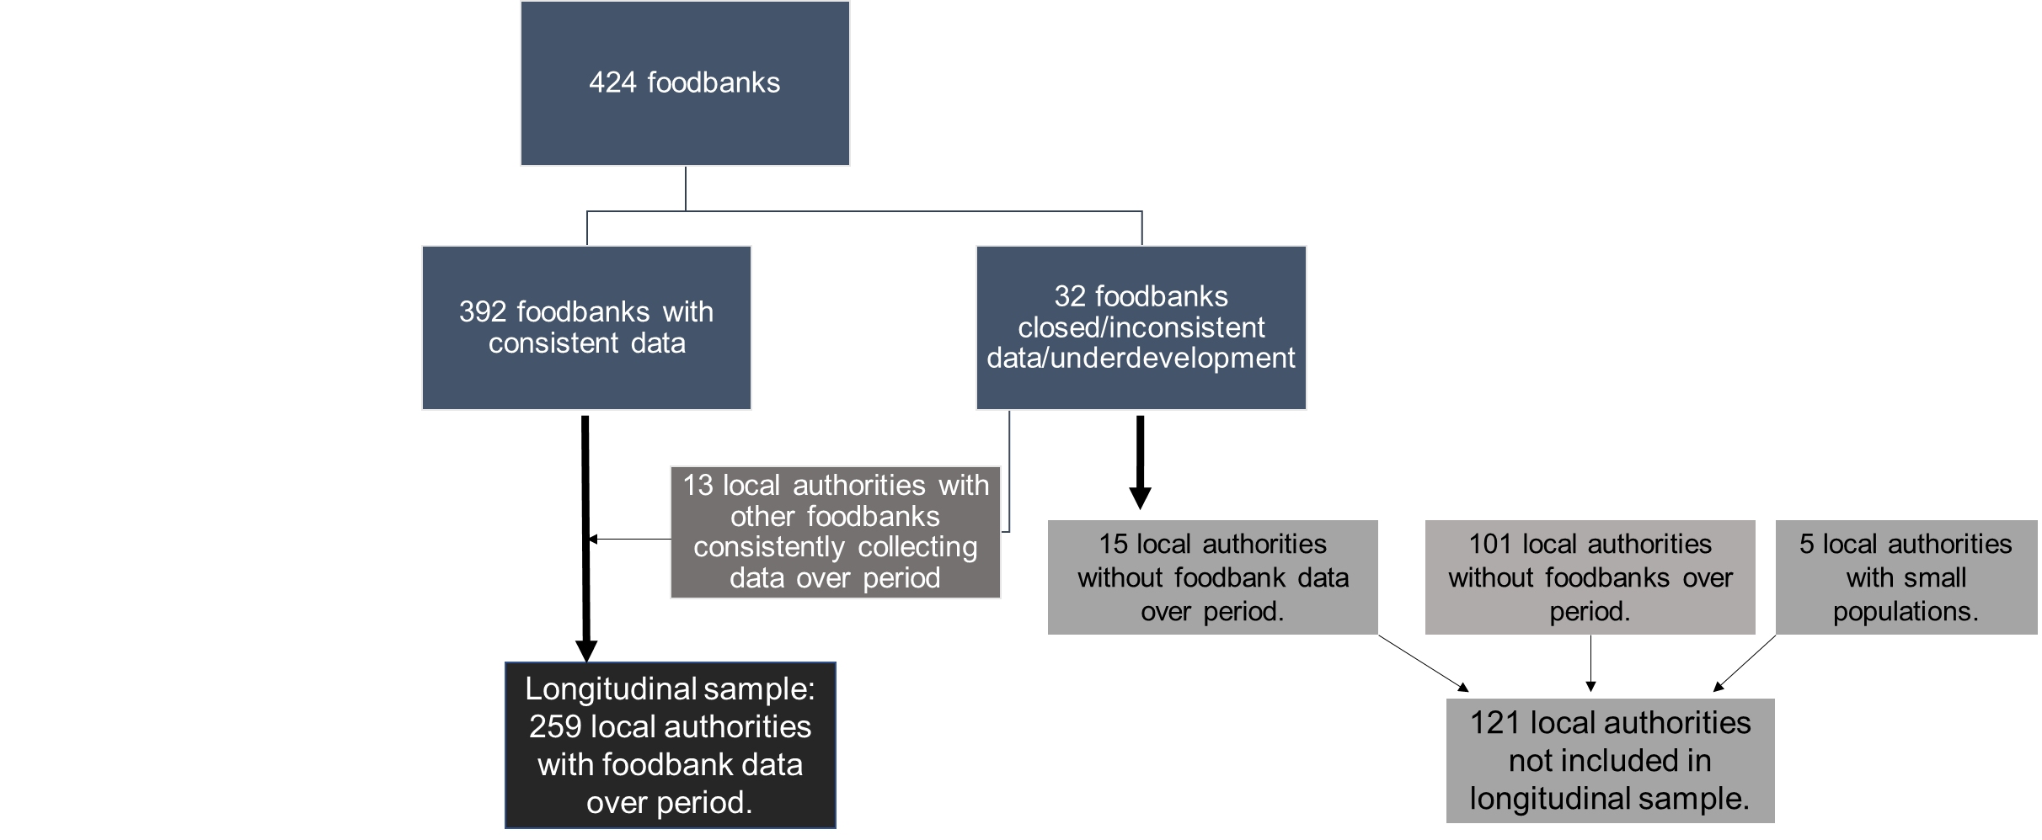

Web Figure A2 Rates of adult food bank usage by when food banks established in local authorities and subsequent growth in Trussell Trust Foodbank Network.

Web Table A1 The expansion of food banks and feeding in local authorities across UK, 2012/13 to 2015/16.
Quarter beginning: | Number of local authorities | Number of food banks | Number of food banks per local authority |  | Number of food banks per 100,000 in local population |  | People fed each quarter as proportion of local population
 | n | n | Mean | SD | Mean | SD | Mean | SD
Apr 2012 | 114 | 138 | 1.21 | 0.87 | 0.74 | 0.37 | 0.24 | 0.22
Jul 2012 | 136 | 165 | 1.21 | 0.90 | 0.76 | 0.38 | 0.26 | 0.25
Oct 2012 | 178 | 221 | 1.24 | 0.83 | 0.80 | 0.42 | 0.34 | 0.31
Jan 2013 | 191 | 240 | 1.26 | 0.85 | 0.81 | 0.42 | 0.39 | 0.32
Apr 2013 | 214 | 278 | 1.30 | 0.86 | 0.86 | 0.47 | 0.46 | 0.37
Jul 2013 | 225 | 301 | 1.34 | 0.88 | 0.90 | 0.49 | 0.54 | 0.40
Oct 2013 | 239 | 336 | 1.41 | 0.96 | 0.92 | 0.52 | 0.65 | 0.48
Jan 2014 | 244 | 350 | 1.43 | 1.02 | 0.93 | 0.53 | 0.66 | 0.53
Apr 2014 | 250 | 361 | 1.44 | 1.04 | 0.94 | 0.53 | 0.55 | 0.43
Jul 2014 | 254 | 372 | 1.46 | 1.05 | 0.95 | 0.54 | 0.59 | 0.48
Oct 2014 | 255 | 379 | 1.49 | 1.08 | 0.96 | 0.55 | 0.69 | 0.55
Jan 2015 | 256 | 385 | 1.50 | 1.08 | 0.97 | 0.54 | 0.61 | 0.49
Apr 2015 | 258 | 388 | 1.50 | 1.08 | 0.97 | 0.54 | 0.53 | 0.42
Jul 2015 | 259 | 390 | 1.51 | 1.10 | 0.98 | 0.54 | 0.58 | 0.43
Oct 2015 | 259 | 392 | 1.51 | 1.10 | 0.98 | 0.54 | 0.66 | 0.44
Jan 2016 | 259 | 392 | 1.51 | 1.10 | 0.98 | 0.54 | 0.60 | 0.40
SD, standard deviation.

Web Table A2 Interactions between level of food bank operations in local authorities and change in sanctions applied in relation to change in number of adult food bank users.
 | Change in number of adult food bank users from previous quarter
 |  |  | (1) | (2) | (3)
Per 10 additional sanctions applied from previous quarter |  |  | 2.40*** | 1.56* | 2.16***
 |  |  | (0.51) | (0.64) | (0.55)
Per 10 additional JSA claimants from previous quarter |  |  | -0.050 | -0.038 | -0.045
 |  |  | (0.28) | (0.28) | (0.28)
Distribution sites per 100,000 |  |  | 1.78*** | 2.21*** | 1.78***
 |  |  | (0.50) | (0.58) | (0.52)
Weekly hours of operation per 100,000 |  |  | -0.10 | -0.11 | -0.082
 |  |  | (0.11) | (0.11) | (0.11)
Change in sanctions* Distribution sites |  |  | --- | 0.20* | ---
 |  |  |  | (0.096)
Change in sanctions * Weekly hours of operation |  |  | --- | --- | 0.012
 |  |  |  |  | (0.0075)
Local authority-quarters |  | 2918 |  | 2918 | 2918
Notes: Robust standard errors in brackets. Models include dummy variables for season and first quarter a food bank operated, and for the number of months food banks were operating.
* p < 0.05, ** p < 0.01, *** p < 0.001

Web Table A3 Model matching Figure 3 interaction model using categorical number of distribution sites.

 | Change in number of adult food bank users from previous quarter
Per 10 sanctions applied per 100,000 adults | 0.46*
 | (0.23)
Per 10 additional sanctions applied from previous quarter | 0.71
 | (0.61)
Distribution sites per 100,000 persons
<1 | Referent
1-<3 | 13.1*
 | (5.93)
3-<5 | 21.2***
 | (6.25)
5+ | 27.9***
 | (5.66)
Interaction term sanctions*distribution sites per 100,000 persons
<1 | Referent
1-<3 | 1.18
 | (1.17)
3-<5 | 1.51
 | (1.08)
5+ | 2.91**
 | (1.06)
Per 10 additional JSA claimants from previous quarter | 0.15
 | (0.33)
Weekly hours of operation per 100,000 | -0.0069
 | (0.069)
Local authority-quarters | 2918
Notes: Robust standard errors in brackets. Models include dummy variables for season and first quarter a food bank operated.
* p < 0.05, ** p < 0.01, *** p < 0.001

Web Table A4 Sensitivity analysis: relationship between sanctions applied and number of adult food bank users in local authorities with food banks after adjustment for employment and unemployment.
 | Number of adult food bank users each quarter per 100,000
 | (1) |  | (2) | (3)
Per 10 additional sanctions per 100,000 | 2.92*** | 2.90*** |  | 2.93***
 | (0.80) | (0.80) |  | (0.80)
Per 10 additional JSA claimants per 100,000 adults | -0.54* | -0.56* |  | -0.53*
 | (0.23) | (0.24) |  | (0.23)
Per 10 additional unemployed adults per 100,000 |  | 0.026 |  | ---
 | --- | (0.029)
Per 10 additional employed adults per 100,000 adults in labour market |  |  |  | 0.013
 | --- | --- |  | (0.020)
Local authority-quarters | 2690 | 2690 |  | 2690
Notes: Robust standard errors in brackets. Models include dummy variable for season, dummy variable for first quarter a food bank operated, number of distribution sites per capita, hours of operation per capita, linear and quadratic time trends, and local authority fixed effects. Constant not shown.
* p < 0.05, ** p < 0.01, *** p < 0.001

Web Table A5 Dynamic relationship between numbers of sanctions applied from quarter-to-quarter and change in numbers using food banks excluding extreme observations.
 | Change in number of adult food bank users from previous quarter
 | (1) | (2) | (3) | (4)
Per 10 additional sanctions applied from previous quarter | 5.20*** | 4.35** | --- | ---
 | (1.12) | (1.45)
Per 10 fewer sanctions applied from previous quarter | --- | --- | -1.79* | -2.42***
 |  |  | (0.73) | (0.61)
Extreme observations removed | No | Yes | No | Yes
Local authority-quarters | 2918 | 2887 | 2918 | 2886
Notes: Robust standard errors in brackets. Extreme observations denotes those with quarterly changes of values > 99th percentile. Models include dummy variables for season and first quarter a food bank operated, change in number of distribution sites, change in hours of operation, and change in number of claimants not shown. * p < 0.05, ** p < 0.01, *** p < 0.001

Web Table A6 Relationship between sanctions applied and number of adult food bank users in English local authorities with food banks using random effects framework and accounting for additional measures of area deprivation and rural-urban classification, 2012-2015.
 | Number of adult food bank users each quarter per 100,000
 | (1) | (2) | (3) | (4) | (5)
Per 10 additional sanctions per 100,000 adults | 2.92** | 2.87** | 2.52** | 2.87** | 2.87**
 | (0.95) | (0.95) | (0.91) | (0.95) | (0.95)
Per 10 additional JSA claimants per 100,000 adults | -0.40 | -0.57* | -0.28 | -0.56* | -0.50*
 | (0.21) | (0.26) | (0.20) | (0.24) | (0.23)
Distribution sites per 100,000 | 26.2** | 26.0** | 25.3*** | 25.6*** | 25.9***
 | (8.19) | (7.97) | (7.67) | (7.60) | (7.86)
Weekly hours of operation per 100,000 | -0.93 | -0.78 | -0.91 | -0.95 | -0.69
 | (1.90) | (1.90) | (1.89) | (1.81) | (1.82)
Months with food banks operating | 3.55** | 3.41** | 3.49*** | 3.58** | 3.09**
 | (1.28) | (1.06) | (1.05) | (1.09) | (1.09)
Per 1 rank increase in deprivation (326=most deprived) | --- | 1.23*  (0.49) | --- | --- | ---
Per 1 additional ESA claimant per 100,000 adults | --- | --- | 0.072***  (0.017) | --- | ---
Per 1 additional disabled person per 100,000 adults | --- | --- | --- | 0.028***  (0.0074) | ---
Per 1 additional lone parent household per 100,000 | --- | --- | --- | --- | 0.023*  (0.0099)
Rural classification | ---
Mainly Rural |  | Referent | Referent | Referent | Referent
Largely Rural | --- | -63.3 | -88.6 | -53.6 | -52.6
 |  | (58.2) | (54.9) | (56.2) | (58.5)
Urban with Significant Rural | --- | 48.7 | 32.5 | 88.3 | 55.9
 |  | (63.3) | (58.8) | (64.4) | (65.6)
Urban with City and Town | --- | 100.9 | 46.7 | 174.0** | 124.4
 |  | (71.1) | (65.1) | (67.4) | (70.0)
Urban with Minor Conurbation | --- | -73.2 | -148.7 | -22.5 | -24.8
 |  | (92.3) | (88.5) | (74.9) | (76.0)
Urban with Major Conurbation | --- | -25.5 | -77.2 | 79.9 | -36.8
 |  | (66.9) | (63.6) | (73.6) | (74.3)
Local authority-quarters | 2502 | 2502 | 2502 | 2502 | 2502
Notes: Robust standard errors in brackets. Models include dummy variable for season, dummy variable for first quarter a food bank operated, linear and quadratic time trends. Constant not shown. * p < 0.05, ** p < 0.01, *** p < 0.001

