Supplement: Modelling flowering adaptation, pt 1
This supplement describes designing a flowering sequence and seed set curve for use in Western Australia, utilising data in Cheam (1986) and Taghizadeh et al. (2012).

Supplementary Figure S1. Fig. S1A; original data from both papers. FigS1B; With the addition of 20 days to Cheam’s data (black discs), to adjust seed production dates to match data in Ashworth et al. (2016). Fig. S1C; Showing the change from germination dates in Taghizadeh et al. (2012) into flowering dates, (the light green squares), data sourced from figure 1, p. 1020. Overlap between the two datasets was engineered to optimise curve fit.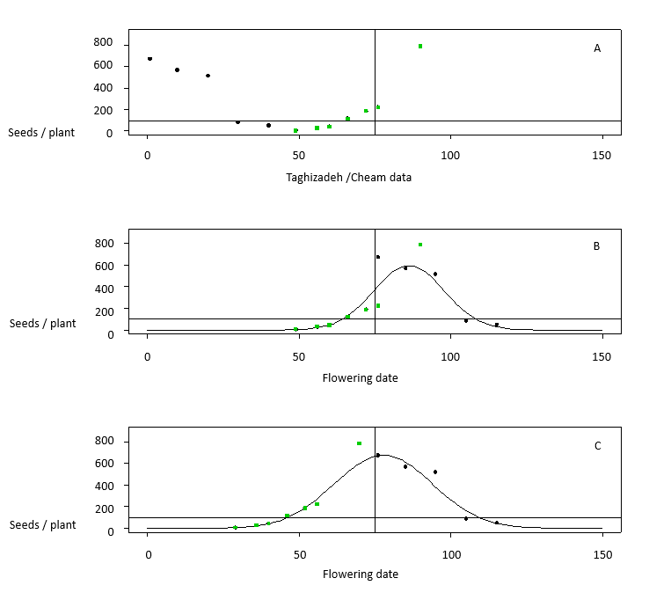
References.
Ashworth MB, Walsh MJ, Flower KC, Vila‐Aiub MM and Powles SB. Directional selection for flowering time leads to adaptive evolution in Raphanus raphanistrum (wild radish). Evol Appl 9:619–629 (2016).
Cheam AH. Seed production and seed dormancy in wild radish (Raphanus raphanistrum L.) and some possibilities for improving control. Weed Res 26:405–414 (1986).
Taghizadeh M, Nicolas M and Cousens R. Effects of relative emergence time and water deficit on the timing of fruit dispersal in Raphanus raphanistrum L. Crop Pasture Sci 63:1018–1025 (2012).

