**Supplemental Material**

Supplemental Table 1**.** Primers and PCR cycle conditions used for identifying weedy *Amaranthus* species based on amplification of intron 1 fragment from *EPSPS* (Wright et al. 2016), for sequence of *ITS* region (Murphy and Tranel 2018), for sequencing of *EPSPS* fragment and copy number estimation relative to *ACTIN* (Lorentz et al. 2014), and for amplification of all loci in the *ALS* associated with herbicide resistance.

|  |  |  |  |
| --- | --- | --- | --- |
| Primers | Sequence | Cycle conditions | Size of PCR product (bp) |
| AW473 | F - (5'-CACAAGAGACACATTATTATCCCT-3') | 94°C 4 min; 30 cycles of 94 °C 30 s, 58°C 30 s, 72°C 2 min; 72°C 5 min; 4°C hold | 1623a |
| AW483 | R - (5'-CTTGGAGCCCAAGTATAATC-3') |
| AW471 | F - (5'-GCGAGACACATTGTTATCCCT-3') | 94°C 4 min; 30 cycles of 94°C 30 s, 55°C 30 s, 72°C 1 min 30 s; 72°C 5 min; 4°C hold | 1616b |
| AW482 | R - (5'-CTTAGAGCTCAAGTATTATCTAGT-3') |
| AW477 | F - (5'-GTGGCTAATCATGTTTACAGGAC-3') | 94°C 4 min; 30 cycles of 94°C 30 s, 55°C 30s, 72°C 1 min 30 s; 72°C 5 min; 4°C hold | 1215c |
| AW493 | R - (5'-GTCTAAGTGATGTTGGATAACT-3') |
| ITS5 | F - (5’-GGAAGTAAAAGTCGTAACAAGG-3’) | 95°C 5 min; 40 cycles of 95°C 1.5 min, 50°C 60 s, 70°C 2 min; 72°C 10 min; 4°C hold | 648d |
| ITS4 | R - (5’-TCCTCCGCTTATTGATATGC-3’) |
| Gly.a.3_F | F - (5’-ATGTTGGACGCTCTCAGAACTCTTGGT-3’) | 95°C 15 min; 39 cycles of 94°C 45 s, 53°C 30 s,70°C 40 s; 72°C 10 min; 4°C hold | 195e |
| Gly.a.4_R | R - (5’-TGAATTTCCTCCAGCAACGGCAA-3’) |
| ALS1_F | F - (5’-TCCTCCGCCGCCCTCTTCAAAT-3’) | 95°C 5 min; 35 cycles of 94°C 30 s, 60°C 30 s, 72°C 90 s; 4°C hold | 374f |
| ALS1_R | R - (5'-AGCACCTGGACCAGAAGTGGCA-3’) |
| ALS3_F | F - (5’-GGGGTTTTCGCTGCTGAAGGCT-3’) | 95°C 5 min; 35 cycles of 94°C 30 s, 60°C 30 s, 72°C 90 s; 4°C hold | 376g |
| ALS3_R | R - (5'-GGCTAGCAAACGCCTCGAGCTT-3’) |
| ALS4_F | F - (5’-TGTTGGGAATGCACGGGACTGT-3’) | 95°C 5 min; 35 cycles of 94°C 30 s, 60°C 30 s, 72°C 90 s; 4°C hold | 400h |
| ALS4_R | R - (5'-ACAACCGCATCGCCCTTCGT-3’) |
| ALS5_F | F - (5’-ACGAAGGGCGATGCGGTTGT-3’) | 95°C 5 min; 35 cycles of 94°C 30 s, 60°C 30 s, 72°C 90 s; 4°C hold | 559i |
| ALS5_R | R - (5'-TGGTGTCCTTGAAGGCGGCA-3’) |
| Gly.a.3_F | F - (5’-ATGTTGGACGCTCTCAGAACTCTTGGT-3’) | 50°C for 1 min, 95°C for 10 min; 40 cycles of 95°C for 15 s, 60°C for 30 s, and 72°C for 30 s. | 195j |
| Gly.a.4_R | R - (5’-TGAATTTCCTCCAGCAACGGCAA-3’) |
| Am_ActinF | F - (5’-GACTCTGGTGATGGTGTGAGTC-3’) | 50°C for 1 min, 95°C for 10 min; 40 cycles of 95°C for 15 s, 60°C for 30 s, and 72°C for 30 s. | 242k |
| Am_ActinR | R - (5'-GAGCTGCTCTTGGCAGTCTC-3’) |

aSize of intron 1 to identify *A. hybridus*; bSize of intron 1 to identify *A. retroflexus*; cSize of intron 1 to identify *A. viridis;* dSize of *ITS* region to identify nine species according to the SNPs; eSize of *EPSPS* gene to verify mutations at Thr102, Ala103, and Pro106 positions; fSize of ALS gene to verify mutations at Ala122 position; gSize of ALS gene to verify mutations at Pro197, Ala205, Ala376, and Arg377 positions; hSize of ALS gene to verify mutations at Ala376, and Arg377 positions; iSize of *ALS* gene to verify mutations at Trp574, Ser653, and Gly654 positions; jSize of *EPSPS* gene to verify copy number in qPCR; k jSize of *ACTN* gene as reference to verify copy number of *EPSPS* gene in qPCR

Supplemental Table 2**.** Parameters of the logistic equation and resistance factor (RF) of variables germination rate at 14 DAT (%), injury at 14 DAT (%) and height reduction at 14 DAT (%) of biotypes exposed to glyphosate solution (mM).

|  |  |  |  |  |  |  |  |
| --- | --- | --- | --- | --- | --- | --- | --- |
|  | Regression parameters2 | | | | | | |
| Biotypes1 | *b* | *c* | *d* | *e* (ED50) | Lower CI | Upper CI | RF |
|  | Germination rate at 14 DAT (%) | | | | | | |
| AMACHY-S | 2.09 | 39.65* | 81.21* | 9.60 | 4.18 | 15.04 | - |
| AMACVI-S | 0.53* | 32.54* | 84.98* | 1.60 | -2.63 | 5.80 | - |
| CAMAQ-R | 1,48 | -76.48 | 94.36* | 107.70 | -1124.29 | 1339,78 | 11.21* |
|  | Injury at 14 DAT (%) | | | | | | |
| AMACHY-S | -34.15 | -0.01 | 100.0* | 0.32 | 0.31 | 0.33 | - |
| AMACVI-S | -2.65* | 2.50* | 101.41* | 1.01 | 0.96 | 1.06 | - |
| CAMAQ-R | -1.18* | -0.81 | 113.93* | 5.87 | 5.01 | 6.72 | 18.39* |
|  | Shoot reduction at 14 DAT (cm) | | | | | | |
| AMACHY-S | 1.19* | -0.02 | 0.77* | 0.34 | 0.08 | 0.60 | - |
| AMACVI-S | 1.95* | 0.04 | 1.21* | 0.97 | 0.65 | 1.29 | - |
| CAMAQ-R | 2.50* | 0.05 | 1.49* | 3.02 | 2.38 | 3.67 | 8.79* |

1 Resistant: CAMAQ-R; susceptible: AMACHY-S and AMACVI-S. 2 *b*: slope; *c*: lower limit; *d*: upper limit; *e*: herbicide dose to control 50% of the variable (ED50); Lower confidence interval (CI) and Upper CI of the variable *e* (ED50); RF: resistance factor (resistant/susceptible). * Statistically significant (p < 0.05).

Supplemental Table 3. Morphological traits of the biotypes were analyzed following two keys of the *Amaranthus* genus.

|  |  |  |  |  |  |  |  |  |
| --- | --- | --- | --- | --- | --- | --- | --- | --- |
| Biotype | Stem | Spine | Male flower | Flower piece | Fruit | Exocarp | Bract form | Size of bracts (relative to ovary)a |
| AMACHY-S | Pubescent | Absent | 5 stamens | 5 tepals | Dehiscent | Smooth | Spinescent | Longer |
| AMACVI-S | Pubescent | Absent | 5 stamens | 4 tepals | Dehiscent | Smooth | Spinescent | Smaller |
| AMACRET-S | Pubescent | Absent | 5 stamens | 4 tepals | Dehiscent | Smooth | Spinescent | Smaller |
| EEA-S | Glabrous | Absent | 3 stamens | 4 tepals | Indehiscent | Pyxis | Non-spinescent | Smallerb |
| ARRGR-R | Pubescent | Absent | 5 stamens | 5 tepals | Dehiscent | Smooth | Spinescent | Longer |
| SAOJER-R | Pubescent | Absent | 5 stamens | 5 tepals | Dehiscent | Smooth | Spinescent | Longer |
| CAMAQ-R | Pubescent | Absent | 5 stamens | 5 tepals | Dehiscent | Smooth | Spinescent | Longer |

Flowers are smaller than size of the ovary; b Bracts is smaller than ovary and tepals. Green color represents morphological traits of *A. viridis*. Blue color represents morphological traits of *A. hybridus*. Gray color represents morphological traits from other *Amaranthus* species.

**List figures**

Supplemental Figure 1**.** Image from Google Earth Pro with two experiments (1 and 2) that were isolated by 145 m and were isolated by a native vegetation. (A) Crossess of experiment 1 and 2; (B) One repetition that was composed of the receptor and donor plants. The distance between the resistant plant (donor) and the susceptible plants was the smallest possible (0.3 to 0.6 meters) to minimize the effect of distance in relation to pollen source, and so that there was no physical contact between the plants. (C) Each set of 13 plants formed a repetition and in total eight sets distanced at 4.5 m between them were included.

Supplemental Figure 2**.** Amplification product of primers AW473 × AW483 for *A. hybridus* (A); AW471 × AW482 for *A. retroflexus* (B); AW477 × AW493 for *A. viridis*. For each species (A, B and C) the size of the fragment (bp) amplified is indicated according to Wright et al. (2016).

Supplemental Figure 3**.**Alignment of *EPSPS* sequences from susceptible biotypes AMACHY-S, AMACVI-S, AMACRET-S and EEA-S, resistant biotypes from Argentina (GenBank MH482843.1 and MG595170.1), and our resistant-biotypes ARRGR-R, SAOJER-R and CAMAQ-R. Nucleotides shown in red are Thr102Ile amino acid substitution, purple are Ala103Val and blue are Pro106Ser amino acid substitution. Nucleotides highlighted in gray do not result in amino acid substitution.

Supplemental Figure 4. Chromatogram of biotype CAMAQ-R presents double peaks, that were also verified in the different self-fertilized generations G1 to G2, that were not segregating the resistant phenotype since G0.

Supplemental Figure 5. Seed-soaking bioassay – visual effect of dose-response curve for AMACHY-S (A); AMACVI-S (B) and CAMAQ-R (C); progenies from the crosses for the intraspecific hybridization of *A. hybridus* (CAMAQ-R × AMACHY-S) (D) and interspecific hybridization of *A. hybridus* × unclassified biotype (CAMAQ-R × AMACVI-S) (E). Under control conditions (0 mM dose): seedling of progeny resulting from crosses (1); seedling of the resistant biotype CAMAQ-R (2); seedling of the susceptible biotypes (AMACHY-S or AMACVI-S) (3); Under herbicide solution (3.2 mM): resistant biotype CAMAQ-R (4); susceptible biotypes (AMACHY-S or AMACVI-S) (5); progenies from the crosses for the intra or interspecific hybridization (6).

Supplemental Figure 6. Chromatogram of AMACHY-S biotypes without mutation, CAMAQ-R (donor) with TAP-IVS *EPSPS* gene mutation and glyphosate-resistant progeny resulting from crossing *A.* *hybridus* (R) × *A. hybridus* (S).

**Supplemental Figure 1.**

**Supplemental Figure 2.**

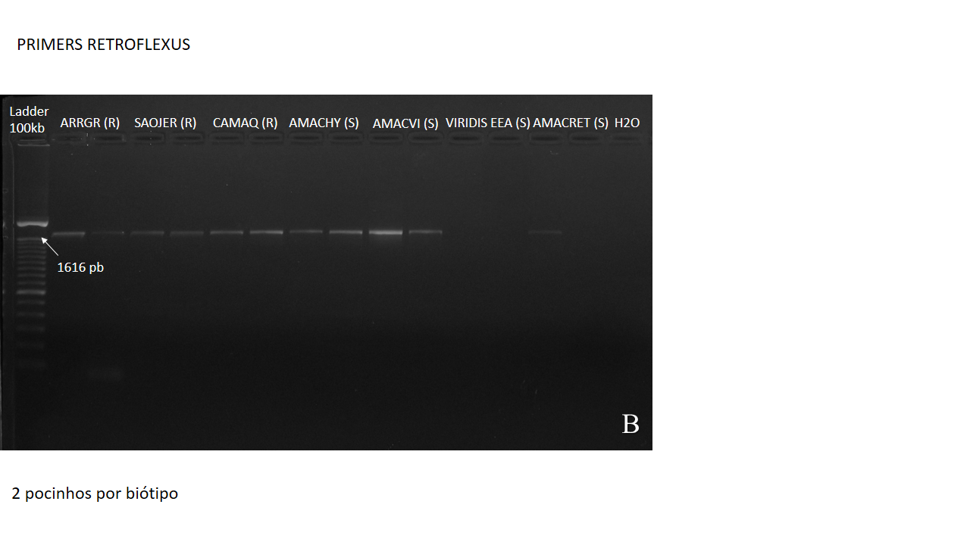

**Supplemental Figure 3.**

**Supplemental Figure 4.**

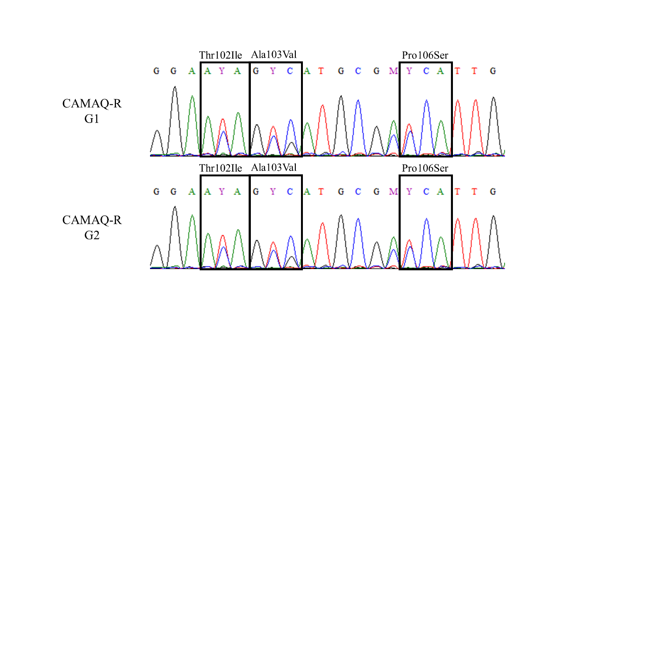

**Supplemental Figure 5.**

|  |  |
| --- | --- |
|  **| |
|  **| |
|  **| |
|  **|  **|

**Supplemental Figure 6.**

