Supplementary Figure S1. Dose response assays for sensitive (POAAN-S) and resistant (POAAN-R) populations of Poa annua treated at 2-to-3 leaf stage with a range of ± recommended field rates of mesosulfuron-methyl + iodosulfuron-methyl 15 + 5 g ai ha⁻¹.

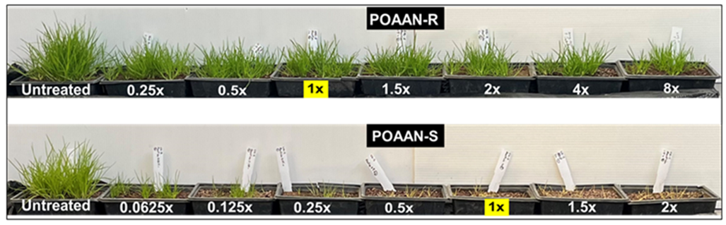

Supplementary Figure S2. Dose response assays for sensitive (POAAN-S) and resistant (POAAN-R) populations of Poa annua treated at 2-to-3 leaf stage with a range of ± recommended field rates of pyroxsulam 18.8 g ai ha⁻
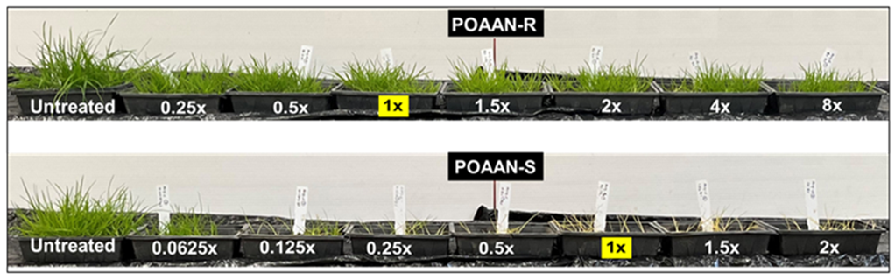

Supplementary Figure S3. Symptoms of sensitive (POAAN-S) and resistant (POAAN-R) populations of Poa annua following application of recommended field rate (15 + 5 g ai ha⁻¹) or 1.5 of recommended field rate (22.5 + 7.5 g ai ha⁻¹) of mesosulfuron-methyl + iodosulfuron-methyl with or without malathion. Plants were treated at 2-to-3 leaf stage. POAAN-R had 100% surviving plants at both rates, while POAAN-S were totally susceptible (i.e. all treated plants died) .
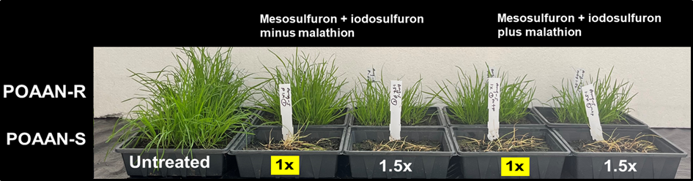

Supplementary Figure S4. Symptoms of sensitive (POAAN-S) and resistant (POAAN-R) populations of Poa annua following application of recommended field rate (18.8 g ai ha⁻¹) or 1.5 of recommended field rate (28.1 g ai ha⁻¹) of pyroxsualm (not registered in Ireland for P. annua control) with or without malathion. Plants were treated at 2-to-3 leaf stage. POAAN-R had 100% surviving plants at both rates, while POAAN-S were totally susceptible (i.e. all treated plants died).

