Supplementary Table S1. Effect of potential 2,4-D synergists on seedling radicle elongation when applied alone. Compounds potentially synergising 2,4-D were incorporated into 0.6% (w/v) agar at a range of concentrations and the rate of radicle elongation of seedlings grown on this agar was measured over 7 d. The concentration causing a 50% decrease in radicle elongation (ED₅₀) was estimated from the dose-response curve using the drc package in R. The resistance index (RI) is the ratio of ED₅₀ values of the R population vs. population S1 within a treatment, and the p-value shows the significance of the RI. There were three replicates of five seedlings for each compound and concentration.

 | Concentration inhibiting radicle elongation by 50% (ED₅₀)
Compound | Population S1 | Population R2 | Population R3 | RI | p-value
ABA | 1.7 ± 1.1 μM | 6.2 ± 0.9 μM | nd | 3.5 ± 2.4 | 0.289
ACC | 0.2 ± 0.0 μM | 0.4 ± 0.1 μM | nd | 2.1 ± 0.7 | 0.126
Adenosine | 0.3 ± 0.0 mM | 0.1 ± 0.1 mM | nd | 0.4 ± 0.3 | 0.052
BAP | 3.2 ± 1.2 nM | 56 ± 7 nM | nd | 18 ± 7 | 0.018
1-Butanol | 0.1 ± 0.0% (v/v) | 0.1 ± 0.0% (v/v) | nd | 1.0 ± 0.3 | 0.145
Cyclanilide | 5.9 ± 4.6 μM | nd | 1.0 ± 0.7 μM | 0.2 ± 0.2 | <0.01
EGTA | 1.0 ± 0.3 mM | nd | 0.7 ± 0.1 mM | 0.7 ± 0.2 | 0.274
IAM | 0.3 ± 0.0 μM | nd | 0.1 ± 0.0 μM | 0.4 ± 0.1 | <0.01
DL-Methionine | 0.3 ± 0.1 mM | 3.0 ± 0.5 | nd | 8.9 ± 3.8 | 0.047
Methyl anthranilate | 59 ± 88 μM | nd | 2.5 ± 1.2 | 0.04 ± 0.07 | <0.01
Tryptamine | 0.2 ± 0.1 μM | nd | 0.3 ± 0.1 | 1.8 ± 0.5 | 0.171

Abbreviations: ABA, abscisic acid; ACC, 1-aminocyclopropane-1-carboxylic acid; BAP, 6-benzylaminopurine; EGTA, ethylene glycol-bis(β-aminoethyl ether)-N,N,N′,N′-tetraacetic acid; IAM, indole-3-acetamide.

Supplementary Table S2. Dose of MCPA, mecoprop or a 1:1 mix required to kill 50% of individuals (ED₅₀) in a dose-response experiment performed in the glasshouse. The resistance index (RI) is the ratio of ED₅₀ values of each population vs. population S1 within a herbicide treatment, and the p-value shows the significance of the RI (bold font indicates a significant difference between a population and S1 within a treatment). Different letters across rows indicate a significant difference among treatments within each population.

 | MCPA |  |  | Mecoprop |  |  | 1:1 mix
Population | ED₅₀ (g ha⁻¹) | RI | p-value | ED₅₀ (g ha⁻¹) | RI | p-value | ED₅₀ (g ha⁻¹) | RI | p-value
S1 | 185 ± 279ª | 1 | n/a | 214 ± 61ª | 1 | n/a | 142 ± 136ª | 1 | n/a
S2 | 68 ± 67ª | 0.4 ± 0.3 | 0.080 | 163 ± 93ª | 0.8 ± 0.3 | 0.446 | 108 ± 184ª | 0.8 ± 1.5 | 0.900
R1 | 287 ± 50ª | 1.5 ± 2.7 | 0.844 | 344 ± 81ª | 1.6 ± 0.6 | 0.282 | 293 ± 47ª | 2.1 ± 1.5 | 0.485
R2 | 10 ± 29^{c} | 0.1 ± 0.3 | <0.001 | 365 ± 48ª | 1.7 ± 0.3 | 0.041 | 180 ± 55^{b} | 1.3 ± 0.8 | 0.755
R3 | 902 ± 289ª | 4.9 ± 8.5 | 0.647 | 1371 ± 480ª | 6.4 ± 2.4 | 0.035 | 1348 ± 853ª | 9.5 ± 10.9 | 0.986
R4 | 1970 ± 932ª | 10.6 ± 27.0 | 0.726 | 2676 ± 1746ª | 12.5 ± 9.8 | 0.253 | 1569 ± 401ª | 11.0 ± 7.8 | 0.211
R5 | 507 ± 90ª | 2.8 ± 4.5 | 0.689 | 507 ± 94ª | 2.4 ± 0.7 | 0.047 | 482 ± 97ª | 3.4 ± 3.6 | 0.508
R6 | 1102 ± 377ª | 5.9 ± 16.4 | 0.765 | 536 ± 158ª | 2.5 ± 1.4 | 0.283 | 820 ± 115ª | 5.8 ± 5.7 | 0.410
R7 | 1180 ± 132ª | 6.4 ± 11.8 | 0.630 | 1064 ± 167ª | 5.0 ± 1.1 | 0.001 | 1123 ± 212ª | 7.9 ± 6.8 | 0.322
R8 | 2135 ± 947ª | 11.5 ± 19.5 | 0.595 | 5550 ± 10072ª | 25.4 ± 37.2 | 0.519 | 2465 ± 1139ª | 17.4 ± 17.1 | 0.348
R10 | 1134 ± 150^{b} | 6.1 ± 12.1 | 0.677 | 6672 ± 11506ª | 31.1 ± 44.6 | 0.507 | 861 ± 161^{ab} | 6.1 ± 5.2 | 0.341
R11 | 1184 ± 276ª | 6.2 ± 17.3 | 0.767 | 897 ± 178ª | 4.2 ± 1.3 | 0.021 | 808 ± 80ª | 5.7 ± 3.6 | 0.210

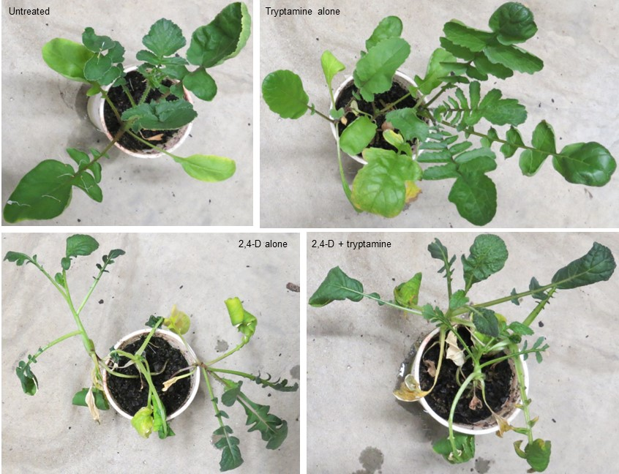

Supplementary Fig. S1. Effect of a foliar spray of tryptamine applied alone, or in combination with 2,4-D, on 2,4-D-resistant wild radish. Plants were sprayed with 178 g ha⁻¹ technical-grade tryptamine, 250 g ha⁻¹ formulated 2,4-D amine (Amicide Advance 700) or with both tryptamine and 2,4-D amine applied at the same rates as for the standalone treatments. Untreated plants were sprayed with the carrier solution used for all three herbicide treatments (5% DMSO plus 0.2% Tween 20). Photographs were taken at 21 d after treatment.

