Supplementary Material
Supplementary Table S1. Date of postemergence herbicide application at each site and year when Amaranthus spp. reached 10 cm in height.
Cover crop management | Illinois
 | 2021 |  | 2022
 | No PRE | Yes PRE | No PRE | Yes PRE
No-till | June 24, 2021 | June 24, 2021 | June 9, 2022 | June 27, 2022
Early-term | June 24, 2021 | June 24, 2021 | June 13, 2022 | June 13, 2022
Plant-green | June 24, 2021 | June 24, 2021 | June 13, 2022 | June 27, 2022
 | Kansas
 | 2021 |  | 2022
No-till | June 22, 2021 | July 16, 2021 | June 16, 2022 | June 27, 2022
Early-term | June 28, 2021 | July 12, 2021 | June 21, 2022 | June 27, 2022
Plant-green | June 28, 2021 | July 6, 2021 | June 21, 2022 | June 27, 2022
 | Pennsylvania
 | 2021 |  | 2022
No-till | June 16, 2021 | July 13, 2021 | June 22, 2022 | July 7, 2022
Early-term | July 2, 2021 | July 13, 2021 | July 7, 2022 | July 7, 2022
Plant-green | July 13, 2021 | July 13, 2021 | June 30, 2022 | July 7, 2022
 | Wisconsin
 | 2021 |  | 2022
No-till | June 15, 2021 | June 22, 2021 | June 20, 2022 | June 27, 2022
Early-term | June 30, 2021 | July 14, 2021 | July 7, 2022 | July 7, 2022
Plant-green | July 14, 2021 | July 14, 2021 | July 7, 2022 | July 7, 2022

Supplementary Table S2. Means and standard errors (SE) of flumioxazin concentration in the soil of the no-till without preemergence herbicide treatment at 0, 7, and 21 days after treatment (DAT).
Site | Year | 0 DAT |  | 7 DAT |  | 21 DAT
 |  | Mean | SE | Mean | SE | Mean | SE
 |  | -------------------- ng g⁻¹ soil --------------------
Illinois | 2021 | 0.3 | 0.2 | 0.0 | 0.0 | 0.5 | 0.3
 | 2022 | 0.0 | 0.0 | 0.0 | 0.0 | 0.0 | 0.0
Kansas | 2021 | 0.4 | 0.4 | 0.2 | 0.2 | 0.0 | 0.0
 | 2022 | 0.3 | 0.1 | 0.1 | 0.1 | 0.1 | 0.1
Pennsylvania | 2021 | 1.1 | 0.5 | 0.1 | 0.1 | 0.7 | 0.7
 | 2022 | 0.0 | 0.0 | 0.0 | 0.0 | 0.0 | 0.0
Wisconsin | 2021 | 0.6 | 0.6 | 0.0 | 0.0 | 0.0 | 0.0
 | 2022 | 0.1 | 0.0 | 0.0 | 0.0 | 0.0 | 0.0

Supplementary Table S3. Means and standard errors (SE) of pyroxasulfone concentration in the soil of the no-till without preemergence herbicide treatment at 0, 7, and 21 days after treatment (DAT).
Site | Year | 0 DAT |  | 7 DAT |  | 21 DAT
 |  | Mean | SE | Mean | SE | Mean | SE
 |  | -------------------- ng g⁻¹ soil --------------------
Illinois | 2021 | 2.4 | 0.3 | 1.4 | 0.1 | 1.4 | 0.1
 | 2022 | 2.5 | 0.6 | 2.3 | 0.4 | 2.1 | 0.3
Kansas | 2021 | 2.0 | 0.7 | 2.4 | 0.7 | 1.8 | 0.4
 | 2022 | 2.2 | 0.3 | 1.9 | 0.1 | 1.6 | 0.1
Pennsylvania | 2021 | 2.7 | 0.8 | 1.5 | 0.2 | 2.5 | 1.3
 | 2022 | 1.5 | 0.1 | 1.5 | 0.1 | 1.5 | 0.1
Wisconsin | 2021 | 2.0 | 0.8 | 1.1 | 0.0 | 1.1 | 0.0
 | 2022 | 0.7 | 0.1 | 0.6 | 0.2 | 0.4 | 0.0

Supplementary Figure S1. Layout of the study design and treatment arrangement. Each cover crop management was applied to two strips and the preemergence herbicide treatment was applied to individual plots.

Supplementary Figure S2. Flumioxazin concentration in the soil (ng g⁻¹ soil) as a function of cover crop management at 0, 7, and 21 days after treatment in all sites in 2021 and 2022. Error bars indicate the 95% confidence interval of means.

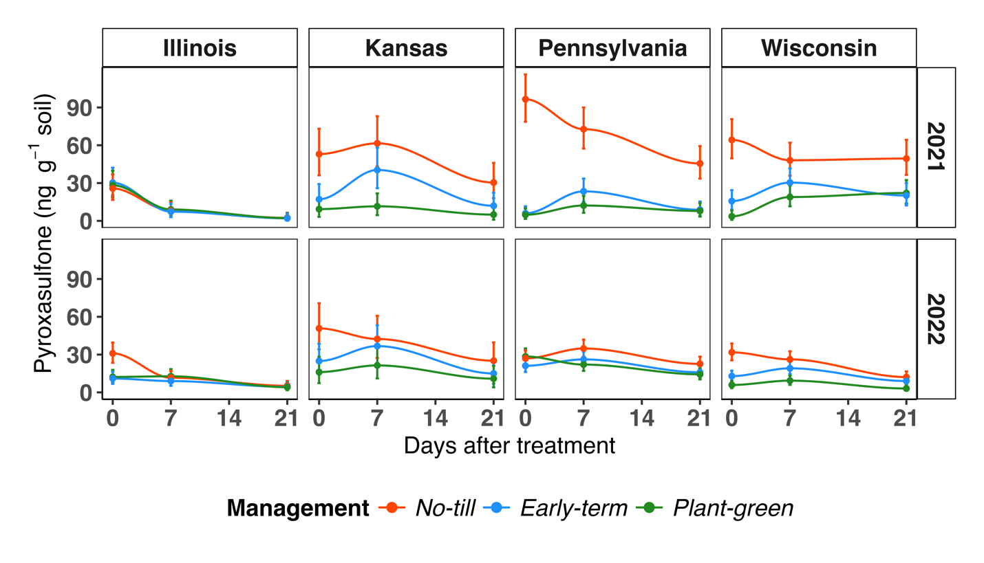
Supplementary Figure S3. Pyroxasulfone concentration in the soil (ng g⁻¹ soil) as a function of cover crop management at 0, 7, and 21 days after treatment in all sites in 2021 and 2022. Error bars indicate the 95% confidence interval of means.

Supplementary Figure S4. Mean air temperature at each site from preemergence herbicide application until 21 days after treatment in 2021 and 2022.

