Table Captions:
Table S1. Component score coefficient matrix.

Table S1. Component score coefficient matrix.
Species | PC1 | PC2 | PC3
A. annua | 2.177010 | -0.797003 | -1.076048
A. canina | 2.320250 | -1.181881 | -0.278657
A. capillaris | 1.923710 | -0.822500 | 0.407106
A. lappa | 1.395000 | -0.584201 | 0.477699
A. rugosa | 1.750220 | -0.116502 | 1.737629
C. album | 2.235640 | 0.438524 | 0.415754
C. arvense | 2.340660 | 1.528803 | 0.430915
C. bursa-pastoris | 2.418000 | -1.179738 | -0.307519
C. majus | 2.321960 | 0.171328 | -1.521461
C. nutans | 2.573730 | -0.796203 | -0.447288
C. pendulus | 1.605360 | -0.663326 | 0.190926
C. tectorum | 2.322600 | 0.566190 | -0.185839
D. indica | 2.986640 | -0.328706 | 1.085572
D. nemorosa | 1.694340 | -0.804577 | -0.956276
E. canadensis | 2.615650 | 3.563583 | -0.063806
F. multiflora | 2.218210 | -0.950050 | 0.916002
G. carolinianum | 0.011740 | 0.004790 | -0.006260
G. hederacea | 2.415410 | -0.613212 | -0.532694
G. spurium | 2.326520 | 1.556238 | -1.552653
H. plantaginea | 2.328280 | -1.247446 | 1.041608
H. scandens | 2.279860 | 0.043902 | 0.326051
H. spectabile | 2.719500 | 4.650490 | 4.262516
I. lactea | 1.947520 | -0.650118 | 2.140542
L. apetalum | 1.850240 | -0.894322 | 0.678441
L. supina | 2.067730 | -1.414863 | 1.637745
O. javanica | 1.118170 | 0.888546 | 0.063676
P. aviculare | 1.595290 | -0.479009 | 0.434638
P. depressa | 1.708310 | -0.951885 | -0.366356
P. grandiflorus | 1.958870 | 1.634108 | -1.796618
P. lapathifolia | 1.829030 | -0.251765 | 0.566864
P. supina | 2.915780 | -0.911956 | -0.722839
R. acetosa | 1.889900 | -1.203196 | 1.733141
S. media | 2.354050 | -0.186075 | -1.887744
S. nemorosa | 1.982600 | 2.437285 | 1.119522
T. mongolicum | 1.657330 | -0.366194 | 0.442879
T. peduncularis | 2.384950 | -1.250487 | -1.998346
T. repens | 2.324580 | 1.679804 | 0.952829
U. angustifolia | 2.396960 | 0.212233 | -0.186357
U. laetevirens | 1.218930 | -0.653957 | 0.285174
V. philippica | 2.977040 | -0.225894 | -3.185578

Figure Captions:
Figure S1. Actual weed shot images: (a) Original weed image; (b) Image of ROI selection results, a red box represents a ROI.

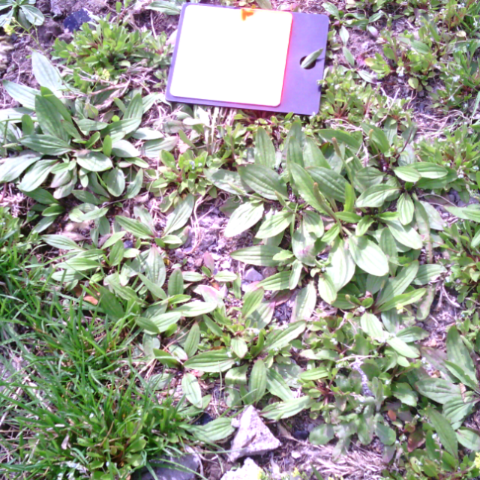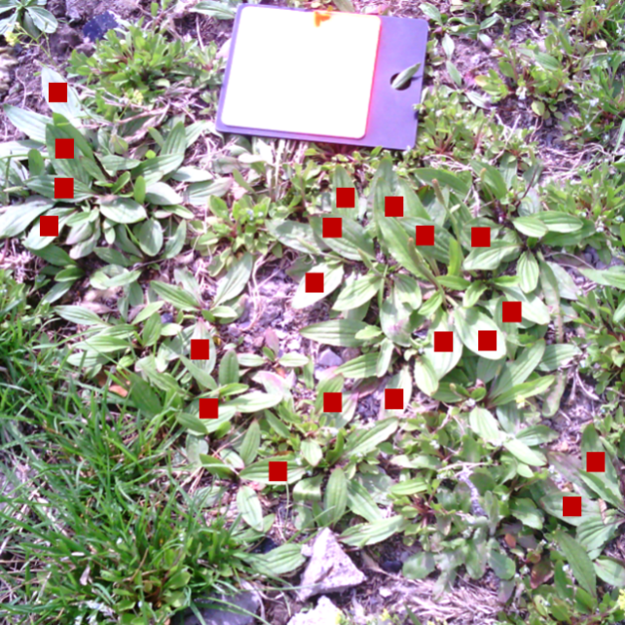
(a) (b)
Figure S1. Actual weed shot images: (a) Original weed image; (b) Image of ROI selection results, a red box represents a ROI.

