Supplementary Material

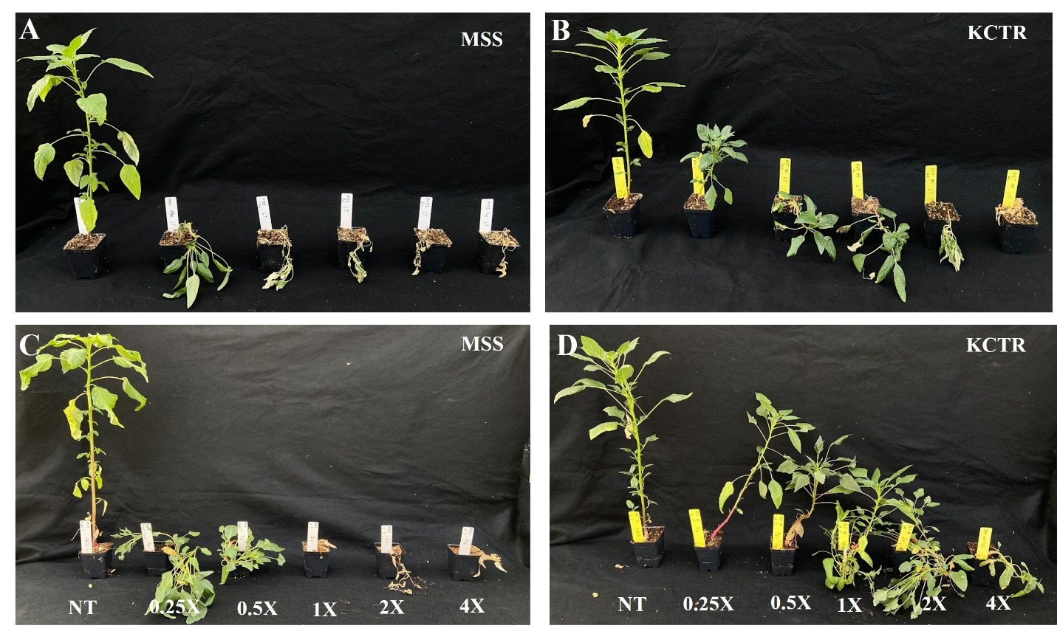
Supplementary Figure S1. 2,4-D dose-response of susceptible (MSS) and -resistant (KCTR) Palmer amaranth at low (LT) (24/14 C d/n ) (A and B) and high (HT) 34/24 C d/n (C and D) temperature regimes, respectively at 4 weeks after treatment. NT= non-treated and 1X= the field recommended dose of 560 g ae ha⁻¹

