Supplementary Material

Dicamba Air Concentrations in Eastern Arkansas and Impact on Soybean
Maria Leticia Zaccaro-Gruener^{1*}, Jason K. Norsworthy², Chad B. Brabham³, L. Tom Barber⁴, Trenton L. Roberts⁵, Andy Mauromoustakos⁶, and Thomas C. Mueller⁷

Affiliations: ¹Graduate Research Assistant, University of Arkansas System Division of Agriculture; ²Distinguished Professor, University of Arkansas System Division of Agriculture; ³Former Postdoctoral Associate, University of Arkansas System Division of Agriculture; ⁴Professor and Extension Weed Scientist, University of Arkansas System Division of Agriculture; ⁵Professor of Soil Fertility/Soil Testing, University of Arkansas System Division of Agriculture; ⁶Professor, Agricultural Statistics Laboratory, University of Arkansas; ⁷Professor, Department of Plant Sciences, University of Tennessee.
*Corresponding author: 1354 W. Altheimer Dr., Fayetteville, AR 72704, mzaccaro@uark.edu.

List of Tables
Table S1. Treated area conditions, the growth stage of soybean utilized for bioassays, and the average detection of dicamba on filters positioned on the target area of herbicide treatment during trials conducted in 2018 and 2019 at Fayetteville and Prairie Grove, AR.

Table S2. Daily maximum air temperature, average relative humidity, and wind speed while air samples were collected in Marianna, AR, in 2020.

Table S3. Daily maximum air temperature, average relative humidity, and wind speed while air samples were collected in Marianna, AR, in 2021.

Table S4. Daily maximum air temperature, average relative humidity, and wind speed while air samples were collected in Keiser, AR, in 2020.

Table S5. Daily maximum air temperature, average relative humidity, and wind speed while air samples were collected in Keiser, AR, in 2021.

Table S1. Treated area conditions, the growth stage of soybean utilized for bioassays, and the average detection of dicamba on filters positioned on the target area of herbicide treatment during trials conducted in 2018 and 2019 at Fayetteville and Prairie Grove, AR.
Year-trial | Treated area groundcover |  | dicamba recovered on filters at the target ª | Bioindicator growth stage ^{b}
 | Type | % living vegetation | ng filter⁻¹
2018-1 | Weed-free soil | 0 | 373,577 | V2
2018-2 | Weed-free soil | 0 | 265,305 | V2
2018-3 | Weed-free soil | 0 | 361,240 | V1
2018-4 | Weed-free soil | 0 | 324,626 | V1
2018-5 | DR soybean ^{c} | 5 | 436,791 | V2
2018-6 | DR soybean | 90 | 369,955 | V1
2018-7 | DR soybean | 99 | 246,805 | V1
2018-8 | DR soybean | 99 | 260,894 | V1
2019-1 | Weed-free soil | 0 | 523,372 | V2
2019-2 | Weed-free soil | 0 | 332,327 | V2
2019-3 | Weed-free soil | 0 | 353,099 | V1
2019-4 | Weed-free soil | 0 | 451,458 | V2
2019-5 | Non-crop weedy | 75 | 370,026 | V1
2019-6 | Weed-free soil | 0 | 331,574 | - ^{d}
2019-7 | DR soybean | 10 | 205,982 | -
2019-8 | DR soybean | 30 | 305,978 | -
ª Results of deposited dicamba reported as total averages in ng of herbicide per filter paper (area = 95 cm²) positioned at the target area prior to introducing soybean bioindicator plants. Conversion of dicamba deposition results ranged from 217 to 551 g ha⁻¹.
^{b} Soybean growth stage of bioindicator plants described by Fehr and Caviness (1977).
^{c} DR soybean; dicamba-resistant soybean.
^{d} Plants were damaged by insects and rodents and unavailable for assessments on trials 2019-6, -7, and -8.

Table S2. Daily maximum air temperature, average relative humidity, and wind speed while air samples were collected in Marianna, AR, in 2020.
Date | Maximum temperature | Average rel. humidity | Average wind speed
 | C | % | km h⁻¹
June 4, 2020 | 30.6 | 74 | 8.05
June 5, 2020 | 33.2 | 71 | 8.05
June 6, 2020 | 31.0 | 62 | 6.44
June 7, 2020 | 31.9 | 66 | 4.83
June 8, 2020 | 27.5 | 67 | 4.83
June 9, 2020 | 30.8 | 83 | 6.44
June 10, 2020 | 27.6 | 68 | 4.83
June 11, 2020 | 27.3 | 70 | 6.44
June 12, 2020 | 29.7 | 63 | 6.44
June 13, 2020 | 31.1 | 60 | 4.83
June 14, 2020 | 31.2 | 63 | 3.22
June 15, 2020 | 31.3 | 64 | 3.22
June 16, 2020 | 28.1 | 59 | 4.83
June 17, 2020 | 29.5 | 64 | 4.83
June 18, 2020 | 30.9 | 66 | 6.44
June 19, 2020 | 31.8 | 64 | 11.26
June 20, 2020 | 31.4 | 62 | 6.44
June 21, 2020 | 29.8 | 63 | 4.83
June 22, 2020 | 28.3 | 69 | 6.44
June 23, 2020 | 27.7 | 75 | 8.05
June 24, 2020 | 28.0 | 74 | 8.05
June 25, 2020 | 29.5 | 67 | 8.05
June 26, 2020 | 24.6 | 63 | 6.44
June 27, 2020 | 30.8 | 83 | 4.83
June 28, 2020 | 31.2 | 74 | 4.83
June 29, 2020 | 28.8 | 73 | 4.83
June 30, 2020 | 31.4 | 76 | 9.65
July 1, 2020 | 31.4 | 75 | 6.44
July 2, 2020 | 33.5 | 67 | 3.22
July 3, 2020 | 32.3 | 65 | 3.22
July 4, 2020 | 31.2 | 69 | 3.22
July 5, 2020 | 31.6 | 69 | 3.22
July 6, 2020 | 31.3 | 66 | 6.44
July 7, 2020 | 31.1 | 67 | 6.44
July 8, 2020 | 30.7 | 68 | 8.05
July 9, 2020 | 31.9 | 76 | 6.44
July 10, 2020 | 31.2 | 70 | 6.44
July 11, 2020 | 33.6 | 67 | 4.83
July 12, 2020 | 31.7 | 68 | 4.83
Table S2. (Cont.)
Date | Maximum temperature | Average rel. humidity | Average wind speed
 | C | % | km h⁻¹
July 13, 2020 | 31.9 | 62 | 4.83
July 14, 2020 | 33.4 | 66 | 4.83
July 15, 2020 | 32.7 | 70 | 4.83
July 16, 2020 | 33.6 | 69 | 3.22
July 17, 2020 | 32.7 | 69 | 6.44
July 18, 2020 | 33.6 | 69 | 8.05
July 19, 2020 | 34.0 | 67 | 4.83

Table S3. Daily maximum air temperature, average relative humidity and wind speed while air samples were collected in Marianna, AR, in 2021.
Date | Maximum temperature | Average rel. humidity | Average wind speed
 | C | % | km h⁻¹
June 6, 2021 | 24.4 | 80 | 8.05
June 7, 2021 | 25.6 | 80 | 8.05
June 8, 2021 | 27.8 | 77 | 6.44
June 9, 2021 | 21.7 | 87 | 4.83
June 10, 2021 | 23.9 | 79 | 4.83
June 11, 2021 | 28.3 | 75 | 6.44
June 12, 2021 | 33.3 | 69 | 4.83
June 13, 2021 | 33.3 | 71 | 6.44
June 14, 2021 | 33.9 | 65 | 6.44
June 15, 2021 | 33.9 | 63 | 4.83
June 16, 2021 | 32.8 | 63 | 3.22
June 17, 2021 | 32.8 | 63 | 3.22
June 18, 2021 | 33.3 | 65 | 4.83
June 19, 2021 | 31.7 | 68 | 4.83
June 20, 2021 | 32.2 | 69 | 6.44
June 21, 2021 | 33.9 | 68 | 11.26
June 22, 2021 | 31.1 | 53 | 6.44
June 23, 2021 | 27.2 | 62 | 4.83
June 24, 2021 | 29.4 | 63 | 6.44
June 25, 2021 | 33.3 | 67 | 8.05
June 26, 2021 | 31.7 | 71 | 8.05
June 27, 2021 | 31.7 | 73 | 8.05
June 28, 2021 | 32.2 | 69 | 6.44
June 29, 2021 | 32.2 | 70 | 4.83
June 30, 2021 | 33.3 | 67 | 4.83
July 1, 2021 | 33.3 | 67 | 4.83
July 2, 2021 | 31.7 | 71 | 9.65
July 3, 2021 | 28.3 | 67 | 6.44
July 4, 2021 | 28.9 | 66 | 3.22
July 5, 2021 | 30 | 66 | 3.22
July 6, 2021 | 31.1 | 66 | 3.22
July 7, 2021 | 32.8 | 64 | 3.22
July 8, 2021 | 31.7 | 68 | 6.44
July 9, 2021 | 33.9 | 67 | 6.44
July 10, 2021 | 32.8 | 72 | 8.05
July 11, 2021 | 31.7 | 70 | 6.44
July 12, 2021 | 27.8 | 80 | 6.44
July 13, 2021 | 29.4 | 73 | 4.83
July 14, 2021 | 31.1 | 70 | 4.83
Table S3. (Cont.)
Date | Maximum temperature | Average rel. humidity | Average wind speed
 | C | % | km h⁻¹
July 15, 2021 | 32.2 | 69 | 4.83
July 16, 2021 | 32.2 | 68 | 4.83
July 17, 2021 | 31.1 | 72 | 4.83
July 18, 2021 | 27.2 | 77 | 3.22
July 19, 2021 | 27.2 | 80 | 6.44
July 20, 2021 | 30 | 74 | 8.05
July 21, 2021 | 29.4 | 73 | 4.83
July 22, 2021 | 31.1 | 72 | 1.61
July 23, 2021 | 34.4 | 68 | 3.22
July 24, 2021 | 32.2 | 72 | 3.22
July 25, 2021 | 34.4 | 69 | 3.22
July 26, 2021 | 34.4 | 68 | 3.22
July 27, 2021 | 34.4 | 69 | 1.61
July 28, 2021 | 34.4 | 66 | 3.22
July 29, 2021 | 34.4 | 63 | 1.61
July 30, 2021 | 34.4 | 65 | 3.22

Table S4. Daily maximum air temperature, average relative humidity, and wind speed while air samples were collected in Keiser, AR, in 2020.
Date | Maximum temperature | Average rel. humidity | Average wind speed
 | °C | % | km h⁻¹
June 6, 2020 | 32.8 | 58 | 4.68
June 7, 2020 | 34.4 | 63 | 13.15
June 8, 2020 | 29.4 | 77 | 25.71
June 9, 2020 | 30.6 | 74 | 21.88
June 10, 2020 | 27.8 | 69 | 6.47
June 11, 2020 | 29.4 | 61 | 4.39
June 12, 2020 | 32.2 | 54 | 7.74
June 13, 2020 | 32.2 | 63 | 5.22
June 14, 2020 | 32.8 | 61 | 7.83
June 15, 2020 | 29.4 | 66 | 9.99
June 16, 2020 | 30.0 | 58 | 6.13
June 17, 2020 | 23.3 | 62 | 4.83
June 18, 2020 | 31.7 | 65 | 4.21
June 19, 2020 | 32.8 | 62 | 6.19
June 20, 2020 | 33.9 | 65 | 11.96
June 21, 2020 | 29.4 | 72 | 4.89
June 22, 2020 | 28.3 | 78 | 8.83
June 23, 2020 | 29.4 | 73 | 5.10
June 24, 2020 | 28.9 | 69 | 5.19
June 25, 2020 | 31.7 | 63 | 5.77
June 26, 2020 | 27.8 | 79 | 16.12
June 27, 2020 | 29.4 | 73 | 11.75
June 28, 2020 | 31.1 | 73 | 12.11
June 29, 2020 | 31.1 | 73 | 9.62
June 30, 2020 | 32.2 | 69 | 13.57
July 1, 2020 | 31.7 | 68 | 8.56
July 2, 2020 | 31.7 | 69 | 3.58
July 3, 2020 | 33.3 | 67 | 3.22
July 4, 2020 | 32.8 | 68 | 4.89
July 5, 2020 | 34.4 | 63 | 4.49
July 6, 2020 | 33.3 | 67 | 4.25
July 7, 2020 | 34.4 | 69 | 5.74
July 8, 2020 | 32.2 | 69 | 5.40
July 9, 2020 | 32.8 | 69 | 8.86
July 10, 2020 | 34.4 | 65 | 2.61
July 11, 2020 | 33.9 | 61 | 7.83
July 12, 2020 | 33.9 | 66 | 3.89
July 13, 2020 | 32.2 | 62 | 4.89
July 14, 2020 | 33.9 | 62 | 4.43
July 15, 2020 | 35.0 | 67 | 12.96
July 16, 2020 | 34.4 | 66 | 4.74
Table S4. (Cont.)
Date | Maximum temperature | Average rel. humidity |  | Average wind speed
 | °C | % |  | km h⁻¹
July 17, 2020 | 32.8 | 66 |  | 7.80
July 18, 2020 | 33.9 | 62 |  | 7.07
July 19, 2020 | 34.4 | 67 |  | 7.01
July 20, 2020 | 34.4 | 67 |  | 7.43
July 21, 2020 | 34.4 | 62 |  | 7.19

Table S5. Daily maximum air temperature, average relative humidity, and wind speed while air samples were collected in Keiser, AR, in 2021.
Date | Maximum temperature | Average rel. humidity | Average wind speed
 | C | % | km h⁻¹
June 10, 2021 | 31.1 | 72 | 11.53
June 11, 2021 | 32.2 | 70 | 7.91
June 12, 2021 | 33.3 | 67 | 3.96
June 13, 2021 | 32.8 | 65 | 12.94
June 14, 2021 | 33.3 | 57 | 8.65
June 15, 2021 | 33.9 | 67 | 10.06
June 16, 2021 | 33.9 | 57 | 6.50
June 17, 2021 | 33.9 | 61 | 10.79
June 18, 2021 | 33.9 | 69 | 13.34
June 19, 2021 | 33.9 | 70 | 11.87
June 20, 2021 | 33.3 | 63 | 16.56
June 21, 2021 | 33.9 | 64 | 15.49
June 22, 2021 | 28.9 | 62 | 8.65
June 23, 2021 | 28.9 | 55 | 8.65
June 24, 2021 | 30 | 63 | 14.75
June 25, 2021 | 32.2 | 74 | 23.06
June 26, 2021 | 33.3 | 70 | 21.25
June 27, 2021 | 33.9 | 70 | 15.08
June 28, 2021 | 33.3 | 65 | 10.79
June 29, 2021 | 33.9 | 66 | 9.72
June 30, 2021 | 34.4 | 72 | 9.72
July 1, 2021 | 34.4 | 85 | 7.58
July 2, 2021 | 34.4 | 69 | 16.22
July 3, 2021 | 28.9 | 64 | 9.39
July 4, 2021 | 28.9 | 61 | 4.29
July 5, 2021 | 31.1 | 65 | 5.77
July 6, 2021 | 32.8 | 65 | 7.58
July 7, 2021 | 34.4 | 70 | 7.58
July 8, 2021 | 34.4 | 69 | 11.53
July 9, 2021 | 35 | 73 | 8.98
July 10, 2021 | 35 | 69 | 18.37
July 11, 2021 | 35 | 80 | 14.41
July 12, 2021 | 30.6 | 78 | 12.27
July 13, 2021 | 30.6 | 72 | 7.17
July 14, 2021 | 30.6 | 66 | 9.72
July 15, 2021 | 32.2 | 70 | 13.34
July 16, 2021 | 32.2 | 75 | 15.49
July 17, 2021 | 30 | 75 | 7.58
July 18, 2021 | 31.1 | 84 | 7.17
July 19, 2021 | 27.8 | 75 | 9.39
July 20, 2021 | 32.2 | 69 | 12.27
Table S5. (Cont.)
Date | Maximum temperature | Average rel. humidity | Average wind speed
 | °C | % | km h⁻¹
July 21, 2021 | 32.2 | 65 | 10.06
July 22, 2021 | 32.2 | 63 | 6.84
July 23, 2021 | 32.2 | 68 | 5.43
July 24, 2021 | 31.1 | 68 | 5.77
July 25, 2021 | 33.3 | 69 | 6.84
July 26, 2021 | 34.4 | 66 | 4.69
July 27, 2021 | 34.4 | 66 | 4.29
July 28, 2021 | 34.4 | 63 | 4.69
July 29, 2021 | 34.4 | 63 | 6.50

List of Figures
Fig. S1. Hourly results of observed average air temperature (C), relative humidity (%), soil temperature at a 1-cm depth (C), and dew point temperature (C) for each of the eight trials conducted in 2018, from 0.5 to 48 h.

Fig. S2. Hourly results of observed average air temperature (C), relative humidity (%), soil temperature at a 1-cm depth (C), and dew point temperature (C) for each of the eight trials conducted in 2019, from 0.5 to 48 h.

Fig. S3. Hourly results of observed accumulated rainfall (mm), from 0.5 to 48 h after application, for each of the sixteen trials conducted in 2018 and 2019.

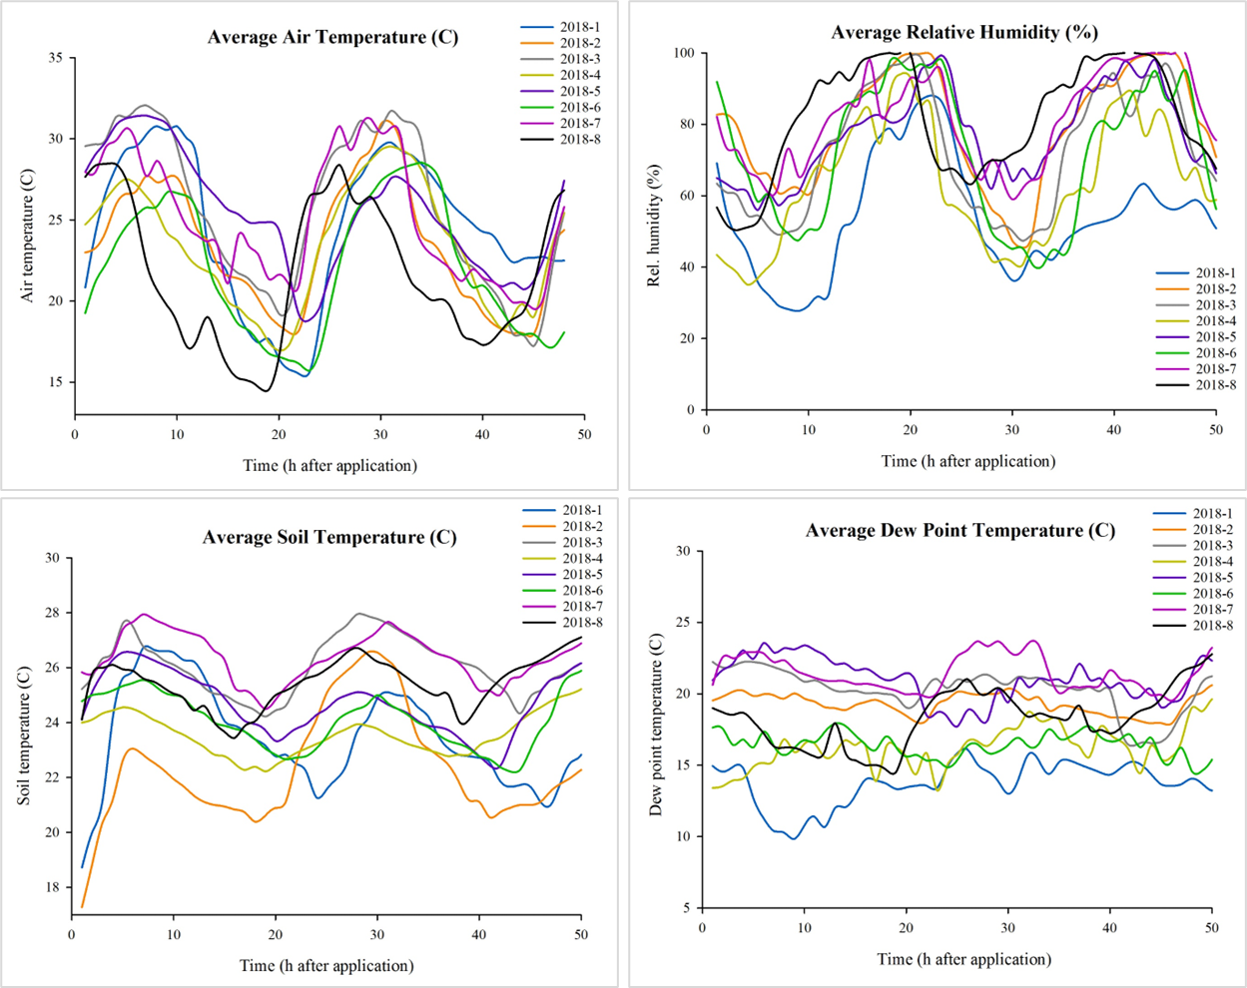
Fig. S1. Hourly results of observed average air temperature (C), relative humidity (%), soil temperature at a 1-cm depth (C), and dew point temperature (C) for each of the eight trials conducted in 2018, from 0.5 to 48 h.
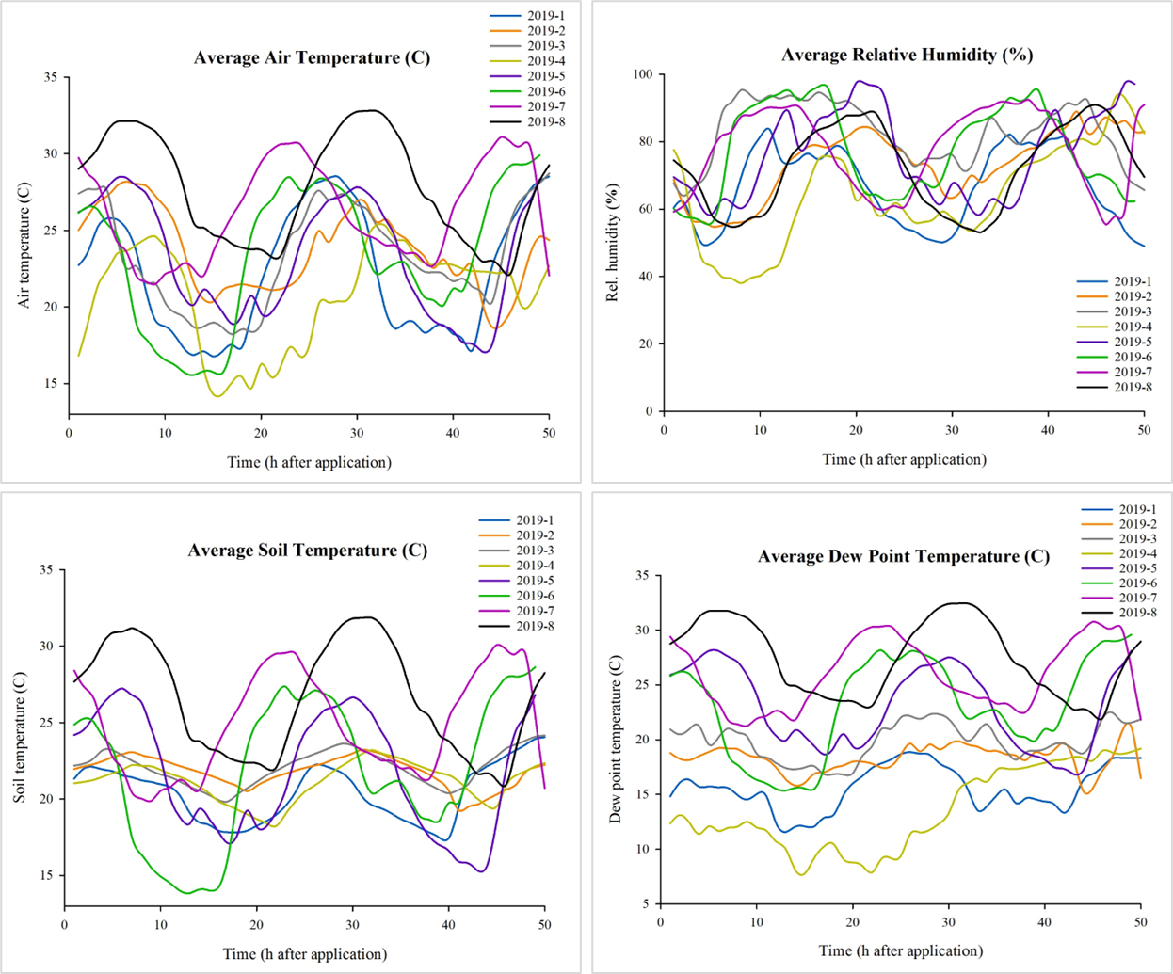
Fig. S2. Hourly results of observed average air temperature (C), relative humidity (%), soil temperature at a 1-cm depth (C), and dew point temperature (C) for each of the eight trials conducted in 2019, from 0.5 to 48 h.

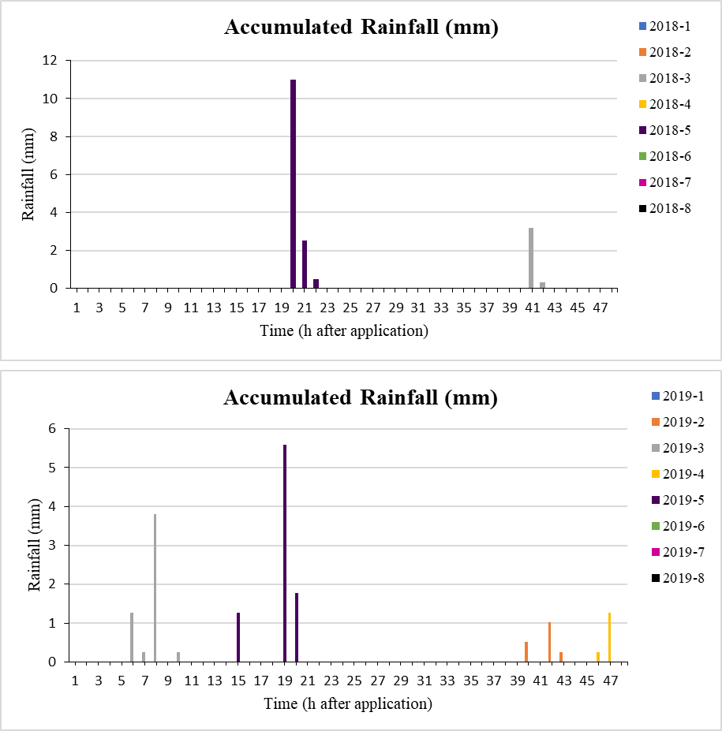
Fig. S3. Hourly results of observed accumulated rainfall (mm), from 0.5 to 48 h after application, for each of the sixteen trials conducted between 2018 and 2019.

