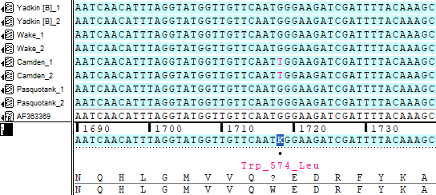
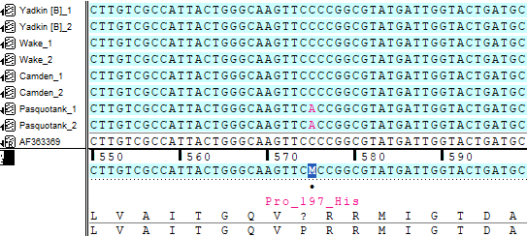
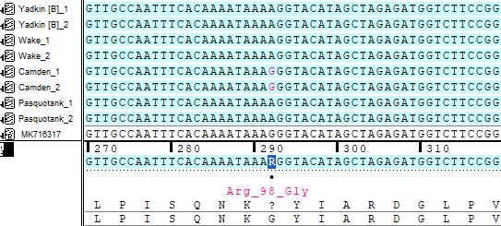
Supplemental figure 1: Visual representations of the single nucleotide polymorphisms found in the ALS and PPX2 genes of Amaranthus retroflexus populations (putative resistant: Camden and Pasquotank County; susceptible: Wake and Yadkin (A & B) County). Top: Trp₅₇₄leu mutation in the ALS gene of the Camden County population. Middle: Pro₁₉₇His mutation in the ALS gene of the Pasquotank County population. Bottom: Arg98Gly mutation in the PPX2 gene of the Camden County population.

