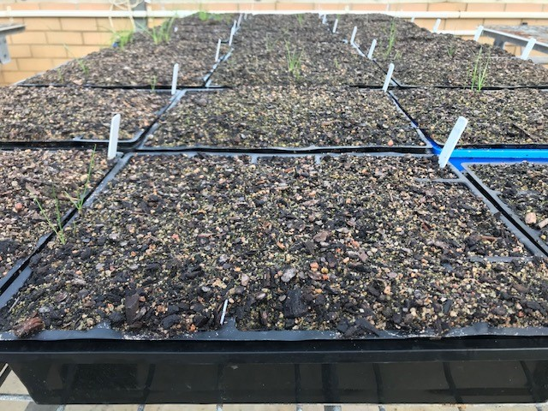

**Supplementary Fig. S1.** Screening of ~500 field-collected *L. rigidum* populations at 375 g cinmethylin ha-1, showing no seedling emergence in most populations.