Supplementary material – visual abstract
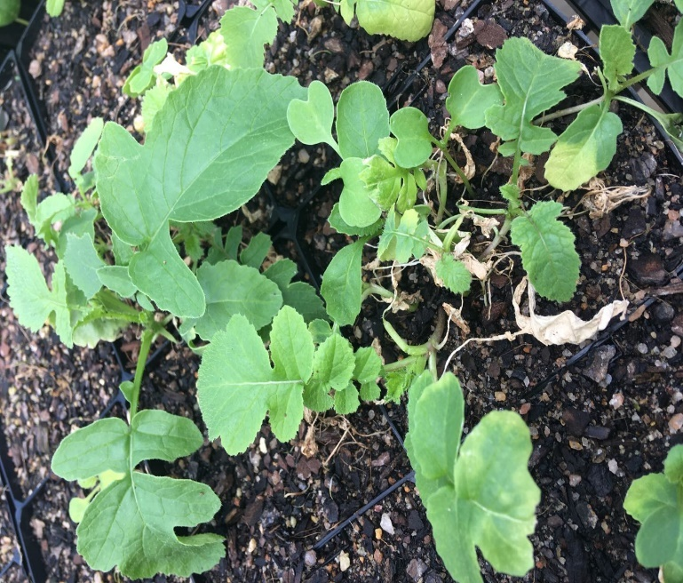
Figure S1. Wild radish plants (population 86-2020) recovering from herbicide damage and surviving pyrasulfotole + bromoxynil treatment.

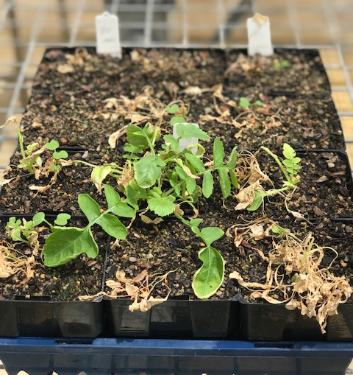
Figure S2. Wild radish plants (population 91-2020) recovering from herbicide damage and surviving pyrasulfotole + bromoxynil treatment.
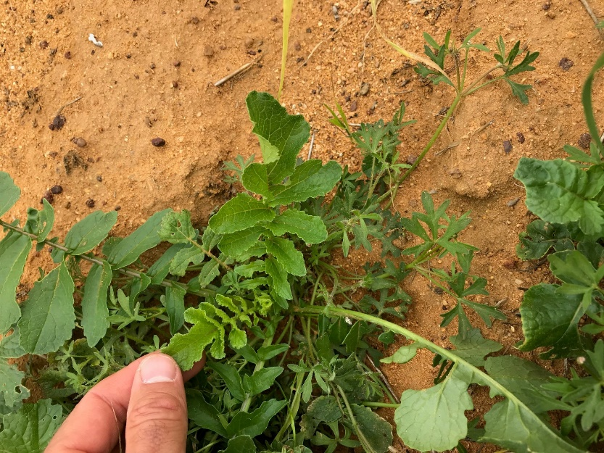
Figure S3. HPPD inhibitor-resistant wild radish (progeny of population 91-2020) surviving treatment with pyrasulfotole + bromoxynil (37.5+210 g ha⁻¹) treatment in a trial conducted in the field where resistance has evolved over the last 10 years of continuous HPPD inhibitor use.

