Supplemental Figures
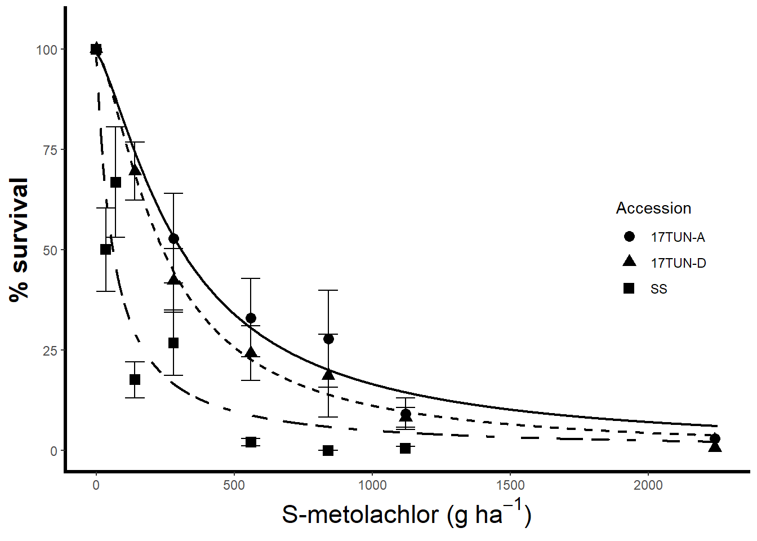
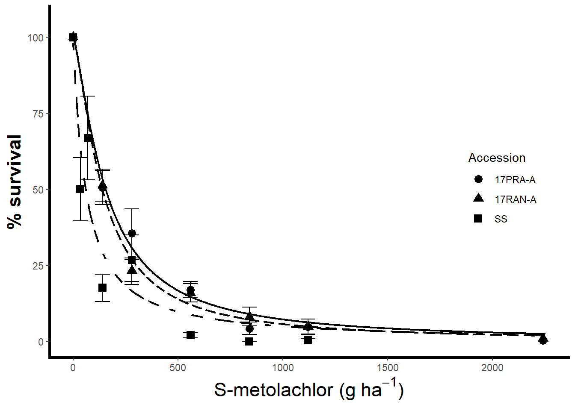
Supplemental Figure 1. S-metolachlor dose–response studies, of parental Palmer amaranth populations collected in 2017 in Mississippi and Arkansas, conducted in the greenhouse at the Shult Agricultural Research & Extension Center (University of Arkansas, Fayetteville, USA). Data were fit using a three-parameter log-logistic equation. Error bars represent Palmer amaranth %survival associated standard errors.

