Supplementary Material

Materials and Methods
The function hclustvar in the package ‘ClustOfVar’ (Chavent et al. 2012a) in R (R Core Team, 2020) is a clustering algorithm that can be used to find clusters of variables that are strongly related to each other within datasets that contain a mixture of quantitative and qualitative variables.
ClustOfVar is based on the Singular Value Decomposition (SVD) approach (Chavent et al. 2012b) of PCAMIX (Kiers 1991), a principal component method for mixtures of qualitative and quantitative variables. The clustering algorithm determines the partition of variable clusters (P_{K}) in a dataset that best maximizes homogeneity (H) within clusters, as:
$H\left(P_{K}\right)=\sum_{k=1}^{K}{H\left(C_{k}\right)}=λ_{1}^{1}+..λ_{1}^{K}$ (eqn. 1)
In eqn. 1, $λ_{1}^{1}...λ_{1}^{K}$ are the first eigenvalues of PCAMIX applied to the K clusters (C_{k}) of P_{K}, and the homogeneity (H) of a cluster (C_{k}) is a measure of relatedness between the variables in the cluster and its central synthetic quantitative variable, y_{k} (see Chavent et al. 2012a for further details):
$H\left(C_{k}\right)=\sum_{\left(x_{j∈C_{k}}\right)}{r_{x_{j,}y_{k}}^{2}}+\sum_{\left(z_{j∈C_{k}}\right)}{η_{y_{k,}z_{j}}^{2}}$ (eqn. 2)
The first term in eqn. 2 measures the relationship between the quantitative variables (x) in C_{k} and y_{k} and is based on the squared Pearson correlation r². The second term measures the relationship between the qualitative variables (z) in C_{k} and y_{k} and is based on the correlation ratio η². Cluster homogeneity is at a maximum when all variables in a cluster convey the same information, i.e., when all the quantitative variables are correlated to y_{k} and all the correlation ratios of the qualitative variables are equal to 1.
In the hierarchical clustering algorithm, hclustvar, an iterative process is used to determine a set of nested partitions of variables, p, that maximizes H across all clusters. First, the data is partitioned into p clusters, where p denotes the total number of variables (quantitative and qualitative) in the dataset. Then clusters of variables are iteratively aggregated by determining levels of dissimilarity between clusters, where dissimilarity (d) is measured as the loss of homogeneity when two clusters (A and B) are merged
$d\left(A,B\right)=H\left(A\right)+H\left(B\right)-\left(A∪B\right)=λ_{A}^{1}+λ_{B}^{1}-λ_{A∪B}^{1}$ (eqn. 3)
Clusters are assessed and merged until a new partition is obtained that maximizes H. Results are plotted as a dendrogram, where the height of each cluster denotes the dissimilarity (see eqn. 3) between clusters:
height(C) = d(A, B).

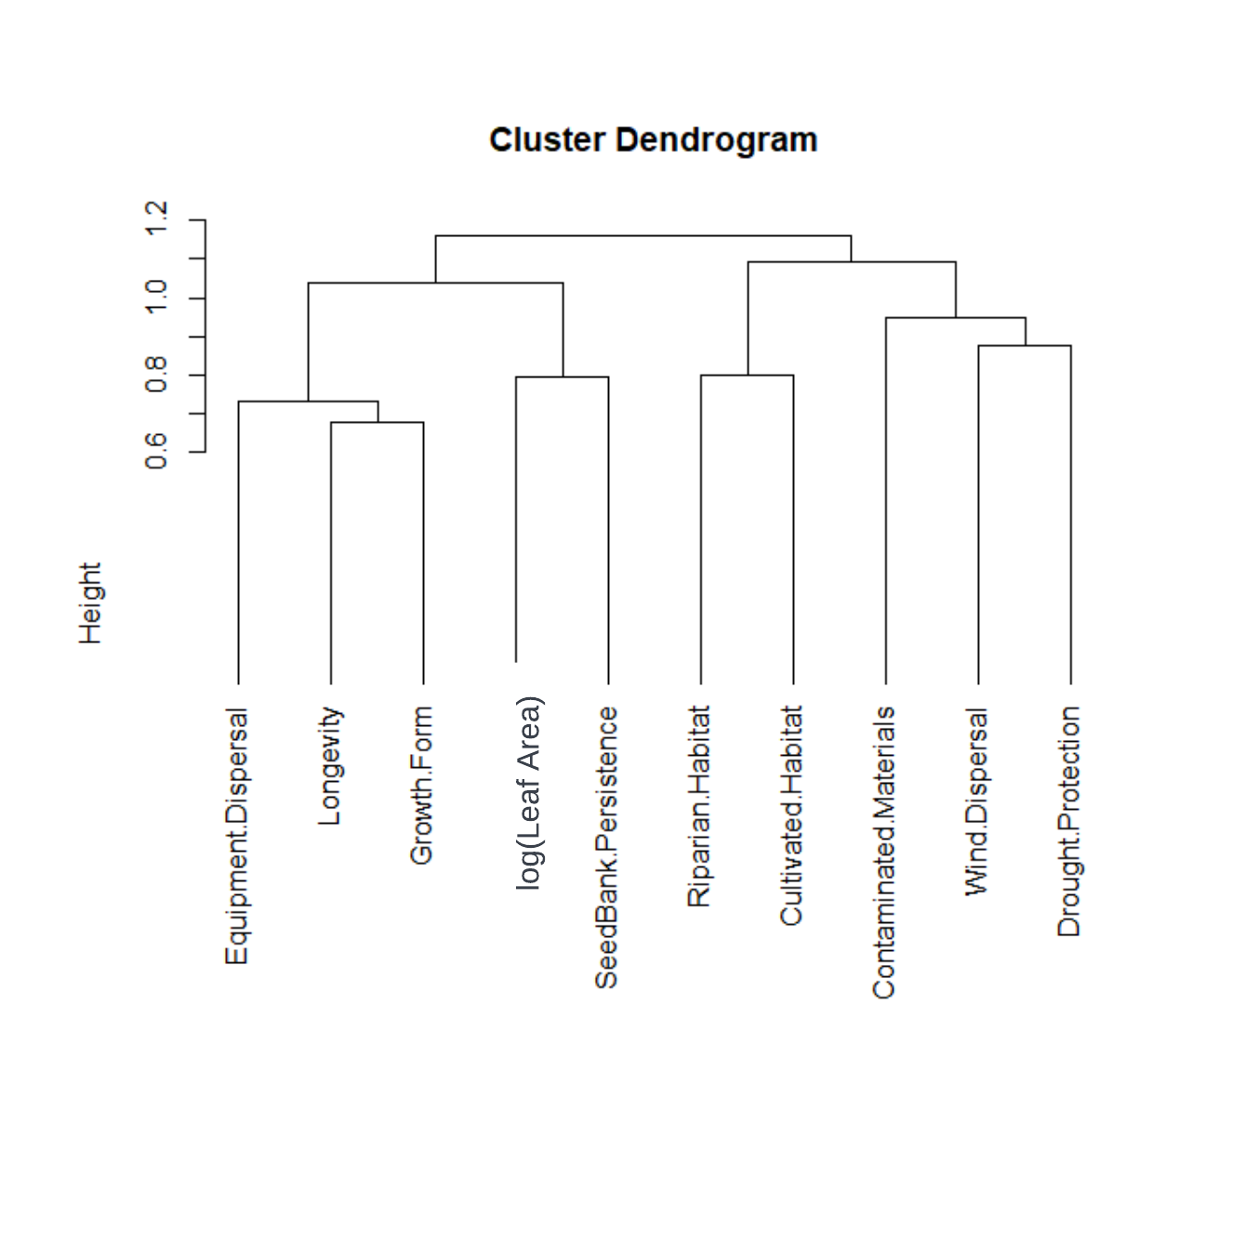
Figure S1. Clusters of related functional plant traits in our non-native, noxious weed dataset as determined by hierarchical clustering algorithm. Height of the branches in the dendrogram is a measure of the dissimilarity between different variables or variable clusters.

Literature Cited
Chavent, M., V. Kuentz-Simonet, B. Liquet, and J. Saracco. (2012a). ClustOfVar: An R package for the clustering of variables. Journal of Statistical Software 50 (13):1–16.
Chavent M, Kuentz V, Saracco J (2012b). Orthogonal Rotation in PCAMIX. Advances in Data Analysis and Classification, 6, 131-146.
Kiers H (1991). Simple Structure in Component Analysis Techniques for Mixtures of Qualitative and Quantitative Variables. Psychometrika, 56, 197–212.

