Supplemental Materials

Figure S1. An image of the sample tumbling setup used for the soil transfer experiment, kernel rinsate experiment, and almond-to-almond transfer experiment.
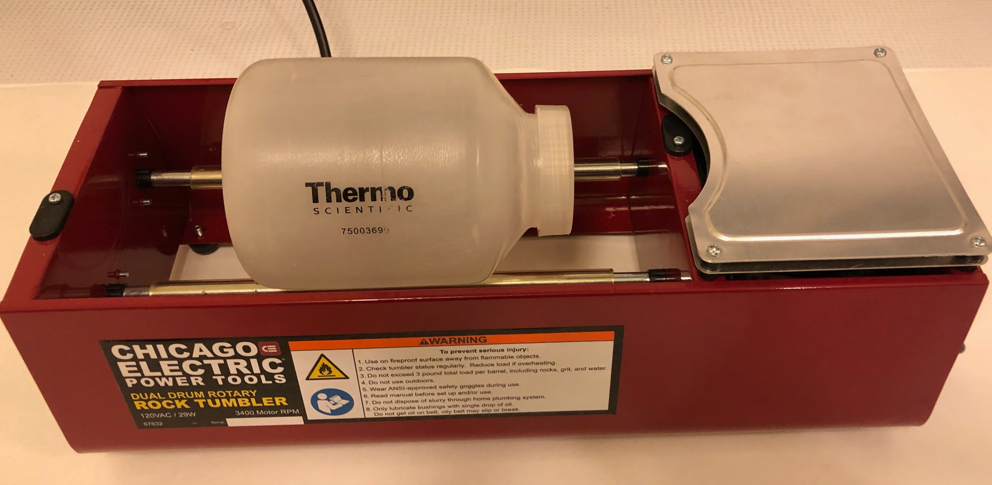

Figure S2. Diagram of the field experiment conducted at Nickels Soil Laboratory. Plots were 19.6 m long by 4 m wide.
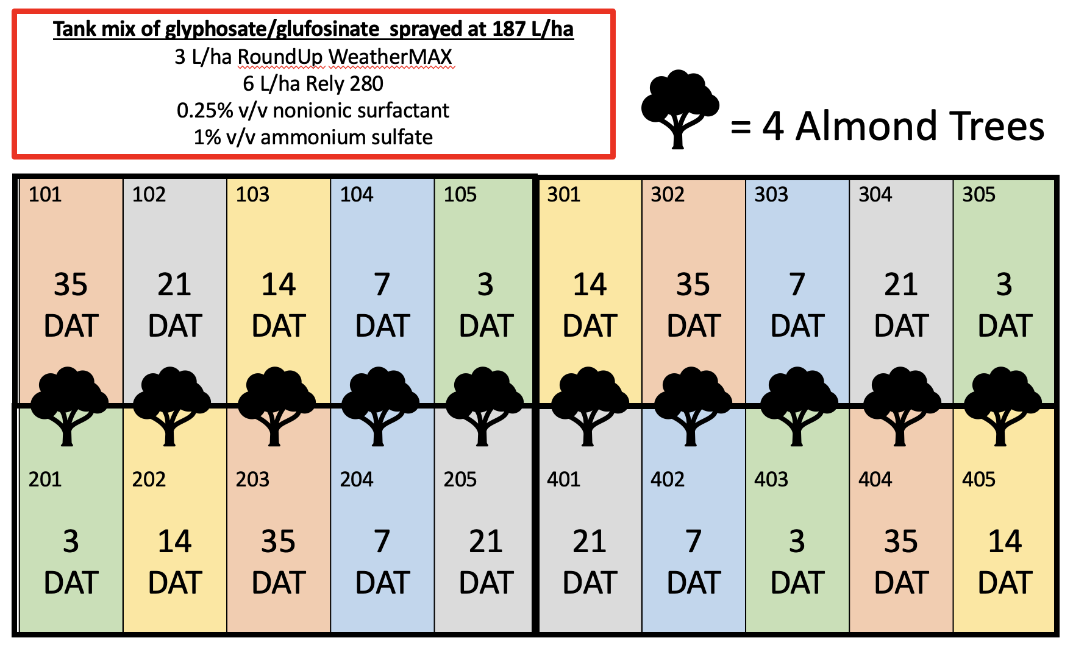

Table S1. Results of the rinsate analysis of the washed whole almonds for the soil transfer experiment. Whole almonds tumbled in [¹⁴C]-herbicide treated soil were rinsed end-over-end in 20 mL of deionized water. The rinsate was analyzed for [¹⁴C]-herbicide using a liquid scintillation counter. A total of 166,500 Bq were added to the soil.
[¹⁴C]-Herbicide | Replicate | Bq | Average Bq | Standard Error (Bq)
Glyphosate | 1 | 11,465 | 6,667 | 1,782
 | 2 | 7,073
 | 3 | 4,888
 | 4 | 3,240
Glufosinate | 1 | 5,817 | 6,130 | 2,319
 | 2 | 12,704
 | 3 | 3,899
 | 4 | 2,101

Table S2. Results of the swipe analysis of the plastic barrier used to crack the almond shells in the soil transfer experiment. After whole almonds were tumbled in [¹⁴C]-herbicide treated soil, almonds were shelled using a plastic barrier to crack the hard outer shell and expose the kernel. The plastic piece was swiped with filter paper and analyzed for [¹⁴C]-herbicide using a liquid scintillation counter. A total of 166,500 Bq were added to the soil.
[¹⁴C]-Herbicide | Replicate | Bq | Average Bq | Standard Error (Bq)
Glyphosate | 1 | 165 | 154 | 36
 | 2 | 248
 | 3 | 128
 | 4 | 75
Glufosinate | 1 | 121 | 109 | 23
 | 2 | 85
 | 3 | 166
 | 4 | 62

Table S3. Results of the post-harvest mimic kernels from the soil transfer experiment. Whole almonds were tumbled in [¹⁴C]-herbicide treated soil. After tumbling, the whole almonds were hulled and shelled. The kernels were collected and analyzed for [¹⁴C]-herbicide using a liquid scintillation counter. A total of 166,500 Bq were added to the soil.
[¹⁴C]-Herbicide | Replicate | Bq mg⁻¹ | Average Bq mg⁻¹ | Standard Error (Bq mg⁻¹)
Glyphosate | 1 | 0.248 | 0.138 | 0.035
 | 2 | 0.097
 | 3 | 0.149
 | 4 | 0.059
Glufosinate | 1 | 0.138 | 0.093 | 0.016
 | 2 | 0.088
 | 3 | 0.063
 | 4 | 0.082

Table S4. Results of the rinsate analysis of the whole almond wash in the almond-to-almond transfer experiment. The experiment was only conducted with glyphosate due to the available amount of [¹⁴C]-glufosinate. Two whole almonds were dotted with a total of 166,500 Bq of [¹⁴C]-glyphosate and tumbled with whole untreated almonds. The treated almonds were removed and the untreated were rinsed in 20 mL of deionized water. The rinsate was analyzed for [¹⁴C]-glyphosate using a liquid scintillation counter.
¹⁴C-Herbicide | Replicate | Bq | Average Bq | Standard Error (Bq)
Glyphosate | 1 | 1,853 | 1,534 | 265
 | 2 | 1,002
 | 3 | 1,173
 | 4 | 2,109

