A
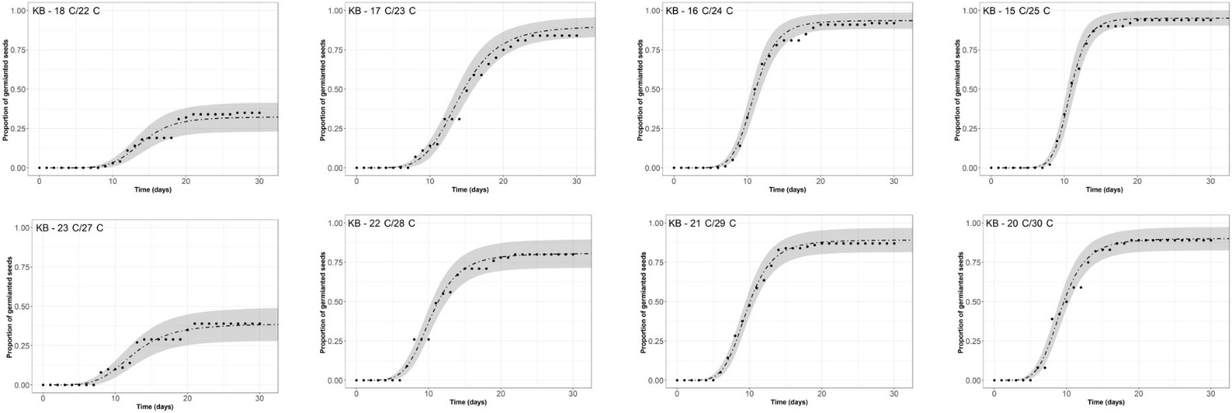
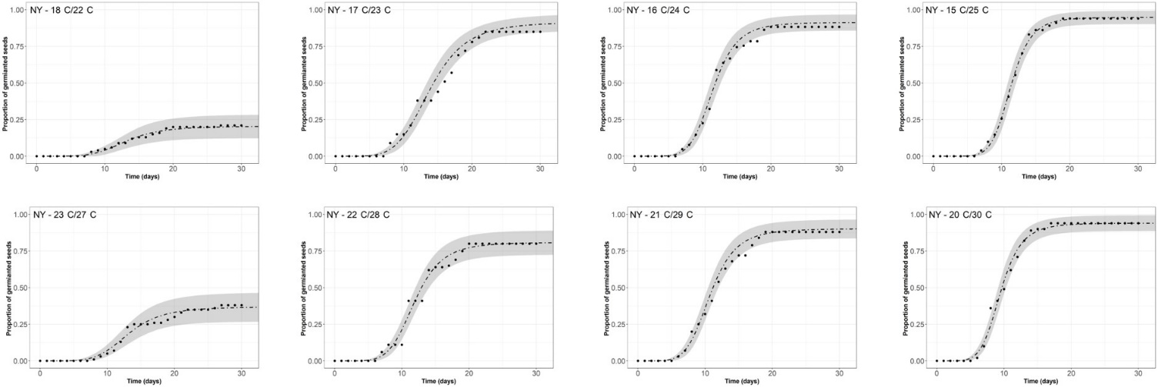
B
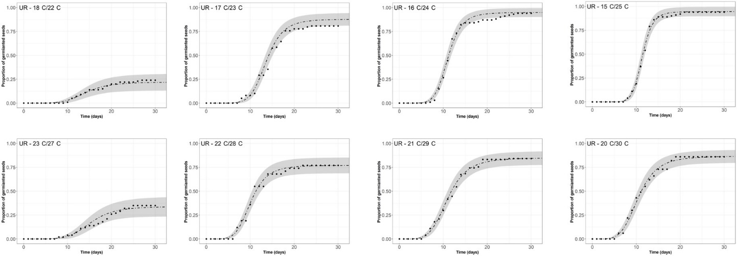
C

Supplementary Figure S1. Time-to-event-method, three-parameter log-logistic equation: $f(t,(b,d,e))=d/(1+exp⁡(b\left(log\left(t\right)-log\left(e\right)\right)$ showing the relationship between different alternating temperature regimes at optimal temperature and germination of three Solanum elaeagnifolium populations: (A) Kfar Blum [KB], (B) Newe Yaar [NY] and (C) Urim [UR].

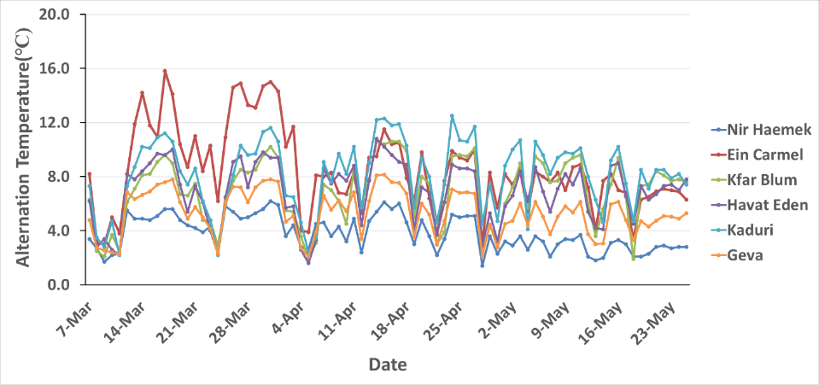

Supplementary Figure S2. Daily alternating temperature range (C), maximal-minimal, measured at a 10-cm soil depth in six locations in Israel: Nir Haemek (blue); Ein Carmel (red); Kfar Blum (green); Havat Eden (purple); Kaduri (light blue); and Geva (orange). This time course reflects the main germination period of S. elaeagnifolium.

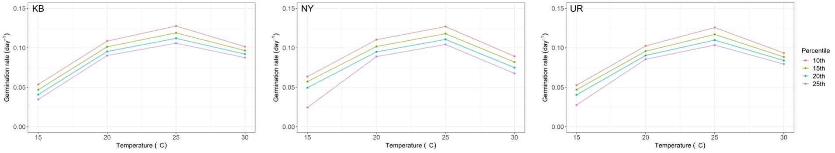

Supplementary Figure S3. Relationship between germination rate (GR) of the 10th, 15th, 20th and 25th percentiles of Solanum elaeagnifolium and temperature T (C) for three populations, Kfar Blum (KB), Newe Yaar (NY) and Urim (UR).

Supplementary Figure S4. Average soil temperature (C) for the years 2016, 2017 and 2018 for the three locations from which the Solanum elaeagnifolium populations were collected: Kfar Blum [KB], Newe Yaar [NY] and Urim [UR].

