Supplementary Materials
Supplementary Table 1. Average temperature at the Flakkebjerg Research Centre, Denmark, during the months of April to August in 2019 (EXP₂₀₁₉) and 2020 (EXP₂₀₂₀) compared with the 10-year average, from 2009 to 2018. Standard errors are presented in parentheses.
Month | Average temperature
 | EXP₂₀₁₉ |  |  | EXP₂₀₂₀ |  |  | 10-year average
 | °C
April | 8.29 | (±0.19) |  | 8.16 | (±0.14) |  | 7.851 | (±0.047)
May | 10.48 | (±0.15) |  | 10.72 | (±0.14) |  | 12.108 | (±0.054)
June | 17.12 | (±0.15) |  | 16.59 | (±0.16) |  | 14.809 | (±0.045)
July | 17.34 | (±0.18) |  | 15.60 | (±0.12) |  | 17.681 | (±0.049)
August | 18.10 | (±0.14) |  | 19.00 | (±0.18) |  | 17.141 | (±0.041)

Supplementary Table 2. Total precipitation at the Flakkebjerg Research Centre, Denmark, during the months of April to August in 2019 (EXP₂₀₁₉) and 2020 (EXP₂₀₂₀) compared with the 10-year average, from 2009 to 2018. Standard errors are presented in parentheses.
Month | Total precipitation
 | EXP₂₀₁₉ |  | EXP₂₀₂₀ |  | 10-year average
 | mm
April | 13.4 |  | 18.1 |  | 27.1 | (±4.2)
May | 48.7 |  | 14.7 |  | 39.3 | (±6.1)
June | 59.1 |  | 48.5 |  | 68.6 | (±15.8)
July | 42.5 |  | 60.6 |  | 54.1 | (±9.4)
August | 55.3 |  | 55.3 |  | 66.9 | (±12.8)

Supplementary Table 3. Target and achieved spring barley (Hordeum vulgare) crop densities in 2019 (EXP₂₀₁₉) and 2020 (EXP₂₀₂₀) across treatment plots possessing row spacings of 15 cm (RS₁₅) and 20 cm (RS₂₀) and target densities of 200 (CD₂₀₀), 300 (CD₃₀₀), 400 (CD₄₀₀), and 500 (CD₅₀₀) plants m⁻². Both full-width and intra-row crop densities are presented. Full-width densities are calculated at field-scale, spanning across both the inter- and intra-row zones. Intra-row densities are defined as 7 cm wide bands centered on crop rows, which do not receive inter-row hoeing. Standard errors are presented in parentheses.
 | Treatment |  | Full-width crop density |  |  |  |  | Intra-row crop density
Experiment |  |  | Target |  | Achieved |  |  | Target |  | Achieved
 |  |  | no. m⁻²
EXP₂₀₁₉ | RS₁₅ | CD₂₀₀ | 200 |  | 215 | (±7) |  | 429 |  | 461 | (±15)
 |  | CD₃₀₀ | 300 |  | 298 | (±9) |  | 643 |  | 639 | (±19)
 |  | CD₄₀₀ | 400 |  | 402 | (±13) |  | 857 |  | 861 | (±28)
 |  | CD₅₀₀ | 500 |  | 516 | (±19) |  | 1071 |  | 1105 | (±41)
 | RS₂₀ | CD₂₀₀ | 200 |  | 235 | (±10) |  | 571 |  | 671 | (±28)
 |  | CD₃₀₀ | 300 |  | 339 | (±10) |  | 857 |  | 970 | (±29)
 |  | CD₄₀₀ | 400 |  | 438 | (±14) |  | 1143 |  | 1253 | (±40)
 |  | CD₅₀₀ | 500 |  | 558 | (±18) |  | 1429 |  | 1593 | (±52)
EXP₂₀₂₀ | RS₁₅ | CD₂₀₀ | 200 |  | 160 | (±8) |  | 429 |  | 343 | (±18)
 |  | CD₃₀₀ | 300 |  | 244 | (±7) |  | 643 |  | 523 | (±16)
 |  | CD₄₀₀ | 400 |  | 298 | (±17) |  | 857 |  | 639 | (±36)
 |  | CD₅₀₀ | 500 |  | 369 | (±26) |  | 1071 |  | 791 | (±55)
 | RS₂₀ | CD₂₀₀ | 200 |  | 158 | (±5) |  | 571 |  | 451 | (±13)
 |  | CD₃₀₀ | 300 |  | 251 | (±10) |  | 857 |  | 717 | (±29)
 |  | CD₄₀₀ | 400 |  | 329 | (±18) |  | 1143 |  | 941 | (±53)
 |  | CD₅₀₀ | 500 |  | 389 | (±16) |  | 1429 |  | 1112 | (±47)
Supplementary Table 4. Estimates of parameters a and b for spring barley crop (Hordeum vulgare) biomass from Equation (1). Parameter estimates of the reduced model are shown for experiments performed in 2020 (EXP₂₀₂₀) among plots sown to 15 cm (RS₁₅) and 20 cm (RS₂₀) row spacings, receiving treatment with herbicide (WMT_{herbicide}), no additional weed management treatment (WMT_{weedy}), and pre-emergence tine harrowing (WMT_{tineharrow}). All plots received inter-row hoeing.
Experiment | Treatment |  | Crop biomass
 |  |  | a |  | b
 |  |  | g m⁻² |  | g m⁻² plant⁻¹
EXP₂₀₂₀ | RS₁₅ | WMT_{herbicide} | 592 |  | 0.3553
 | RS₁₅ | WMT_{weedy} | 558 |  | 0.3553
 | RS₁₅ | WMT_{tineharrow} | 558 |  | 0.3553
 | RS₂₀ | WMT_{herbicide} | 592 |  | 0.3553
 | RS₂₀ | WMT_{weedy} | 558 |  | 0.3553
 | RS₂₀ | WMT_{tineharrow} | 558 |  | 0.3553

Supplementary Table 5. Estimates of parameters a and b for spring barley (Hordeum vulgare) grain protein from Equation (1). Parameter estimates of the reduced model are shown for experiments performed in 2019 (EXP₂₀₁₉) among plots sown to 15 cm (RS₁₅) and 20 cm (RS₂₀) row spacings, receiving treatment with herbicide (WMT_{herbicide}), no additional weed management treatment (WMT_{weedy}), and pre-emergence tine harrowing (WMT_{tineharrow}). All plots received inter-row hoeing.
Experiment | Treatment |  | Grain protein
 |  |  | a |  | b
 |  |  | % |  | % plant⁻¹
EXP₂₀₁₉ | RS₁₅ | WMT_{herbicide} | 10.45 |  | -0.001249
 | RS₁₅ | WMT_{weedy} | 10.45 |  | -0.001249
 | RS₁₅ | WMT_{tineharrow} | 10.45 |  | -0.001249
 | RS₂₀ | WMT_{herbicide} | 10.45 |  | -0.001249
 | RS₂₀ | WMT_{weedy} | 10.45 |  | -0.001249
 | RS₂₀ | WMT_{tineharrow} | 10.45 |  | -0.001249

Supplementary Table 6. Estimates of parameters a and b for spring barley (Hordeum vulgare) grain bulk density from Equation (1). Parameter estimates of the reduced model are shown for experiments performed in 2019 (EXP₂₀₁₉) and 2020 (EXP₂₀₂₀) among plots sown to 15 cm (RS₁₅) and 20 cm (RS₂₀) row spacings, receiving treatment with herbicide (WMT_{herbicide}), no additional weed management treatment (WMT_{weedy}), and pre-emergence tine harrowing (WMT_{tineharrow}). All plots received inter-row hoeing.
Experiment | Treatment |  | Grain bulk density
 |  |  | a |  | b
 |  |  | kg hL⁻¹ |  | kg hL⁻¹ plant⁻¹
EXP₂₀₁₉ | RS₁₅ | WMT_{herbicide} | 64.09 |  | -0.006060
 | RS₁₅ | WMT_{weedy} | 64.09 |  | -0.006060
 | RS₁₅ | WMT_{tineharrow} | 64.09 |  | -0.006060
 | RS₂₀ | WMT_{herbicide} | 64.09 |  | -0.006060
 | RS₂₀ | WMT_{weedy} | 64.09 |  | -0.006060
 | RS₂₀ | WMT_{tineharrow} | 64.09 |  | -0.006060
EXP₂₀₂₀ | RS₁₅ | WMT_{herbicide} | 73.23 |  | -0.005408
 | RS₁₅ | WMT_{weedy} | 72.52 |  | -0.005408
 | RS₁₅ | WMT_{tineharrow} | 72.52 |  | -0.005408
 | RS₂₀ | WMT_{herbicide} | 73.23 |  | -0.005408
 | RS₂₀ | WMT_{weedy} | 72.52 |  | -0.005408
 | RS₂₀ | WMT_{tineharrow} | 72.52 |  | -0.005408

Supplementary Figure 1. The relationship between crop biomass (g m⁻²; Hordeum vulgare) and crop density (plants m⁻²). Observed values represent means of the reduced model for two row spacings, 15 cm (RS₁₅) and 20 cm (RS₂₀), and three weed management treatments, receiving treatment with herbicide (WMT_{herbicide}), no additional weed management treatment (WMT_{weedy}), and pre-emergence tine harrowing (WMT_{tineharrow}) in 2020 (EXP₂₀₂₀). All plots received inter-row hoeing.
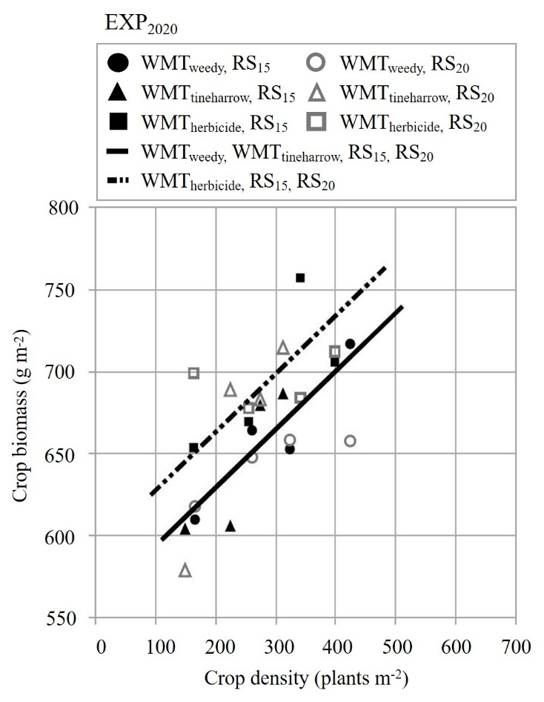
Supplementary Figure 2. The relationship between grain protein (%; Hordeum vulgare) and crop density (plants m⁻²). Observed values represent means of the reduced model for two row spacings, 15 cm (RS₁₅) and 20 cm (RS₂₀), and three weed management treatments, receiving treatment with herbicide (WMT_{herbicide}), no additional weed management treatment (WMT_{weedy}), and pre-emergence tine harrowing (WMT_{tineharrow}) in 2019 (a; EXP₂₀₁₉) and 2020 (b; EXP₂₀₂₀). All plots received inter-row hoeing.
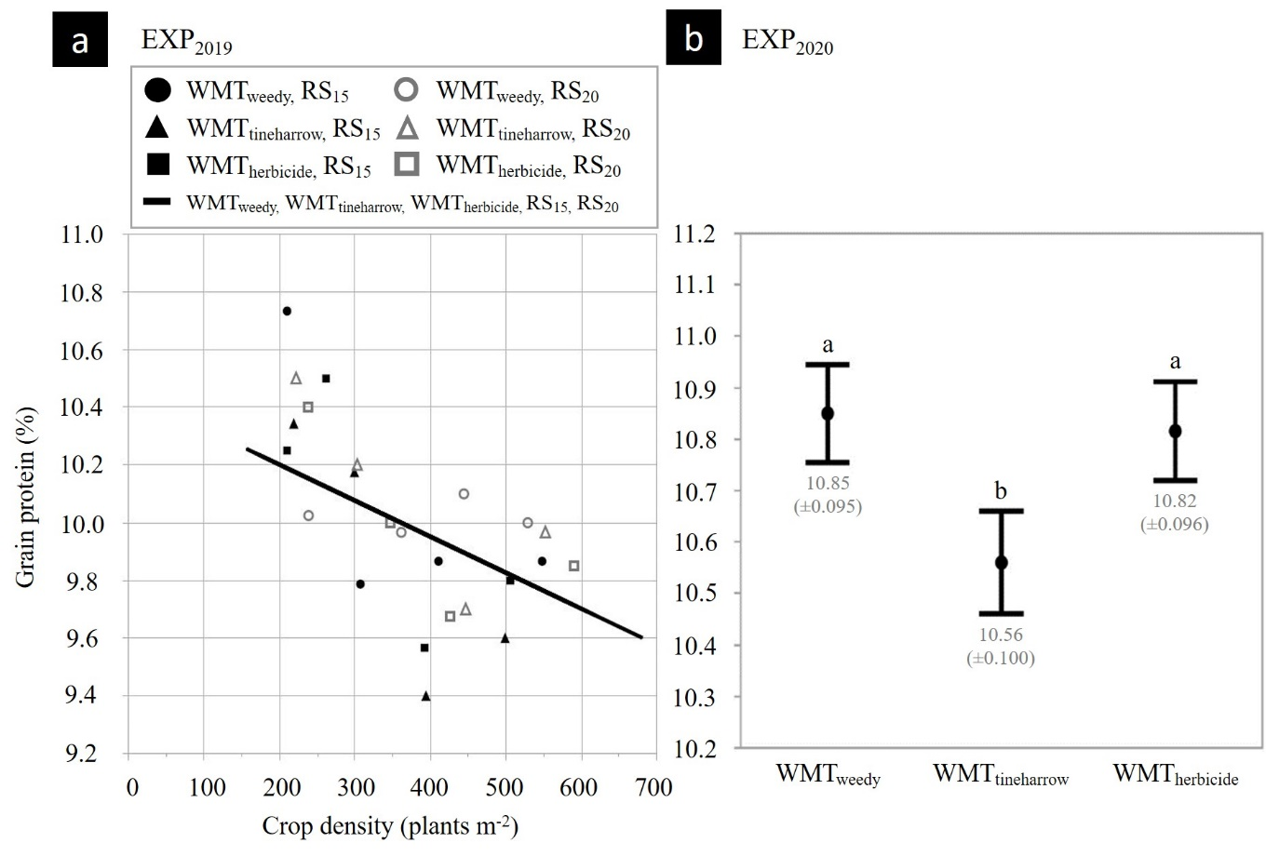
Supplementary Figure 3. The relationship between grain bulk density (kg hL⁻¹; Hordeum vulgare) and crop density (plants m⁻²). Observed values represent means of the reduced model for two row spacings, 15 cm (RS₁₅) and 20 cm (RS₂₀), and three weed management treatments, receiving treatment with herbicide (WMT_{herbicide}), no additional weed management treatment (WMT_{weedy}), and pre-emergence tine harrowing (WMT_{tineharrow}) in 2019 (a; EXP₂₀₁₉) and 2020 (b; EXP₂₀₂₀). All plots received inter-row hoeing.
