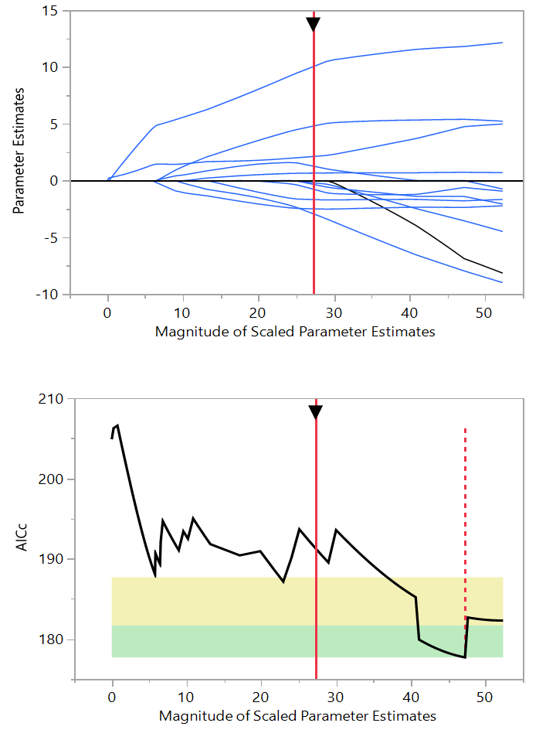

Supplemental figure 1. Representation of scaled parameter estimates to determine the relative influence of of crop production practices on weedy rice infestation.

